Supplementary material

S1 – Optimum number of random points to obtain the NOD distribution.
To determine which was the optimum number of random points for the calculation of the NODs distribution, we did a sensitivity analysis. Sup. Fig. 1 shows the computed pore size and the execution time versus the number of random points. As can be observed, the pore size stabilizes at about 50.000 random points with a reasonable computation time. In fact, we finally used 100.000 random points for safety.
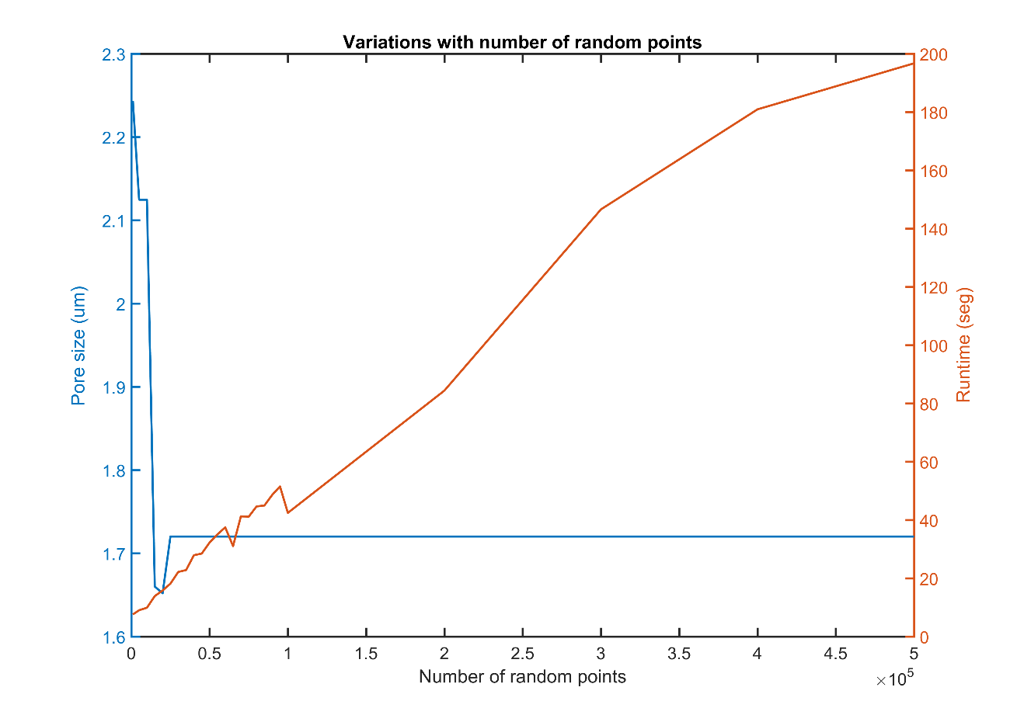
Supplementary figure 1. Variations of the pore size and runtime with the number of random points.

S2 – Connectivity check by adding the crosslinking enzyme transglutaminase 2 (TG2).
We have analysed other images obtained in our laboratory for a concentration of 4mg/ml with and without the enzyme TG2. Transglutaminase are a group of enzymes that can modify some protein functionalities, the most important being the ability to cross link the peptides or proteins, which strengthen the matrix (Chau et al., 2005). To test this, we quantified the connectivity of a collagen with and without TG2. It can be observed in Sup. Fig. 2 that low connectivities, the curve of cross-linked collagen matrix is below the control collagen curve. However, for high connectivity, this is inverted and the collagen curve with TG2 is above the collagen curve. This means that collagen with transglutaminase presents a higher connectivity than without.
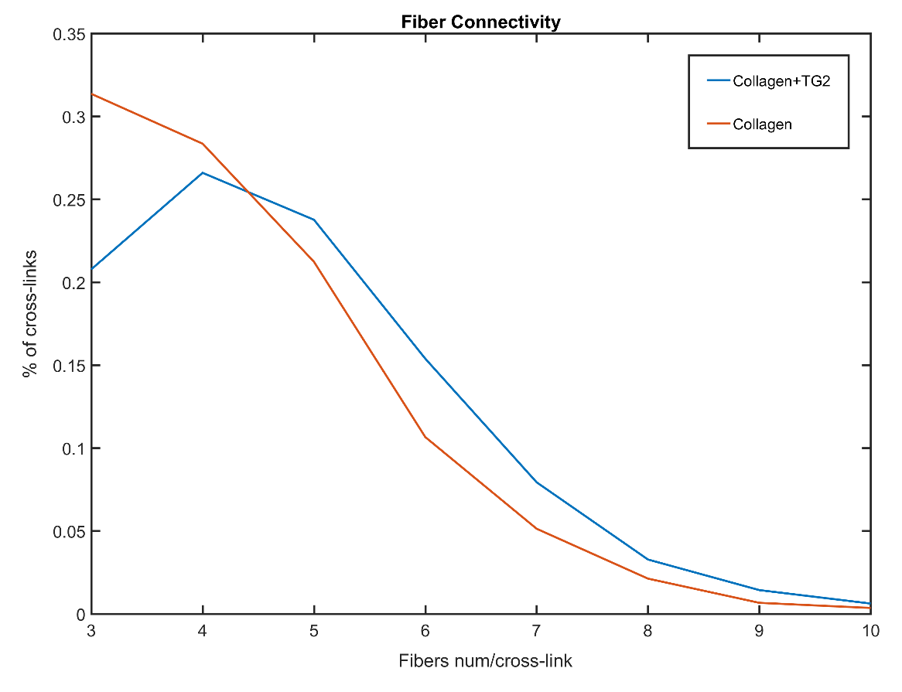
Supplementary figure 2. Connectivity for a non cross-linked and a cross-linked matrix of collagen.

