Supporting Information
Ion Beam Induced Artifacts in Lead Based Chalcogenides
Xiaomi Zhang¹, Shiqiang Hao¹, Gangjian Tan², Xiaobing Hu^{1,3}, Eric W. Roth³, Mercouri G. Kanatzidis², Chris Wolverton¹, Vinayak P. Dravid^{1,3}
- Department of Materials Science and Engineering, Northwestern University, Evanston, IL, 60208
- Department of Chemistry, Northwestern University, Evanston, IL, 60208
- NUANCE Center, Northwestern University, Evanston, IL, 60208

Key words: Aberration-corrected STEM, Thermoelectric materials, Ion irradiation, Damage, Beam effects, Sample prep

Figure S1: Schematic illustration of the elimination of surface damage with low energy Ar ion milling. When specimen is prepared with high energy (>1 keV) ion milling, a damaged layer will be formed on the specimen surface. After 35 min of low energy Ar ion milling, the damaged layer thickness was reduced, but not eliminated, that explains why we observed a lower number density of nanoscale features. After additional 35 min, the damaged layer in electron transparent area (indicated by the green shadow) has been mostly removed, this explains why no obvious nanoscale features can be observed in the specimen.
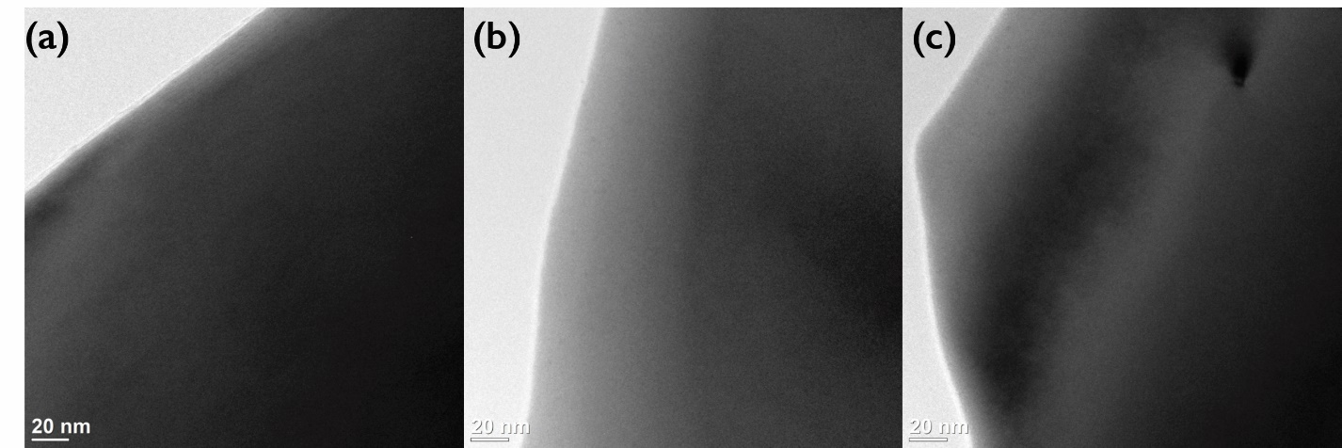
Figure S2: Conventional TEM images of different regions of the ingot PbTe specimen at 220 °C. No obvious nanoscale features were observed.
Figure S3: Formation energy of individual defect and defect clusters with different configurations and orientations. On the left side, (a) and (c) present calculated formation energy in Pb rich environment, the red bars represent the formation energy of vacancy or vacancy clusters while the green bars represent the formation energy of self-interstitial atom of SIA clusters. Similarly, on the right side, (b) and (d) present calculated formation energy in Te rich environment, the purple bars represent the formation energy of vacancy or vacancy clusters while the yellow bars represent the formation energy of SIA or SIA clusters. (a)-(b): Formation energy (per atom defect) for Te mono-defects, di-defect cluster and tri-defect cluster in (a) Pb rich environment and (b) Te rich environment. For interstitial clusters, we are only showing the formation energy along the <001> direction. (c)-(d): Formation energy of Te SIA clusters along the <001>, <011> and <111> crystal orientations in (c) Pb rich environment and (d) Te rich environment.
Figure S4: The atomic structure of PbTe. The white and pink balls are respectively Pb and Te atoms. For the vacancy, we simply remove an atom from its original site. For the interstitial, as shown a red sphere, we consider the interstitial atoms in the cubic cage. For the cluster along certain directions, like Pb_{i-<001>}, we arrange two or three Pb atoms at interstitial sites (i.e. cubic cages) but along the <001> direction.

