Electron beam effects on oxide thin films – Structure and electrical properties
Krishna Kanth Neelisetty^{1,2}, Xiaoke Mu¹, Sebastian Gutsch³, Alexander Vahl⁴, Alan Molinari¹, Falk von Seggern¹, Mirko Hansen⁵, Torsten Scherer^{1,7}, Margit Zacharias³, Lorenz Kienle⁴, VS Kiran Chakravadhanula^{1,6,§} and Christian Kübel^{1,6,7*}

¹ Institute of Nanotechnology, Karlsruhe Institute of Technology, 76344, Eggenstein-Leopoldshafen.
² Technische Universität Darmstadt, 64289 Darmstadt.
³ Institute of Microsystems Engineering, Albert-Ludwigs-University Freiburg, 79110 Freiburg, Germany.
⁴ Technische Fakultät der CAU Kiel, Institut für Materialwissenschaft, 24143 Kiel, Germany.
⁵ Technische Fakultät der CAU Kiel, Institut für Elektrotechnik, 24143 Kiel, Germany.
⁶ Helmholtz Institute Ulm, Karlsruhe Institute of Technology, 76344, Eggenstein-Leopoldshafen, Germany.
⁷ Karlsruhe Nano- Micro Facility, Karlsruhe Institute of Technology, 76344, Eggenstein-Leopoldshafen, Germany.
§ Presently at Materials Characterization Division, Vikram Sarabhai Space Centre, 695022 Thiruvananthapuram, India.

Supplementary information

Experimental

Deposition of silicon oxide – magnetron sputering
The SiOx thin films were deposited by pulsed DC reactive magnetron sputtering from a Si target (Goodfellow GmbH, 99.999 %, 2 inch diameter) in a reactive Ar/O₂ atmosphere. The magnetron source (Thin Film Consulting, ION’X-2UHV) was mounted in a custom-built vacuum chamber at a distance of 70 mm from the substrate position. Prior to deposition, a vacuum of least 10⁻⁴ Pa was reached by a turbo molecular pump (Pfeiffer Vacuum, TMU 262) and a dry scroll pump (Agilent Technologies, SH-110). The reactive gas atmosphere was supplied by a flow of 48 SCCM Ar (purity 99.999%, gas regulating valve: Pfeiffer, EVR116 with attached hot ion cathode IMR 285) and 10SCCM of O₂ (purity 99.999%, mass flow controller Alicat, H-MC-100SCCM-D / 5M). For pulsed reactive sputtering, the DC power (supplied by Advanced Energy, MDX 500) was pulsed by a high power MOSFET (Behlke Power Electronics, HTS 31 CF I), that was triggered by a frequency generator (PeakTech, DDS Function Generator 4025, rectangular 0-5 V signal, 80 kHz, 35 % duty cycle). Prior to every deposition process, the target was cleaned and conditioned for a sufficient time (at least 60 s) to reach stable deposition conditions.

Deposition of Titanium oxide – pulsed laser deposition
TiO₂ thin films with a thickness of about 30 nm were grown via pulsed laser deposition using a KrF excimer laser (λ = 248 nm) with a fluence of ~2 J cm⁻² and a repetition rate of 1 Hz. The target to substrate distance was maintained at 50 mm. The deposition process was carried out at room temperature and a background oxygen pressure of 0.05 mbar.

Characterization

XPS
X-ray photoelectron spectroscopy (XPS, Omicron Nano-Technology GmbH, operating with an Al-anode at a power of 240 W) was used to investigate the chemical composition of the oxide thin films. The recorded spectra were charge referenced by using aliphatic carbon C-1s at 285.0 eV using the software CasaXPS (version 2.3.16). For the quantification of the chemical composition of the oxide thin films, Cr (using Cr-2p lines), O (using O-1s line), Si (using Si-2p line) and Nb (using Nb-3d lines) were used respectively.

Discussion

XPS results of SiOx
In Figure S1 the XPS spectra of a SiO_{x} thin film (overview spectrum and high-resolution spectrum of Si-2p line) and a NbO_{x} thin film (overview spectrum and high resolution spectrum of Nb-3d lines) are shown. The overview spectra were analysed for elemental composition and the respective characteristic peaks were marked in the spectra. For the SiO_{x} thin film the elements O, C, Cr and Si and for the NbO_{x} thin film the elements O, C, Cr and Nb were detected. The occurrence of Cr originates in the chromium coated sample holder. Carbon containing surface contamination, such as carbohydrates, result in the presence of carbon in the spectra.
The peak position of the Si-2p line, as shown in Figure S 1b, is at around 103.3 eV, which correlates well with the chemical shift of the line from pure Si at 99.3 eV to SiO₂ at 103.3 eV^{[1]}. The ratio of oxygen to silicon was quantified based on the peak area in the XPS spectra. However, the amount of oxygen signal from SiO_{x} was corrected by assuming fully oxidised Cr₂O₃ on the sample holder. In agreement with the observed chemical shift of the Si-2p line, the quantification yields an O/Si ratio of roughly 1.96, underlining that the investigated thin film is quasi stoichiometric SiO₂.

XPS results of NbOx
Figure S1d shows peak position of Nb-3d lines at 209.6 eV (3d_{3/2}) and 206.8 eV (3d_{5/2}). The splitting of both lines correlates well with the literature value of 2.7 eV^{[1]}. Compared to the position for metallic Nb at 202.4 eV^{[1]}, the 3d_{5/2} line is shifted by approximately 4.6 eV, which is typically interpreted as oxidation to Nb₂O₅ with a Nb-3d_{5/2} line at around 206.5-208.2 eV^{[2,3]} or NbO₂ with a Nb-3d_{5/2} line at around 205.2-207.6 eV^{[3]}. However, the quantification based on the assumption of fully oxidized Cr₂O₃ on the sample holder leads to an O/Nb ratio of roughly 1.9, which is close to the ratio for NbO₂.

However, the I/V curves shows an insulating behaviour in the as prepared state and we expect to have a stable oxide phase.

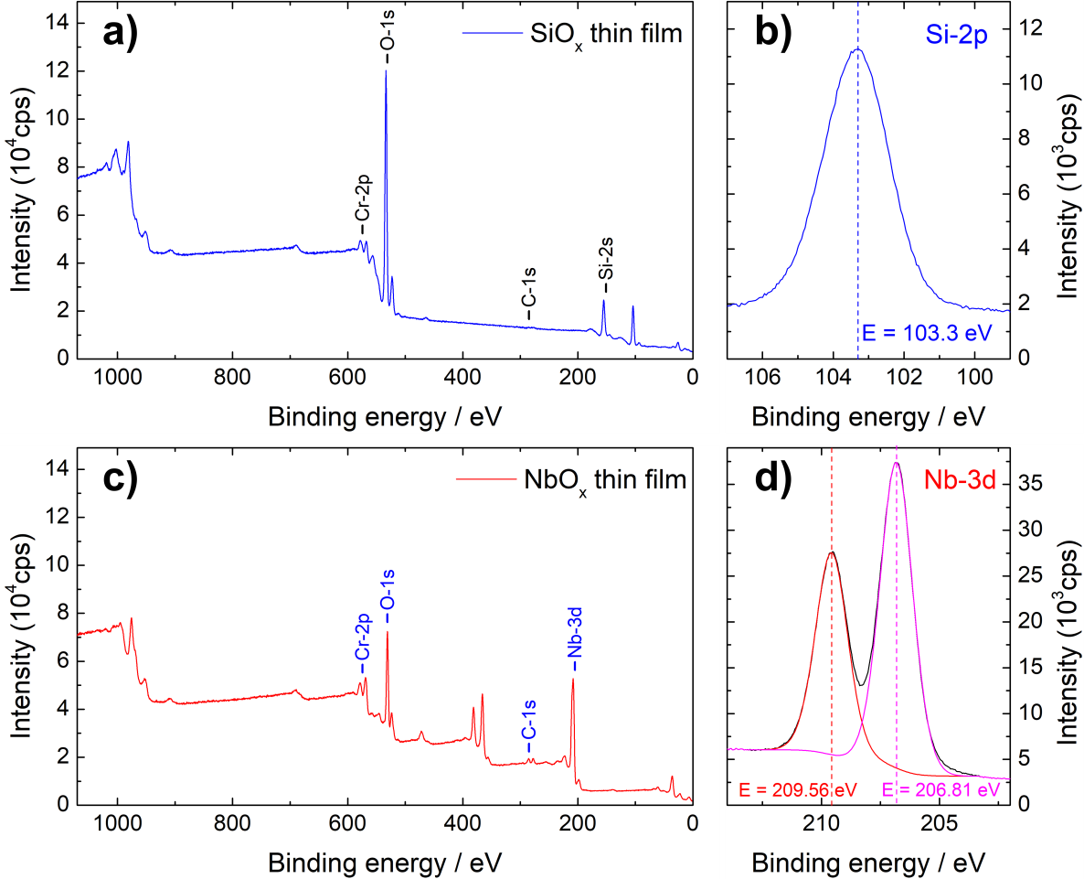
Figure S1 XPS spectra of SiO_{x} (blue line, a+b) and NbO_{x} (red line, c+d) thin films; a) and c): overview spectra; b) high resolution spectrum of Si-2p line; d) high resolution spectrum of Nb-3d lines

References:
[1] J.F. Moulder, W.F. Stickle, P.E. Sobol, K.D. Bomben, Handbook of X-Ray Photoelectron Spectroscopy, Perkin-Elmer Corporation, Physical Electronics Division, 1992.
[2] N. Singh, M.N. Deo, M. Nand, S.N. Jha, S.B. Roy, Raman and photoelectron spectroscopic investigation of high-purity niobium materials: Oxides, hydrides, and hydrocarbons, J. Appl. Phys. 120 (2016) 114902. doi:10.1063/1.4962650.
[3] NIST X-ray Photoelectron Spectroscopy Database, NIST Standard Reference Database Number 20, National Institute of Standards and Technology, Gaithersburg MD, 20899 (2000), doi:10.18434/T4T88K, (retrieved 2018-02-08).

XPS of TiOx thin films
Qualitative assessment of the chemical composition of TiO_{x} thin films was carried out by means of low (Al radiation, 250 W power) and high (Al-K_{α} radiation, 300 W power) resolution XPS spectroscopy. The drift of about 1 eV observed in the spectra due to charging effect has been compensated by considering the C-1s line at 284.5 eV as a reference. The left panel in Figure S2 shows an overview scan of a representative sample of TiO_{x} thin film. The observed shift of the O-1s line from 531 eV to about 530 eV is within the 528-531 eV range expected for metal oxides¹. The presence of the characteristic carbon line (C-1s) is related to surface contamination after air exposure. A high-resolution scan of the Ti-2p lines is depicted in the right panel. The Ti-2p_{1/2} and Ti2p_{3/2} lines, which in pure titanium occur at 460 eV and 454 eV, shift towards 464.5 eV and 458.8 eV, respectively, as expected [1,2] for TiO₂.

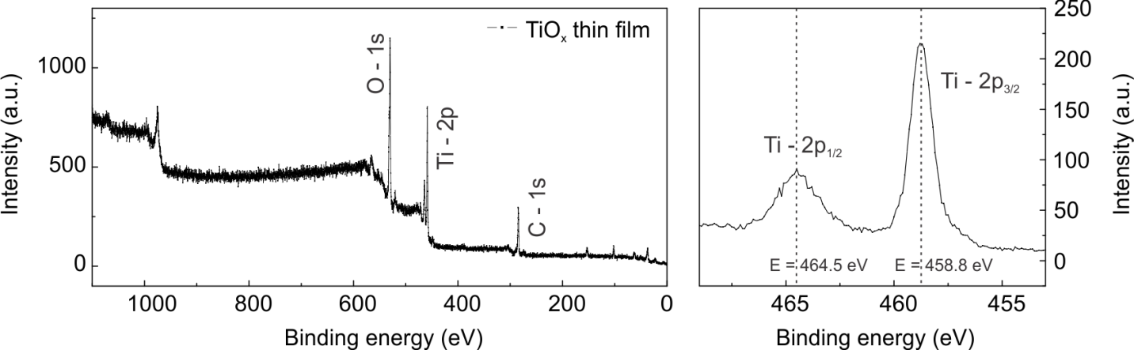
Figure S2 XPS analysis of TiO₂ thin films. Low resolution overview scan (left panel) and high resolution Ti-2p lines (right panel).

References:
[1]J.F. Moulder, W.F. Stickle, P.E. Sobol, and K.D. Bomben,” Handbook of X-Ray Photoelectron Spectroscopy”, Perkin-Elmer Corporation, Physical Electronics Division, 1992.
[2] U. Diebold, and T. E. Madey, “TiO2 by XPS”, Surface Science Spectra, vol. 4, no. 3, pp. 227–231, 1996, http://doi.org/10.1116/1.1247794.

Supplementary Figures:

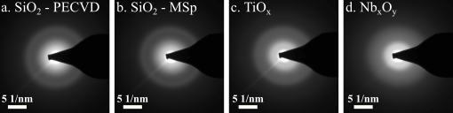
Figure S3 Diffraction showing amorphous thin films a) PECVD SiO₂; b) mSp-SiO₂; c) TiO_{x}; d. Nb_{x}O_{y}

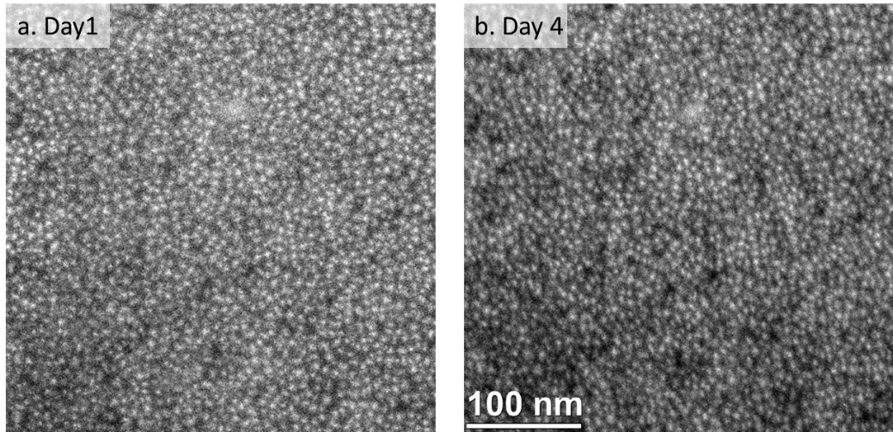
Figure S4 Comparison of silicon particles formed by the electron beam in SiO₂ Simpore chips: the same area was investigated directly after electron beam irradiation and after 4 days when stored in atmosphere.

Figure S5 I/V cycles of electron beam exposed PECVD SiO₂ in ref. to Figure 2.

Figure S6: a) I/V cycles recorded during reoxidation of the PECVD silicon oxide exposed to the electron beam starting from a semiconductive state after beam exposure to an insulating state when exposed to air. b) Current at 3V vs. time plotted for the reoxidation.

Figure S7: a) I/V curves of TiO₂ after a dose of 2.0E5 e/nm² with the electron beam off (green) and on (red). b) I/V curves of NbO₂ after dose of 9.9E6 e/nm² with the electron beam off (blue) and on (red) revealing an offset in the measurement due to electron beam induced current.

Figure S8: Impedance measurements showing strong resistivity change of titanium oxide after electron beam exposure.
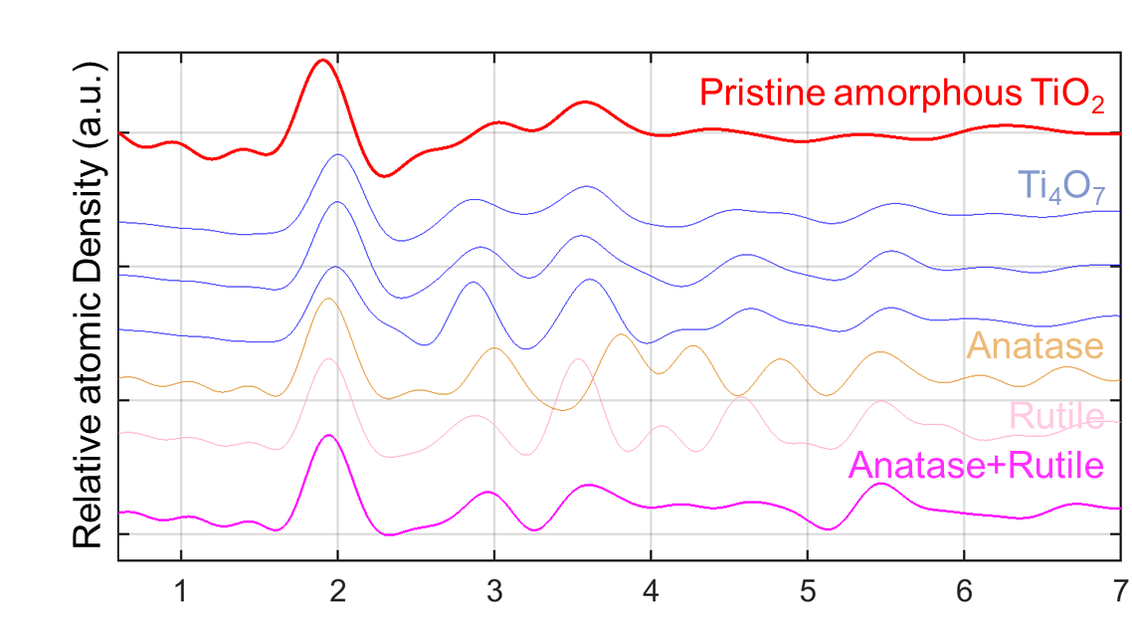
Figure S9: RDF analysis of titanium oxide of the as prepared film.

Figure S10: Resistivity vs. Dose of all three oxides

