Supplemental Information
This work required modifications to the standard data processing procedures used in EBSD, and thus the explicit details of the approaches employed are detailed here. In most cases, the procedures implemented are intended to mimic those used by Aztec (Oxford Instrument’s analysis software).

Flat Field Correction of Unprocessed EBSPs
The raw image recorded by the EBSD detector (unprocessed EBSP) is nearly always processed to provide the EBSPs that are used for analysis. Although the processing steps vary for different analysis software, static and/or dynamic background subtraction is usually offered. In this work, we refer to these processing steps as flat fielding since the operation performed is typically division (not subtraction) and the geometric projection effect that causes the long-range contrast is real signal (not background). An example of an unprocessed and flat fielded EBSP are provided in Figure S1.
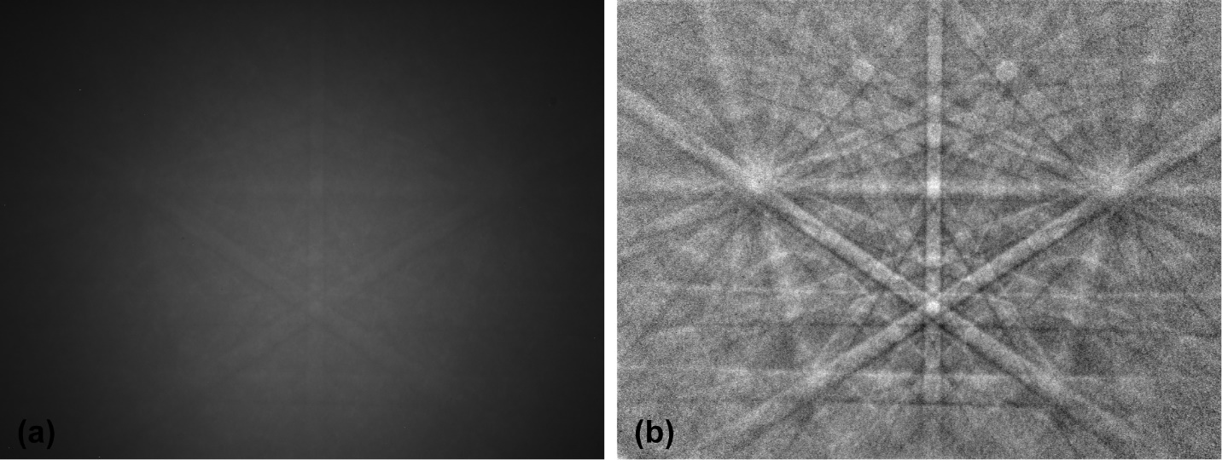
Figure S1: An unprocessed EBSP (a) and the flat fielded version of the same EBSP (b). Flat fielding of (b) used both static and dynamic methods. The static method used the thickest Pt mesa, and a 7th order polynomial was used for the dynamic method.
Accurate static flat field calibration of an EBSD experiment is the central purpose of this work, and assessment of the effectiveness of EBID deposited material requires extra care in the flat fielding process. In most applications, an observed EBSP is divided by the background EBSP (recorded previously from an amorphous region or by rastering the beam over many randomly oriented grains). This division corrects the local variations in intensity that are introduced, by non-uniformity in the phosphor coating and most of the global intensity variation caused by geometric projection, simultaneously. An additional dynamic correction is typically applied by dividing the processed EBSP by a blurred version of the processed EBSP. This yields a flat field correction that account for local variations once (static) and global variations twice (static & dynamic). By convolving both local and global variations in one factor—the static background EBSP—the experimental setup requires minimizing the factors that are changed between where the background EBSP was taken and the experiment is performed.
An alternative approach was employed in this work that allows the separation of the local variations from the global variations. To accomplish this, the local variations are measured by collecting an EBSP from a known amorphous material (a-Si). This EBSP has both local and global intensity variations that can be separated by fitting a low order polynomial surface (7th order in both dimensions) to the EBSP intensity. This polynomial describes the global intensity variation while the fit residual can be normalized by the polynomial intensity to provide the local variations. We use the term phosphor quantum efficiency (PQE) to describe the local variations, and have found that PQE is very consistent regardless of experimental parameters (e.g. pattern center, sample tilt, and EBSD detector distance) that change the global intensity of an unprocessed EBSP. Figure S2 shows a background EBSP (top left) and the calculated PQE and global intensity variation (bottom left and middle right respectively).
Figure S2: Calculation of PQE from an amorphous sample.
Since PQE is dominated by the EBSD detector system, the PQE calculated on a separate sample of a-Si can be used on the EBID sample where the substrate is crystalline Si. Using this method, the PQE is applied to the unprocessed EBSP and then the resulting processed EBSP is down sampled (typically 8×) and then fit to a 7th order polynomial to allow variations in the global intensity profile that result from sample parameters that may be different. An additional benefit to this approach is the computation of the PQE can be performed from both known a-Si samples as well as mesas of EBID material and compared. For the thickest mesas (> 50 nm), the difference between the PQE from a-Si and EBID material was negligible and had no crystalline character.

Band Contrast of EBSPs
Although well-defined conceptually, the implementation of BC by commercial EBSD software is less transparent. The author’s interpretation of the available references is that the byte value reported by Aztec (0-255) is the average of the peak heights in the Hough transform of the found bands. However, the normalization scheme, butterfly filter parameters, and Hough normalization methods are unclear. Efforts to exactly reproduce the numeric results provided by Aztec were unsuccessful, so instead we provide a rigorous description of our implementation such that others can reproduce our work.
To compute the BC value for an EBSP, a Hough transform of the EBSP was computed with a resolution of 240 × 240 in θ × d space. This Hough transform is normalized by dividing by the Hough transform of an image of a constant 0.5 intensity image. The resulting image is then convolved with a butterfly filter with the following kernel:
$${\begin{matrix}-10 & -15 & -22 & -22 & -22 & -22 & -22 & -15 & -10 \\ -1 & -6 & -13 & -22 & -22 & -22 & -13 & -6 & 1 \\ 3 & 6 & 4 & -3 & -22 & -3 & 4 & 6 & 3 \\ 3 & 11 & 19 & 28 & 42 & 28 & 19 & 11 & 3 \\ 3 & 11 & 27 & 42 & 42 & 42 & 27 & 11 & 3 \\ 3 & 11 & 19 & 28 & 42 & 28 & 19 & 11 & 3 \\ 3 & 6 & 4 & -3 & -22 & -3 & 4 & 6 & 3 \\ -1 & -6 & -13 & -22 & -22 & -22 & -13 & -6 & -1 \\ -10 & -15 & -22 & -22 & -22 & -22 & -22 & -15 & -10\end{matrix}}/{42}$$
An additional masking step is used to remove pixels that have zero intensity in Hough transform of the constant intensity image. This mask is eroded in by 3 pixels in d space to remove the outer rim of the EBSP where noise is dominant.
Because the Si single crystal substrate for this work was only translated between EBID mesas, the position of the 9 selected bands was invariant for all EBSPs. This allow the maximum value in a 9 × 9 sub-region of the normalized and butterfly filtered Hough transform, centered around each of the 9 peaks, to be selected even when the band was not indexed (required for the thicker mesas where there the band contrast is effectively zero). The value for each peak was normalized to the peak height from an EBSP recorded from pure Si, and all 9 normalized peak values were averaged to result in a single BC value for the EBSP. This is the value presented in Figure 3 of the main text. Normalizing the BC values to the peak height of Si is arbitrary, but makes the BC values intuitively meaningful and is appropriate in the context of this work.

Total Intensity of EBSPs from EBID Mesas
The total intensity of an EBSP is a function of many parameters including the material being sampled. The goal of the mesa approach is to deposit enough material to re-scatter the substrate’s diffraction pattern, but this also means that the material being sampled is a combination of the substrate and the mesa material. Describing the product of the thickness and atomic number (sometimes known as Z thickness) of the Pt or W containing carbonations deposits is outside the scope of this work; however, assessing the change in total intensity observed at the EBSD camera gives insight about how strongly the mesa material changes the backscattered electron yield.
Figure S3: Intensity sum of the EBSPs for the Si substrate and the mesas.
The summed intensity of the EBSP which is serving as an analog for backscattered electron yield does increase with increasing mesa thickness, but the magnitude of the effect is small. It’s probable that the sign of this effect would be negative when depositing EBID mesa on heavy elements. However, in practice, a dynamic flat field operation would correct for even modestly large changes in global intensity.

Computational Tools for EBSD Flat Fielding
All of the analysis tools used for this work are available as function in Mathematica; however, the polynomial flat field process is described here as well. An EBSP is mean downsampled by a factor of 8 such that upper left pixel of the downsampled image is the average value of the upper left 8×8 pixel values in the original EBSP. For our camera, the original pixel resolution is 1344×1024, and the downsampled resolution is 168×128. The downsampled points are then fit to a 7th order polynomial of the form
$$\left(1+x+x^{2}+⋯+x^{n}\right)\left(1+y+y^{2}+⋯+y^{n}\right)$$
where n is 7 and yields 64 monomial terms to fit to the 21504 {x, y, intensity} values. The intensity of each pixel of the original EBSP is then divided by the value of the fitted function to form the unscaled flat field intensities. The unscaled intensities are statically rescaled such that the mean ± 4σ is 1 and 0 intensity respectively, which is the final polynomial flat fielded EBSP.

Availability of Data
The raw EBSPs and AFM scans are also provided in a data repository. Additionally, the Mathematica notebook is also provided and includes all of the functions used to analyze the data presented in this manuscript.
https://doi.org/10.18434/T4/1503158

