Supplementary Materials

Field-dependent measurement of GaAs composition by Atom Probe Tomography
E. Di Russo, I. Blum, J. Houard, G. Da Costa, D. Blavette, L. Rigutti.

Normandie Univ, UNIROUEN, INSA Rouen, CNRS, Groupe de Physique des Matériaux, 76000 Rouen.
Corresponding author: lorenzo.rigutti@univ-rouen.fr.

A – Laser energy/power conversion table.
In the image S-1, the correspondence between laser pulse energy (E_{las}) and laser energy density is reported. The laser spot diameter is estimated to be 50 µm and the laser pulse width is 500 fs.
Fig. S-1: Laser energy density as a function of the pulse intensity for λ = 515 (green) and 1029 (IR) nm.
B – Mass spectra
The mass spectra associated with all constant detection rate measurements are reported in fig. S-2. The details of the analysis parameters used are reported in the caption of the figure.

Fig. S-2: (a) GaAs mass spectrum at constant detection rate: φ ≈ 0.0010 ÷ 0.0020 event/puls; E_{las} = 0.03 nJ (green mode); T = 60 K. GaAs mass spectrum at constant detection rate φ ≈ 0.0020 ÷ 0.0035 event/pulse, T = 50 K and a laser pulse energy (IR mode) equal to (b) 3.4 nJ; (c) 5.4 nJ; (d) 15.7 nJ; (e) 32.1 nJ; (f) 41 nJ; (g) 65.3 nJ. The number of ions detected for each dataset is 2.75 ·10⁵.

C – Correlation tables
The correlation tables calculated for each dataset acquired are reported in the fig. S-3. The details of the analysis parameter used are reported in the caption of the figure.

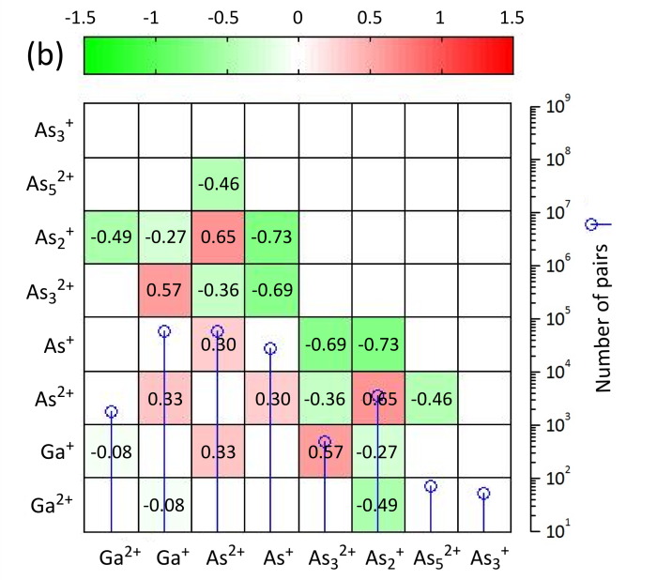

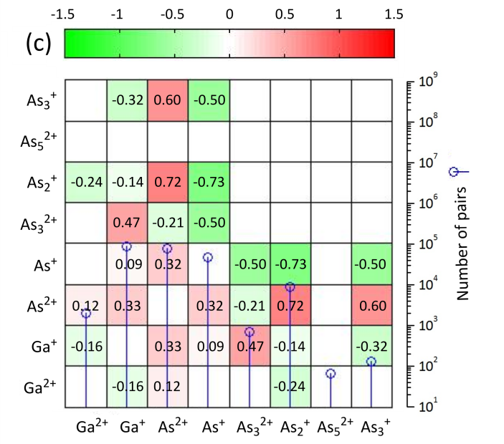

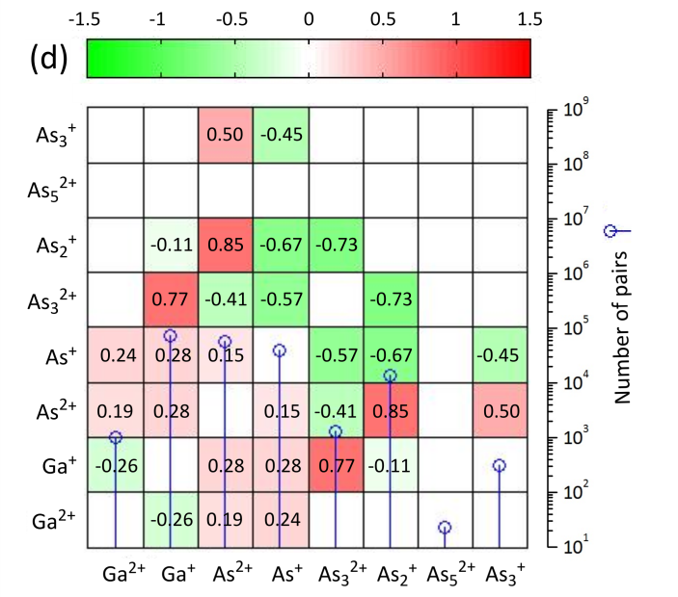

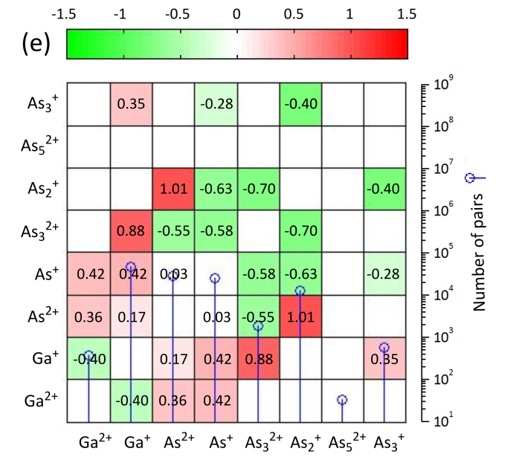

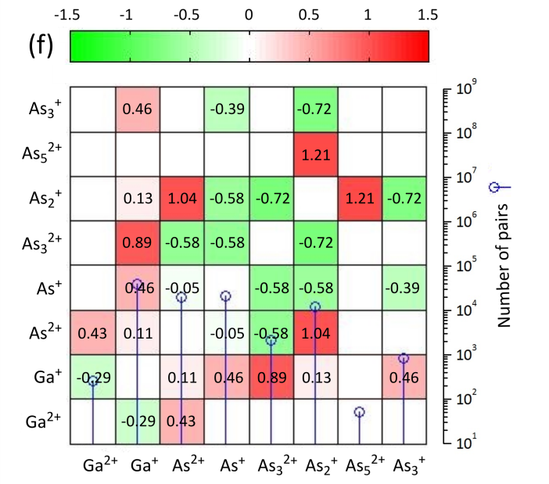

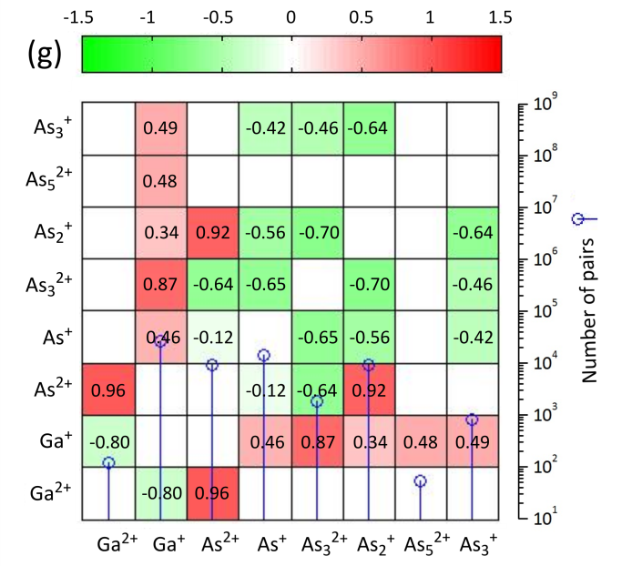

Fig. S-3: (a) GaAs correlation table at constant detection rate: φ ≈ 0.0010 ÷ 0.0020 event/puls; E_{las} = 0.03 nJ (green mode); T = 60 K. GaAs correlation table at constant detection rate φ ≈ 0.0020 ÷ 0.0035 event/pulse, T = 50 K and a laser pulse energy (IR mode) equal to (b) 3.4 nJ; (c) 5.4 nJ; (d) 15.7 nJ; (e) 32.1 nJ; (f) 41 nJ; (g) 65.3 nJ. The number of ions detected for each dataset ranges from 2.75 ·10⁵ to 5.75 ·10⁵ ions.

