S1. Typical Interface Specimen Microstructure
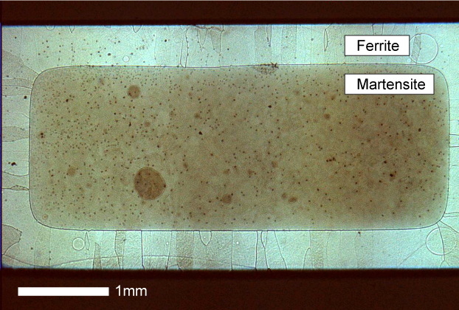
The light microscopy image above shows a cross-section of a sample, following quenching. A border of ferrite surrounds the outside of the sample, due to the decarburizing/denitriding treatment. The ferrite grains are relatively columnar, with grain sizes of >100 µm. The core of the sample remained as austenite, which transformed to martensite when quenched. The planar, well-defined transformation interface is clearly observed between the two phases.

S2. FIB Specimen Preparation and Interface Tracking
The following images and descriptions show how the transformation interface (indicated by arrows) is tracked through SEM-FIB sample preparation, imaged by TEM, and examined in the APT reconstructed volume. All images come from the preparation and analysis of the same single Fe-Mn-N specimen.

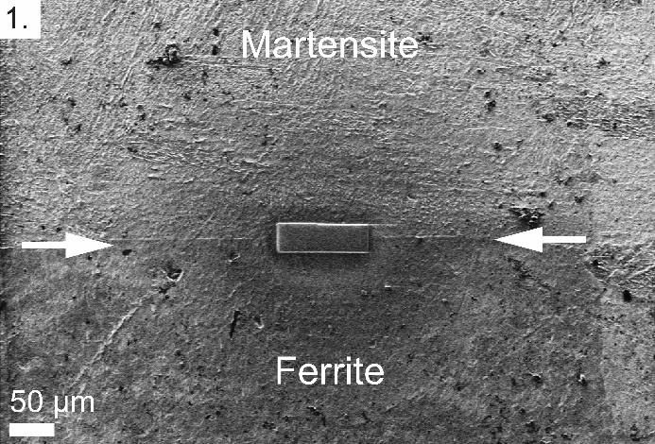 | 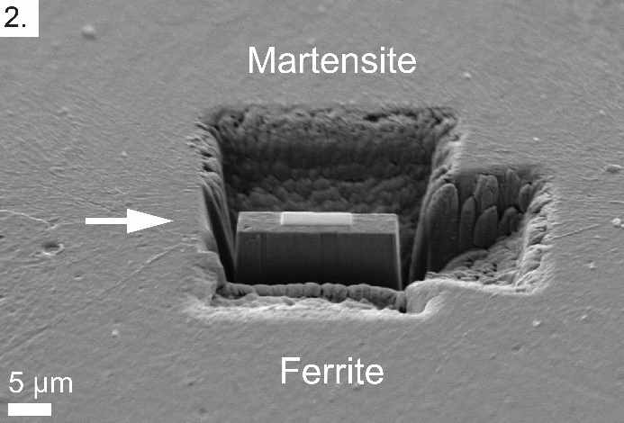
The martensite (former austenite) / ferrite interface is located on the sample in the FIB-SEM, and extracted. | The liftout is prepared by milling away material to either side of the interface.
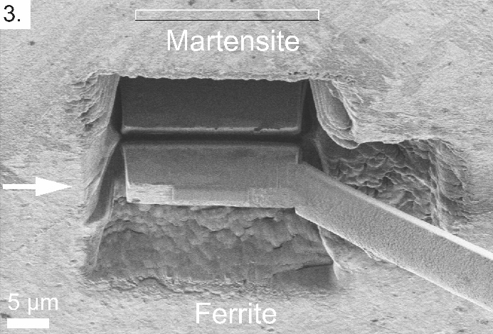
The liftout, which contains material on either side of the interface, is extracted using the FIB manipulator. | The liftout is attached to another, horizontally-mounted needle, and cut off from the manipulator. This is done for the purposes of rotating the interface.
 | 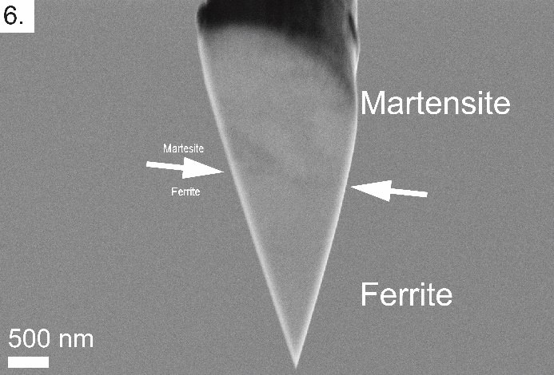
The needle is rotated ~90°, orienting the liftout so that the interface will be normal to the tip axis of the final APT specimen. | The liftout is trimmed into a wedge, and mounted back onto the manipulator.
Sections of the sample are mounted onto a Si post or W wire (as shown here), and bonded with W deposition. | The sample is sharpened by annular milling with the FIB, while tracking the location of the interface.
Final sharpening of the tip is conducted in the FIB with a defocused, low-kV beam, while  tracking the position of the interface. | The sample is sharpened until the tip apex is close to the interface.
Bright-field TEM imaging of the tip confirms the location of the interface. Note that the ferrite beneath the interface contains no grain boundaries. | With diffraction contrast, the two phases are clearly observed. The location of the interface can be measured.
The location of the interface and the two phases, visible by examining Fe atom density in APT, match with the TEM images. | N segregation to the interface is visible in 3D atom maps of the reconstructed volume. A profile (15) can be taken normal to the interface.
 | A 1D concentration profile, normal to the interface plane, shows the relative segregation levels of N and Mn. N exhibits clear segregation to the interface, while there is no segregation of Mn. These results were consistent among all Fe-Mn-N interfaces examined.

S3. Visualizing the Interface and Martensite/Ferrite Grains
The image below shows how an interface in Fe-Mn-N, visible in bright-field TEM, appears when mapping Fe atomic density. Poles are also apparent from cross sections of the Fe density volume map. These poles change when crossing the interface, confirming that it is a crystallographic boundary. The poles in the ferrite grain are indexed. Numerous defects are also visible, which are mostly in the martensite grain, but can extend slightly into the ferrite. N is observed to segregate to these features, as well as the interface, but there is no apparent Mn segregation.

S4. Correcting for Fe²⁺ Ion Loss in the Presence of Overlapping N₂⁺
The preferential loss of solvent Fe ions due to detector pile-up effects can artificially increase the concentrations of solute elements measured by APT. A procedure to compensate for this effect has been developed by Miyamoto et al. (2012), which utilizes discrepancies in the observed isotopic ratios for Fe, compared to their natural abundances, to estimate detection loss. Specifically, this procedure examines reductions in the main ⁵⁶Fe²⁺ peak. The application of this correction procedure to Fe alloys containing N is therefore complicated by overlap of ⁵⁶Fe²⁺ with ¹⁴N₂⁺ at 28 Da.
To evaluate the potential effect of this overlap, data for the current Fe-Mn-N alloys can be examined, assuming the experimentally-measured peak at 28 Da, $n^{28}$, to be some combination of Fe and N (i.e. $n^{28}=$ ⁵⁶Fe²⁺ + ¹⁴N₂⁺). The correction procedure of Miyamoto et al. can then be applied, with detection loss calculated as a function of the number of ¹⁴N₂⁺ ions in the 28 Da peak. Results for two datasets – one acquired in voltage pulse (VP) mode, where detection loss is expected to be high, and one acquired in laser pulse (LP) mode, where detection loss is expected to be much lower – are shown in the following figure.
The results show that for both cases, there is very little change in the corrected N concentrations with increasing amount of ¹⁴N₂⁺ ions. For large amounts of ¹⁴N₂⁺ ions, the Fe ion detection loss does eventually go up (at a point dependent on the original ion content of the dataset). However, it must be considered that having large amounts of ¹⁴N₂⁺ would only occur if the bulk N content of the sample was also increased. The bulk N concentration for each dataset is therefore also plotted in the figure, represented in a simplified form by only considering N and Fe. It shows that by the time the presence of ¹⁴N₂⁺ begins to significantly effect the Fe detection loss, bulk N concentrations become unreasonable (>8 at. % and >5 at. % for VP and LP, respectively). That the bulk N concentration can increase while the matrix and segregation component concentrations can stay constant, or even decrease, is due to the fact that increasing fractions of ¹⁴N₂⁺ , hidden in the ⁵⁶Fe²⁺ peak, would lead to larger differences between the real and measured N concentrations.
For reasonable ranges of bulk N concentration, there are only insignificant changes in Fe detection loss, and the corrected concentration values. Considering the original values (i.e. those which are artificially inflated by Fe detection loss), they will either also be close to the corrected values, assuming no ¹⁴N₂⁺ ions (e.g. in LP mode) or be off but a much larger difference than the magnitude of change in the corrected values (e.g. in VP mode). It can thus be seen that the effect of ¹⁴N₂⁺ ions on the correction procedure for these alloys is negligible, and the effect of Fe ion loss, for any reasonable quantity of overlapping ¹⁴N₂⁺ ions, is dominant. Therefore, applying the procedure of Miyamoto et al. to the current Fe-Mn-N APT datasets will yield more accurate concentration values by correcting for Fe ion loss, and assuming ¹⁴N₂⁺ ions overlapping at 28 Da to have a negligible effect on this procedure is valid.

