**Visualization of Cellular Components in a Mammalian Cell with Liquid Cell Transmission Electron Microscopy**

Liquid cell TEM of Cellular Components

Stephanie Besztejan1,3‡, Sercan Keskin2‡, Stephanie Manz2, Günther Kassier2, Robert Bücker2, Deybith Venegas-Rojas4, Hoc Khiem Trieu4, Andrea Rentmeister5 and R.J. Dwayne Miller2,3,6*

1 University of Hamburg, Chemistry Department, Institute for Biochemistry and Molecular Biology, Martin-Luther-King Platz 6, 20146 Hamburg, Germany

2 Max Planck Institute for the Structure and Dynamics of Matter, Luruper Chaussee 149, Geb. 99 (CFEL), 22761 Hamburg, Germany

3 The Hamburg Centre for Ultrafast Imaging, Luruper Chaussee 149, 22761 Hamburg, Germany

4 Hamburg University of Technology (TUHH), Institute of Microsystems Technology, Eißendorfer Straße 42, 21073 Hamburg, Germany

5 Westfälische Wilhelms-Universität Münster, Institute of Biochemistry, 48149 Muenster, Germany

6 Departments of Chemistry and Physics, University of Toronto, 80 St George St, Toronto, Ontario, Canada M5S3H6

‡These authors contributed equally to this work.

* Correspondence should be addressed to R.J. Dwayne Miller [dwayne.miller@mpsd.mpg.de](mailto:dwayne.miller@mpsd.mpg.de), phone: +49 (0)40 8998-6200, fax: +49 (0)40 8994-6260

Shape differentiation of PC3 cells during settlement on silicon nitride

The PC3 cells were imaged with a light microscope to analyze the settlement status. The cells were imaged with light microscopy 1, 4 and 24 h after seeding. Most of the cells were still round and floating above the window one hour after seeding. After 4 hours some cells already contacted the silicon nitride (these cells were imaged with liquid cell TEM and described in the main manuscript) but appeared in round shapes. After 24 hours the cells showed the typical long stretched shape.

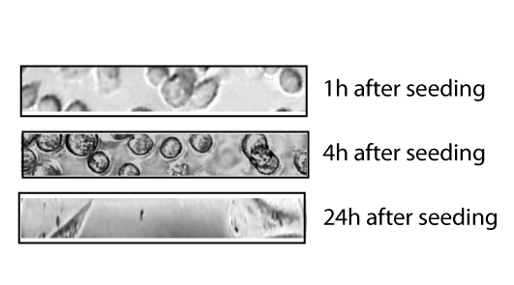

Suppl. Figure 1: Light microscopy images of the silicon nitride viewing areas of nanofluidic cells seeded directly with PC3 cells for attachment. Light microscopy images were taken 1 h, 4 h and 24 h after seeding. Images were taken before liquid cell TEM measurements.

TEM frames of vesicle 2

As mentioned in the main manuscript, vesicle 2 is very close to the membrane and seems to bud off the membrane at reference time point 0 (Suppl. Figure 2, left image). The budding process is known for different types of vesicles (clathrin coated particles, macropinocytosis etc.). We measured a distance of 0.3 µm between the edge of the vesicle and the membrane at 200 s and 0.5 µm at 600 s.



Suppl. Figure 2: Liquid cell TEM images of non-fixed PC3 cells. Images show the displacement (white line) of vesicle 2 to the membrane over 10 min.

Internalization assay of anti-PSMA on LNCaP cells

The 2’-fluoropyrimidine containing aptamers were synthesized as described using the DNA listed in Suppl. Table 1. The samples and controls, anti-PSMA RNA aptamer and the scrambled control treated with NaOH for alkaline hydrolysis of the RNA, were analyzed on a 10 % denaturing polyacrylamide gel and detected using ethidium bromide staining of the gel (Suppl. Figure 3). Only the lanes without additional NaOH hydrolysis showed signals near to 100 nt in UV detection of the stained gel. This proves that RNA synthesis was successful and the signals were not from DNA. The RNA aptamer and control were hybridized on functionalized AuNPs carrying a capture ssDNA complementary to the extension of the RNA aptamer. Hybridization was checked via DLS. Supplementary Table 2 shows the mean diameters of the AuNPs before and after DNA coupling.

Suppl. Table 1: RNA and DNA sequences used in the experiments. Grey highlighted subunits show aptamer and scrambled control, respectively. Underlined subunit marks complementary units for hybridization.

|  |  |  |
| --- | --- | --- |
| Name | Length/nt | Sequence |
| Anti-PSMA A9 | 91 | GGG AGG ACG AUG CGG ACC GAA AAA GAC CUG ACU UCU AUA CUA AGU CUA CGU UCC CAG ACG ACU CGC CCG ACG ACG ACG ACG ACG ACG ACG A |
| scrambled Anti-PSMA A9 | 92 | GGG AGG ACG AUG CGG CAG GCA UGC CUA GCU AAG CAG CCC AUG GCU UAU GCG CGG ACA GAC GAC UCG CCC GAC GAC GAC GAC GAC GAC GAC GA |
| 5’-thiol modified capture DNA | 33 | 5-HS-CC-AAAAAAAAAA-TCG TCG TCG TCG TCG TCG TCG |
| T7 promotor | 33 | TAA TAC GAC TCA CTA TAG GGA GGA CGA TGC GG |
| anti-PSMA DNA template | 91 | GGG AGG ACG ATG CGG ACC GAA AAA GAC CTG ACT TCT ATA CTA AGT CTA CGT TCC CAG ACG ACT CGC CCG ACG ACG ACG ACG ACG ACG ACG A |
| scrambled anti-PSMA A9 DNA template | 92 | GGG AGG ACG ATG CGG CAG GCA TGC CTA GCT AAG CAG CCC ATG GCT TAT GCG CGG ACA GAC GAC TCG CCC GAC GAC GAC GAC GAC GAC GAC GA |

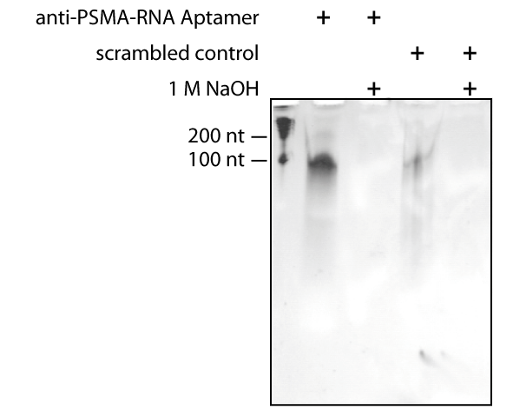

Suppl. Figure 3: Evaluation of 2’-fluoropyrimidine-stabilized anti-PSMA-RNA aptamer and scrambled control-PSMA-RNA aptamer from *in vitro* transcription on a 10 % denaturing PAA gel. First lane shows a 100 nt marker. Second lane and third lane show anti-PSMA-RNA aptamer. The sample in the third and fifth lanes was mixed with 1 M NaOH to digest the RNA. This is a control reaction to prove the signal is originated from RNA instead of remaining DNA. The lane 4 and 5 show the results for scrambled anti-PSMA-RNA aptamer and the non-binding control RNAs, respectively.

Suppl. Table 2: Mean diameters of gold nanoparticles

|  |  |
| --- | --- |
| Sample | Diameter (nm) |
| 20 nm AuNPs | 27.9±2 |
| Coupled AuNPs | 46.2±5 |
| Anti-PSMA-AuNPs | 135±23 |
| Control PSMA-AuNPs | 730±293 |

A number of 105 LNCaP cells were seeded 24 hours before the experiment. The cells were washed twice with PBS and incubated in media containing of RPMI 1640 and 10 % Hepes for 30 minutes before anti-PSMA-AuNP addition. The anti-PSMA-AuNPs and control PSMA-AuNPs were added at a final concentration of 1 nM and incubated up to 20 min at 37 °C before imaging using either dark field microscopy (Suppl. Figure 4C) or liquid cell TEM. Samples of LNCaP cells treated with 1 nM anti-PSMA-AuNPs showed a brighter signal compared to cells treated with 1 nM of the control PSMA-AuNPs after 10 min of incubation.

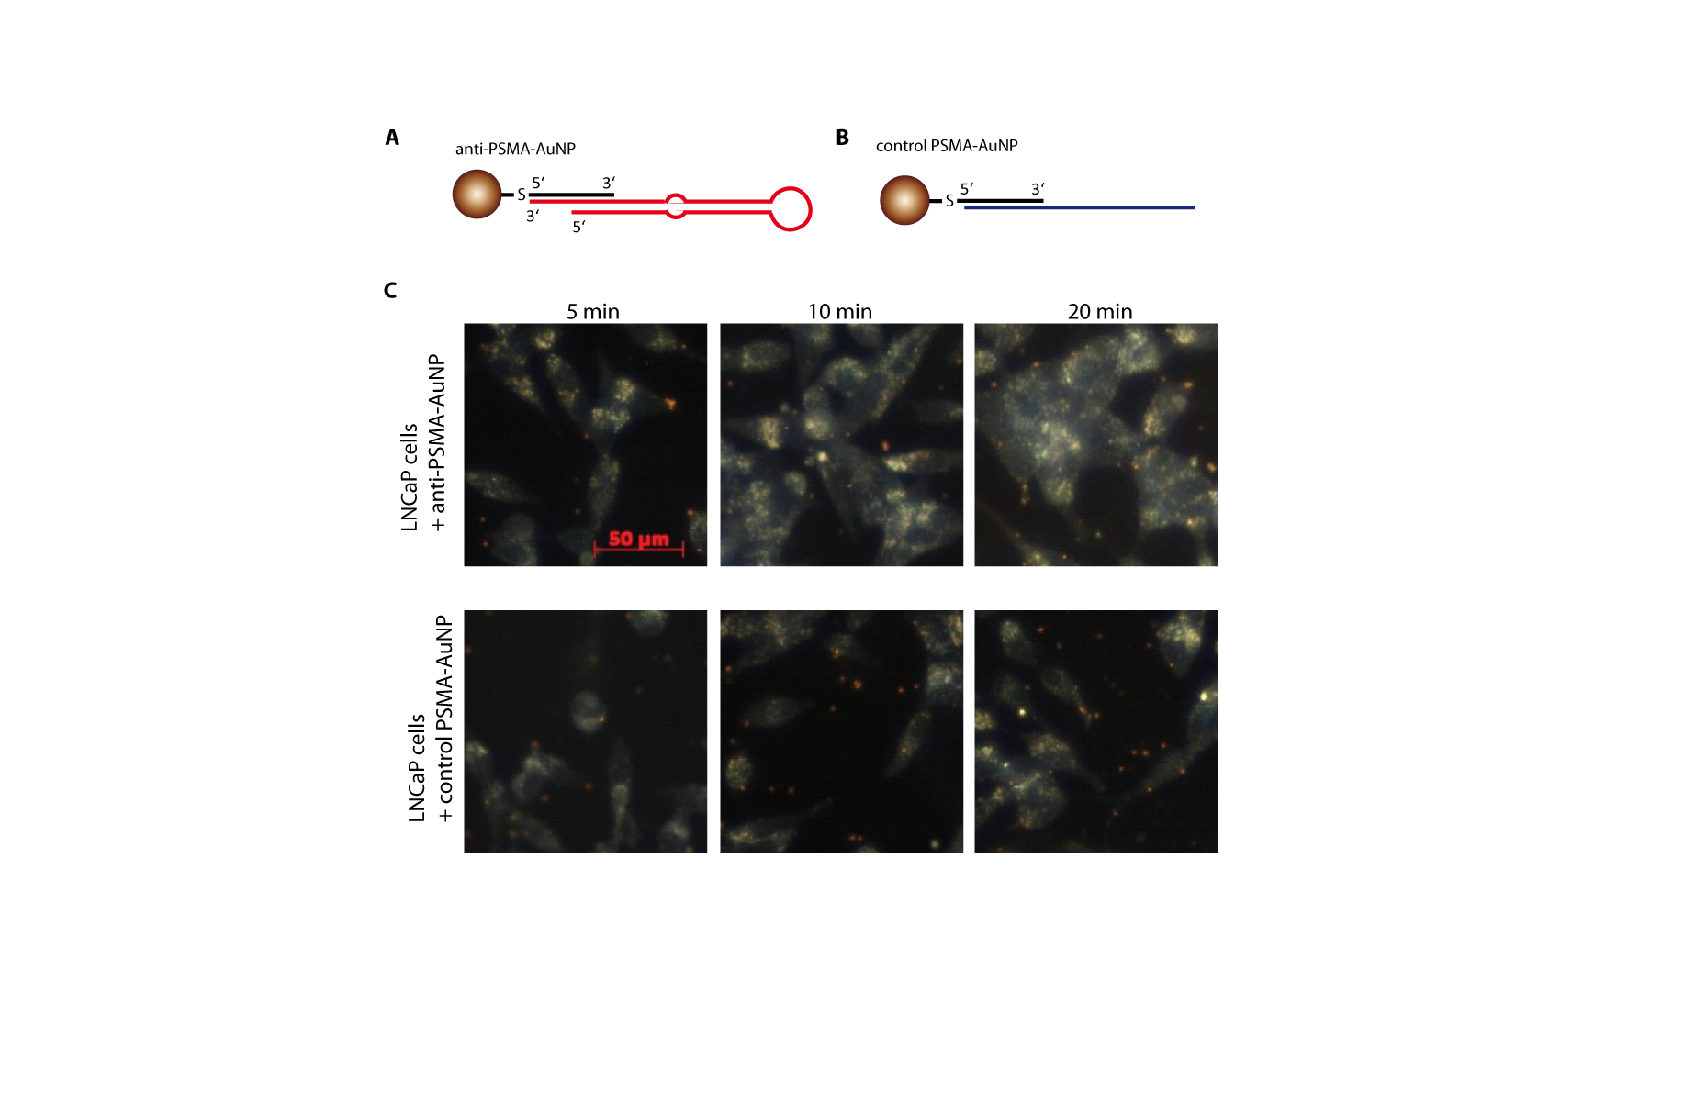

Suppl. Figure 4: Characterization of anti-PSMA-AuNPs and analysis of their internalization into LNCaP cells. (A) Schematic overview of AuNPs functionalized with anti-PSMA (red, top left panel) and (B) a non-binding control (blue, top right panel). (C) Dark field microscopy images of LNCaP cells treated with either anti-PSMA-AuNPs (upper row) or non-binding control PSMA-AuNPs (lower row) for 5 to 20 min. Cells appear as brighter signals in dark field microscopy due to the scattering ability of the cell components. AuNPs can be visualized via dark field microscopy based on their good scattering ability. They appear as orange golden spots. The cells treated with anti-PSMA-AuNPs had more orange golden spots next to the cells and overlapping to the cell signals compared to the non-binding control PSMA-AuNPs at the same time point. This indicates binding of the functionalized AuNPs to the cells. Scale bar represents 50 µm and is the same for all the images.