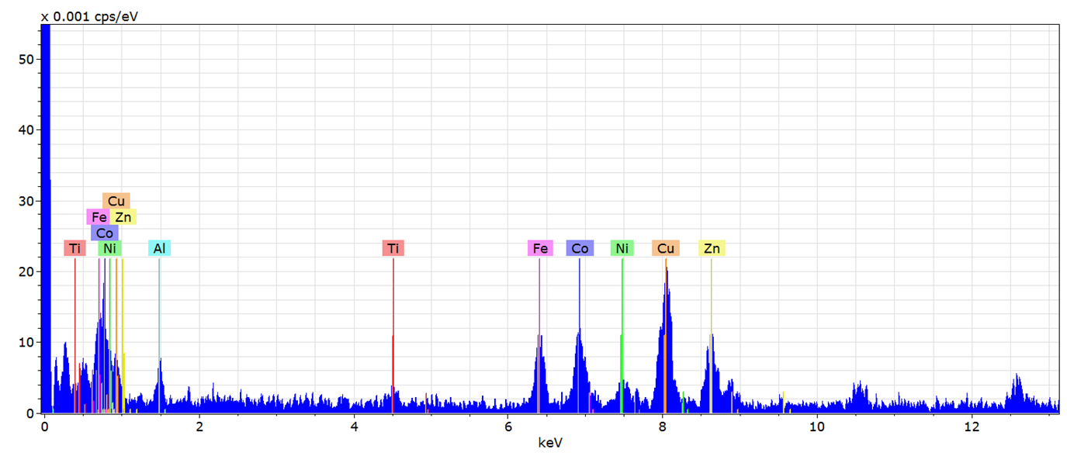

Figure S1. Summed spectra from selected area over vacuum (hole count) of 12 EDS maps selected from various tilts throughout the series showing the increased Cu and Zn signal in the background relative to the other metals due to the bronze holder.

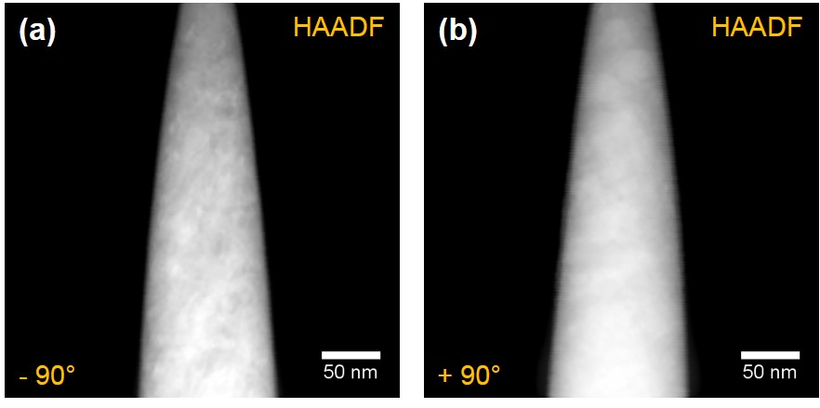
Figure S2. STEM-HAADF images of the tip before (a) and after (b) EDS data collection.

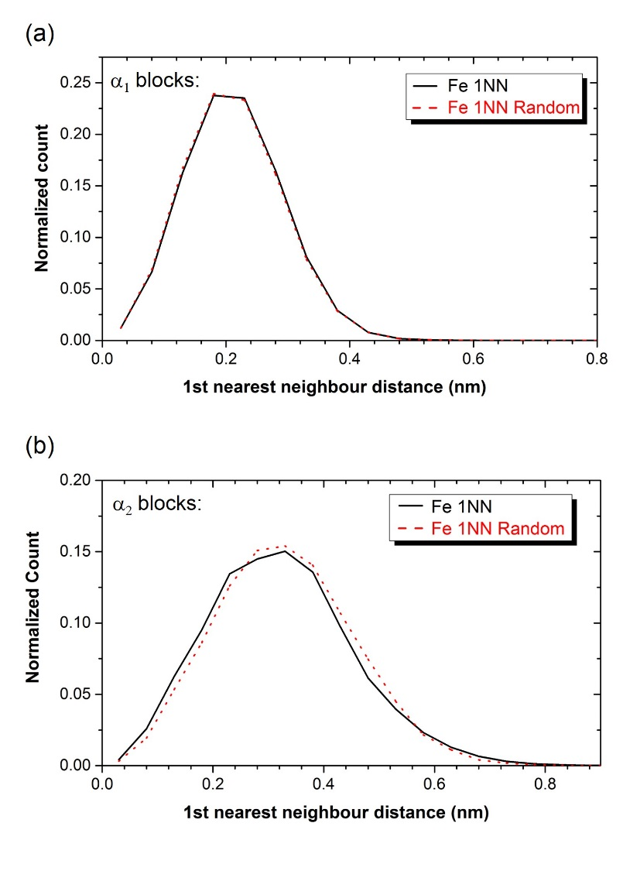
Figure S3. Observed (black) and Randomized (black) distribution of 1st nearest neighbor of Fe-Fe distance for both α₁ and α₂ blocks.

Table S1. Average composition of α₁ and α₂ phases line profiles and total volume composition from a) EDS and b) APT volumes.

a) | EDS | α₂  at.% | α₁  at.% | total EDS volume | b) | APT | α₂  at.% | α₁  at.% | total APT volume
 | Al | 23.8 | 4.8 | 15.1 |  | Al | 21.1 | 4.2 | 13.9
 | Co | 29.0 | 35.1 | 32.3 |  | Co | 33.1 | 36.6 | 34.0
 | Cu | 2.3 | 1.2 | 2.4 |  | Cu | 2.7 | 1.2 | 2.2
 | Fe | 18.6 | 55.9 | 29.7 |  | Fe | 13.7 | 51.4 | 31.1
 | Ni | 14.3 | 2.6 | 12.4 |  | Ni | 16.1 | 5.2 | 11.9
 | Ti | 11.9 | 0.3 | 8.1 |  | Ti | 13.3 | 1.1 | 6.8

Table S2: Pearson coefficients for the frequency distribution analysis (normalized chi-square value) of constituent elements for both α₁ and α₂ blocks. Values are obtained by comparing the experimental observations with a binomial distribution. The sampling value is 100 ions per bin.

Pearson coefficient, μ: | Al | Ni | Fe | Ti | Co
α₁ | 0.12 | 0.20 | 0.12 | 0.07 | 0.14
α₂ | 0.43 | 0.25 | 0.73 | 0.48 | 0.29

