Modeling of Infrared-Visible Sum-Frequency Generation Microscopy Images of a Giant Liposome
Victor Volkov, Carole C. Perry

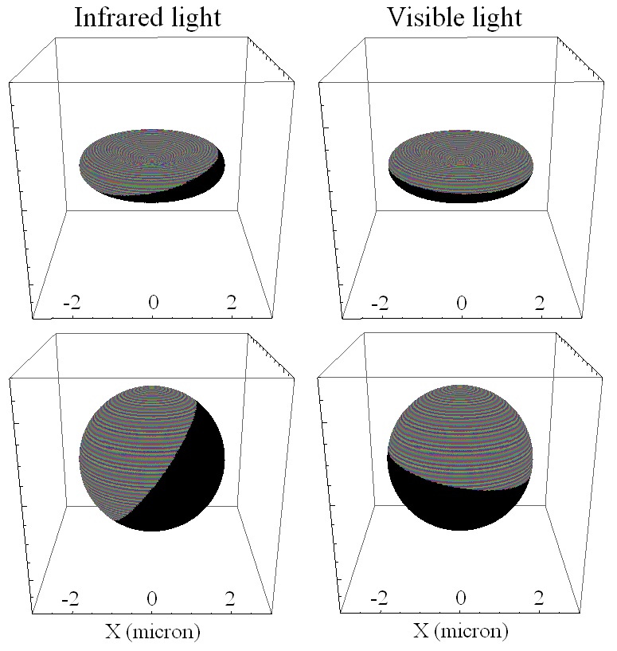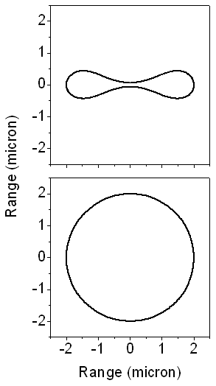

Fig. S1. Left side: graphical presentations of sites sorted to be either under direct exposure (on the light side) or not (on the shadow side) at the interface of an elliptical biconcave object and a perfect sphere for Infrared and Visible beams under a non-degenerate experimental geometry, as shown in Fig. 1B in the article. Right side: profiles of the structures generated using the solution by Mladenov group (Djondjorova et al., 2004).

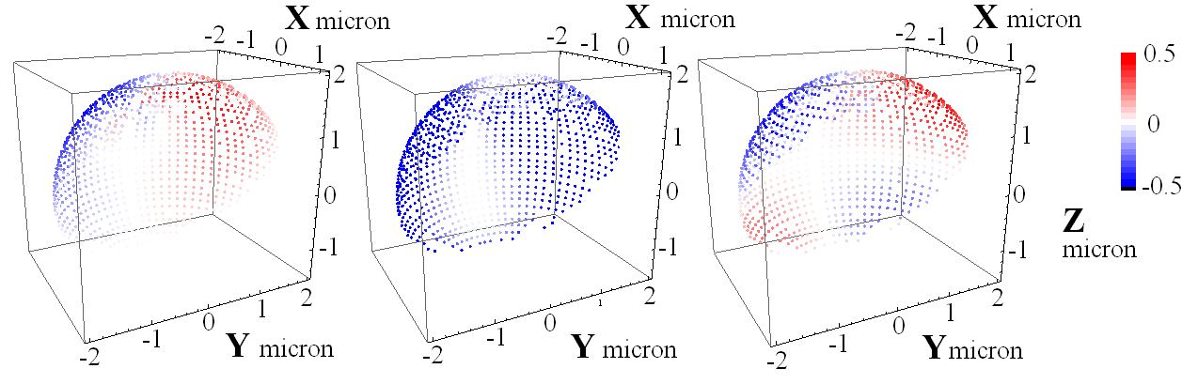

Fig. S2. Changes (gains or losses) of the S-polarized vector {0, 1, 0} in the laboratory frame of an IR beam upon passing sites at the surface side, under direct exposure to this field, under a non-degenerate geometry, when β₁ ≠ β₂ according to Fig. 1B in the article. Panels from left to right: changes of the X, Y and Z components after transmission. Each site is represented by a small sphere colored according to a linearly scaled blue-white-red blend, the amplitudes of which is according to the minimum-maximum numerical values.

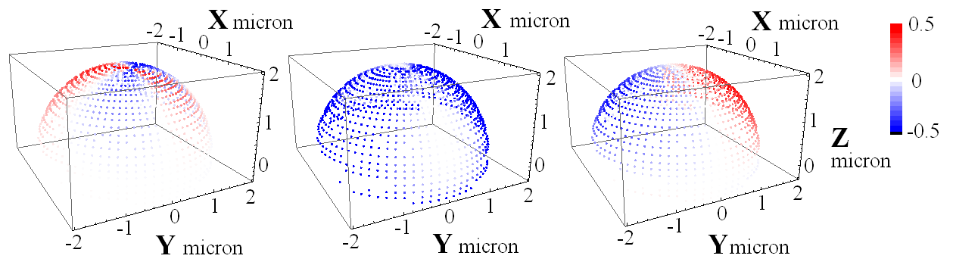

Fig. S3. Changes (gains or losses) of the S-polarized vector {0, 1, 0} in the laboratory frame of IR beam upon passing sites at the surface side under direct exposure to this field, under a degenerate geometry, when β₁ = β₂ according to Fig. 1B in the article. Panels from left to right: changes of the X, Y and Z components after transmission. Each site is represented by a small sphere colored according to a linearly scaled blue-white-red blend, the amplitudes of which is according to the minimum-maximum numerical values.

An example of the Mathematica code to express χ_{XXX} nonlinearity as a function of Φ and Θ angles:

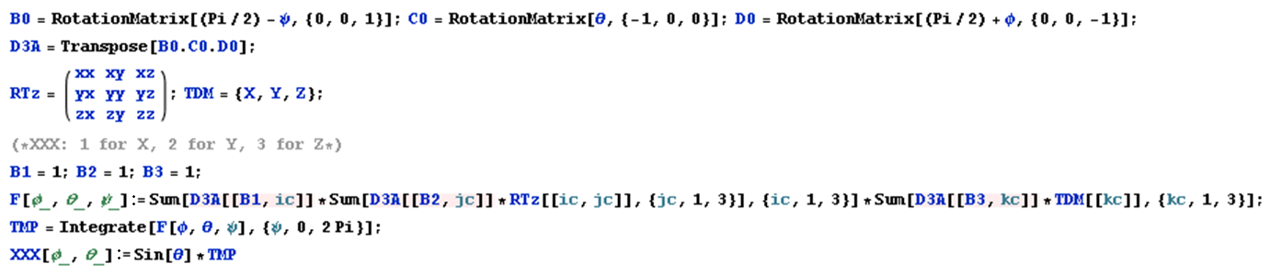

Multiplication with a sine function is according to the numerator integral in Equation A1 in Appendix A.
Comparisons of results of approximate expressions received upon “rotations to angles” (solid red line) with the outcomes of exact integrations (black dots), for nonlinearity χ_{XXX}.

