Supplementary Information

Three-Phase 3D Reconstruction of LiCoO₂ Cathode via FIB-SEM Tomography

Zhao Liu, Yu-chen Karen Chen-Wiegart, Jun Wang, Scott A. Barnett*, and Katherine T. Faber*

E-mail: k-faber@northwestern.edu; s-barnett@northwestern.edu

Figure S1. Schematic view of path length ratio (PLR) method; (a) geometric definition of calculating the tortuosity τ via PLR method; (b) schematic of skeletonization process for the pore volume with nodes (blue dots) and channels (blue lines) are selected for calculations [2]

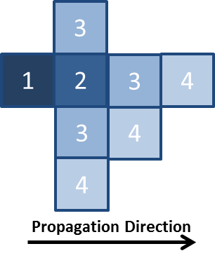
Figure S2. Schematic view of distance propagation (DP) method with “city-block” as neighboring pixel definition [1]

Figure S3. 3D reconstruction rendering of electrolyte phase connectivity: percolated (green), unknown (yellow) and isolated (red)

Figure S4. Comparison of distance propagation (DP) method and PLR method for the tortuosity of electrolyte and electrolyte plus carbon and binder phases; the DP method here use city-block as the neighboring definition

Figure S5. (a) Three-dimensional distance map of electrolyte-plus-CB in the direction to the current collector (along X direction); (b) 2D Tortuosity distribution of electrolyte-plus-CB, respectively, at X = 34.5 µm; (c) Histogram of the tortuosity distribution of electrolyte-plus-CB;

Table S1. Tortuosity value of pore and pore-plus-CB
 | X | Y | Z | Average | PLR
Electrolyte | 1.90 | 1.66 | 1.99 | 1.85 | 2.01±0.29
Electrolyte-plus-CB | 1.43 | 1.34 | 1.47 | 1.41 | 1.40±0.05

[1] Y.-c.K. Chen-Wiegart, R. DeMike, C. Erdonmez, K. Thornton, S.A. Barnett, J. Wang, Tortuosity characterization of 3D microstructure at nano-scale for energy storage and conversion materials, Journal of Power Sources, 249 (2014) 349-356.
[2] N.O. Shanti, V.W.L. Chan, S.R. Stock, F. De Carlo, K. Thornton, K.T. Faber, X-ray micro-computed tomography and tortuosity calculations of percolating pore networks, Acta Materialia, 71 (2014) 126-135.

