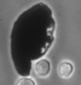 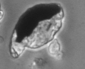 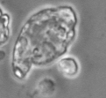

60 m

**Figure 1S.** Time lapse microphotographs of a MgPa degradation during 24h period. The formation of corrosion products (probably Mg(OH)2) layer (light grey) on the surface can be seen.

**Imagen1 limpia.tif Imagen2 limpia.tif**

100 m

**Figure 2S.** Control cells growing without MgPa at the beginning of the assay (left) and 24h after (right). Magnification (400X)



**Figure 3S.** Time lapse microphotographs of J774 macrophages in contact with 1500 µg/ml MgPa during a 24h assay: a-f Interaction of macrophages with MgPa, duplication of cells, displacement of particles by the cells and formation of corrosion products on the surface and dead cells can be observed.

**Control MgPa 1000µg/ml**

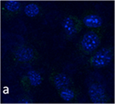 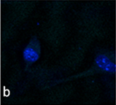

20 m

Control

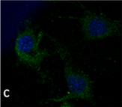 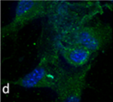

Anti ICAM-1

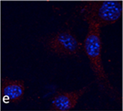 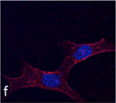

Anti-vimentin

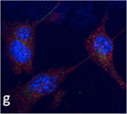 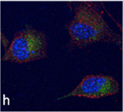

Anti ICAM1 + vimentin

**Figure 4S.** Confocal microscopy and inmunofluorescence studies with primary and secondary antibodies with MC3T3-E1 cells in the absence and in the presence of MgPa: a and b controls without antibodies; c, e, g controls without particles; d, f, h with 1000µg/ml MgPa. c and d anti-ICAM1 (green); e and f Anti-vimentin (red); g and h anti-ICAM1 and Anti-vimentin.

**Tabla 1S.** Differential expression level of proteins identified by 2-DE and MS/MS in J774 and MC3T3-E1 cell cultures in the absence and presence of MgPa

|  |  |
| --- | --- |
| **Protein** | **Expression in presence of MgPa compared to the control without MgPa** |
| **J774 cell line** | |
| Heat Shock Protein 90 (HSP 90) | Decreased |
| Heat Shock Protein 8 (HSP 8) | Decreased |
| Tubulin α1β chain | Decreased |
| Peptide elongation factor 1α1 | Decreased |
| γ-actin | Increased (IP shift in the acid direction) |
| protein isoform 2 | Increased |
| [Glyceraldehyde 3-phosphate dehydrogenase](http://en.wikipedia.org/wiki/Glyceraldehyde_3-phosphate_dehydrogenase) (G3PDH) | Increased |
| **MC3T3-E1 cell line** | |
| Tubulin β-5 | Decreased |
| Peptide elongation factor 1 α1 | Decreased |
| γ-actin | Increased (IP shift in the acid direction) |
| Tubulin β-5 | Decreased |