Support information
SI Figure 1
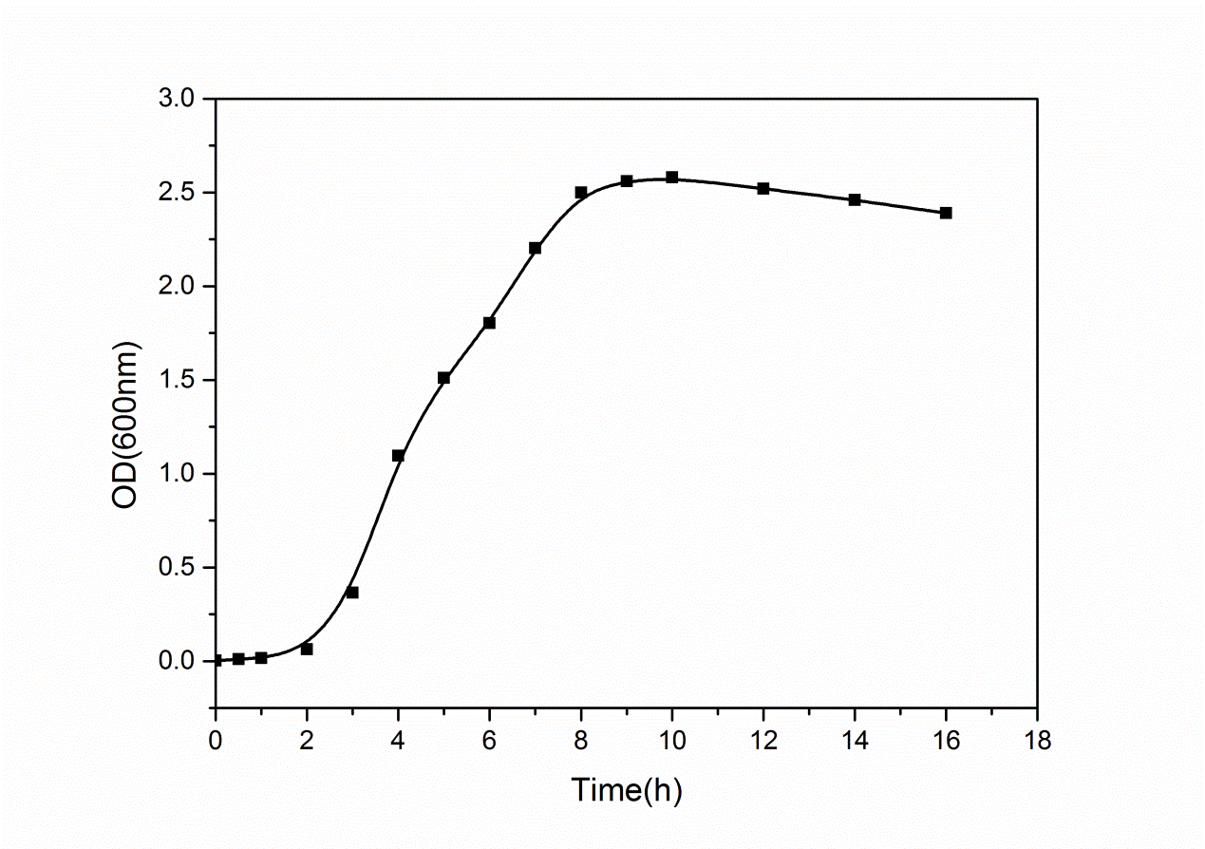
Fig. 1 Growth curve of B. subtilis

SI Figure 2

Fig. 2 TEM images of selenylated B. subtilis cultured with (a) and without (b) CdCl₂ for 48h

SI Figure 3

Fig. 3 Fluorescence emission spectra of achieved fluorescent B. Subtilis cells under different conditions
A: Different pH from 5.0 to 12.0
B: Different temperature from 4℃ to 90 ℃
C: Long-term storage from 0d to 30d

SI Figure 4

Fig.4 Photographs of S. aureus and control B. Subtilis dormant spores ( without Na₂SeO₃ and CdCl₂ ) .
a-g: B. subtilis and S. aureu cells co-cultured for 0h, 1h, 2h, 3h, 4h, 5h and 6h respectively.

SI Figure 5
Fig.5 TEM images of blank S. aureus (A) and intracellular biosynthesized QD-contained S. aureus (B).

