Supplementary Information

Paper title: Direct-Writing Cu Nano-Pattern with Electron Beam
Authors: Shih-En Lai, Ying-Jhan Hong, Yu-Ting Chen, Yu-Ting Kang, Pin Chang and Tri-Rung Yew*

Materials and Methods

Sample preparation and Cu patterns reduction process
To confine liquid solution in high vacuum environment of TEM, a liquid sample holder, K-kit, was used in this work. The 3D perspective drawing of a K-kit is shown in Fig. S1a. Silicon is shown in white, silicon nitride shown in orange color, and the spacer in gray. Fig. S1b and S1c show the top view and x-x’ cross-section view of K-kit, and the dimensions of each layer are indicated on the figure. CuSO₄ solution was applied in K-kit through a sample loading opening. Then, the opening was sealed with glue to form vacuum tight space, and the K-kit was mounted to Cu grid. For the realistic case, there was still an interval of 15 ~ 20 sec between the steps of applying solution and sealing the opening, which might possibly cause the formation of solution thin film.
JEOL TEM JEM-2010, operating at 200 kV, served as electron beam source. K-kit mounted on Cu grid was loaded into TEM and pumped down to a base pressure of 1.12 × 10⁻⁷ torr. Converged e-beam, 50 nm in diameter, was applied to reduce Cu from CuSO₄ solution and was moved along a pre-designed path, as shown in Fig. S2a. The moving speed was maintained at 10 nm/s. Unconverged e-beam, 10 μm in diameter, was then applied to take images, as shown in Fig. S2b.
Calculation of distance between two layers of Cu patterns
Fig. S3a shows the TEM image of Cu patterns, Fig. 1c, after tilting K-kit with 30°, and the schematic diagram of tilted K-kit is shown beside Fig. S3a. There were two layers of Cu patterns and each layer was marked by green and blue rectangle separately. To make sure two of them were formed on the upper and lower silicon nitride films respectively, the distance between them was calculated. The following equation described the geometric projection relationships, as shown in Fig. S3b.
d_{real} = d_{measure}/cos60°
where d_{real} is the real distance between upper and lower layers of Cu patterns and d_{measure} is the distance between them measured from TEM image after tilting K-kit with 30°. d_{measure} was 960 nm in Fig. S3a. Therefore, d_{real} was 1920 nm, which quite matched to the separation of two silicon nitride films, 2 μm. It was reasonable to believe that two layers of Cu patterns were formed on two silicon nitride films separately. Moreover, from the direction of tilting, Cu patterns in green rectangle were the upper layer and in the blue one were the lower.

Calculation of thickness of CuSO₄ solution layer
Fig. S4a shows EELS (electron energy loss spectrum) of K-kit loaded with CuSO₄ solution (blue line) and empty K-kit (black line) as reference. The signal of blue line contributed from two layers of CuSO₄ solution and silicon nitride films, as shown in Fig. S4b. The spectrum of black line represented two silicon nitride films, as shown in Fig. S4c. Then, thickness of specimen can be obtained from EELS following the equation.
t/λ = ln (I_{t}/I₀)
where t is the thickness of specimen, λ is electron inelastic mean free path, I_{t} and I₀ are the total integrated intensity and the integrated intensity of zero-loss peak of EELS respectively. The above equation can be applied to the following form in our work.
(2t_{Si3N4} / λ_{Si3N4}) + (2t_{CuSO4} / λ_{CuSO4}) = ln (I_{t}/I₀)
where t_{Si3N4} is the thickness of single layer silicon nitride, λ_{Si3N4} is electron inelastic mean free path of silicon nitride, t_{CuSO4} is the thickness of single layer CuSO₄ solution, λ_{CuSO4} is electron inelastic mean free path of CuSO₄ solution, I_{t} and I₀ are the total integrated intensity and the integrated intensity of zero-loss peak of EELS respectively. I_{t} and I₀ was calculated from blue line, 2t_{Si3N4} / λ_{Si3N4} was obtained from black line, and λ_{liquid} was 287 nm.¹ Then, t_{CuSO4} was determined to be 210 nm.

Calculation of thickness of reduced Cu
The following equation was applied to calculate the thickness of reduced Cu and Fig. S5a reveals how we derived it.
t = (W₃₀ - W_{top} × cos30°) / cos60°
where t is the thickness of reduced Cu pattern, W₃₀ and W_{top} are the widths of reduced Cu pattern measured from TEM image after tilting K-kit with 30° and TEM image without tilting K-kit (top-view) respectively. Then, the thickness of reduced Cu could be calculated. The thickness of the reduced Cu patterns ranges from 180 to 280 nm for the upper layer, and from 70 to 120 nm for the lower layer, as shown in Fig. S5b. The thickness variation is attributed to the variations in the e-beam writing speed. This method was based on straightforward geometric projections. However, there are simplifications that may lead to systematic errors. First, the shape must not be rounded off at thickness edges. Rounded edges would make the estimate appear thinner than actual thickness. Second, the contrast might not be high enough in the image to identify the true edge of the shape. Again, this would have led to an estimation thinner than actual. Nonetheless, this method provided reasonable estimations for this work.

The spreading of the beam in the solution
Fig. S7, conducted by Casino simulation, shows the spreading of e-beam in Si₃N₄ and CuSO_{4(aq)} thin film. The thickness of Si₃N₄ was set in 100 nm as designed and that of CuSO_{4(aq)} thin film was about 200 nm as EELS indicated. It shows over 99% of incident electron will directly penetrate through Si₃N₄ and CuSO_{4(aq)} thin film. Therefore, the effect of spreading of the beam in the solution could be neglected. Fig. S8 shows the spreading of e-beam after 100 nm Cu was reduced. More electrons were scattered in Cu, which might cause the Cu dot widening slightly.

REFERENCE
1. Sousa, A.; Aitouchen, A.; Libera, M. Ultramicroscopy 2006, 106, (2), 130-145.

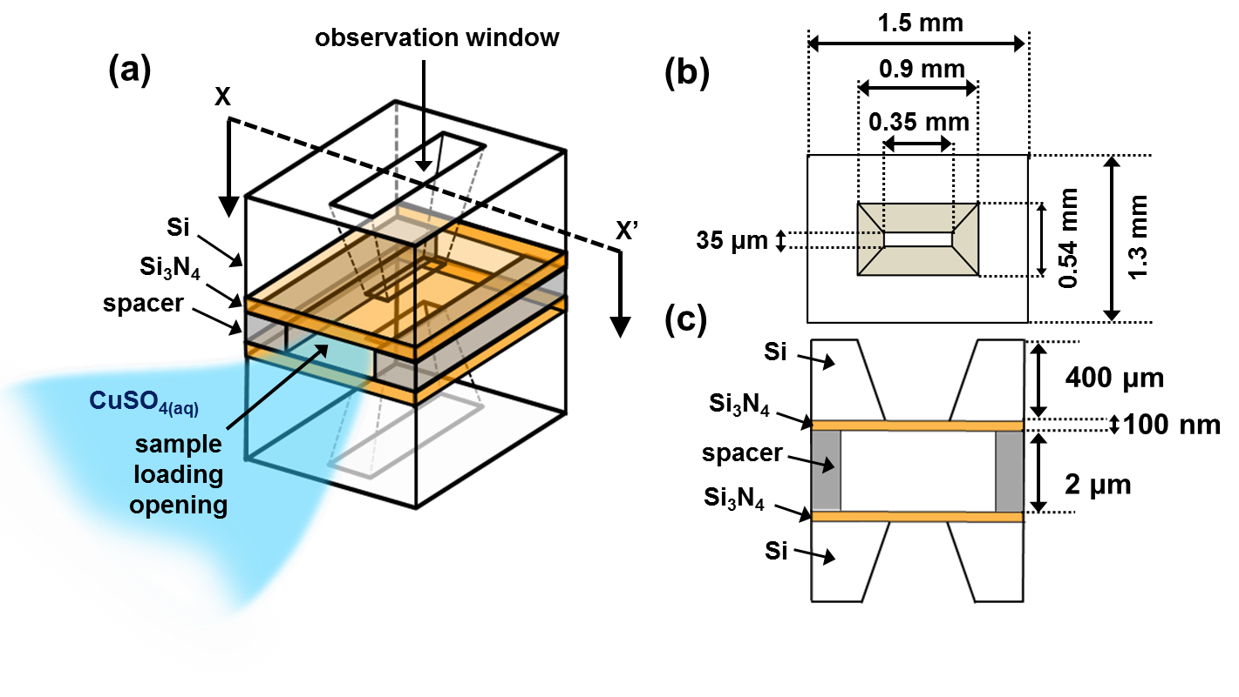

Fig. S1 Schematic diagram of K-kit (drawings are not to scale). (a) 3D perspective drawing of K-kit (white for silicon, orange color for silicon nitride, and gray for spacer). (b) Top view of K-kit. (c) x-x’ cross-section view of K-kit.

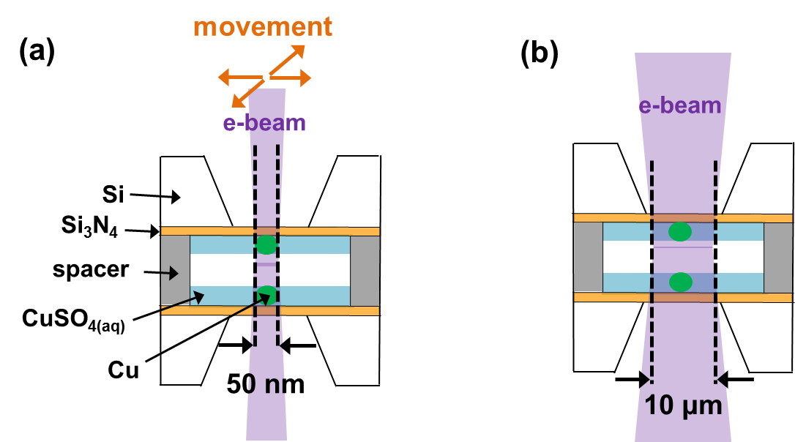

Fig. S2 Schematic diagram of reducing Cu patterns and imaging process (drawings are not to scale). (a) Converged e-beam with 50 nm in diameter is used to reduce Cu and moved along a pre-designed path. (b) Unconverged e-beam with 10 μm in diameter is utilized for imaging.

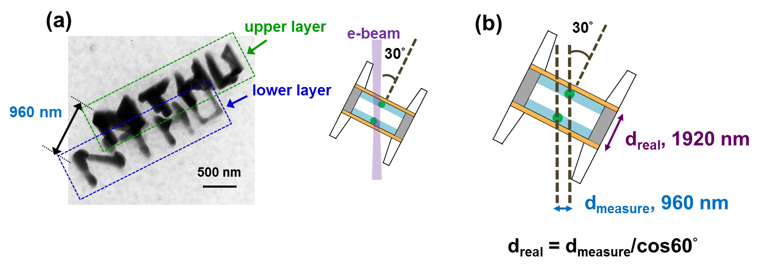

Fig. S3 The measurement of distance between two layers of Cu patterns. (a) TEM image of Cu patterns, Fig. 1c, after tilting K-kit with 30°. Green and blue rectangles label each layer respectively. The schematic diagram of tilted K-kit is shown beside. (b) Relation between d_{real} (real distance between two layers of Cu patterns) and d_{measure} (distance between two layers of Cu patterns measured from TEM image after tilting K-kit with 30°) is obtained. And d_{real} is measured to be 1920 nm.

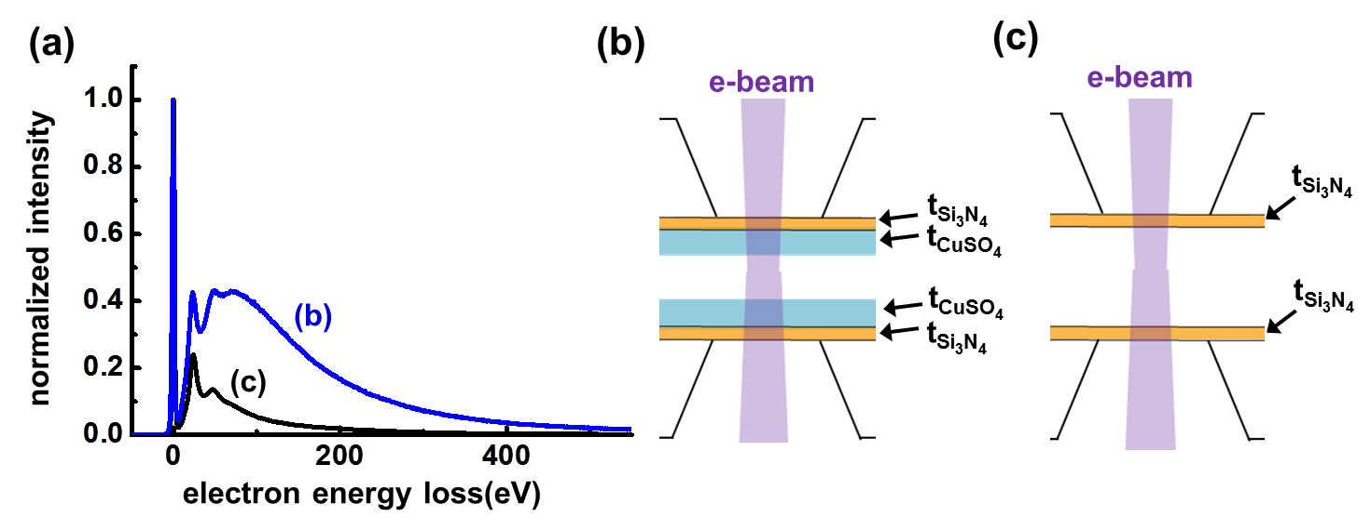

Fig. S4 EELS of K-kit with CuSO₄ solution and empty K-kit. (a) EELS of K-kit with CuSO₄ solution (blue line) and empty K-kit (black line). (b) Schematic diagram of K-kit with CuSO₄ solution. (c) Schematic diagram of empty K-kit.

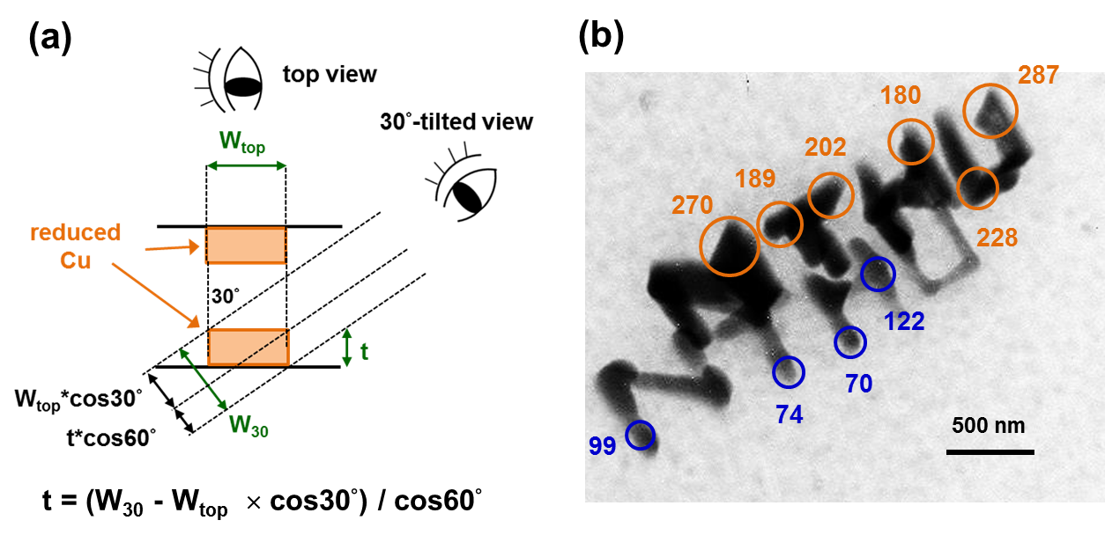

Fig. S5 Prediction of the thickness of reduced Cu by equation, t = (W₃₀ - W_{top} × cos30°) / cos60°. t is the thickness of reduced Cu pattern, W₃₀ and W_{top} are the widths of reduced Cu pattern measured from TEM image after tilting K-kit with 30° and TEM image without tilting K-kit (top-view) respectively. (a) Schematic diagram of how the equation, t = (W₃₀ - W_{top} × cos30°) / cos60°, is achieved. (b) The thickness of reduced Cu is indicated beside each measurement location and the units are all in nm.

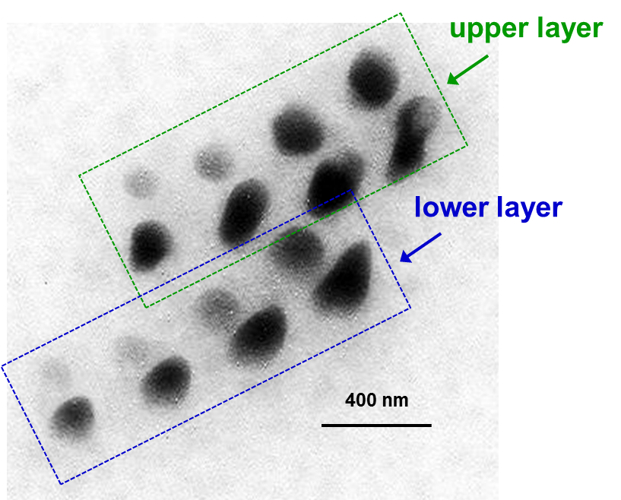

Fig. S6 TEM image of eight dots after tilting K-kit with 30°. Upper layer and lower layer of dots are labeled by green and blue rectangles separately. This figure combined with Fig. 2a is able to calculate the thickness of each dot by equation in Fig. S5a. And the thickness of upper layer is shown in Fig. 2b.

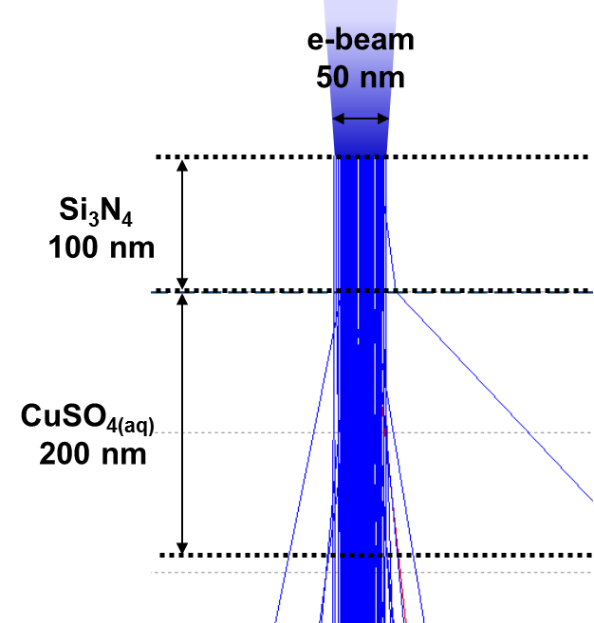
Fig. S7 Spreading of e-beam in 100 nm Si₃N₄ and 200 nm CuSO_{4(aq)} thin film.

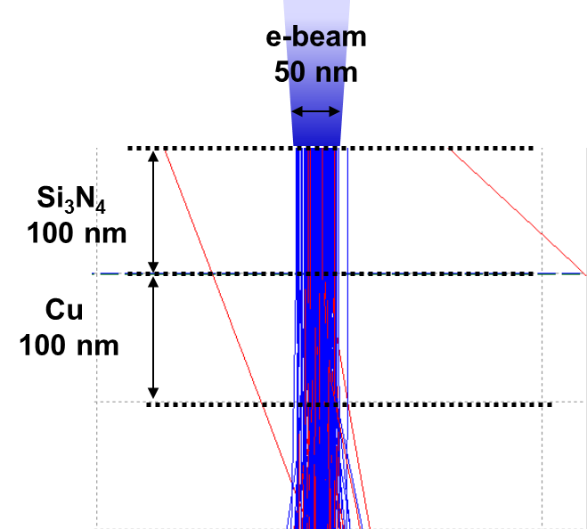

Fig. S8 Spreading of e-beam in 100 nm Si₃N₄ thin film and 100 nm Cu dot.

