Supplementary Information

Quantification of the Laser Beam Waist
The diffusion times of Rhodamine GreenTM was measured with a Zeiss Confocor 2 LSM510 equipped with an Argon laser excitation source (i.e. 488 nm) using a 40x/1.2 NA water-immersion objective lens with 30 runs each of 10 seconds duration. A single component fit was utilised to derive the diffusion time and following the application of the following equation the laser waist beam was determined;

Equation S 1
The laser beam waist, ω₀, for the Argon (green) excitation laser was derived from the autocorrelation curves (ACF) obtained from Rhodamine Green™ diffusion through the confocal volume. Using previously reported diffusion coefficients of Rhodamine 6G (2.8 x 10⁻⁶ cm²/sec), the laser waist beam was determined- this assumption was made as the molecular weight of Rhodamine GreenTM (507 g/mol) is similar to that of Rhodamine 6G (479 g/mol) [1]. The diffusion time obtained from FCS analysis of Rhodamine GreenTM using the Confocor 2 LSM510 setup was determined as 18.95 ± 2.61 (ω₀: 0.139 ± 0.001 µm) microseconds.

Characterisation of Photomultiplier Tube (PMT) Shot Noise
Varying PMT voltage conditions and laser powers may be used to assess the conditions under which direct linearity is existent between the photoelectric current and the measured fluorescence intensity [2]. This is significant since the derived brightness and number of particles parameters following SpIDA analysis of confocal images are influenced by shot noise. In this study this measurement was performed through imaging immobilised pre-bleached beads (Zeiss, Jena, Germany) using either an Argon excitation laser and a c-Apochromat 40 x/NA 1.2 water-immersion objective. The beads were excited over a range of laser powers, at different PMT gains (i.e. 600, 650 and 700) with a pixel dwell time of 3.2 µs (utilised for image acquisition) and the results averaged over 1024 points (i.e. pixels).

The results obtained from these measurements at gains 600, 650 and 700 are presented as follows;
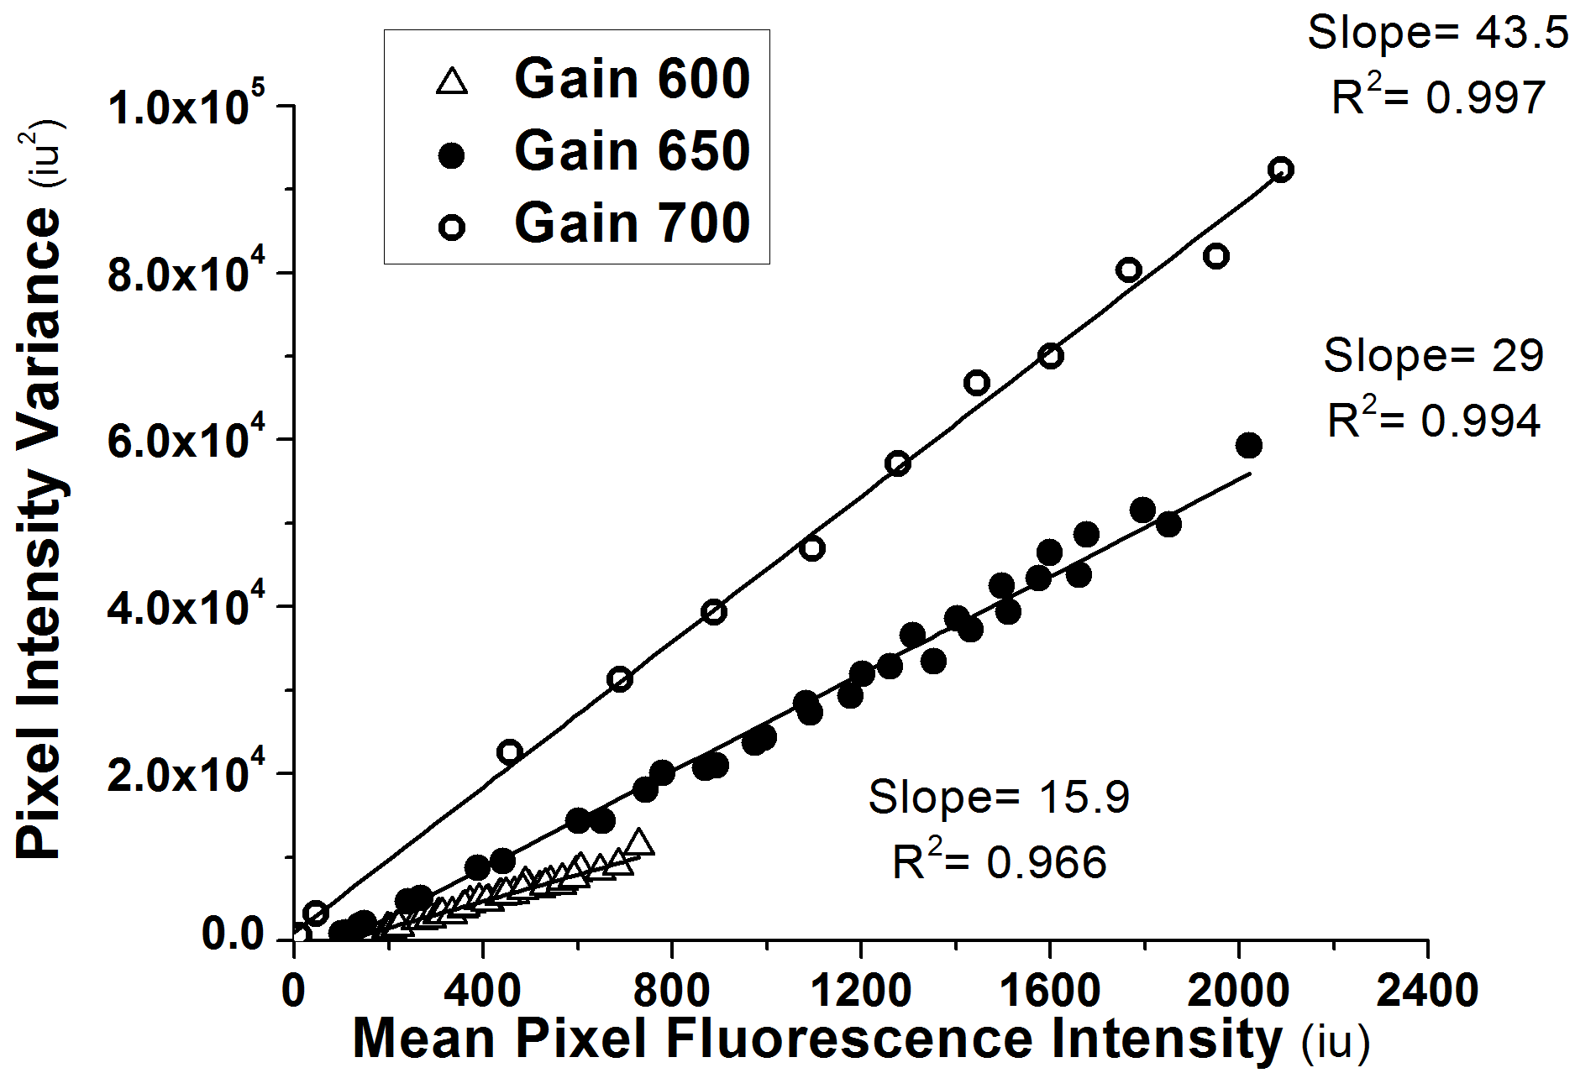

Figure A 1 Plots of pixel intensity variance versus mean pixel intensity for a 488 nm Argon laser for various detector gain settings (n=1024).
The line of best fit was determined at various detector gain settings within the linear pixel intensity range.

Determination of White Noise
In order to eliminate white noise contributions to output data, multiple regions of interest (i.e. extracellular regions) were selected in each image, the mean fluorescence intensity of which was determined from all the regions of interest for each image and inputted into the SpIDA user interface [3].

Negative Staining of Immunofluorescence Images
MDCK-MDR1 and MDCK-wt cells utilised in this study were subjected to immunofluorescence staining in order to quantify p-glycoprotein expression. In order to rule out non-specific staining monolayers were stained in the absence of primary antibody. Confocal images acquired from the negative control samples are presented as follows;
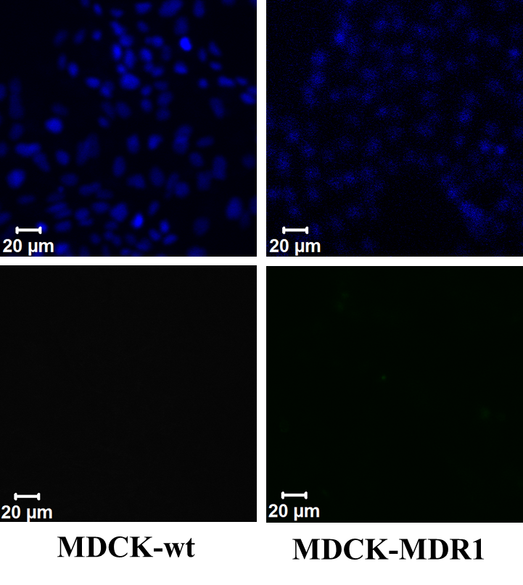

Figure A 2 Blue DAPI counterstain (top) and negative stain of MDCK-wt (left) and MDCK-MDR1 (right) for p-glycoprotein expression (bottom) for images with a resolution of 1024 x 1024 pixels and corresponding pixel size of 220 nm.
Images obtained from negative controls of immunofluorescently stained samples indicate the absence of autofluorescence and non-specific labelling following incubation with secondary labelled antibody.

References
1 Rigler, R., et al. (1993) Fluorescence correlation spectroscopy with high count rate and low background- Analysis of translational diffusion. European Biophysics Journal with Biophysics Letters 22, 169-175
2 Sergeev, M., et al. (2012) Determination of Membrane Protein Transporter Oligomerization in Native Tissue Using Spatial Fluorescence Intensity Fluctuation Analysis. PLoS ONE 7, e36215
3 Godin, A.G., et al. (2011) Revealing protein oligomerization and densities in situ using spatial intensity distribution analysis. Proceedings of the National Academy of Sciences 108, 7010-7015

