Supplementary Information 2 (Not for review)

Complete View of Western Blot Lanes
To illustrate the absence of non-specific labelling in the developed film following incubation with primary and secondary antibody (Figure 1G), a complete view is included for the reviewers as follows;

Figure A 1 Negative control (left) and western blot of MDCK-wt, MDCK-MDR1 passage 10 and MDCK-MDR1 passage 14 whole cell lysates following incubation with primary and secondary antibody and a 10 second exposure time (right).

SpIDA Analysis of Intracellular Calcein Retention
Images acquired from the intracellular retention of Calcein as a function of verapamil concentration and period of incubation were subjected to SpIDA analysis and the population statistics determined for each condition in both MDCK-MDR1 and MDCK-wt cell lines.
The descriptive statistics and corresponding probability and histogram plot for each concentration and time point in MDCK-MDR1 and MDCK-wt cells are presented as follows;

Table A 1 Statistical parameters derived from the analysis of intracellular Calcein in MDR1 cells co-incubated with 2.5 µM verapamil.
Time(min) | Mean | Median | Stdev | Min | Max | LQR | UQR
10 | 3.7 | 3.9 | 2.0 | 0.8 | 12.6 | 2.2 | 6.8
15 | 2.9 | 3.2 | 2.4 | 0.3 | 32.4 | 1.7 | 5.7
30 | 27.5 | 30.9 | 2.7 | 1.6 | 186.2 | 15.8 | 50.1
45 | 30.2 | 31.6 | 1.8 | 4.0 | 104.7 | 22.4 | 46.8
60 | 81.3 | 79.4 | 2.8 | 8.3 | 549.5 | 43.7 | 158.5
75 | 158.5 | 72.4 | 2.7 | 12.6 | 741.3 | 72.4 | 631.0
90 | 81.3 | 70.8 | 1.9 | 22.9 | 645.7 | 56.2 | 120.2

To assess the normality of the distribution obtained at this concentration, representative histogram and probability plots were constructed for each time point and typical plots are presented as follows;
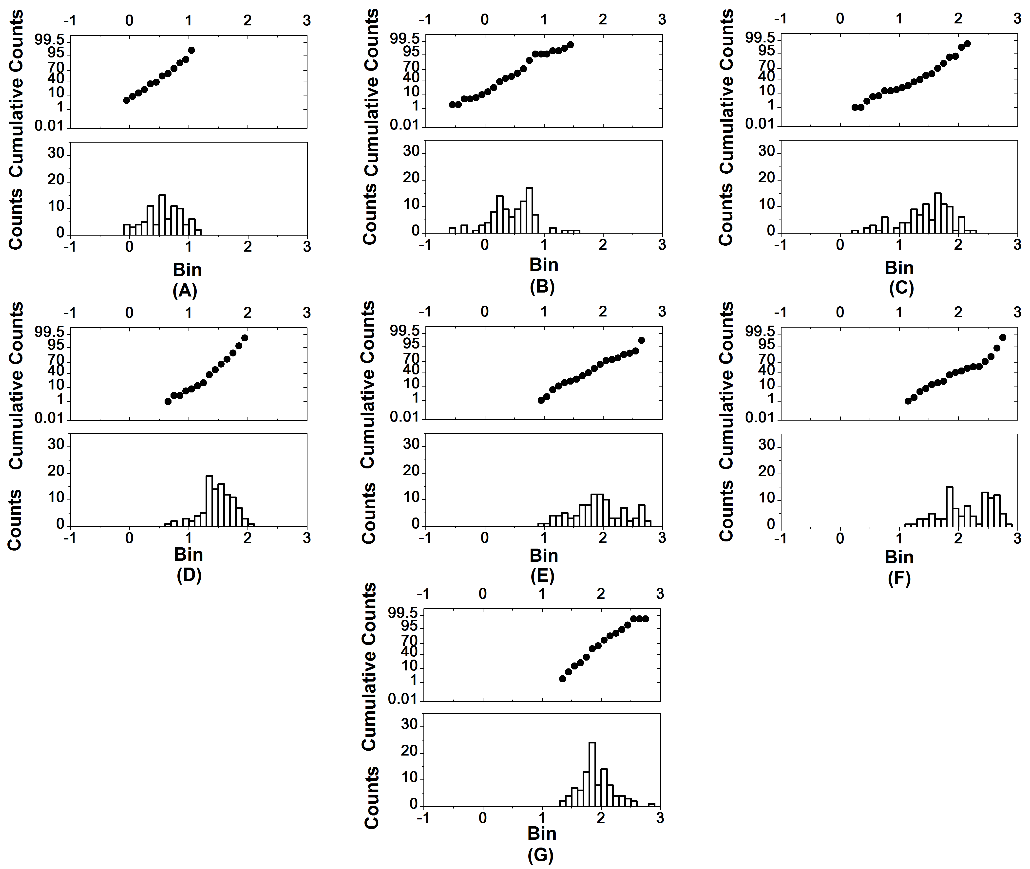

Figure A 2 Representative probability and histogram plots of intracellular Calcein obtained from MDCK-MDR1 cells at (A) 10 minutes (B) 15 minutes (C) 30 minutes (D) 45 minutes (E) 60 minutes (F) 75 minutes and (G) 90 minutes at a 2.5 µM concentration of verapamil.
MDCK-MDR1 cells exhibited a normal distribution upon incubation with 2.5 µM verapamil over various time periods (i.e. 10, 45, 60 and 90 minutes). However, a lack of linearity of the probability histogram fits at some points was evident, which is consistent with the presence of more than one sub-population (i.e. a bimodal distribution) within the data as indicated above in the case of 15, 30 and 75 minute incubations.

A summary of descriptive statistics derived from the analysis of samples incubated with 5 µM verapamil is presented in Table A 2 as follows;

Table A 2 Statistical parameters derived from the analysis of intracellular Calcein in MDR1 cells co-incubated with 5 µM verapamil.
Time(min) | Mean | Median | Stdev | Min | Max | LQR | UQR
10 | 1.7 | 1.7 | 2.1 | 0.5 | 15.8 | 1.1 | 2.7
15 | 8.5 | 6.3 | 2.0 | 2.4 | 31.6 | 5.4 | 15.8
30 | 39.8 | 41.7 | 2.5 | 5.8 | 354.8 | 18.2 | 72.4
45 | 25.1 | 31.6 | 2.8 | 4.3 | 251.2 | 6.3 | 55.0
60 | 55.0 | 69.2 | 4.3 | 2.3 | 251.2 | 18.6 | 199.5
75 | 100.0 | 100.0 | 2.7 | 6.0 | 660.7 | 60.3 | 263.0
90 | 125.9 | 131.8 | 2.5 | 10.0 | 407.4 | 69.2 | 281.8

Figure A 3 Representative probability and histogram plots of intracellular Calcein obtained from MDCK-MDR1 cells at (A) 10 minutes (B) 15 minutes (C) 30 minutes (D) 45 minutes (E) 60 minutes (F) 75 minutes and (G) 90 minutes at a 5 µM concentration of verapamil.
Histogram and probability fits indicated multimodal distributions and the presence of more than one sub-population after periods of incubation with verapamil. For example, MDCK-MDR1 cells displayed multimodal distributions due to the lack of linearity of the probability plots.

A summary of descriptive statistics derived from the analysis of MDR1 samples incubated with 5 µM verapamil is presented in Table A 3 below;

Table A 3 Statistical parameters derived from the analysis of intracellular Calcein in MDR1 cells co-incubated with 10 µM verapamil.
Time/min | Mean | Median | Stdev | Min | Max | LQR | UQR
10 | 3.3 | 3.1 | 2.2 | 0.6 | 14.1 | 1.9 | 5.5
15 | 31.6 | 31.6 | 1.9 | 5.8 | 158.5 | 20.4 | 52.5
30 | 58.9 | 56.2 | 2.2 | 12.6 | 426.6 | 32.4 | 83.2
45 | 79.4 | 63.1 | 2.5 | 15.8 | 676.1 | 39.8 | 125.9
60 | 63.1 | 50.1 | 2.8 | 5.6 | 691.8 | 15.8 | 83.2
75 | 125.9 | 125.9 | 2.5 | 20.0 | 676.1 | 63.1 | 295.1
90 | 109.6 | 74.1 | 2.5 | 18.2 | 631.0 | 56.2 | 218.8

Figure A 4 Representative probability and histogram plots of intracellular Calcein obtained from MDCK-MDR1 cells at (A) 10 minutes (B) 15 minutes (C) 30 minutes (D) 45 minutes (E) 60 minutes (F) 75 minutes and (G) 90 minutes at a 10 µM concentration of verapamil.
After shorter incubation periods, a normal distribution was observed for MDCK-MDR1 cell populations co-incubated with verapamil and Calcein-AM.

In Table A 4 a summary of descriptive statistics derived from the analysis of samples incubated with 20 µM verapamil is presented;

Table A 4 Statistical parameters derived from the analysis of intracellular Calcein in MDR1 cells co-incubated with 20 µM verapamil.
Time(min) | Mean | Median | Stdev | Min | Max | LQR | UQR
10 | 2.5 | 2.5 | 1.9 | 0.7 | 18.2 | 1.5 | 3.5
15 | 18.6 | 18.6 | 1.6 | 4.0 | 57.5 | 12.6 | 25.1
30 | 38.9 | 36.3 | 2.2 | 7.9 | 398.1 | 21.9 | 69.2
45 | 97.7 | 89.1 | 2.5 | 15.5 | 691.8 | 46.8 | 199.5
60 | 79.4 | 66.1 | 3.2 | 31.6 | 724.4 | 40.7 | 158.5
75 | 158.5 | 158.5 | 2.3 | 30.2 | 645.7 | 70.8 | 316.2
90 | 134.9 | 125.9 | 2.8 | 17.8 | 891.3 | 97.7 | 158.5

Figure A 5 Representative probability and histogram plots of intracellular Calcein obtained from MDCK-MDR1 cells at (A) 10 minutes (B) 15 minutes (C) 30 minutes (D) 45 minutes (E) 60 minutes (F) 75 minutes and (G) 90 minutes at a 20 µM concentration of verapamil.
Histogram and probability plots derived from samples incubated with 20 µM verapamil indicate normal distributions at earlier time points (i.e. 10, 15, 30 and 45 minutes) and the emergence of more than one sub-population at later time points.

A summary of descriptive statistics derived from the analysis of MDR1 cell samples incubated with 50 µM verapamil is presented in Table A 5;

Table A 5 Statistical parameters derived from the analysis of intracellular Calcein in MDR1 cells co-incubated with 50 µM verapamil.
Time/min | Mean | Median | Stdev | Min | Max | LQR | UQR
10 | 5.8 | 5.5 | 1.7 | 1.6 | 19.5 | 4.2 | 8.7
15 | 83.2 | 70.8 | 2.7 | 4.9 | 501.2 | 44.7 | 158.5
30 | 87.1 | 70.8 | 2.0 | 20.9 | 512.9 | 63.1 | 128.8
45 | 131.8 | 125.9 | 2.4 | 27.5 | 758.6 | 61.7 | 239.9
60 | 125.9 | 100.0 | 1.9 | 37.2 | 794.3 | 77.6 | 158.5
75 | 199.5 | 186.2 | 2.2 | 33.9 | 851.1 | 120.2 | 389.0
90 | 158.5 | 631.0 | 2.1 | 47.9 | 831.8 | 158.5 | 631.0

Figure A 6 Representative probability and histogram plots of intracellular Calcein obtained from MDCK-MDR1 cells at (A) 10 minutes (B) 15 minutes (C) 30 minutes (D) 45 minutes (E) 60 minutes (F) 75 minutes and (G) 90 minutes at a 50 µM concentration of verapamil.
With the exception of 60 minute and 90 minute incubation times, a normal distribution of intracellular Calcein retention was observed.
Table A 6 a summarises representative descriptive statistics derived from the analysis of wt samples incubated with 2.5 µM verapamil.

Table A 6 Statistical parameters derived from the analysis of intracellular Calcein in wt cells co-incubated with 2.5 µM verapamil.
Time/min | Mean | Median | Stdev | Min | Max | LQR | UQR
10 | 25.7 | 28.2 | 1.7 | 6.0 | 70.8 | 17.0 | 38.9
15 | 49.0 | 46.8 | 2.3 | 6.0 | 338.8 | 33.9 | 70.8
30 | 60.3 | 63.1 | 1.8 | 13.2 | 190.5 | 40.7 | 95.5
45 | 120.2 | 123.0 | 1.9 | 29.5 | 501.2 | 74.1 | 199.5
60 | 91.2 | 91.2 | 1.8 | 15.8 | 389.0 | 64.6 | 158.5
75 | 213.8 | 223.9 | 2.7 | 21.9 | 912.0 | 100.0 | 524.8
90 | 213.8 | 218.8 | 2.1 | 42.7 | 691.8 | 114.8 | 436.5

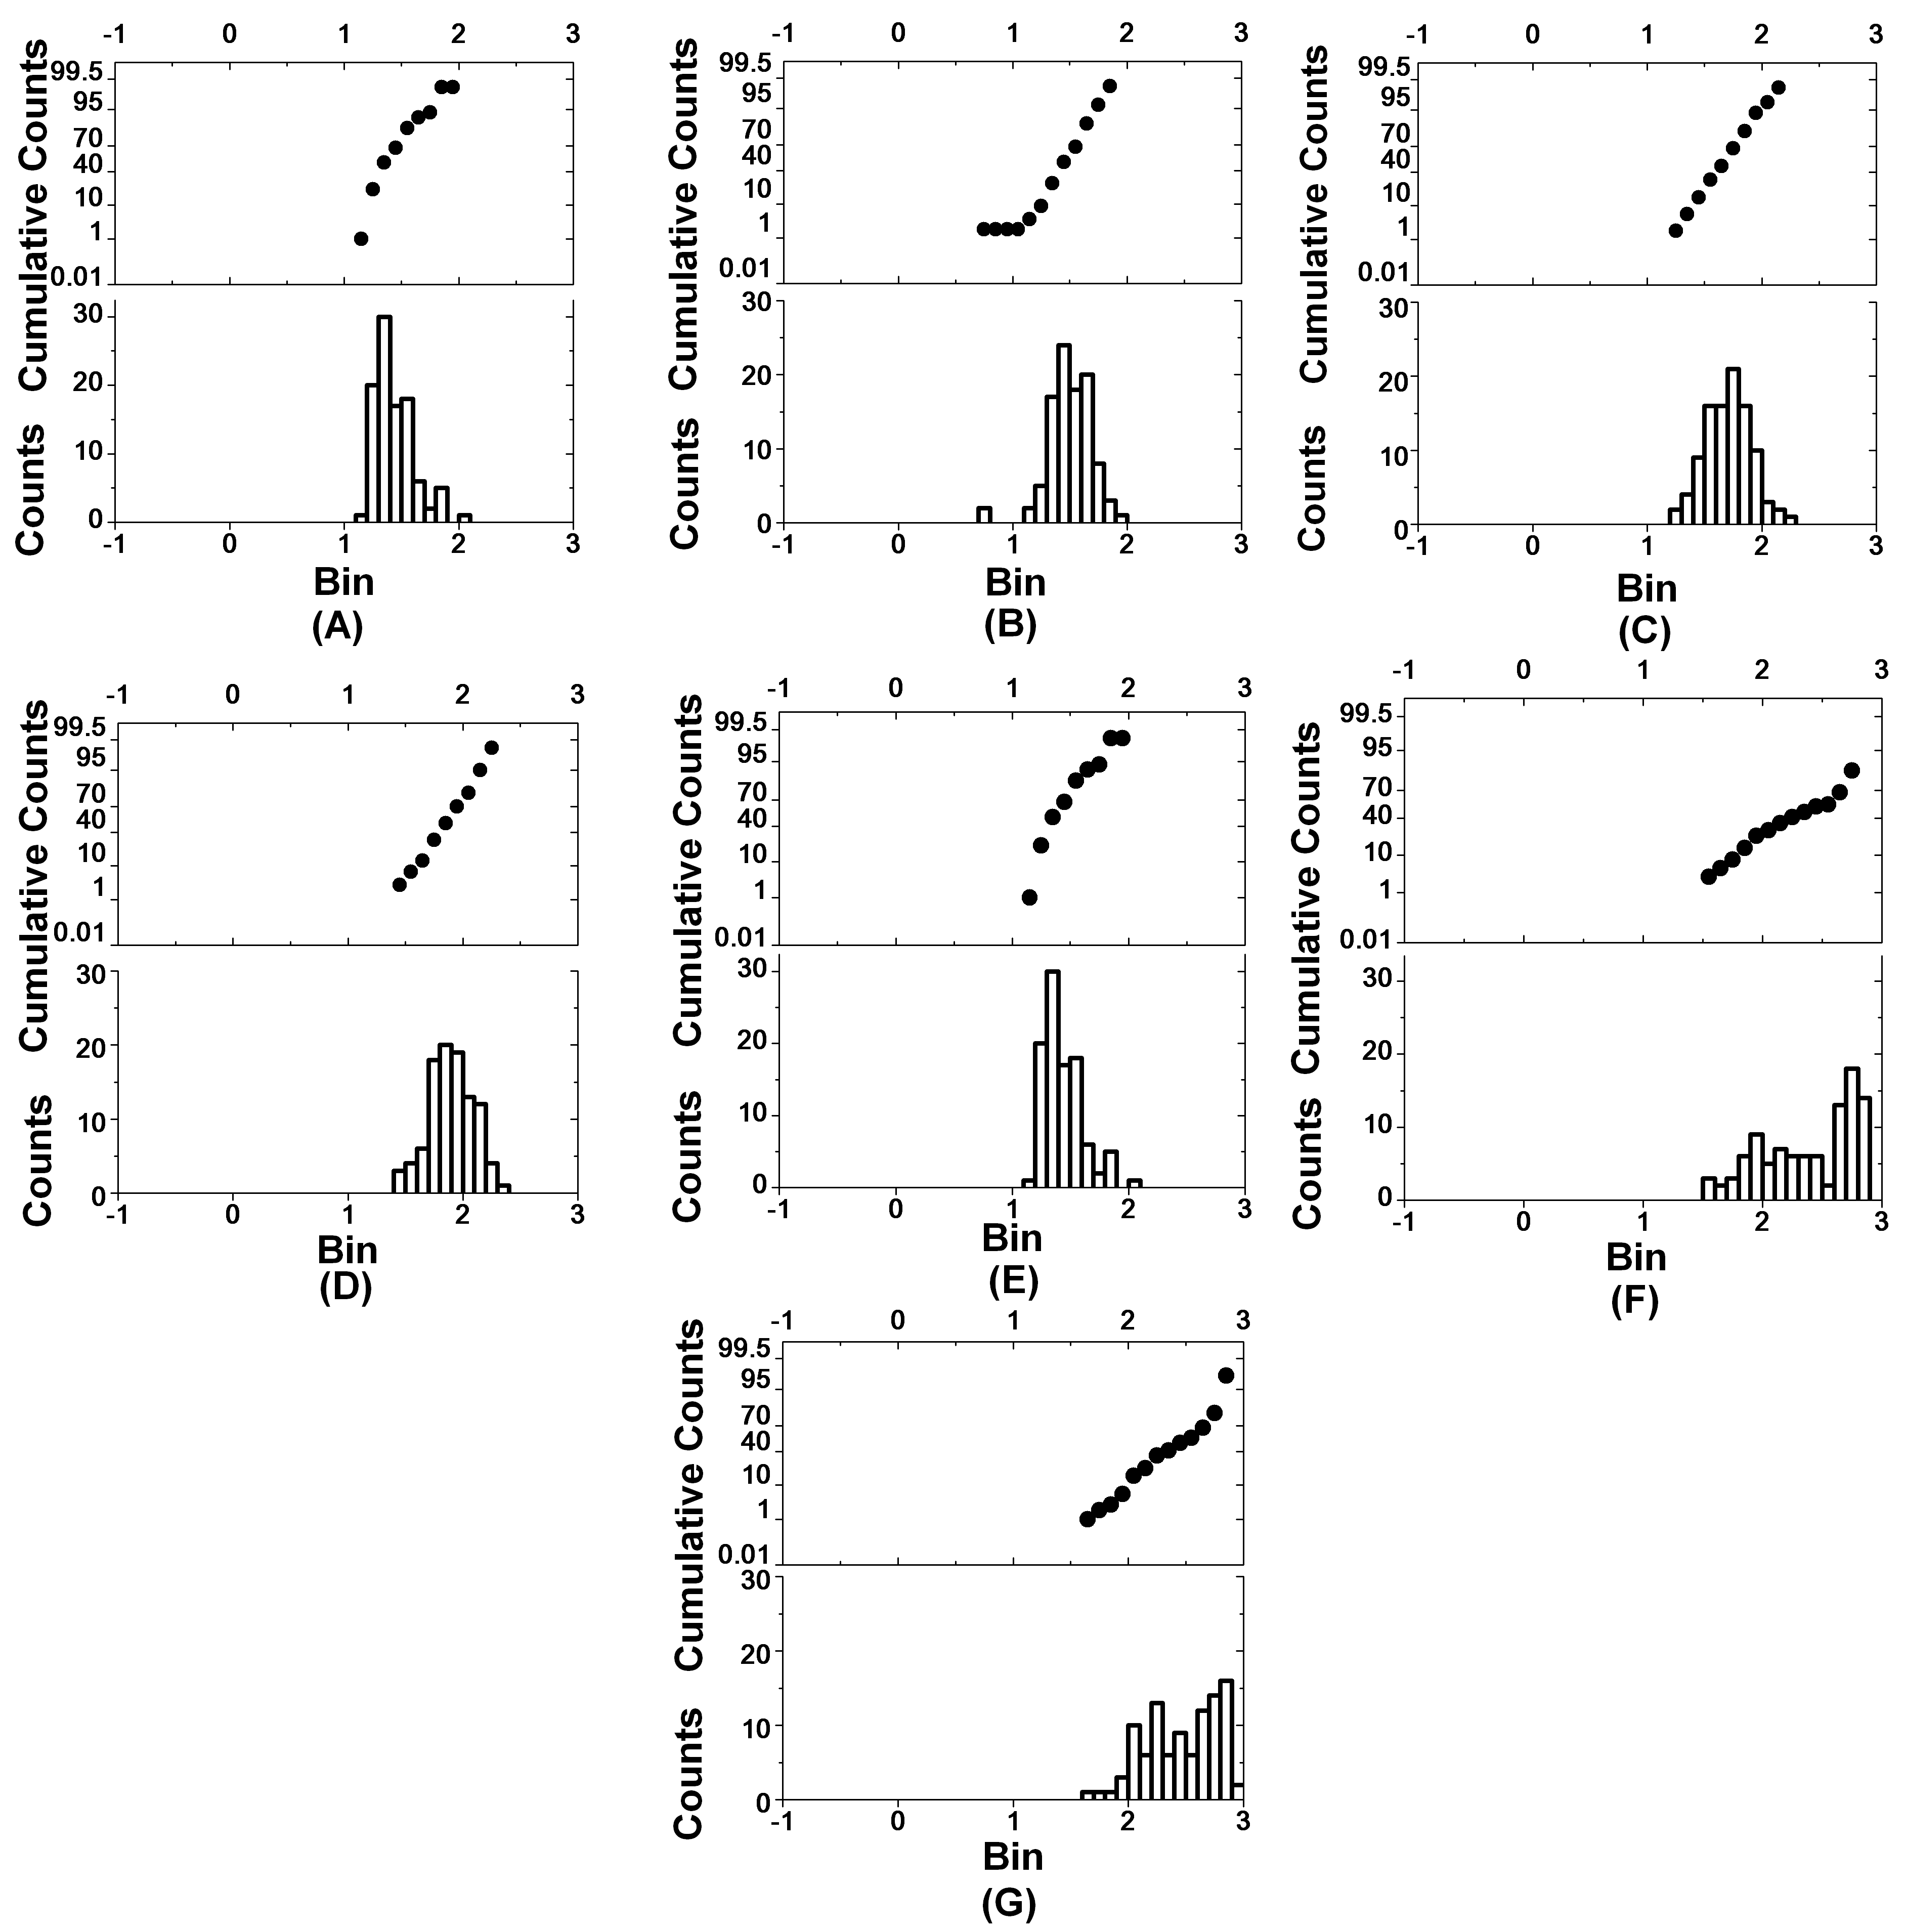

Figure A 7 Representative probability and histogram plots of intracellular calcein obtained from MDCK-wt cells at (A) 10 minutes (B) 15 minutes (C) 30 minutes (D) 45 minutes (E) 60 minutes (F) 75 minutes and (G) 90 minutes at a 2.5 µm concentration of verapamil.
Descriptive statistics derived from analysis of MDCK-wt samples incubated with 5 µM verapamil are summarised below in Table A 7;

Table A 7 Statistical parameters derived from the analysis of intracellular Calcein in wt cells co-incubated with 5 µM verapamil.
Time/min | Mean | Median | Stdev | Min | Max | LQR | UQR
10 | 27.5 | 25.1 | 1.5 | 12.6 | 125.9 | 20.9 | 35.5
15 | 31.6 | 31.6 | 1.5 | 6.0 | 85.1 | 24.5 | 43.7
30 | 50.1 | 51.3 | 1.6 | 15.8 | 177.8 | 38.9 | 70.8
45 | 79.4 | 70.8 | 1.6 | 25.7 | 213.8 | 58.9 | 104.7
60 | 134.9 | 114.8 | 2.8 | 15.1 | 758.6 | 60.3 | 389.0
75 | 239.9 | 281.8 | 2.5 | 33.1 | 776.2 | 112.2 | 549.5
90 | 295.1 | 323.6 | 2.1 | 49.0 | 977.2 | 166.0 | 575.4

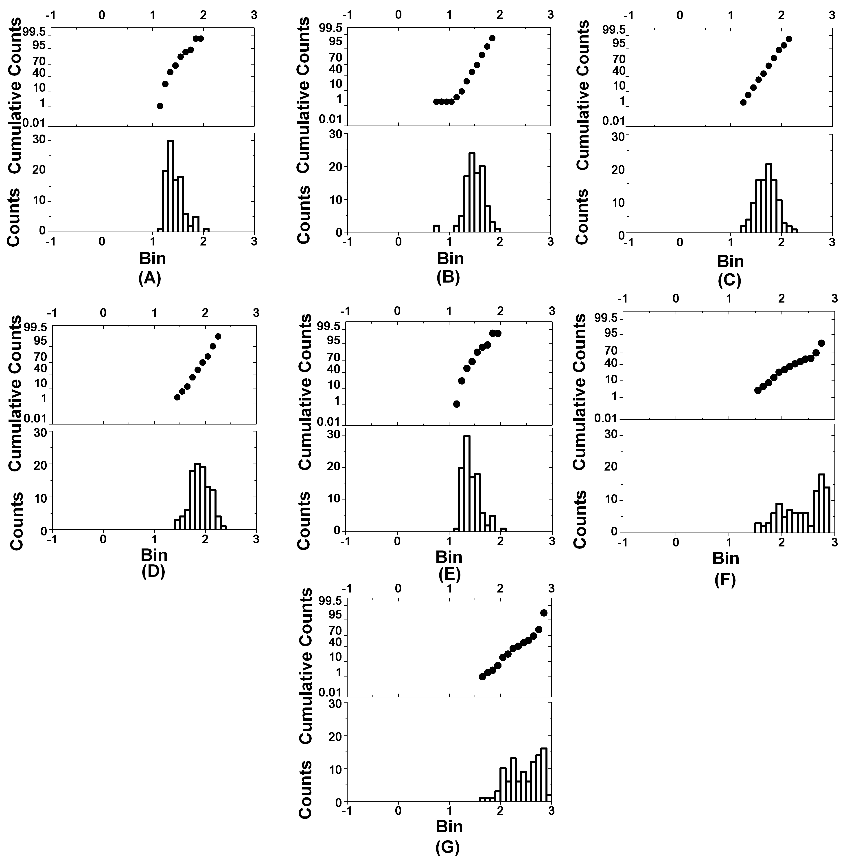

Figure A 8 Representative probability and histogram plots of intracellular Calcein obtained from MDCK-wt cells at (A) 10 minutes (B) 15 minutes (C) 30 minutes (D) 45 minutes (E) 60 minutes (F) 75 minutes and (G) 90 minutes at a 5 µM concentration of verapamil.

Descriptive statistics derived from the analysis of MDCK-wt samples incubated with 10 µM verapamil are presented in Table A 8;

Table A 8 Statistical parameters derived from the analysis of intracellular Calcein in wt cells co-incubated with 10 µM verapamil.
Time/min | Mean | Median | Stdev | Min | Max | LQR | UQR
10 | 39.8 | 41.7 | 1.9 | 4.0 | 199.5 | 25.1 | 50.1
15 | 31.6 | 30.9 | 1.7 | 10.5 | 91.2 | 23.4 | 45.7
30 | 36.3 | 39.8 | 1.8 | 8.9 | 112.2 | 24.0 | 58.9
45 | 89.1 | 85.1 | 2.8 | 12.6 | 660.7 | 46.8 | 182.0
60 | 125.9 | 100.0 | 2.6 | 12.6 | 851.1 | 66.1 | 190.5
75 | 95.5 | 91.2 | 2.2 | 15.8 | 758.6 | 63.1 | 158.5
90 | 85.1 | 79.4 | 2.2 | 12.6 | 812.8 | 50.1 | 125.9

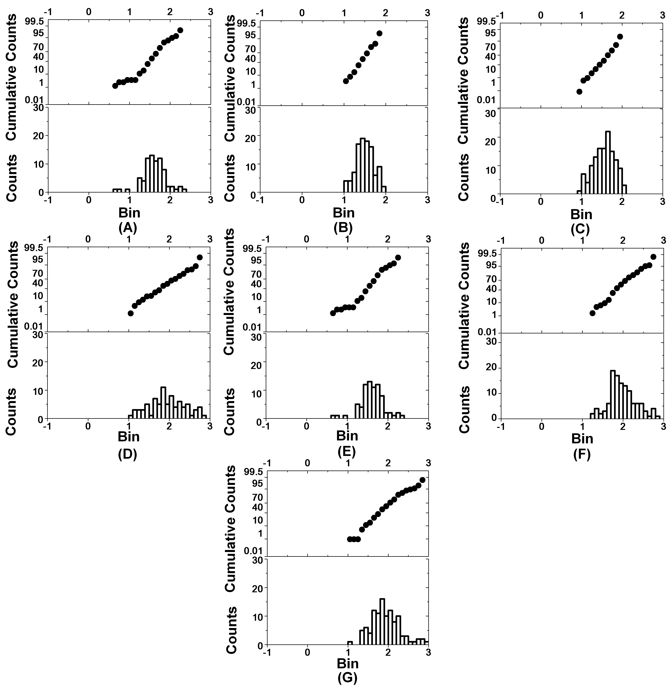

Figure A 9 Representative probability and histogram plots of intracellular Calcein obtained from MDCK-wt cells at (A) 10 minutes (B) 15 minutes (C) 30 minutes (D) 45 minutes (E) 60 minutes (F) 75 minutes and (G) 90 minutes at a 10 µM concentration of verapamil.

A summary of descriptive statistics derived from the analysis of MDCK-wt samples incubated with 20 µM verapamil is presented in Table A 9;

Table A 9 Statistical parameters derived from the analysis of intracellular Calcein in wt cells co-incubated with 20 µM verapamil.
Time | Mean | Median | Stdev | Min | Max | LQR | UQR
10 | 36.3 | 37.2 | 1.7 | 13.2 | 100.0 | 25.7 | 56.2
15 | 53.7 | 38.9 | 2.3 | 14.5 | 478.6 | 30.9 | 89.1
30 | 91.2 | 70.8 | 2.5 | 19.5 | 467.7 | 43.7 | 245.5
45 | 100.0 | 70.8 | 2.8 | 6.0 | 501.2 | 50.1 | 302.0
60 | 117.5 | 100.0 | 2.7 | 20.9 | 891.3 | 58.9 | 208.9
75 | 166.0 | 147.9 | 2.5 | 35.5 | 912.0 | 93.3 | 380.2
90 | 158.5 | 151.4 | 2.5 | 30.9 | 724.4 | 74.1 | 288.4

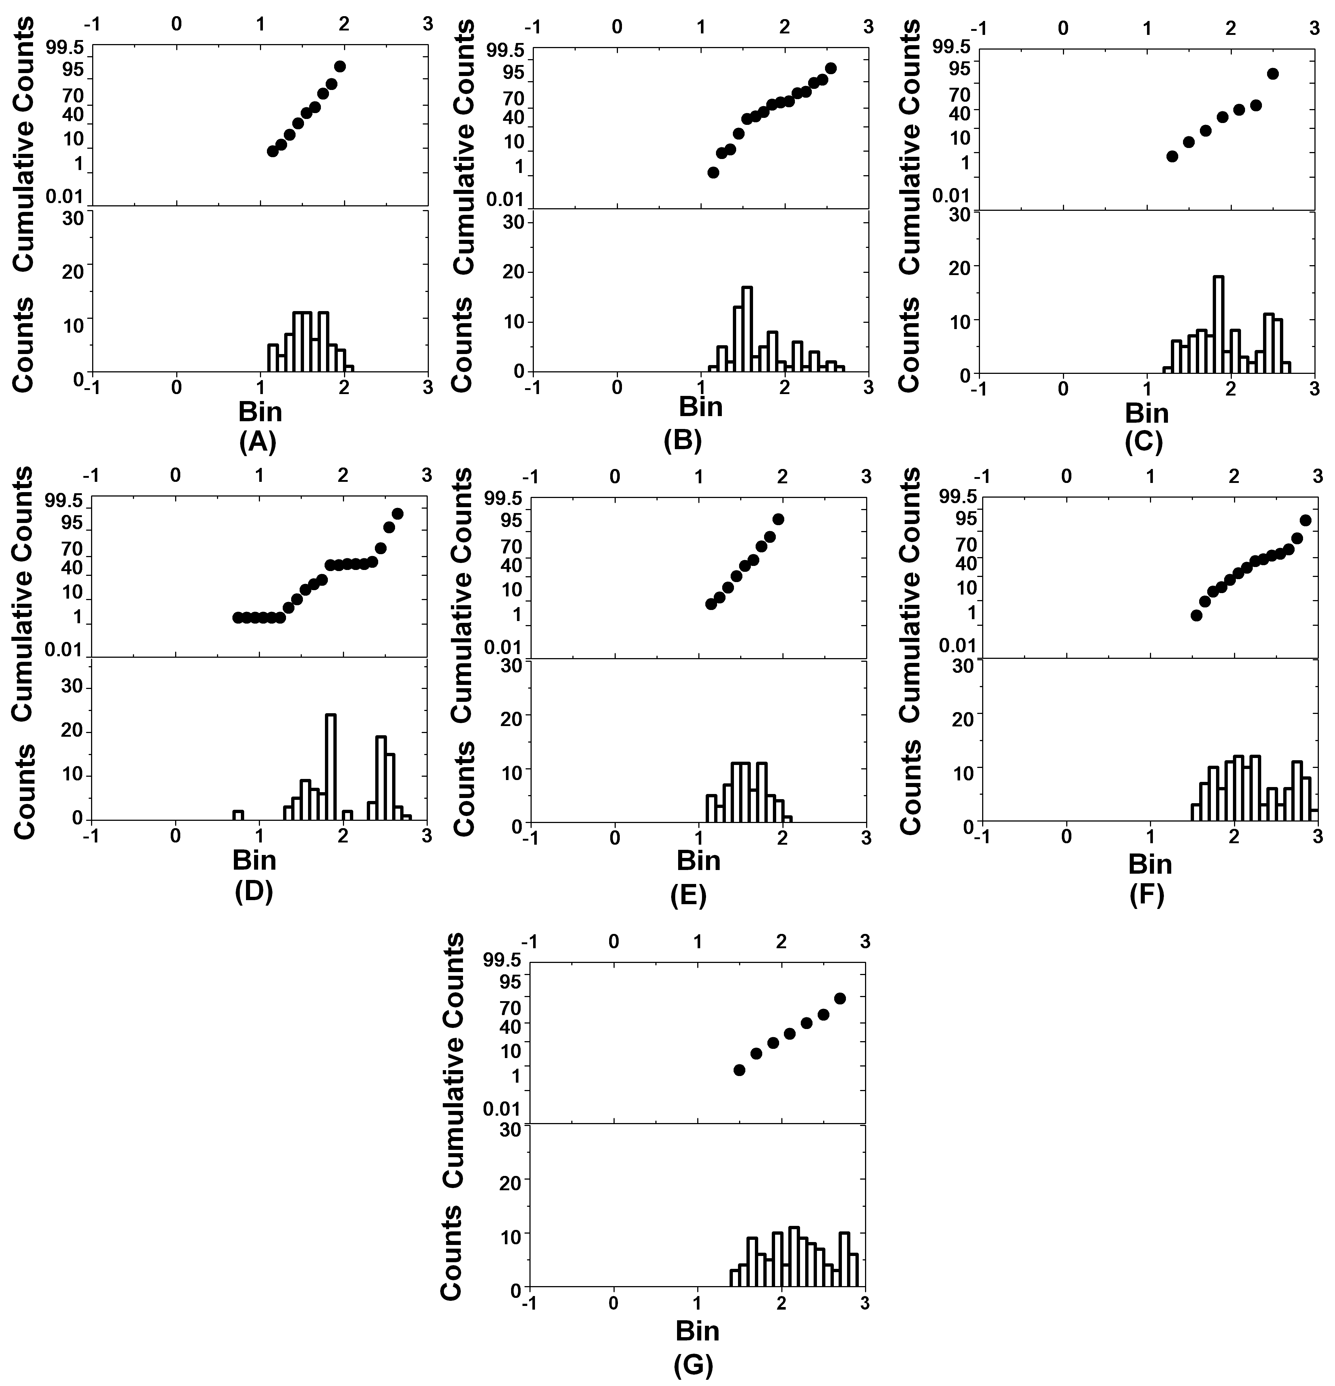

Figure A 10 Representative probability and histogram plots of intracellular Calcein obtained from MDCK-wt cells at (A) 10 minutes (B) 15 minutes (C) 30 minutes (D) 45 minutes (E) 60 minutes (F) 75 minutes and (G) 90 minutes at a 20 µM concentration of verapamil.

Descriptive statistics from analysis of MDCK-wt data incubated with 50 µM verapamil are similarly presented in Table A 10;

Table A 10 Statistical parameters derived from the analysis of intracellular Calcein in wt cells co-incubated with 50 µM verapamil.
Time/min | Mean | Median | Stdev | Min | Max | LQR | UQR
10 | 20.9 | 21.4 | 1.8 | 4.8 | 53.7 | 14.5 | 33.9
15 | 29.5 | 36.3 | 1.9 | 6.2 | 114.8 | 18.2 | 50.1
30 | 40.7 | 39.8 | 2.3 | 8.7 | 478.6 | 22.4 | 70.8
45 | 87.1 | 70.8 | 2.6 | 10.0 | 812.8 | 50.1 | 158.5
60 | 251.2 | 316.2 | 1.9 | 39.8 | 724.4 | 158.5 | 501.2
75 | 131.8 | 125.9 | 2.4 | 30.2 | 831.8 | 70.8 | 302.0
90 | 208.9 | 213.8 | 2.2 | 34.7 | 741.3 | 125.9 | 436.5

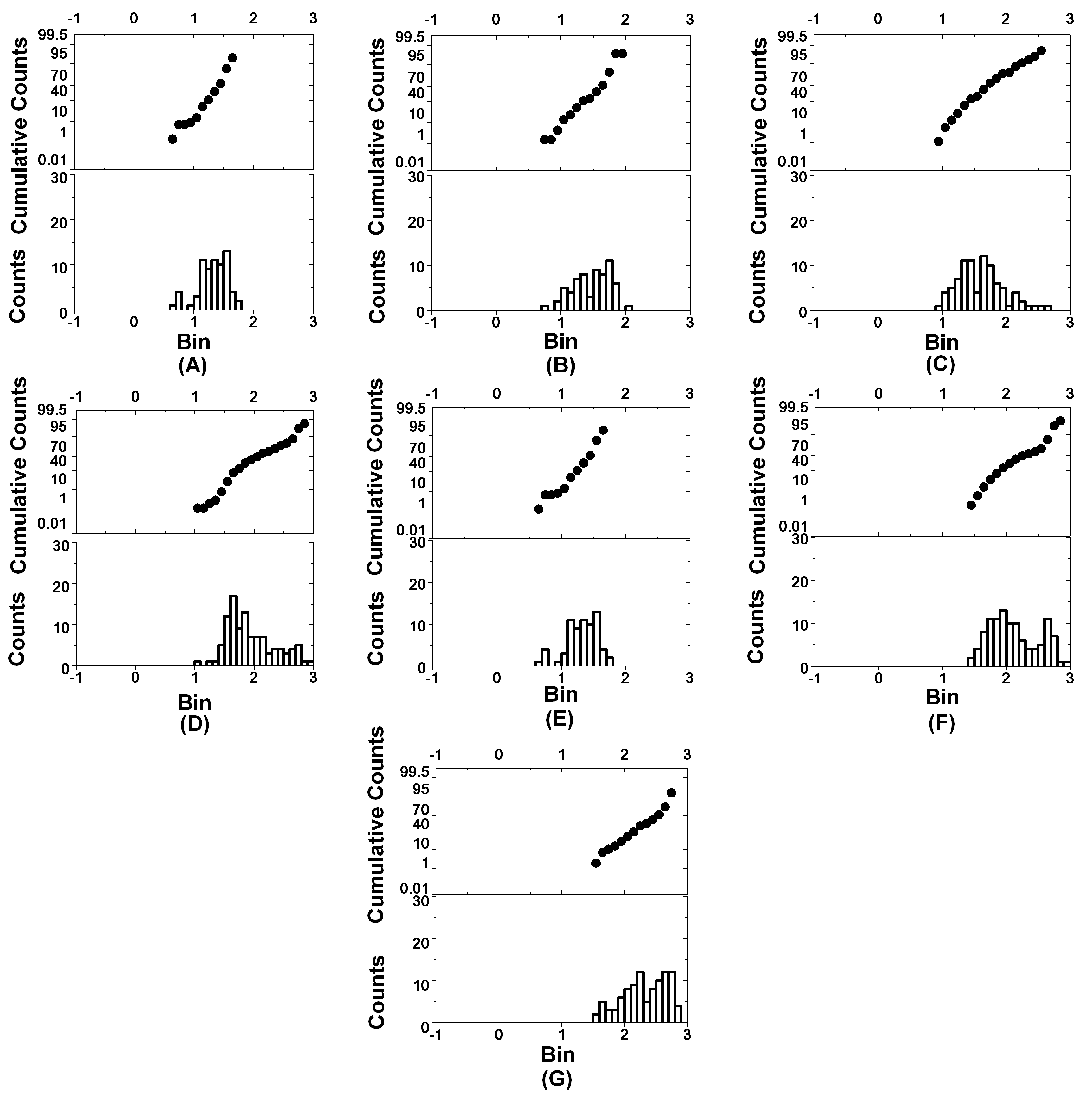

Figure A 11 Representative probability and histogram plots of intracellular Calcein obtained from MDCK-wt cells at (A) 10 minutes (B) 15 minutes (C) 30 minutes (D) 45 minutes (E) 60 minutes (F) 75 minutes and (G) 90 minutes at a 50 µM concentration of verapamil.
All samples followed a normal distribution, with the exception of the 75 minute incubations.

