Supporting online Materials
Signaling Analyzer User Manual
Installation
- Download and install the following National Instruments modules (If aren’t already installed on your PC):
- NI Labview Runtime Engine 2011, downloadable from
http://joule.ni.com/nidu/cds/view/p/id/2534
- Vision Development Module Run-Time 2011, downloadable from http://joule.ni.com/nidu/cds/view/p/id/2599
- Download and unpack the program file “Signalinganalyzerinstaller.zip” into this folder.
- Open the folder /Signalinganalyzerinstaller /Volume and execute the file “setup.exe” and select the directory in which to install the program.
- At the end of the Signaling analyzer installation process, you will be eventually prompted to activate your software. If you have already a license for National instruments Vision Development Module 2011 you can activate it inserting Vision Development Module 2011 serial number. Otherwise you can buy it (www.ni.com) ,or use the evaluation version which expires after 30 days.
- Launch “Signaling Analyzer” either from the Start/Programs menu or by navigating to the folder in which it was installed and opening the file “Signaling Analyzer.exe.”
Overview
The program “Signaling Analyzer” is organized into four subsections: “Image loader” “image preprocessor” “Output images” and “output graphs” (Fig. S1).

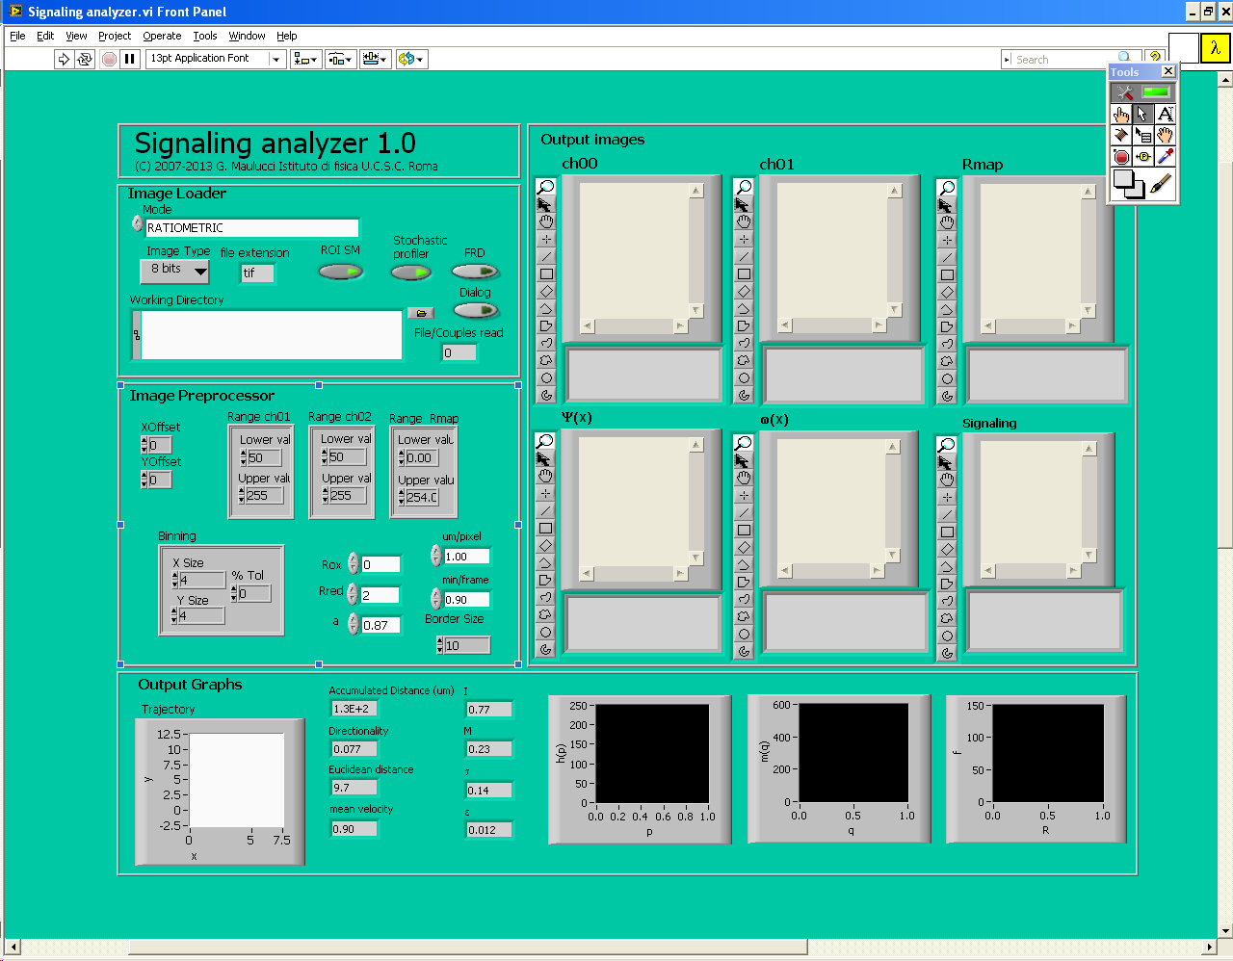
Fig.S1. Main page of Signaling Analyzer program.
The software has several optional features. (i) Either the entire image can be processed or a ROI may be selected for processing. (ii) If the quality of the original images is low, due to noise or low probe concentration, the images may be low-pass filtered to obtain higher-quality redox-based pseudoimages. The low-pass filter calculates the interpixel variation between the pixel being processed and those pixels surrounding it. Pixels to include are defined and then compared to surrounding pixels to determine the interpixel variation. If the interpixel has a variation greater than a specified percentage of the total pixel intensity, then the average pixel value is calculated from the neighboring pixels. If the variation is less than the specified percentage, the calculation is not performed. The percentage can be specified in the %Tol box (for “percent tolerance”), and the default value for “%Tol” is 0%. (iii) Signal thresholds can be set in the original images in order to remove background noise or to select a particular range of fluorescence values: By doing so, brightness values of pixels below the lower threshold and above the upper threshold are set to 0. The other pixels maintain their original value. Help is available within the software: simply select “Show context help” under the “Help” menu, then click on any object or input box. This will open a pop-up window that contains notes and contextual help about the selected object.

Image loader Subsection
- Mode toolbar: select NORMAL if your input images are single channel time lapses, RATIOMETRIC if your input images are dual channel time lapses (Fig.S2).
- In the “Image type” input box (Fig.S2), select the option appropriate to the original images [8 bits, 16 bits, Float, Complex, RGB (red green blue), HSL (hue saturation lightness)]. The default setting is 8 bits.

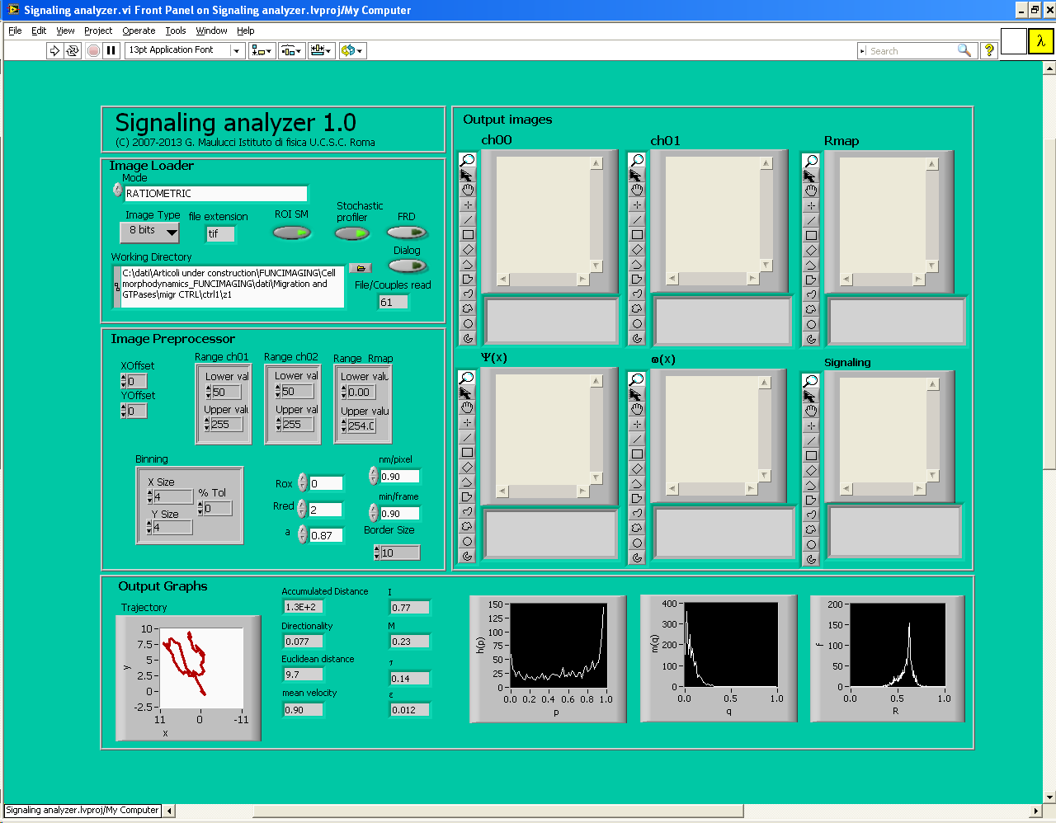
Fig.S2. Image Loader Subsection.

- To enable the ability to select an ROI from the original image, press the ROI selection manager (ROI SM) button (Fig.S2). The arrowhead on the ROI button is green when this option is selected. This step is optional. If this is enabled, then when the image processing starts, a window will appear allowing the ROI to be selected. If no ROI is selected, the entire image will be processed.
- To enable the Stochastic profiler, press the Stochastic profiler button (Fig.S2). The arrowhead on the ROI button is green when this option is selected. Otherwise no profiling will be executed.
- In the Working Directory window (Fig.S2), you can select the Directory in which images to be processed are stored.
- File/couples read reports the number of read files (normal mode) or couples (ratiometric mode) which have been processed (Fig.S2).
- The image files must be in .tif format. If the images are in formats other than .tif, prepare a list of the files you wish to process in a text file. Save this file as “files.txt” and store it in the same working directory in which the images are stored. Next, press the “file reader debugger” button in the “ Image loader” section (Fig.S2).
- To activate a dialog window when you run the software, you must press the Dialog button (Fig.S2) is and when this option is selected the color of arrow is green.

Image preprocessor Subsection
- X offset and Y offset adjust the relative position of image couples, if misalignment problems occurred in acquisition of dual color images (Fig.S3).
- To remove background noise or to select a particular range of fluorescence values, apply a threshold to the images in the “range ch1” and “range ch2” input boxes by choosing the lower and the upper values of the pixels to be included; then use the “binning” input box to calculate the interpixel variation between the included pixels and those pixels surrounding it (Fig.S3).
Note: This step is optional. If the “range ch1” and “range ch2” lower and upper values are set, respectively, to 0 and 255, no threshold will be applied. If “X size” and “Y size” values are both set to 1, images are not low-pass filtered.

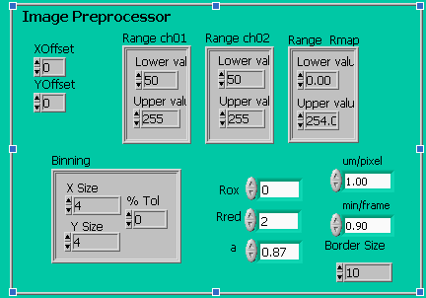
Fig.S3. Image Preprocessor Subsection.

- Apply a threshold for the R-image in the “range R-image” input box by setting the lower and the upper values of the pixels you want to include in the processed image (Fig.S3).
- Insert the R_{ox}, R_{red}, and a values into which you find into subsection R-image properties (Fig.S3) and probe calibration of the Redox Maps Generator software (22).
Note: The a value depends upon the probe and the wavelengths used. The default is 0.89, for rxYFP as the probe and 458 and 488 nm as the excitation wavelengths.
- In the box um/pixel and min/frame, you can insert the pixel resolution values in µm and the time resolution of your time lapse images, in minutes.

- Specify the width (in pixels) of the border to create around the R-image in the “border size” input box (Fig.S3). The default border value is 10.

Run and Output images and graphs subsections
- Press the white arrow button in the upper bar or open the “Operate” menu, then select “Run” (Fig.S4)

Fig.S4. Run Toolbar.

- If nothing is specified in working directory and the dialog button is pressed, a dialog box (Fig.S5) will display the path to the selected folder

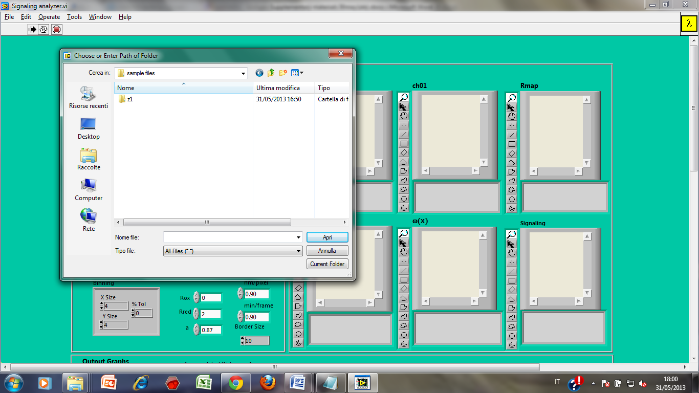
Fig.S5. Dialog Box.

- If the “ROI SM” button is green (enabled) (Fig.S2), then a window appears allowing the ROIs to be directly selected on the image (Fig.S6). Use the selection tool to draw a rectangle around the ROI and then press “OK”. During the image processing, the calculation can be aborted by pressing the red circle button (“Abort execution” command) in the upper bar (Fig.S4).

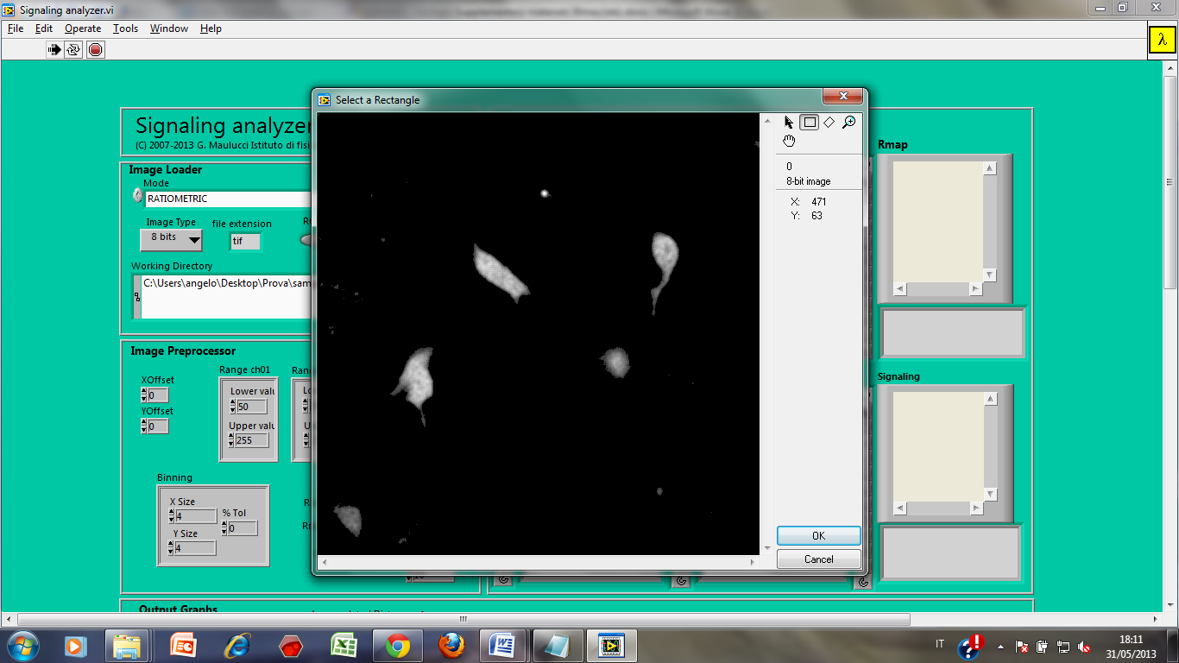
Fig.S6. ROI Manager Dialog Box.

3) The two original images and the R-image will be displayed in three windows “ch00”, “ch01”, and “Rmap”, respectively (Fig.S7).

Fig.S7. Output Images subsection ch00, ch01 and Rmap windows.

- After the execution the Psi map, the omega map and the Signaling maps (in our case <R>) will be plotted in the “output images” Subsection “Ψ(x)”, “ω(x)”, and “Signaling”, respectively (Fig.S8).

Fig.S8. Output Images subsection Ψ(x), ω(x), and Signaling windows.

- Image histograms and the values of the indexes defined in the article are shown in the “output graphs” subsection (Fig.S9).

Fig.S9. Output Graphs subsection

Go to the “results” folder, a subdirectory of the original working directory to access the processed images, which are stored as .tif files: 0.tif is an image file which represents the average R map, omega.tif is an image file which represents the ω map, psi.tif. is an image file which represents the Ψ map and migrationctrlAt00ch**.tif are the R maps at all time points(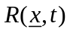). A text file called “results.txt”, contains all the values of the image histograms and their mean values and ΔR values at all time points. In the same folder, “Dynamic par.txt” contains Directionality(eq.14), Accumulated Distance (eq.13), Euclidean Distance values(eq.12), the average values of velocity(eq.11), the trajectory, I(eq.3), M (eq.4), τ (eq.5) and ε (eq.10) and the h(p) and m(q) histograms.

Example – Procedure Step by Step

- Start the Signaling Analyzer software.
- Insert the path where sample files are located (you can find samples in the folder /signalinganalyzerinstaller/sample ) in working directory box or push the Dialog button (Fig.S2).
- If you want to use a Roi Manager dialog box you must push the ROI SM button (Fig.S2).
- Set in the Binning box (Fig.S3) Xsize = 3; Ysize = 3; %tol = 0.
- Set in the Range ch00 box (Fig.S3) Lower value = 25; Upper value = 255.
- Set in the Range ch01 box (Fig.S3) Lower value = 25; Upper value = 255.
- Set in the Range Rmap box (Fig.S3) Lower value = 0; Upper value = 254.
- Set Rred = 2.12; Rox = 1.14; a = 0.89 (Fig.S3).
- Set µm/pixel = 0.40 and min/frame = 1.
- Set Border Size box = 10 (Fig.S3).
- Run the program by pushing the white arrow button in the upper bar or open the “Operate” menu, then select “Run” (Fig.S4).
- If you selected the ROI SM option (step 3), the ROI Manager Box will open (Fig.S6).
- Use the selection tool to draw a rectangle around the ROI and then press OK.
- Run the program by pushing the white arrow button in the upper bar or open the “Operate” menu, then select “Run” (Fig.S4).
- If you want to abort the execution you have to press the red circle button (“Abort execution” command) in the upper bar (Fig.S4).
- After the execution the Psi, omega, the Rmean, Ψ(x), ω(x), and Signaling maps will be plotted in the Output images Subsection (Fig.S8).
- After the execution image histograms, the Trajectory and the values of the indexes will be shown in the Output Graphs Subsection (Fig.S9).
- Output files are in the directory C:\...\...\Desktop\Signaling Analyzer\sample files\z1. Here you find:
- 0.tif. is an image file which represents the average R map(eq.15).
- omega.tif. is an image file which represents the ω map(eq.8).
- psi.tif. is an image file which represents the Ψ map(eq.1).
- migrationctrlAt00ch**.tif are the R maps at all time points.
- Results.txt file contains the R histograms at all time points.
- Dynamicpar.txt contains the Directionality(eq.14), Accumulated Distance(eq.13), Euclidean Distance values(eq.12), the average values of velocity(eq.11), the trajectory, I(eq.3), M (eq.4), τ (eq.5) and ε (eq.10) and the h(p) and m(q) histograms.

independence of Ψ(x) and ω(x) from the observational time T

If environmental conditions are constant (i.e. temperature T, pCO₂, etc), 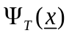and
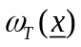are independent from T. This statements are equivalent to the mathematic conditions (6) and (13).
These condition may be verified experimentally, by varying the observational times 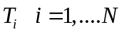 and measuring parameters like M, τ and ε. The convergence of the parameters to an horizontal asymptote is sufficient to verify (6). In figure S10, sample plots of M, τ and ε are reported for a single cell for different total observational times T. As can be seen, for the particular cell type used, an observational time T=60 min is sufficient to reach the corresponding horizontal asymptote, and therefore to build significative maps with the stochastic sampling method.

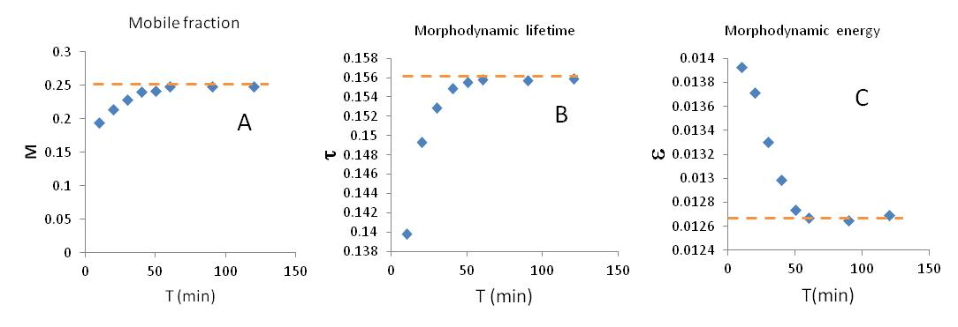
Fig.S10. Mobile fraction M, Morphodynamic lifetime τ and energy ε versus observational time T.

