In situ determination and imaging of physical properties of soft organic materials by ATEM
Supporting Information

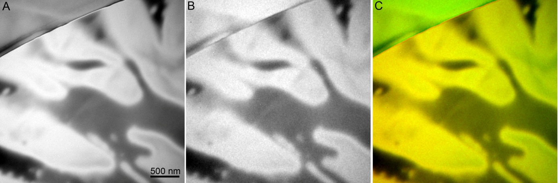
Figure ES 1. The quality of the drift correction between plasmon image and carbon elemental map of Polycaprolactone - Polylactid (PCL-PLA) polymer blend. (A) EFTEM bulk plasmon image recorded using 10 eV integration window centered on 21 eV; (B) conventional three window carbon elemental map (C K); (C) superimposed bulk plasmon image (red) and carbon map (green) after drift correction procedure.

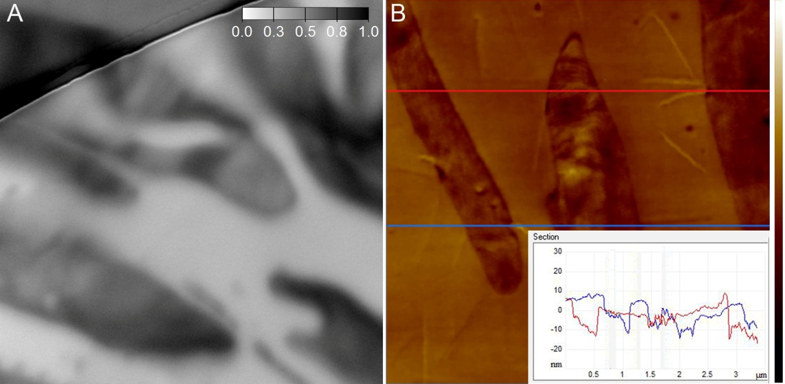
Figure ES 2. TEM relative thickness map with t/λ scales (A) versus AFM topographical profile (B) of Polycaprolactone - Polylactid (PCL-PLA) polymer blend. The insert in Figure (B) represents randomly selected sections of the surface profiles. Height variation: 0-100 nm in (B).
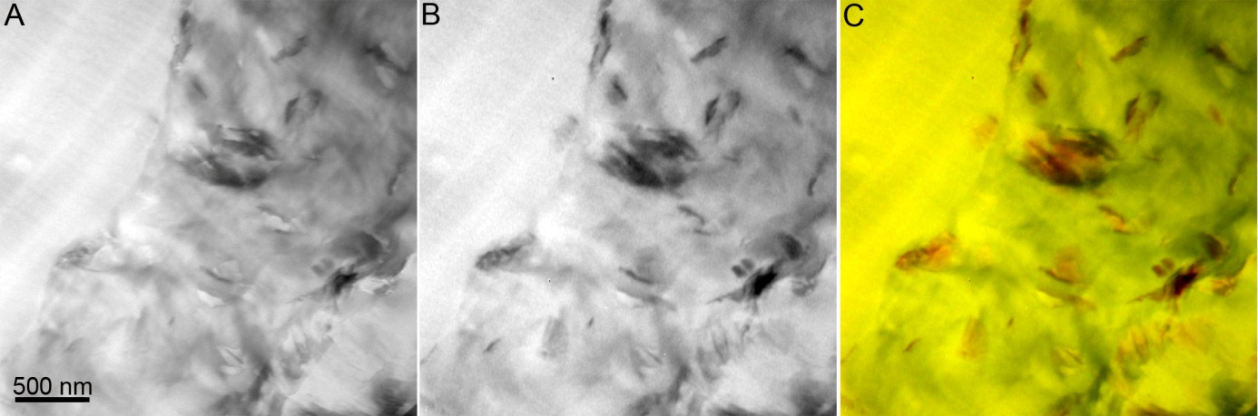
Figure ES 3. The quality of the drift correction between plasmon image and carbon elemental map of polyethylene – polystyrene - graphite nanocomposite. (A) EFTEM bulk plasmon image recorded using 10 eV integration window centered on 21 eV; (B) conventional three window carbon elemental map (C K); (C) superimposed bulk plasmon image (red) and carbon map (green) after drift correction procedure.

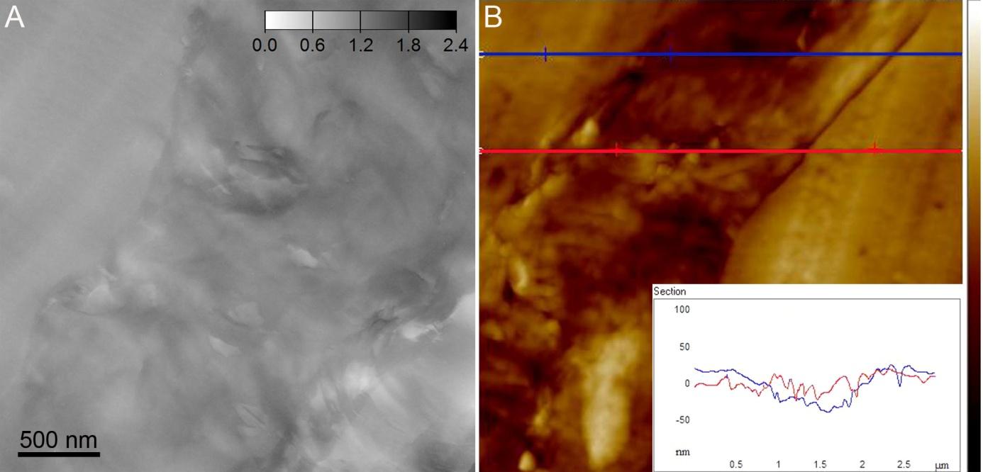
Figure ES 4. TEM relative thickness map with t/λ scales (A) versus AFM topographical profile (B) of polyethylene – polystyrene - graphite nanocomposite. The insert in Figure (B) represents randomly selected sections of the surface profiles. Height variation: 0-150 nm in (B).
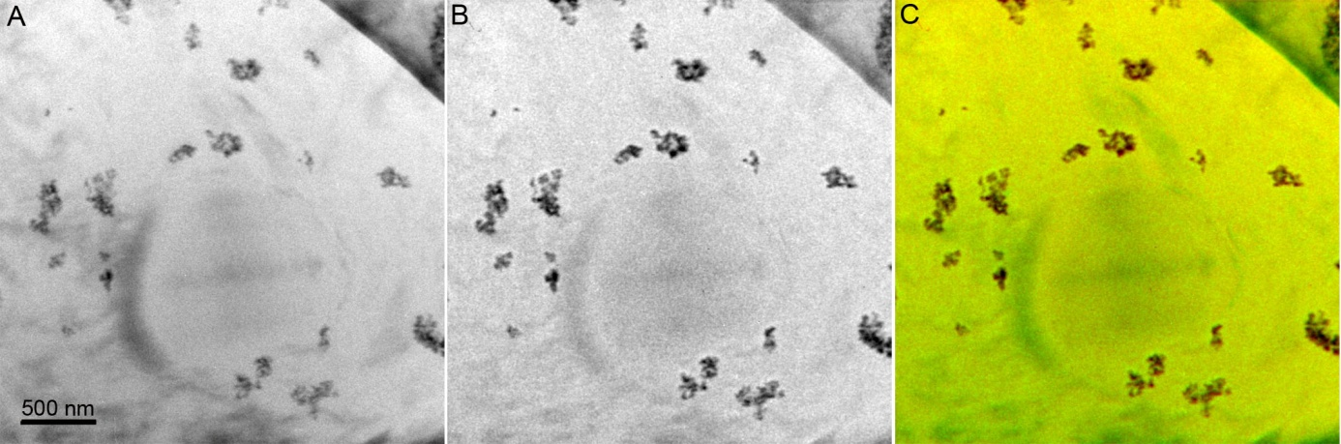
Figure ES 5. The quality of the drift correction between plasmon image and carbon elemental map of polyethylene – polystyrene - silica nanocomposite. (A) EFTEM bulk plasmon image recorded using 10 eV integration window centered on 25 eV; (B) conventional three window carbon elemental map (C K); (C) superimposed bulk plasmon image (red) and carbon map (green) after drift correction procedure.

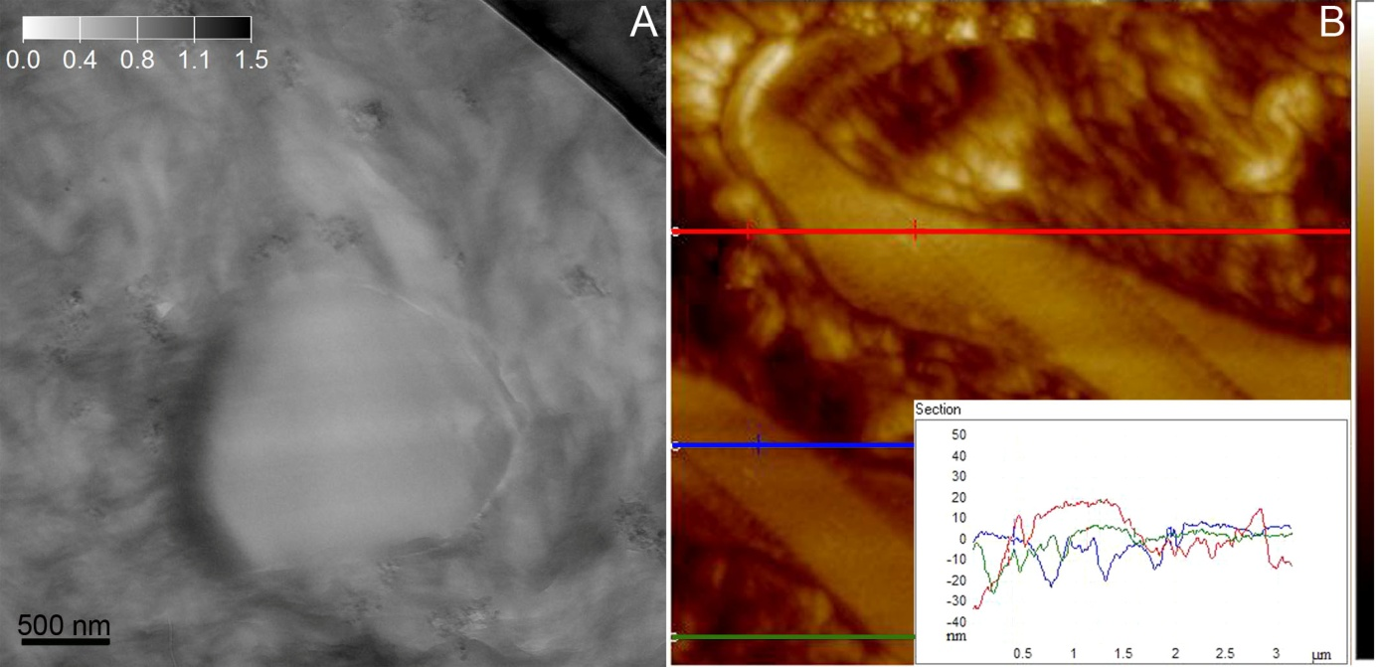
Figure ES 6. TEM relative thickness map with t/λ scales (A) versus AFM topographical profile (B) of polyethylene – polystyrene - silica nanocomposite. The insert in Figure (B) represents randomly selected sections of the surface profiles. Height variation: 0-150 nm in (B).

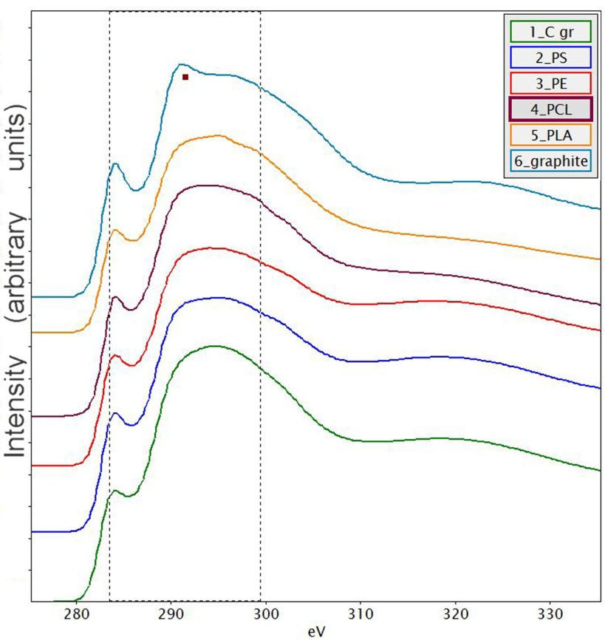
Figure ES 7. EELS spectra from carbon K ionization edge, obtained from the each component of presented organic-inorganic samples. PE - polyethylene, PS - polystyrene, PCL - Polycaprolactone, PLA - Polylactid, C gr - holey carbon grid.

