Supplementary Information

Understanding Mechanisms of Nanocrystal Formation and Transformation Via Liquid Cell TEM

Michael H. Nielsen¹, Dongsheng Li², Shaul Aloni³, Thomas Y.J. Han⁴, Cathrine Frandsen⁵, Jong Seto⁶, Jillian F. Banfield⁷, Helmut Coelfen⁶ and James J. De Yoreo^{2,*}

¹Department of Materials Science and Engineering, University of California, Berkeley, Berkeley, CA 94720
²Physical Sciences Division, Pacific Northwest National Laboratory, Richland, WA 99352
³Molecular Foundry, Lawrence Berkeley National Laboratory, Berkeley, CA 94720
⁴Physical Sciences Directorate, Lawrence Livermore National Laboratory, Livermore, CA 94551

⁵Department of Physics, Technical University of Denmark, 2800 Kongens Lyngby, Denmark

⁶Physical Chemistry, University of Konstanz, Konstanz, Germany

⁷Department of Earth and Planetary Science, University of California, Berkeley, CA 94720

Figure S1 - Ex situ TEM image showing late-stage hematite spindle. (a) After 6 hours at 150°C, no akaganeite nanorods remain and the spindles are well crystallized. (b) 48 hour hematite spindle with diffraction pattern demonstrating it is single crystal.

Movie M1 - Nucleation of Au nanoparticles.

Movie M2 - Growth of ferryhidrite by oriented attachment.

Movie M3 - Growth of calcite by aggregation of what appear to be amorphous nanoparticles.

Movie M4 - Diffusion and collision of calcite nanocrystals that do not appear to exhibit coalescence events. This experiment was conducted in a commercially available (Hummingbird Scientific) three port liquid flow TEM stage and compatible fluid cell.
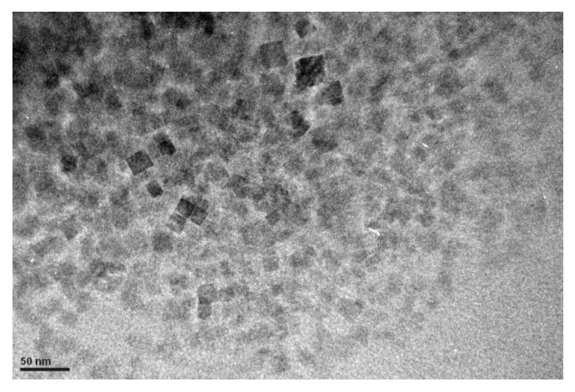

Movie M5 - Dendritic growth of Au nanoparticles induced by the electron beam.

