Supplementary Information

Visualization of the coalescence of Bi nanoparticles
Kai-Yang Niu,¹ Hong-Gang Liao,¹ and Haimei Zheng^{1,2*}
¹ Materials Sciences Division, Lawrence Berkeley National Laboratory, Berkeley, CA 94720, USA
² Department of Materials Science and Engineering, University of California, Berkeley, California 94720, United States
*Correspondence should be addressed to: hmzheng@lbl.gov

- Movie recording
All imaging results were acquired in a JEOL 2100 with a high-resolution pole piece (Cs = 1 mm) and a LaB₆ filament. A Gatan Orius CCD camera was used for in situ imaging. The electron beam (200 kV; beam current density of about 500 electrons·Å⁻²·s⁻¹) passes through the silicon nitride window (3×50 μm), and induces the growth of Bi nanoparticles in the liquid layer. The movie was recorded at a rate of 5 frames/s by the open-sourced software VirtualDub embedded in the DigitalMicrograph software. The as-recorded movie was compressed to reduce the file size (480 × 480 pixels), and the play speed of the movie S1 and S1 is 12 times faster than the original movies:
Movie S1: Coalescence of Bi nanoparticles with beam current density of about 500 electrons·Å⁻²·s⁻¹.
Movie S2: Motion and coalescence of Bi nanoparticles with beam current density of about 1000 electrons·Å⁻²·s⁻¹.
- The a value in the power law (d_{neck} ~ t ª) for six pairs of coalescing Bi nanoparticles
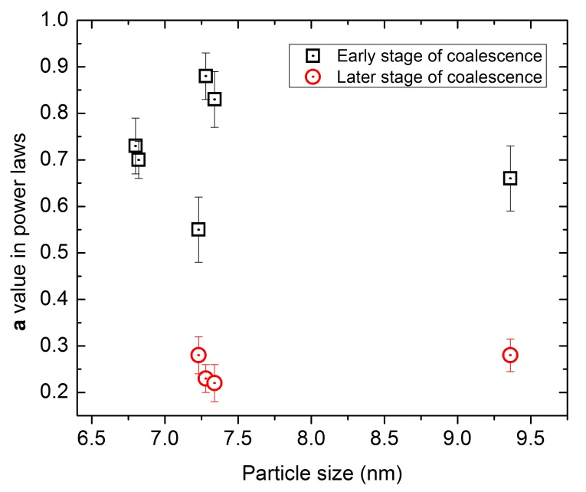
Supplementary Figure S1. The value of a in the power law (d_{neck} ~ t ª) for coalescence.

For the six pairs of Bi nanoparticles shown in Figure 6, the smaller particle with diameter around 6.8 nm has no obvious feature of two-stages coalescence, larger particles show clear two stages of coalescence (Supplementary Figure 1). The a value in the power law (d_{neck} ~ t ª), derived from the log-log scale of Figure 6a, is 0.73 ± 0.16 and 0.25 ± 0.03 for the early and late stages of coalescence, respectively.

- Electron beam effect on the motion and coalescence of the Bi nanoparticles
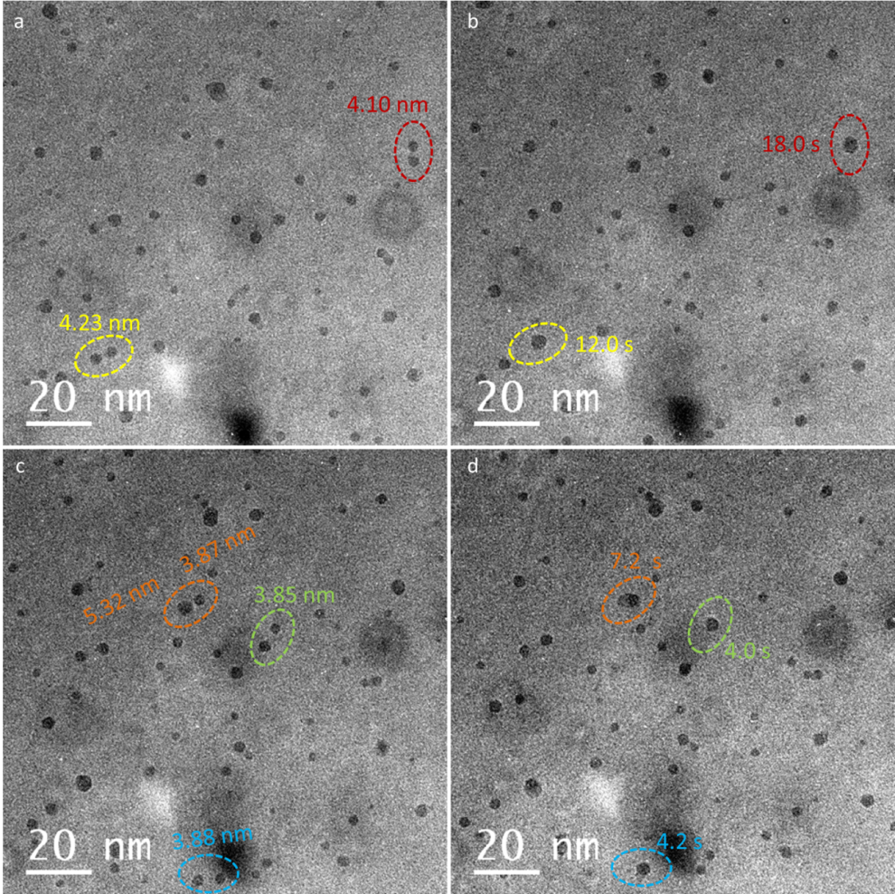
Supplementary Figure S2. Sequential TEM images from Movie S2 with the electron beam current density of ~ 1000 electrons·Å⁻²·s⁻¹. Five pairs of the coalescing nanopariticles are concerned, each pair of the coalescing nanoparticles is circled with the same color, the size of the primary particles and the relaxation time are labeled for each coalescence events.
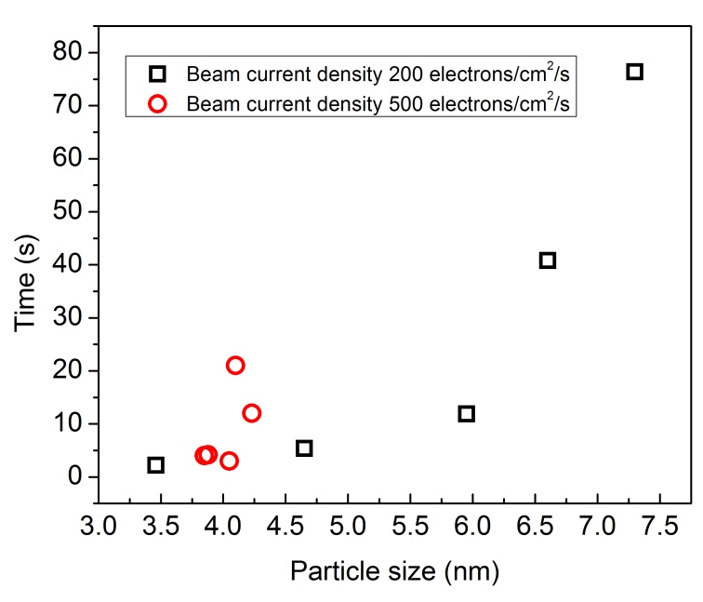
Supplementary Figure S3. Comparison of the relaxation time of the coalesced nanoparticles under different current densities.

- Geometry of two coalescing particles

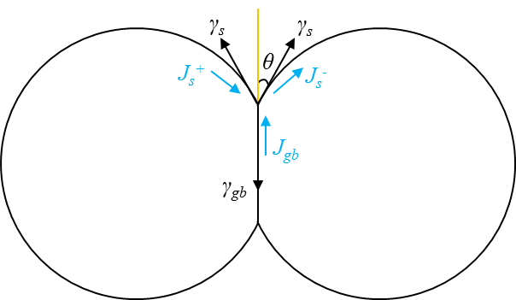
Supplementary Figure 4 Geometry of two coalescing particles

