Supplementary Table 1. Detailed coding framework for child-directed promotional techniques on pack, with examples
Code Level 1 | Code Level 2 | Description | Examples
A. Child-directed characters | A1. Cartoon and fantastical characters (52) | - Including but not limited to licensed characters and trademarked characters (e.g., Trix the rabbit, Coco the monkey)  - Cross promotional characters (e.g., cartoons from TV shows) | 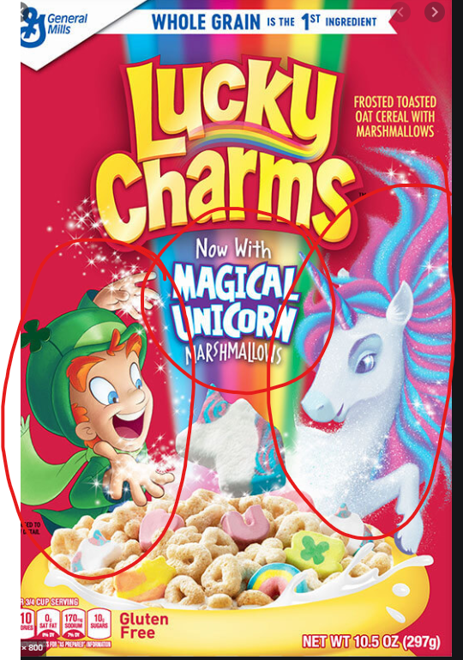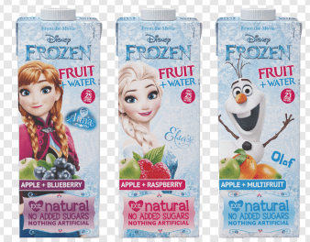  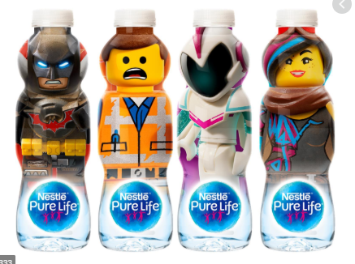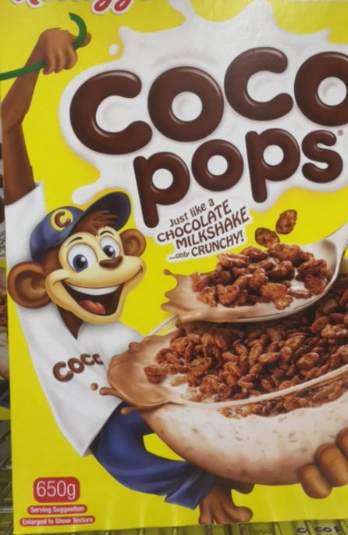
A. Child-directed characters | A2. Children and child-like figures (52) | - Human youth (images of people <14 years of age)  - Can be cartoon like or actual human (photo or drawing) | 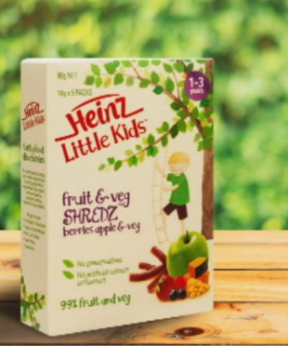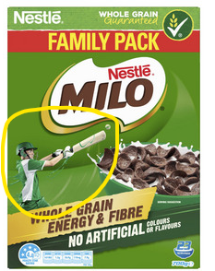
A. Child-directed characters | A3. Personified objects (52) | Includes packaging and the product itself with the following element/s:  - Anthropomorphized creature/s  - Personified object/s  - Personified product/s or ingredient/s  - Personified animal/s  AND the creature/object/animal above is not a licensed/trademarked or branded character (which would be classified under A1) | 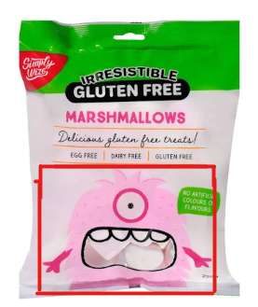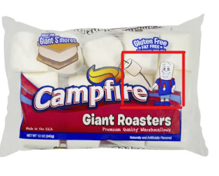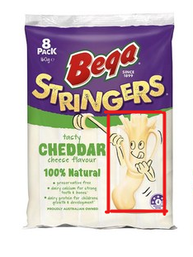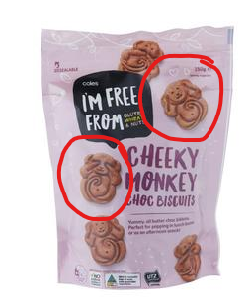
A. Child-directed characters | A4. Presence of celebrities (39, 52) | - Child-directed celebrities  - Famous sports personnel  We coded the celebrity in the open coding section and two coders later determined whether the celebrity appealed to children <14 years. | 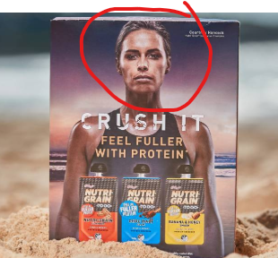
B. Non-character- based elements that appeal to children | B1. Childhood life references (53):  - Action-adventure  - Fantasy  - Fun  - Mood alteration (e.g., be happy)  - Coolness  - Peer acceptance | Including (54):  - Consuming/acquiring the food product is described/depicted as ‘cool’ or ‘hip’  - Shows children in groups of friends or other children depicting themes of friendship, peer acceptance, popularity or modelling behaviour of peers.  - Shows imaginary characters, situations or events, or uses words ‘fantasy’, ‘imagination’ or similar expressions.  - Adventurous activities described or depicted, for example, mountain climbing.  - Non-verbal display of happiness (e.g., smiling or playing) or uses words ‘fun’, ‘happiness’ or similar expressions. | 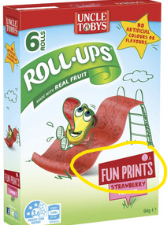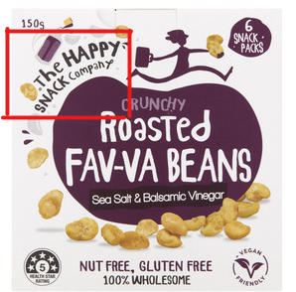
B. Non-character- based elements that appeal to children | B2. Gifts (53) | - Free products (toys or gifts) that come with the purchase of the food items  - Collectable gifts | 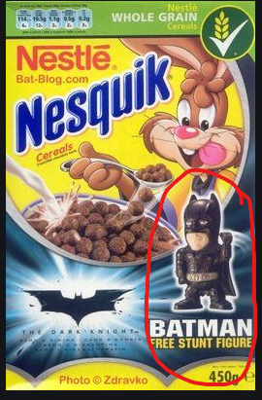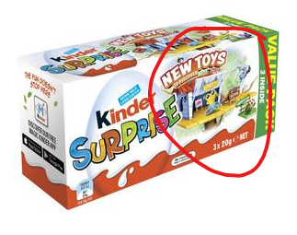  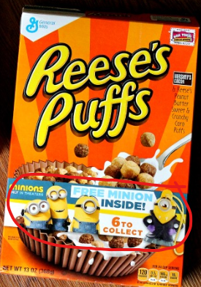
Non-character- based elements that appeal to children | B3. Games (53, 55) | The product acts as a vehicle to fun by including:  - Word searches, puzzles, stories or other activities on the box | 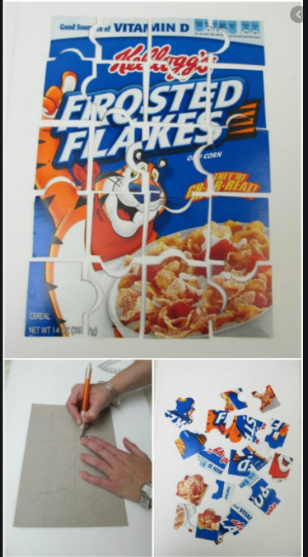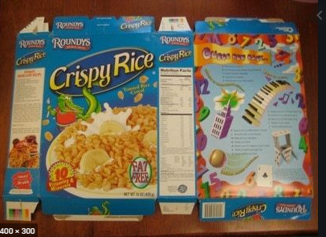  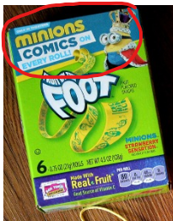
B. Non-character- based elements that appeal to children | B4. Contests (55) | - The product acts as a vehicle to fun by promoting (or allowing for) other activities. Examples include product packaging that includes a contest or competition to win passes to the zoo or movies, or the product directs children to games on websites or offer the chance to win prizes.  We coded all contests and two coders determined whether the contest was directed at children <14 years vs adult directed contest (the example on the right would be adult directed) | 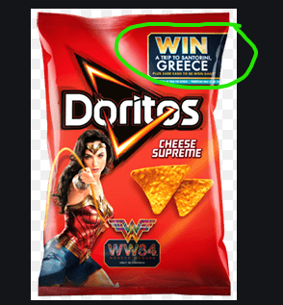
B. Non-character- based elements that appeal to children | B5. Unconventional packaging (55) | The packaging of the product includes:  - Non-standard shapes  - Unusual colours *  - Elements that attract children’s attention  *Note that bright colours were not sufficient to meet this criterion | 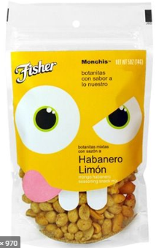  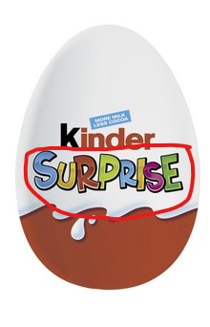  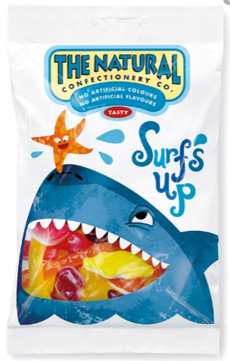  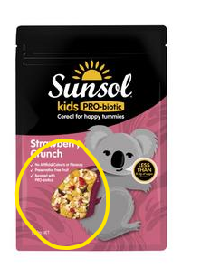
B. Non-character- based elements that appeal to children | B6. Name specifically references children (55) | - The product’s name specifically mentions children/child/kid or similar in the title  NB: this did not include products that are statutorily required to reference things like ‘infant’ e.g., “infant formula” | 