Supplementary Table 1: The details of health education lessons

Week # | Theme | Description
Week 1 | Physical  activity (PA) | What is Physical Activity (PA)? Examples of PA. Activity pyramid. How much physical activity do you need (physical activity guidelines)?  Interactive session with students: “How you can maintain or improve your Physical Activity habits?”
Week 2 |  | Introduce different domains of physical activity.  Interactive session with students: Some examples of daily physical activity that students participate in.
Week 3 |  | Physical activity vs physical education. Benefits of physical activities. FITT Principle  Interactive session with students: shared the Info-graph: ‘Benefits of Regular Physical Activity’
Week 4 |  | Why is Physical Activity important for schools? How to increase physical activity at school?  Comprehensive School Physical Activity Program (CSPAP).
Week 5 | Sedentary behaviours (SB) | What is sedentary behaviour? What are some sedentary activities? SB guidelines.  Interactive session with students: shared the Info-graph:
Week 6 |  | What is screen time? How does it affect your health?  Student-Student classroom interaction: “Talk to each other.”
Week 7 |  | Ways to Limit Screen Time. Reasons for Limiting Screen Time  Interactive session with students: shared the Info-graph:
Week 8 |  | How to limit SB at school? How to increase PA at school? How can families be involved in limiting SB? How can families be involved in increasing PA  Interactive whiteboard classroom session: Plan in some active time when you are usually sedentary
Week 9 | Healthy eating behaviours | What is a Healthy Lifestyle? Introduce healthy food plate.  Interactive whiteboard classroom session: Making smart choices from every food group/healthy food pyramid/ lunchbox lesson
Week 10 |  | School Meals  Group activities: Lunch box lessons-What to put in healthier school lunches. ‘Prepare a healthy school lunch box’
Week 11 |  | “Healthy Habits” What are the good habits and bad habits? Healthy food and Junk food/Soft-drinks.  Interactive session with students: shared the Info-graphs:
Week 12 |  | Self-assessment: Introduce the worksheet ‘My Pyramid for Healthy Eating’ and ask students to complete this individually.  Wrap-up of the lesson: Student’s comments about understanding

Supplementary Figure 1: My pyramid for healthy eating

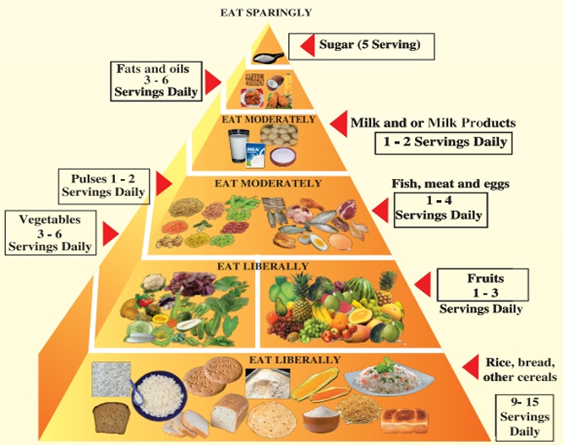
(Source: The Bangladeshi food pyramid https://www.fao.org/nutrition/education/food-dietary-guidelines/regions/countries/bangladesh/en/)

Supplementary Figure 2a: Infographics

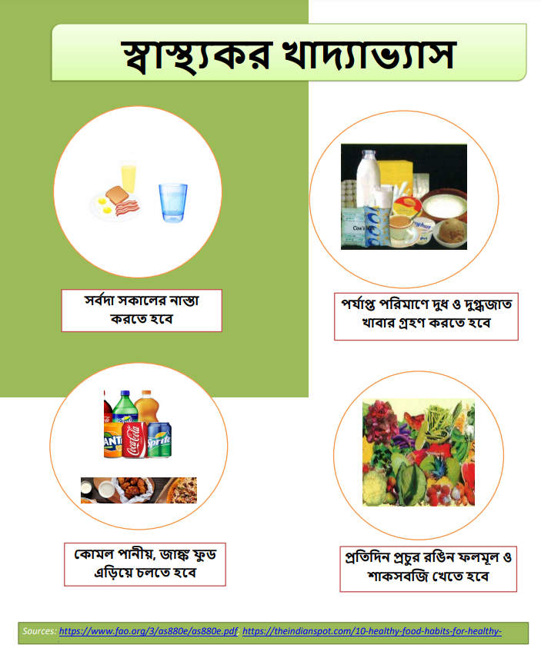

Supplementary Figure 2b: Infographics

