Supplemental Table 1. Base costs and extrapolation dimensions used to adapt Namutumba costs to all other rural districts in Uganda
 | Base cost¹  (2020 US dollars) | Extrapolation dimension²
Programmatic start-up costs
Social and behavior change communication
Personnel | 13,592 | VHT Pop
Transport | 3,356 | Space
Materials | 58,874 | VHT Pop
In-kind incentives | 1,342 | VHT Pop
Capacity building
Personnel | 6,567 | VHT Pop
Transport | 2,190 | Space
Materials | 10,759 | VHT Pop
In-kind incentives | 10,709 | VHT Pop
Opportunity costs
Household opportunity cost "Last Mile"
Opportunity cost | 0.98 | Child Pop
Recurring programmatic costs
Social and behavior change communication
Personnel | 13,593 | VHT Pop
Transport | 3,357 | Space
Materials | - | VHT Pop
In-kind incentives | 1,343 | VHT Pop
Logistics
Personnel | 32,035 | VHT Pop
Transport | 1,928 | Space
Materials | - | Space
In-kind incentives | - | Space
Capacity building
Personnel | 53,715 | VHT Pop
Transport | 10,458 | Space
Materials | 2,832 | VHT Pop
In-kind incentives | 8,998 | VHT Pop
Operational M&E
Personnel | 15,505 | VHT Pop
Transport | 2,676 | Space
Materials | 1,251 | VHT Pop
In-kind incentives | - | VHT Pop
Overhead and capital costs
Equipment / Vehicles | 997 | VHT-Child Den
Buildings/Structures (desks, etc.) | 21 | VHT Pop
Other Materials (office supplies, etc.) | 24 | VHT Pop
Overhead | 164 | VHT Pop
M&E, monitoring and evaluation.
¹Base costs based on community arm of Schott, Richardson⁽¹⁾ costing study of micronutrient powder in Namutumba district.
²VHT pop, the number of village health team (VHT) community health workers per district; Space, the area of each district; Child pop, the number of eligible children per district; VHT-Child Den, the ratio of VHTs to eligible children per district.

Supplemental Table 2. Rural Uganda child population projections
Age band | 2022 | 2023 | 2024 | 2025 | 2026 | 2027 | 2028 | 2029 | 2030 | 2031
6 – 9 mo | 274,758 | 275,647 | 276,574 | 277,656 | 278,915 | 280,257 | 281,314 | 282,283 | 283,246 | 285,200
9 – 18 mo | 824,274 | 826,942 | 829,722 | 832,968 | 836,744 | 840,770 | 843,942 | 846,850 | 849,738 | 855,601
18 – 24 mo | 549,516 | 551,295 | 553,148 | 555,312 | 557,829 | 560,513 | 562,628 | 564,567 | 566,492 | 570,400
Rural population projections for children 0-59 months based on population projections for children 0-59 months from the Lives Saved Tool (https://list.spectrumweb.org/), weighted by projections of the percentage of the Ugandan population classified as rural from the UN World Urbanization Prospects (https://population.un.org/wup/Download/). Age band-specific population estimates calculated by assuming a uniform child population size among children 0-59 months.

Supplemental Table 3. Estimated cost of providing daily SQ-LNS to all children in rural Uganda¹
 | 2021 | 2022 | 2023 | 2024 | 2025 | 2026 | 2027 | 2028 | 2029 | 2030 | 2031
Millions of 2020 US dollars | $10.97 | $56.74 | $56.90 | $57.07 | $57.27 | $57.49 | $57.72 | $57.91 | $58.09 | $58.27 | $58.60
¹Cost estimates based on providing SQ-LNS to all children from 6-12 months of age. Estimates include one year of start-up (2021) in which costs are incurred but benefits do not yet accrue.

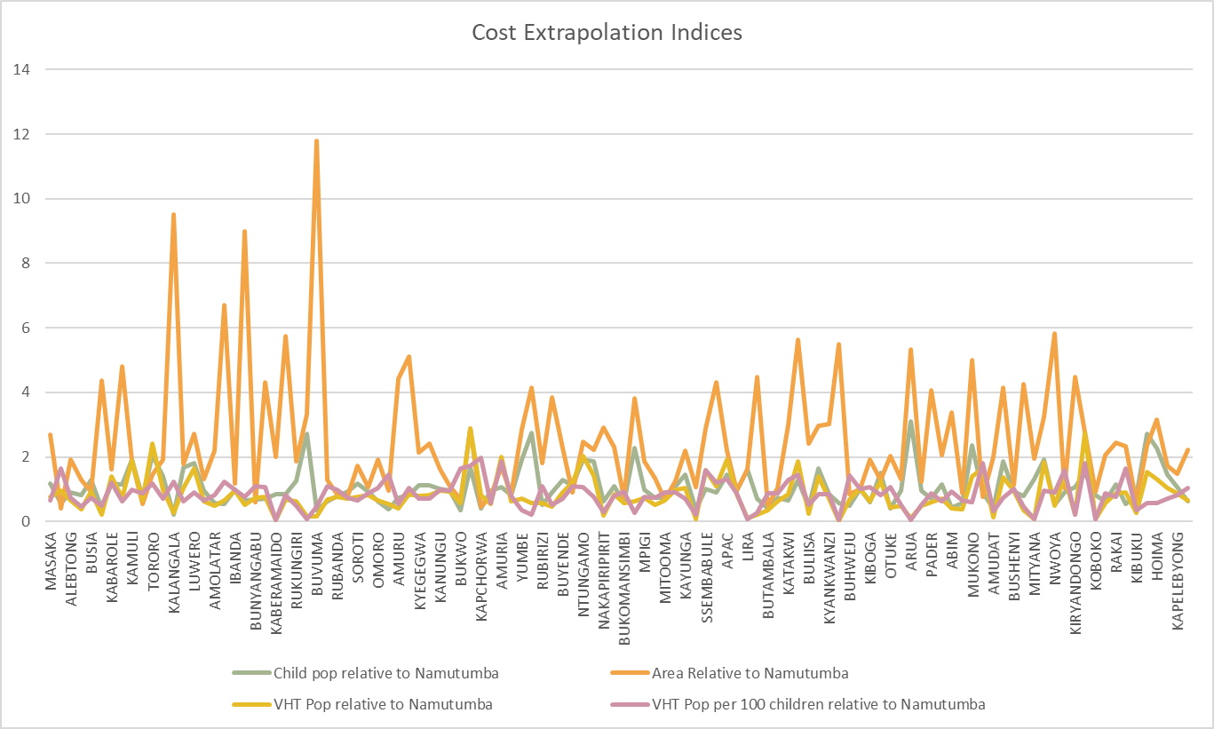
Supplemental Figure 1. Extrapolation indices used to estimate district-level costs based on Namutumba unit costs. Note that the names of all rural districts included in the modeling are not shown on the x-axis.

References

1. Schott W, Richardson B, Baker E et al. (2021) Comparing costs and cost-efficiency of platforms for micronutrient powder (MNP) delivery to children in rural Uganda. Ann N Y Acad Sci 1502, 1, 28-39.

