Online supplementary material

Supplementary Table 1: Intentional activities lesson plan

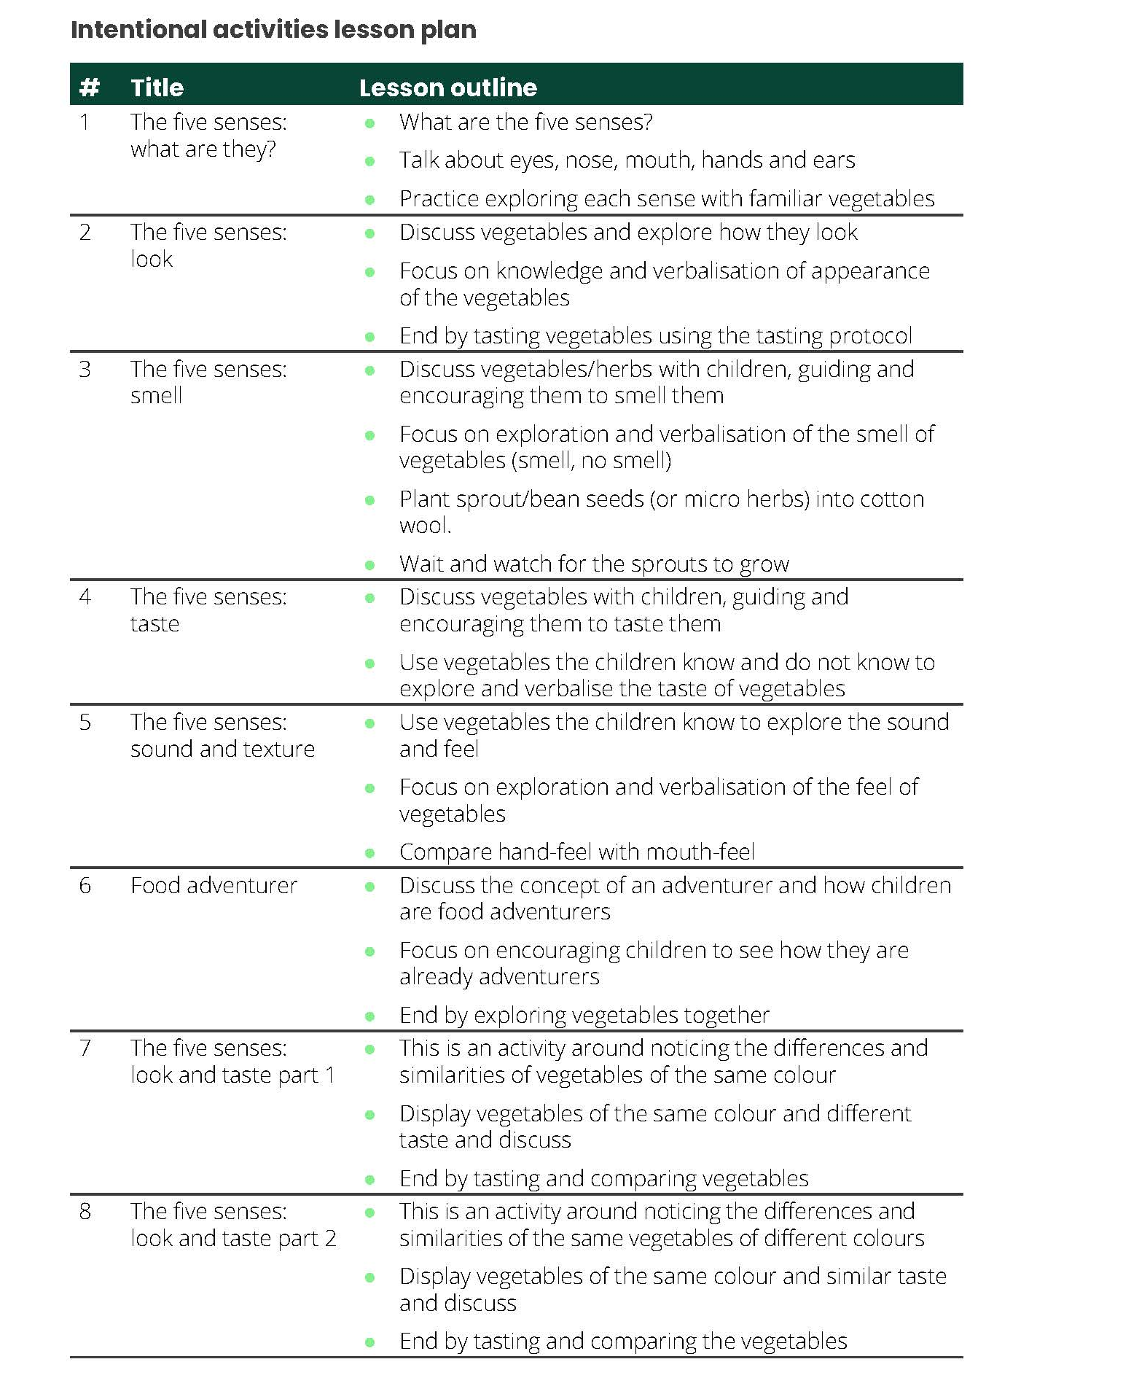

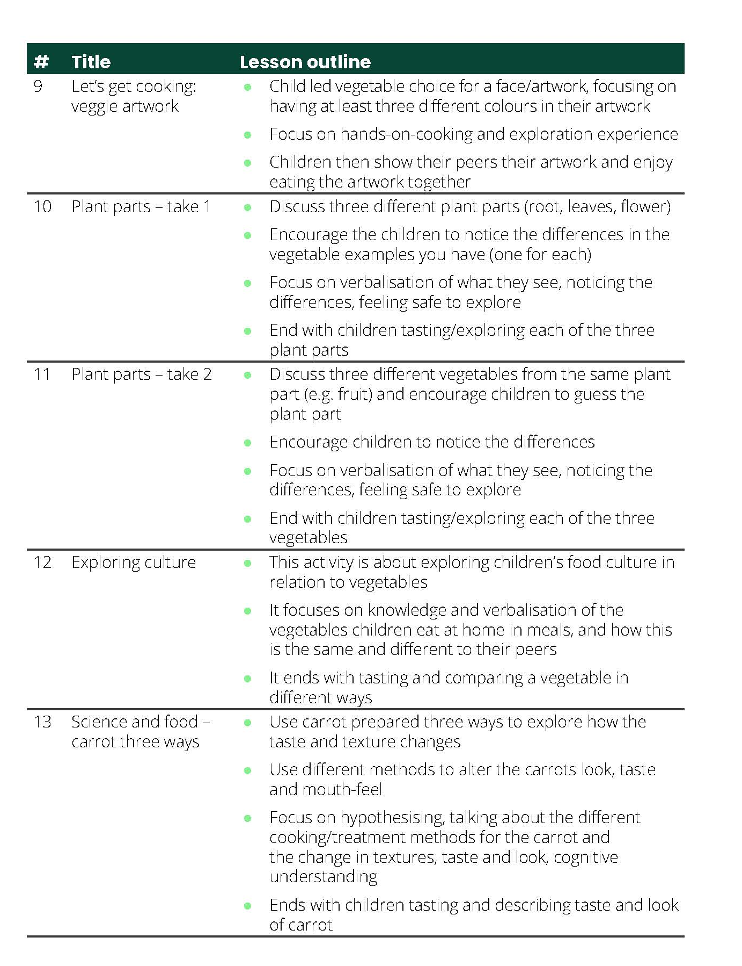
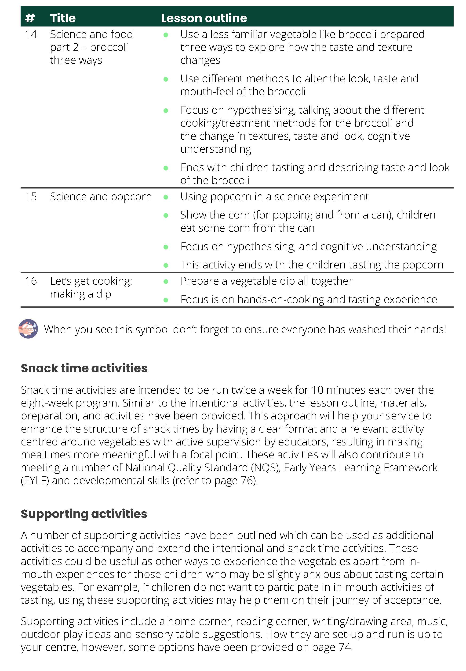

Supplementary Table 2. Median (IQR) baseline vegetable provision, waste and intake (g/day) * (N=711)
Groups | n | Provision | Waste | Intake
- Control | 96 | 57.9 (41.0-85.0) | 19.4 (10.0-35.4) | 31.5 (14.6-53.2)
- Curriculum | 79 | 54.4 (37.0-77.5) | 19.0 (11.2-29.4) | 26.4 (15.2-56.2)
- Curriculum+ Mealtime environment | 93 | 62.8 (19.8-108.8) | 14.4 (3.2-41.6) | 24.2 (6.4-68.9)
- Curriculum+ Food provision | 104 | 52.7 (33.8-70.7) | 18.1 (8.9-32.3) | 28.7 (12.4-47.1)
- Food provision | 88 | 58.3 (35.3-81.8) | 19.1 (9.3-33.8) | 32.5 (15.2-56.6)
- Food provision + Mealtime environment | 85 | 101.4 (65.4-127.1) | 29.7 (7.9-57.0) | 59.1 (22.8-95.9)
- Mealtime environment | 93 | 67.8 (47.9-105.1) | 21.0 (5.8-40.3) | 34.6 (11.8-73.7)
- Curriculum+ Food provision + Mealtime environment | 73 | 55.6 (26.6-72.3) | 22.6 (7.0-36.8) | 21.3 (4.7-59.0)
Total | 711 | 61.2 (37.0-95.8) | 19.0 (7.3-37.6) | 31.2 (12.0-61.7)
IQR, Interquartile range.
*not adjusted for cofounding variables of age or sex. Data not used in the final analysis due to 40% of the children at follow up not being present at baseline.

Supplementary Table 3: Main effects analyses of the initiatives compared to control (no initiative)
Comparison/control | Ratio of geometric mean | 95% CI | p-value
Food provision/control | 0.73 | (0.37, 1.43) | 0.34
Mealtime environment/control | 1.77 | (0.90, 3.48) | 0.09
Curriculum/control | 1.54 | (0.78, 3.04) | 0.21

Supplementary Table 4: Acceptability of the initiatives: Number of staff who completed or partially completed the Mealtime environment (n=38), Curriculum (n=16) and Food provision (n=11) initiatives who agree or strongly agree with the following LORI framework statements
LORI statements | Number agree/strongly agree
Curriculum | N=16
Content Quality
The level of detail in the lesson outline was appropriate | 14
The lesson outline was easy to understand and use | 15
Presentation design
The presentation of the lesson outline was appealing | 13
Re-usability/Accessibility
I would recommend the Curriculum to other educators | 13
The Curriculum is suitable for educators with different levels of experience | 10
The Curriculum is suitable for children of different ages | 8
The Curriculum is suitable for children from different backgrounds (including cultural, religious etc) | 14
Motivation
I found the Curriculum interesting | 13
The Curriculum was engaging for children | 12
The information provided in the lesson outline prepared me well to teach the curriculum | 14
Duration and other
The amount of preparation for the Curriculum was reasonable | 11
The number of lessons was appropriate | 8
The number of snack time activities was appropriate | 10
The duration of the lessons was appropriate | 12
The duration of the snack time activities was appropriate | 13
I used the vegetables that were suggested for the lessons | 13
I used the vegetables that were suggested for the snack time activities | 13
Mealtime environment | Total N=38
Content Quality
The content of the training was relevant to promoting vegetables at mealtimes | 36
The level of detail in the training was appropriate | 33
The training was useful | 34
Learning goal alignment
The training provided me with practical strategies to promote vegetables at mealtimes | 30
Using the strategies promoted in the training has improved children’s liking of vegetables | 23
Using the strategies promoted in the training has helped children to taste new vegetables | 25
Motivation
I found the training interesting | 30
The training motivated me to promote vegetables at mealtimes | 29
Interaction useability
The training was easy to navigate | 29
It was easy to download the resources from the training | 26
Presentation design
The design of the training supported the content well | 28
There was a good mix of pictures, text, video, and audio in the training | 33
Re-usability /accessibility
The training is suitable for educators with different levels of experience | 34
The training is suitable for educators working in different childcare centre environments | 30
I would recommend this training to other educators | 31
Duration
The duration of the training was appropriate | 34
The number of learning topics was appropriate | 34
Food provision | N=11
Content Quality
The content of the training was relevant to providing more vegetables on the menu | 10
The level of detail in the training was appropriate | 9
The training was useful | 10
*FoodChecker was useful | 5
Learning Goal alignment
The training improved my knowledge about how to provide more vegetables on the menu | 8
*FoodChecker supported me well to provide vegetables on the menu in line with the menu planning guidelines | 6
*FoodChecker improved my knowledge about how to provide more vegetables on the menu | 6
*FoodChecker helped me with the practical implementation of a menu aligned with guidelines | 7
Motivation
The training motivated me to provide more vegetables on the menu | 9
*Using FoodChecker motivated me to provide vegetables on the menu in line with the menu planning guidelines | 7
I found the training interesting | 9
Interaction Useability
The training was easy to navigate | 5
It was easy to download the resources from the training | 5
*FoodChecker was easy to navigate | 4
*It was easy to enter my centre menu into FoodChecker | 4
*It was easy to download the resources and recommendations from FoodChecker | 7
Presentation design
The design of the training supported the content well | 8
There was a good mix of pictures, text, video, and audio in the training | 9
Re-usability/Accessibility
The training is suitable for cooks with different levels of experience | 9
The training is suitable for cooks working in different childcare centre environments | 10
I would recommend this training to other cooks | 7
*FoodChecker is suitable for cooks with different levels of experience | 6
*FoodChecker is suitable for cooks working in different childcare centre environments | 8
*I would recommend FoodChecker to other cooks | 6
Duration
*The amount of time it took me to complete the menu assessment using FoodChecker was reasonable | 3
The duration of the training was appropriate | 8
*N=10 respondents for the menu assessment component of the Food provision initiative

