Supplement file
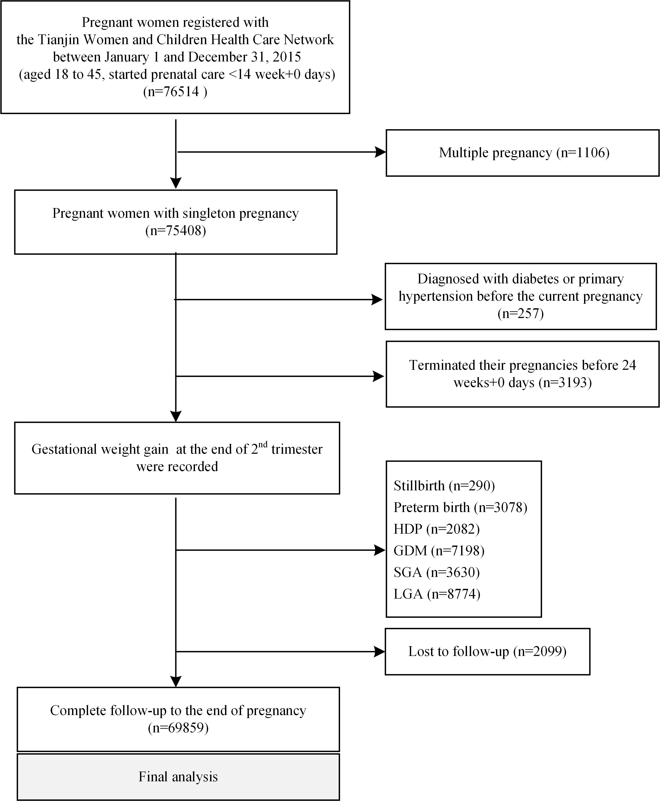

eFigure 1. Study flow chart
Abbreviations: HDP = hypertensive disorders of pregnancy, GDM = gestational diabetes mellitus, SGA = small for gestational age, LGA = large for gestational age.

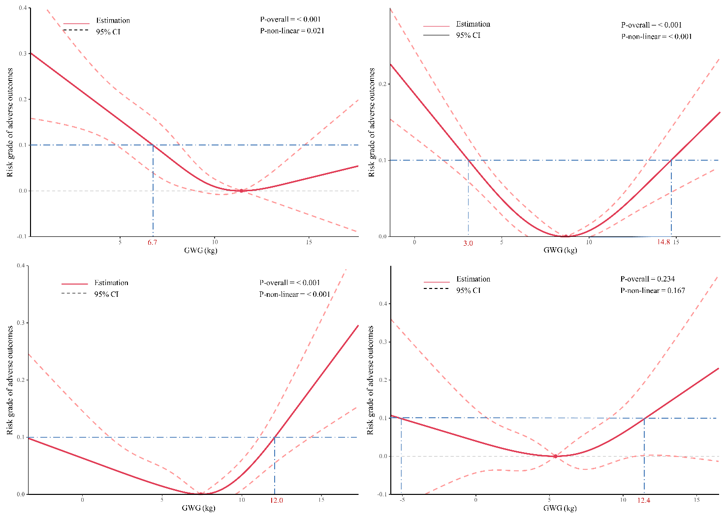

eFigure 2. Restricted cubic spline for the associations between weight gain and risk grade of adverse outcomes.
A. underweight group, B. normal weight group, C. overweight group, D. obesity group. Prepregnancy BMI groups were divided following the Chinese standard: underweight, <18.5 kg/m²; normal weight, 18.5–23.9 kg/m²; overweight, 24.0–27.9 kg/m²; obesity, ≥ 28.0 kg/m². The curves represent the effect of GWG at the end of the second trimester on the risk grade. The model was adjusted for maternal age, maternal height, gestational age of weight measure, parity (primipara or multipara), history of stillbirth (no verse yes), education (≤12 years or >12 years), and active smoking (no verse yes). The reference values were set at the nadir of risk (y=0). The knots in the default positions were set at the 5th, 35th, 65th, and 95th percentiles of the GWG. The solid lines represent estimation, the long dashed lines represent 95% confidence intervals, and the dashed dot lines represent the possible threshold (y=0.1). Values outside the -3SD and +3SD were excluded. GWG = gestational weight gain.

eTable 1. Odds Ratios and 95% Confidence Intervals for the Effects of Weight Gain at the end of the second trimester on the Composite Adverse Outcome
Underweight Group |  |  | Normal weight Group
GWG (kg) | OR (95% CI) |  | GWG (kg) | OR (95% CI)
7.0 | 1.103 (1.029 ~ 1.182) |  | 4.0 | 1.087 (1.039 ~ 1.138)
7.1 | 1.096 (1.025 ~ 1.172) |  | 4.1 | 1.083 (1.036 ~ 1.132)
7.2 | 1.089 (1.021 ~ 1.162) |  | 4.2 | 1.079 (1.034 ~ 1.126)
7.2 | 1.083 (1.017 ~ 1.153) |  | 4.3 | 1.075 (1.031 ~ 1.121)
7.3 | 1.076 (1.014 ~ 1.143) |  | 4.4 | 1.071 (1.028 ~ 1.116)
7.4 | 1.070 (1.011 ~ 1.133) |  | 4.5 | 1.067 (1.026 ~ 1.110)
7.5 | 1.064 (1.008 ~ 1.123) |  | 4.6 | 1.063 (1.023 ~ 1.105)
7.6 | 1.058 (1.006 ~ 1.113) |  | 4.7 | 1.059 (1.020 ~ 1.100)
7.7 | 1.052 (1.004 ~ 1.102) |  | 4.8 | 1.056 (1.017 ~ 1.096)
7.8 | 1.046 (1.002 ~ 1.092) |  | 4.9 | 1.052 (1.015 ~ 1.091)
7.8 | 1.040 (1.001 ~ 1.082) |  | 5.0 | 1.049 (1.012 ~ 1.087)
7.9 | 1.035 (1.000 ~ 1.071) |  | 5.1 | 1.045 (1.009 ~ 1.083)
8.0 | 1.029 (0.999 ~ 1.061) |  | 5.2 | 1.042 (1.007 ~ 1.078)
8.1 | 1.024 (0.998 ~ 1.051) |  | 5.3 | 1.039 (1.004 ~ 1.075)
8.2 | 1.019 (0.998 ~ 1.040) |  | 5.4 | 1.036 (1.002 ~ 1.071)
8.3 | 1.014 (0.998 ~ 1.030) |  | 5.4 | 1.033 (0.999 ~ 1.067)
8.4 | 1.009 (0.999 ~ 1.020) |  | 5.5 | 1.030 (0.997 ~ 1.064)
8.5 | 1.005 (0.999 ~ 1.011) |  | 5.6 | 1.027 (0.995 ~ 1.060)
8.5 | 1.000 (1.000 ~ 1.001) |  | 5.7 | 1.024 (0.992 ~ 1.057)
8.6 | 0.996 (0.992 ~ 1.001) |  | 5.8 | 1.022 (0.990 ~ 1.054)
8.7 | 0.992 (0.982 ~ 1.002) |  | 5.9 | 1.019 (0.989 ~ 1.050)
8.8 | 0.988 (0.974 ~ 1.003) |  | 6.0 | 1.017 (0.987 ~ 1.047)
8.9 | 0.985 (0.965 ~ 1.005) |  | 6.1 | 1.014 (0.985 ~ 1.045)
9.0 | 0.981 (0.957 ~ 1.006) |  | 6.2 | 1.012 (0.984 ~ 1.042)
9.1 | 0.978 (0.949 ~ 1.008) |  | 6.3 | 1.010 (0.983 ~ 1.039)
9.2 | 0.975 (0.941 ~ 1.009) |  | 6.4 | 1.009 (0.982 ~ 1.036)
9.2 | 0.972 (0.934 ~ 1.011) |  | 6.5 | 1.007 (0.981 ~ 1.033)
9.3 | 0.969 (0.927 ~ 1.013) |  | 6.6 | 1.005 (0.980 ~ 1.031)
9.4 | 0.966 (0.920 ~ 1.015) |  | 6.7 | 1.004 (0.980 ~ 1.028)
9.5 | 0.964 (0.914 ~ 1.017) |  | 6.8 | 1.003 (0.980 ~ 1.026)
9.6 | 0.962 (0.908 ~ 1.019) |  | 6.9 | 1.001 (0.980 ~ 1.023)
9.7 | 0.960 (0.903 ~ 1.020) |  | 7.0 | 1.000 (0.981 ~ 1.021)
9.8 | 0.958 (0.898 ~ 1.022) |  | 7.1 | 1.000 (0.981 ~ 1.018)
9.9 | 0.957 (0.894 ~ 1.024) |  | 7.2 | 0.999 (0.982 ~ 1.016)
9.9 | 0.955 (0.890 ~ 1.026) |  | 7.3 | 0.998 (0.983 ~ 1.014)
10.0 | 0.954 (0.886 ~ 1.028) |  | 7.3 | 0.998 (0.985 ~ 1.012)
10.1 | 0.953 (0.883 ~ 1.030) |  | 7.4 | 0.998 (0.986 ~ 1.010)
10.2 | 0.953 (0.880 ~ 1.031) |  | 7.5 | 0.998 (0.988 ~ 1.008)
10.3 | 0.952 (0.878 ~ 1.033) |  | 7.6 | 0.998 (0.990 ~ 1.006)
10.4 | 0.952 (0.876 ~ 1.035) |  | 7.7 | 0.998 (0.992 ~ 1.004)
10.5 | 0.952 (0.874 ~ 1.037) |  | 7.8 | 0.999 (0.995 ~ 1.003)
10.6 | 0.952 (0.873 ~ 1.038) |  | 7.9 | 0.999 (0.998 ~ 1.001)
10.6 | 0.952 (0.871 ~ 1.040) |  | 8.0 | 1.000 (1.000 ~ 1.000)
10.7 | 0.953 (0.871 ~ 1.042) |  | 8.1 | 1.001 (0.999 ~ 1.004)
10.8 | 0.953 (0.870 ~ 1.044) |  | 8.2 | 1.002 (0.998 ~ 1.007)
10.9 | 0.954 (0.870 ~ 1.046) |  | 8.3 | 1.004 (0.997 ~ 1.010)
11.0 | 0.955 (0.869 ~ 1.048) |  | 8.4 | 1.005 (0.996 ~ 1.014)
11.1 | 0.956 (0.869 ~ 1.051) |  | 8.5 | 1.007 (0.996 ~ 1.017)
11.2 | 0.957 (0.870 ~ 1.053) |  | 8.6 | 1.009 (0.996 ~ 1.021)
11.3 | 0.958 (0.870 ~ 1.055) |  | 8.7 | 1.011 (0.996 ~ 1.025)
11.3 | 0.960 (0.870 ~ 1.058) |  | 8.8 | 1.013 (0.996 ~ 1.030)
11.4 | 0.961 (0.871 ~ 1.061) |  | 8.9 | 1.015 (0.997 ~ 1.034)
11.5 | 0.963 (0.872 ~ 1.064) |  | 9.0 | 1.018 (0.998 ~ 1.038)
11.6 | 0.965 (0.873 ~ 1.067) |  | 9.1 | 1.021 (0.999 ~ 1.043)
11.7 | 0.967 (0.874 ~ 1.070) |  | 9.2 | 1.024 (1.001 ~ 1.048)
11.8 | 0.969 (0.875 ~ 1.073) |  | 9.3 | 1.027 (1.002 ~ 1.053)
11.9 | 0.971 (0.876 ~ 1.077) |  | 9.3 | 1.031 (1.005 ~ 1.057)
11.9 | 0.973 (0.877 ~ 1.081) |  | 9.4 | 1.034 (1.007 ~ 1.062)
12.0 | 0.976 (0.878 ~ 1.085) |  | 9.5 | 1.038 (1.010 ~ 1.068)
12.1 | 0.978 (0.879 ~ 1.090) |  | 9.6 | 1.042 (1.013 ~ 1.073)
12.2 | 0.981 (0.880 ~ 1.094) |  | 9.7 | 1.047 (1.016 ~ 1.078)
12.3 | 0.984 (0.881 ~ 1.099) |  | 9.8 | 1.051 (1.019 ~ 1.084)
12.4 | 0.987 (0.881 ~ 1.104) |  | 9.9 | 1.056 (1.023 ~ 1.089)
12.5 | 0.989 (0.882 ~ 1.110) |  | 10.0 | 1.061 (1.027 ~ 1.095)
12.6 | 0.992 (0.883 ~ 1.115) |  | 10.1 | 1.066 (1.031 ~ 1.101)
12.6 | 0.996 (0.884 ~ 1.122) |  | 10.2 | 1.071 (1.036 ~ 1.107)
12.7 | 0.999 (0.884 ~ 1.128) |  | 10.3 | 1.076 (1.040 ~ 1.113)
12.8 | 1.002 (0.885 ~ 1.134) |  | 10.4 | 1.082 (1.045 ~ 1.120)
12.9 | 1.005 (0.885 ~ 1.141) |  | 10.5 | 1.088 (1.050 ~ 1.126)
13.0 | 1.009 (0.886 ~ 1.149) |  | 10.6 | 1.094 (1.056 ~ 1.133)

Overweight Group |  |  | Obesity Group
GWG (kg) | OR (95% CI) |  | GWG (kg) | OR (95% CI)
-0.3 | 0.958 (0.823 ~ 1.114) |  | -0.1 | 1.007 (0.894 ~ 1.133)
-0.2 | 0.957 (0.826 ~ 1.110) |  | 0.0 | 1.006 (0.897 ~ 1.129)
-0.1 | 0.957 (0.828 ~ 1.106) |  | 0.2 | 1.006 (0.900 ~ 1.125)
0.0 | 0.957 (0.831 ~ 1.102) |  | 0.3 | 1.006 (0.902 ~ 1.121)
0.1 | 0.956 (0.833 ~ 1.098) |  | 0.4 | 1.005 (0.905 ~ 1.117)
0.3 | 0.956 (0.835 ~ 1.094) |  | 0.5 | 1.005 (0.907 ~ 1.114)
0.4 | 0.956 (0.838 ~ 1.090) |  | 0.6 | 1.005 (0.909 ~ 1.110)
0.5 | 0.955 (0.840 ~ 1.086) |  | 0.7 | 1.004 (0.911 ~ 1.107)
0.6 | 0.955 (0.843 ~ 1.082) |  | 0.8 | 1.004 (0.913 ~ 1.104)
0.7 | 0.955 (0.845 ~ 1.078) |  | 0.9 | 1.004 (0.915 ~ 1.102)
0.8 | 0.954 (0.848 ~ 1.074) |  | 1.0 | 1.004 (0.916 ~ 1.099)
0.9 | 0.954 (0.850 ~ 1.070) |  | 1.2 | 1.003 (0.918 ~ 1.097)
1.0 | 0.954 (0.852 ~ 1.067) |  | 1.3 | 1.003 (0.919 ~ 1.094)
1.1 | 0.953 (0.855 ~ 1.063) |  | 1.4 | 1.003 (0.920 ~ 1.092)
1.2 | 0.953 (0.857 ~ 1.059) |  | 1.5 | 1.002 (0.922 ~ 1.090)
1.3 | 0.953 (0.859 ~ 1.056) |  | 1.6 | 1.002 (0.923 ~ 1.089)
1.4 | 0.952 (0.862 ~ 1.052) |  | 1.7 | 1.002 (0.924 ~ 1.087)
1.5 | 0.952 (0.864 ~ 1.049) |  | 1.8 | 1.002 (0.924 ~ 1.085)
1.6 | 0.952 (0.866 ~ 1.045) |  | 1.9 | 1.001 (0.925 ~ 1.084)
1.7 | 0.951 (0.868 ~ 1.042) |  | 2.1 | 1.001 (0.926 ~ 1.082)
1.8 | 0.951 (0.870 ~ 1.039) |  | 2.2 | 1.001 (0.927 ~ 1.081)
1.9 | 0.951 (0.872 ~ 1.036) |  | 2.3 | 1.001 (0.927 ~ 1.080)
2.0 | 0.950 (0.874 ~ 1.033) |  | 2.4 | 1.000 (0.928 ~ 1.079)
2.1 | 0.950 (0.876 ~ 1.030) |  | 2.5 | 1.000 (0.929 ~ 1.077)
2.2 | 0.950 (0.878 ~ 1.027) |  | 2.6 | 1.000 (0.930 ~ 1.076)
2.3 | 0.949 (0.880 ~ 1.024) |  | 2.7 | 1.000 (0.930 ~ 1.075)
2.4 | 0.949 (0.882 ~ 1.022) |  | 2.8 | 1.000 (0.931 ~ 1.073)
2.5 | 0.949 (0.884 ~ 1.019) |  | 3.0 | 0.999 (0.932 ~ 1.072)
2.6 | 0.949 (0.885 ~ 1.017) |  | 3.1 | 0.999 (0.933 ~ 1.070)
2.7 | 0.949 (0.887 ~ 1.015) |  | 3.2 | 0.999 (0.934 ~ 1.068)
2.9 | 0.949 (0.888 ~ 1.013) |  | 3.3 | 0.999 (0.936 ~ 1.066)
3.0 | 0.948 (0.890 ~ 1.011) |  | 3.4 | 0.999 (0.937 ~ 1.065)
3.1 | 0.948 (0.891 ~ 1.009) |  | 3.5 | 0.999 (0.939 ~ 1.062)
3.2 | 0.948 (0.892 ~ 1.008) |  | 3.6 | 0.999 (0.941 ~ 1.060)
3.3 | 0.948 (0.894 ~ 1.007) |  | 3.7 | 0.998 (0.942 ~ 1.058)
3.4 | 0.949 (0.895 ~ 1.005) |  | 3.8 | 0.998 (0.945 ~ 1.055)
3.5 | 0.949 (0.896 ~ 1.004) |  | 4.0 | 0.998 (0.947 ~ 1.052)
3.6 | 0.949 (0.897 ~ 1.003) |  | 4.1 | 0.998 (0.950 ~ 1.049)
3.7 | 0.949 (0.898 ~ 1.003) |  | 4.2 | 0.998 (0.952 ~ 1.046)
3.8 | 0.949 (0.899 ~ 1.002) |  | 4.3 | 0.998 (0.956 ~ 1.042)
3.9 | 0.950 (0.900 ~ 1.002) |  | 4.4 | 0.998 (0.959 ~ 1.038)
4.0 | 0.950 (0.902 ~ 1.001) |  | 4.5 | 0.998 (0.962 ~ 1.035)
4.1 | 0.951 (0.903 ~ 1.001) |  | 4.6 | 0.998 (0.966 ~ 1.031)
4.2 | 0.951 (0.904 ~ 1.001) |  | 4.7 | 0.998 (0.970 ~ 1.027)
4.3 | 0.952 (0.905 ~ 1.001) |  | 4.9 | 0.998 (0.974 ~ 1.022)
4.4 | 0.952 (0.906 ~ 1.001) |  | 5.0 | 0.998 (0.979 ~ 1.018)
4.5 | 0.953 (0.908 ~ 1.001) |  | 5.1 | 0.998 (0.983 ~ 1.014)
4.6 | 0.954 (0.909 ~ 1.001) |  | 5.2 | 0.999 (0.988 ~ 1.010)
4.7 | 0.955 (0.911 ~ 1.001) |  | 5.3 | 0.999 (0.993 ~ 1.006)
4.8 | 0.956 (0.913 ~ 1.001) |  | 5.4 | 1.000 (0.998 ~ 1.002)
4.9 | 0.957 (0.914 ~ 1.001) |  | 5.5 | 1.000 (0.998 ~ 1.003)
5.0 | 0.958 (0.916 ~ 1.001) |  | 5.6 | 1.001 (0.994 ~ 1.008)
5.1 | 0.959 (0.919 ~ 1.001) |  | 5.7 | 1.002 (0.990 ~ 1.013)
5.2 | 0.960 (0.921 ~ 1.002) |  | 5.9 | 1.003 (0.987 ~ 1.019)
5.4 | 0.962 (0.924 ~ 1.002) |  | 6.0 | 1.004 (0.984 ~ 1.025)
5.5 | 0.963 (0.927 ~ 1.002) |  | 6.1 | 1.005 (0.981 ~ 1.030)
5.6 | 0.965 (0.930 ~ 1.002) |  | 6.2 | 1.007 (0.978 ~ 1.036)
5.7 | 0.967 (0.933 ~ 1.002) |  | 6.3 | 1.008 (0.975 ~ 1.042)
5.8 | 0.969 (0.937 ~ 1.002) |  | 6.4 | 1.010 (0.973 ~ 1.048)
5.9 | 0.971 (0.940 ~ 1.002) |  | 6.5 | 1.012 (0.971 ~ 1.053)
6.0 | 0.973 (0.944 ~ 1.002) |  | 6.6 | 1.014 (0.970 ~ 1.059)
6.1 | 0.975 (0.949 ~ 1.001) |  | 6.8 | 1.016 (0.969 ~ 1.065)
6.2 | 0.977 (0.953 ~ 1.001) |  | 6.9 | 1.018 (0.968 ~ 1.071)
6.3 | 0.979 (0.958 ~ 1.001) |  | 7.0 | 1.021 (0.968 ~ 1.077)
6.4 | 0.982 (0.963 ~ 1.001) |  | 7.1 | 1.024 (0.968 ~ 1.083)
6.5 | 0.984 (0.969 ~ 1.001) |  | 7.2 | 1.027 (0.968 ~ 1.089)
6.6 | 0.987 (0.974 ~ 1.000) |  | 7.3 | 1.030 (0.969 ~ 1.095)
6.7 | 0.990 (0.980 ~ 1.000) |  | 7.4 | 1.033 (0.970 ~ 1.101)
6.8 | 0.993 (0.986 ~ 1.000) |  | 7.5 | 1.037 (0.972 ~ 1.107)
6.9 | 0.996 (0.992 ~ 1.000) |  | 7.7 | 1.041 (0.974 ~ 1.113)
7.0 | 0.999 (0.998 ~ 1.000) |  | 7.8 | 1.045 (0.976 ~ 1.119)
7.1 | 1.002 (1.000 ~ 1.004) |  | 7.9 | 1.049 (0.978 ~ 1.125)
7.2 | 1.006 (1.000 ~ 1.011) |  | 8.0 | 1.054 (0.981 ~ 1.131)
7.3 | 1.009 (1.001 ~ 1.017) |  | 8.1 | 1.058 (0.984 ~ 1.138)
7.4 | 1.012 (1.001 ~ 1.024) |  | 8.2 | 1.063 (0.987 ~ 1.144)
7.5 | 1.016 (1.001 ~ 1.031) |  | 8.3 | 1.068 (0.991 ~ 1.151)
7.6 | 1.020 (1.002 ~ 1.038) |  | 8.4 | 1.073 (0.995 ~ 1.157)
7.7 | 1.024 (1.003 ~ 1.045) |  | 8.5 | 1.078 (0.998 ~ 1.164)
7.8 | 1.027 (1.004 ~ 1.052) |  | 8.7 | 1.084 (1.002 ~ 1.171)
8.0 | 1.031 (1.005 ~ 1.058) |  | 8.8 | 1.089 (1.007 ~ 1.178)
8.1 | 1.036 (1.007 ~ 1.065) |  | 8.9 | 1.095 (1.011 ~ 1.186)
8.2 | 1.040 (1.008 ~ 1.072) |  | 9.0 | 1.101 (1.015 ~ 1.194)
8.3 | 1.044 (1.010 ~ 1.079) |  | 9.1 | 1.107 (1.020 ~ 1.202)
8.4 | 1.048 (1.012 ~ 1.086) |  | 9.2 | 1.113 (1.024 ~ 1.210)
8.5 | 1.053 (1.014 ~ 1.093) |  | 9.3 | 1.119 (1.029 ~ 1.218)
8.6 | 1.057 (1.017 ~ 1.099) |  | 9.4 | 1.126 (1.033 ~ 1.227)
8.7 | 1.062 (1.019 ~ 1.107) |  | 9.6 | 1.133 (1.038 ~ 1.236)
8.8 | 1.067 (1.022 ~ 1.113) |  | 9.7 | 1.139 (1.042 ~ 1.246)
8.9 | 1.072 (1.026 ~ 1.120) |  | 9.8 | 1.146 (1.047 ~ 1.255)
9.0 | 1.077 (1.029 ~ 1.127) |  | 9.9 | 1.154 (1.051 ~ 1.266)

eTable 2. Risk grade of adverse outcomes
Risk grade | Score range | the corresponding adverse outcomes
- No risks | 0 | none
- Low risk | 1~30 | LGA
- Medium risk | 31~55 | SGA or GDM
- High risk | 56~80 | HDP or preterm birth
- Very high risk | 81~ | Stillbirth; 2 or more adverse outcomes
Abbreviations: HDP = hypertensive disorders of pregnancy, GDM = gestational diabetes mellitus, SGA = small for gestational age, LGA = large for gestational age.

eTable 3. Values for establishing recommended ranges of weight gain at the end of the second trimester
Prepregnancy BMI Group | Y= composite adverse outcome |  |  |  | Y= risk score |  |  |  | Y= risk grade
 | the nadir point | lower cutoff | upper cutoff |  | the nadir point | lower cutoff | upper cutoff |  | the nadir point | lower cutoff | upper cutoff
Underweight | 10.5 | 7.8 | 12.3 |  | 10.6 | 8.2 | 13.5 |  | 11.4 | 6.7 | N/A
Normal weight | 7.5 | 4.8 | 10.0 |  | 8.4 | 5.0 | 11.4 |  | 8.7 | 3.0 | 14.8
Overweight | 3.2 | 0.1 | 8.5 |  | 6.9 | 2.2 | 9.7 |  | 7.4 | N/A | 12
Obesity | 4.5 | 1.0 | 7.3 |  | 6.3 | 0 | 9.4 |  | 5.4 | -5.0 | 12.4
Notes: Prepregnancy BMI groups were divided following the Chinese standard: underweight, <18.5 kg/m²; normal weight, 18.5–23.9 kg/m²; overweight, 24.0–27.9 kg/m²; obesity, ≥ 28.0 kg/m².

