Association of coffee consumption with the prevalence of hearing loss in US adults, NHANES 2003-2006

Supplementary Figures and Tables

Supplementary Figures
Supplementary Figure. S1
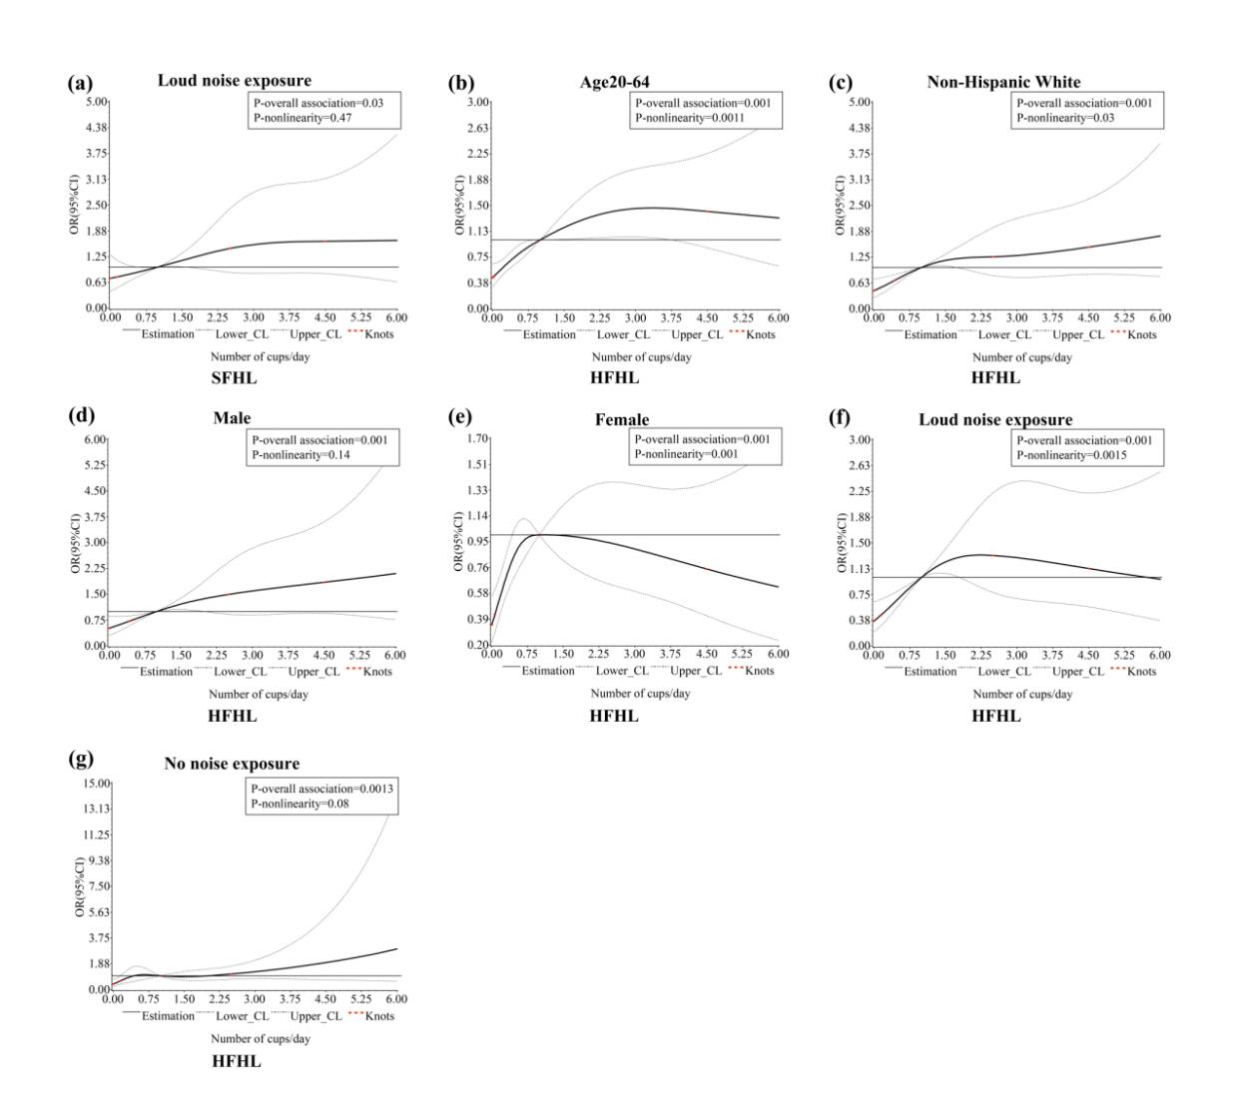
Supplementary Figure. S1 Multivariable adjusted spline curves of relation between total coffee and the risk of hearing loss in age, sex, ethnicity and noise exposure status. (a)SFHL. (b)-(g)HFHL. Covariates were age, sex, ethnicity, ear infection, occupational noise exposure, non-occupational noise exposure, smoking status, drinking status, hypertension, diabetes mellitus, BMI. OR = odds ratios.

Supplementary Tables
Supplementary Table S1 Odds ratios and 95% confidence intervals of coffee consumption for hearing loss stratified by noise exposure.
 | Frequency of Coffee Consumption
 | None | < 1cup/d | 1cup/d | 2-3cup/d | ≥ 4cup/d | P trend
SFHL
Loud noise exposure
Yes (n = 774)
Cases/N | 46/180 | 55/173 | 61/129 | 121/224 | 35/68
Crude model | Ref | 1.80 (0.93, 3.46) | 2.75 (1.03, 7.36)^{b} | 3.51 (1.98, 6.23)^{b} | 3.33 (1.63, 6.81)^{b} | 0.001*
Model 1ª | Ref | 1.35 (0.55, 3.31) | 1.14 (0.48, 2.75) | 1.97 (0.94, 4.13) | 2.27 (0.99, 5.20) | 0.048*
No (n = 727)
Cases/N | 41/178 | 52/187 | 70/150 | 71/176 | 20/36
Crude model | Ref | 1.48 (0.86, 2.54) | 2.88 (1.63, 5.09)^{b} | 2.56 (1.45, 4.51)^{b} | 3.77 (1.46, 9.76)^{b} | 0.001*
Model 1ª | Ref | 1.49 (0.61, 3.65) | 1.47 (0.64, 3.39) | 0.92 (0.33, 2.55) | 1.95 (0.55, 6.94) | 0.95
Noise exposure unknown (n = 391)
Cases/N | 17/88 | 19/114 | 19/54 | 42/103 | 10/32
Crude model | Ref | 0.44 (0.20, 1.01) | 2.16 (0.38, 12.43) | 1.22 (0.31, 4.71) | 1.28 (0.62, 2.66) | 0.27
Model 1ª | Ref | 0.39 (0.14, 1.05) | 1.37 (0.24, 7.93) | 0.57 (0.11, 3.01) | 0.46 (0.20, 1.05) | 0.46
HFHL
Loud noise exposure
Yes (n = 768)
Cases/N | 61/178 | 78/173 | 84/127 | 160/222 | 48/68
Crude model | Ref | 1.75 (0.93, 3.27) | 4.16 (1.81, 9.61)^{b} | 4.74 (2.45, 9.17)^{b} | 4.32 (2.26, 8.24)^{b} | 0.001*
Model 1ª | Ref | 1.18 (0.52, 2.65) | 2.72 (0.998, 7.40) | 3.79 (1.72, 8.37)^{b} | 2.07 (0.81, 5.27) | 0.003*
No (n = 724)
Cases/N | 55/177 | 77/187 | 97/149 | 111/175 | 28/36
Crude model | Ref | 1.41 (0.77, 2.57) | 3.47 (1.89, 6.38)^{b} | 4.88 (2.68, 8.86)^{b} | 9.19 (2.98, 28.31)^{b} | 0.001*
Model 1ª | Ref | 1.50 (0.59, 3.83) | 2.86 (1.09, 7.51)^{b} | 3.28 (0.77, 13.90) | 8.59 (1.96, 37.72)^{b} | 0.03*
Noise exposure unknown (n = 389)
Cases/N | 29/88 | 37/114 | 30/54 | 59/101 | 15/32
Crude model | Ref | 0.67 (0.28, 1.58) | 2.37 (0.64, 8.84) | 1.80 (0.85, 3.80) | 1.08 (0.46, 2.56) | 0.07
Model 1ª | Ref | 0.59 (0.17, 2.00) | 2.50 (0.74, 8.37) | 0.93 (0.28, 3.10) | 0.32 (0.07, 1.48) | 0.59
ª Adjusted for age, sex, ethnicity, ear infection, smoking status, drinking status, hypertension, diabetes mellitus, BMI.
^{b} P < 0.05.
*P trend < 0.05.

Supplementary Table S2 Odds ratios and 95% confidence intervals of coffee consumption for hearing loss stratified by coffee type.
 | Frequency of Coffee Consumption
 | < 1cup/d | 1cup/d | 2-3cup/d | ≥ 4cup/d | P trend
SFHL
Both (n = 265)
Cases/N | 24/93 | 20/56 | 34/90 | 11/26
Crude model | Ref | 2.01 (0.74, 5.50) | 3.07 (1.36, 6.95)^{b} | 1.90 (0.65, 5.57) | 0.03*
Model 1ª | Ref | 1.23 (0.35, 4.39) | 1.86 (0.95, 3.64) | 0.65 (0.15, 2.86) | 0.79
Caffeinated coffee (n = 850)
Cases/N | 43/230 | 87/202 | 150/323 | 43/95
Crude model | Ref | 2.16 (1.12, 4.15)^{b} | 2.09 (1.13, 3.85)^{b} | 2.48 (1.04, 5.92)^{b} | 0.02*
Model 1ª | Ref | 1.05 (0.42, 2.66) | 0.81 (0.34, 1.93) | 1.02 (0.32, 3.27) | 0.78
Decaffeinated coffee (n = 298)
Cases/N | 55/129 | 39/70 | 48/85 | 10/14
Crude model | Ref | 1.66 (0.87, 3.19) | 1.68 (0.72, 3.94) | 5.31 (1.83, 15.41)^{b} | 0.03*
Model 1ª | Ref | 2.79 (0.89, 8.73) | 1.60 (0.47, 5.42) | 13.14 (1.49, 115.61)^{b} | 0.14
HFHL
Both (n = 264)
Cases/N | 32/93 | 36/56 | 56/90 | 16/25
Crude model | Ref | 7.22 (2.43, 21.48)^{b} | 4.64 (1.82, 11.82)^{b} | 2.45 (0.80, 7.47) | 0.02*
Model 1ª | Ref | 7.33 (2.14, 25.07)^{b} | 2.17 (0.77, 6.07) | 0.81 (0.16, 4.05) | 0.71
Caffeinated coffee (n = 844)
Cases/N | 74/230 | 120/201 | 205/317 | 63/96
Crude model | Ref | 2.17 (1.21, 3.90)^{b} | 3.01 (1.81, 5.02)^{b} | 3.48 (1.86, 6.51)^{b} | 0.001*
Model 1ª | Ref | 1.40 (0.62, 3.17) | 2.06 (1.08, 3.93)^{b} | 1.70 (0.53, 5.46) | 0.09
Decaffeinated coffee (n = 297)
Cases/N | 79/129 | 51/68 | 66/85 | 11/14
Crude model | Ref | 1.66 (0.77, 3.59) | 3.20 (1.23, 8.34)^{b} | 4.67 (1.17, 18.69)^{b} | 0.01*
Model 1ª | Ref | 2.34 (0.92, 5.98) | 1.91 (0.68, 5.33) | 3.85 (0.62, 24.01) | 0.12
ª Adjusted for age, sex, ethnicity, ear infection, occupational noise exposure, non-occupational noise exposure, smoking status, drinking status, hypertension, diabetes mellitus, BMI.
^{b} P < 0.05.
*P trend < 0.05.

