Supplementary figure 1. Recruitment flow chart of participants in the SONIC study at baseline and follow-up^{1,2}
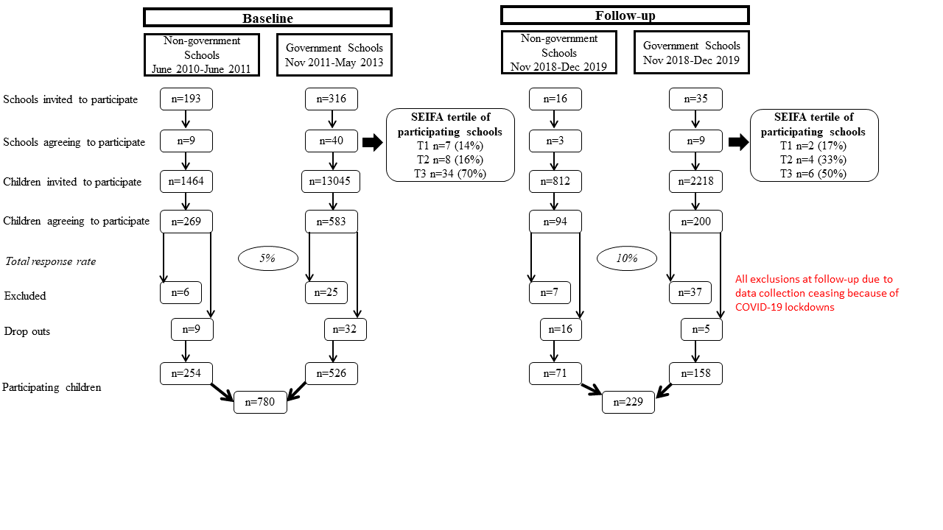
¹ Baseline: Non-government schools
Reasons for exclusion: aged =>13 years (n=6) e.g. in grade 8 of high school
Reasons for attrition: no longer interested in participating (n=3), absent on the day of data collection (n=5), no longer attending the school (n=1)
Baseline: Government schools
Reasons for exclusion: n=25 refused to attend data collection day at Deakin University (note: children from participating schools where response rate was low (<10 children) were invited to complete data collection procedures on a scheduled day at Deakin University (e.g. 41 in total invited)
Reasons for attrition: no longer interested in participating (n=7), absent on day of data collection (n=18)
Follow-up: Non-government schools
Reasons for exclusion: data collection ceased due to COVID-19 lockdowns (n=7)
Reasons for attrition: no longer interested in participating (n=4), absent on day of data collection (n=9), no longer attending the school (n=3)
Follow-up: Government schools
Reasons for exclusion: data collection ceased due to COVID-19 lockdowns (n=37)
Reasons for attrition: absent on day of data collection (n=2), no longer attending the schools (n=3)

² The school’s postcode and corresponding Socio-Economic Indexes for Areas (SEIFA), Index of Relative Socio-Economic Disadvantage was used to group participating schools into tertiles of socioeconomic disadvantage
(T1=bottom tertile, T2=mid tertile, T3=top tertile)

Supplementary figure 2. Flow chart for assessment of complete 24-hour urine collections at baseline and follow-up¹
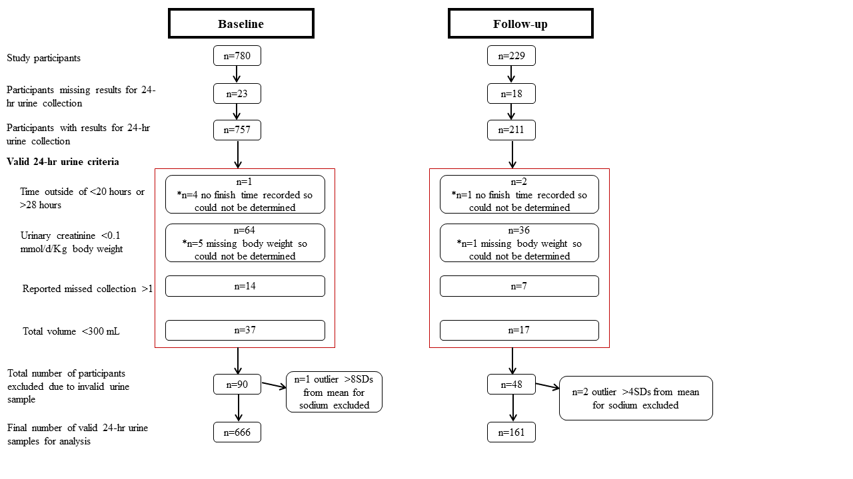
¹Participant’s sample could be excluded on more than one criteria, therefore total number across each of the four criteria exceeds final number of participants excluded

Supplementary figure 3. Flow chart for assessment of valid 24-diet recalls at baseline and follow-up
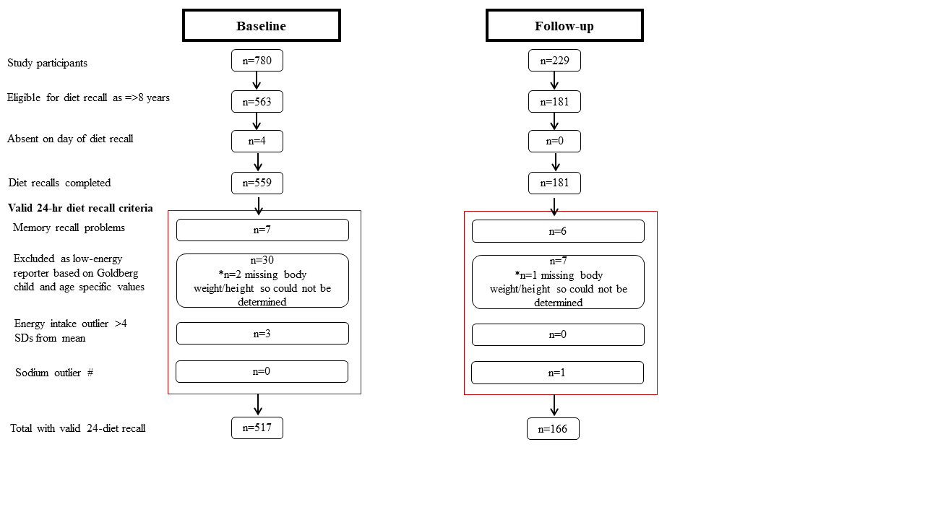
# Follow-up n=1 participant excluded on basis of extreme intake of reported sodium (4 SDs from mean)

Supplementary figure 4. Daily contribution (%) of sodium from major food groups among participants aged 8-12 years at T1 (n=517) and T2 (n=166)^{1, 2, 3}
¹ includes major food groups provided ≥1.5% of daily intake of sodium. Food groups ranked in order of greatest contributor to sodium intake.
² The population proportion method was used to calculate contribution of sodium from each food group e.g. (the sum of sodium intake from food group / total sum of sodium from all foods) * 100.
³ Data are mean ± 95% confidence interval
Supplementary table 1. Demographic characteristics of participants with a valid 24-hour dietary recall
Characteristic | Baseline (n=517) |  | Follow-up (n=166) |  | p-value¹
 | n or mean | % or SE | n or mean | % or SE
Age (years) | 10.1 | 0.1 | 10.6 | 0.3 | <0.001
Age group
4-8 years | 120 | 23% | 21 | 13% | 0.003
9-12 years | 397 | 77% | 145 | 87%
Gender
Boy | 277 | 54% | 88 | 53% | 0.89
Girl | 240 | 46% | 78 | 47%
Parental educational attainment²
Low | 106 | 25% | 16 | 11% | 0.002
Mid | 63 | 15% | 23 | 16%
High | 255 | 60% | 104 | 73%
Socioeconomic disadvantage of school³
Low | 92 | 18% | 62 | 37% | <0.001
Mid | 102 | 20% | 59 | 36%
High | 323 | 18% | 45 | 27%
School type
Non-government | 201 | 39% | 62 | 37% | 0.73
Government | 316 | 61% | 104 | 63%
Weight category
Underweight | 37 | 7% | 8 | 5% | 0.38
Healthy weight | 373 | 72% | 131 | 79%
Overweight | 87 | 17% | 22 | 13%
Obese | 20 | 4% | 5 | 3%
BMI z-score | 0.22 | 0.05 | 0.20 | 0.09 | 0.87
Day of dietary recall
School day | 409 | 79% | 102 | 62% | <0.001
Non-school day | 108 | 21% | 64 | 39%
¹ p-value determined via Pearson’s chi-squared test or Independent t-test
² Missing data at baseline n=93, follow-up n=23
³ Based on school postcode and corresponding Socio-Economic Indexes for Areas, Index of Relative Socio-Economic Disadvantage⁽¹⁾
⁴ Weight classification based on the International Obesity Task Force BMI reference cut-offs ^{(2, 3)}
⁵ d

References
1. Australian Bureau of Statistics. Socio-Economic Indexes for Areas: ABS; 2013 [Available from: https://www.abs.gov.au/websitedbs/censushome.nsf/home/seifa.
2. Cole TJ. Establishing a standard definition for child overweight and obesity worldwide: international survey. BMJ. 2000;320(7244):1-6.
3. Cole TJ, Flegal KM, Nicholls D, et al. Body mass index cut offs to define thinness in children and adolescents: international survey. BMJ. 2007;335(7612):194-7.

