Supplementary Table 1. Results of Shapiro–Wilk tests
Indicator |  | Shapiro–Wilk tests result | P-value
Total Carbohydrates (g/100g) |  | W = 0.93493 | 5.037e-05
 | Free sugars (g/100g) | W = 0.59163 | 7.286e-16
Total Protein (g/100g) |  | W = 0.97216 | 0.02288
Total Fat (g/100g) |  | W = 0.86866 | 2.469e-08
 | Trans Fat (g/100g) | W = 0.9024 | 8.257e-07
Fibre (g/100g) |  | W = 0.97976 | 0.099
Salt (g/100g) |  | W = 0.94788 | 0.0003439
Kilocalories (kcal/100g) |  | W = 0.8999 | 6.227e-07
GHGE up to supermarket shelf (gCO2e/100 g) |  | W = 0.89487 | 3.568e-07
 | Gas Stove cooked – (gCO2e /100 g) | W = 0.89993 | 8.995e-05
 | Electric Stove cooked – (gCO2e /100 g) | W = 0.89912 | 8.389e-05
 | Microwave cooked – (gCO2e /100 g) | W = 0.89088 | 0.001221
 | Oven cooked – (gCO2e /100 g) | W = 0.89156 | 7.79e-06
Total cost (GBP /100 g) |  | W = 0.93446 | 4.711e-05
Significance estimated at a p-value < 0.05

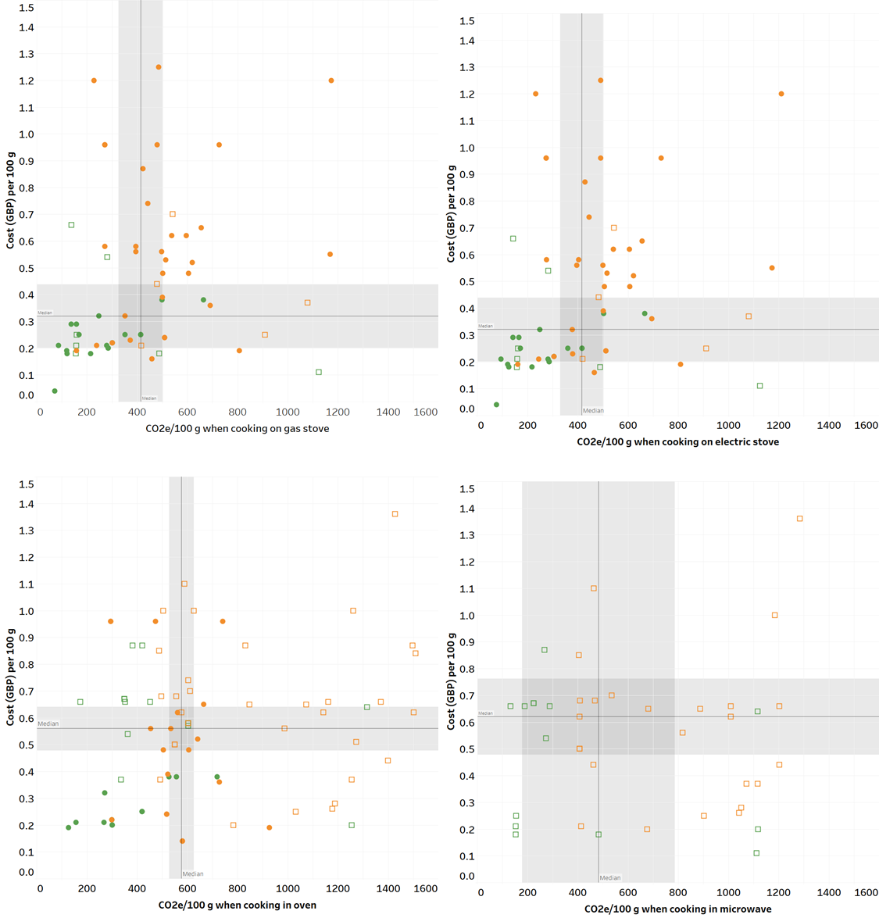

Supplementary Figure 1. Comparison of GHGE and cost of ready meals and equivalent home-cooked meals, either animal or plant-based. □ready meal home-cooked meal, animal-based meals, plant-based meals. CO2e - gCO2-equivalents. GBP-Great British pound £. Grey lines show the median and 95% Confidence Interval. Gas and electric stove cooked meals: n=62 (n=12 ready meals of which 5 animal-based and 7 plant-based; and n=50 home-cooked meals of which 33 animal-based and 17 plant-based). Microwave cooked meals: n=39 ready meals, of which 25 were animal-based and 14 plant-based. Oven cooked meals: n=77 (n=46 ready meals of which 52 animal-based and 25 plant-based; and n=31 home-cooked meals of which 20 animal-based and 11 plant-based).

