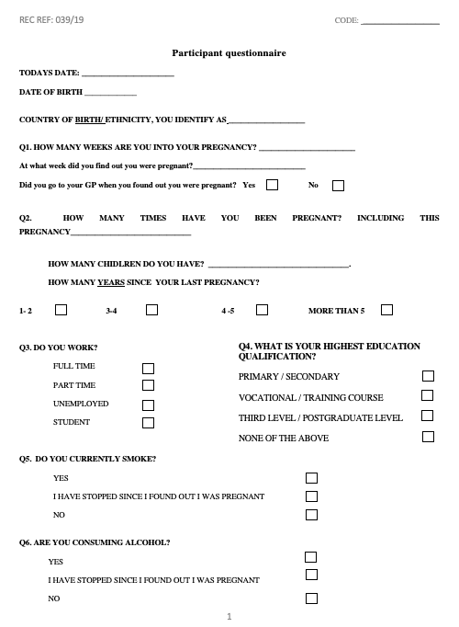
Supplementary Material 1. Participant Questionnaire Page 1.

Supplementary Material 1: Participant Questionnaire Page 2.
