Supplementary Online Content

Supplementary Figure 1. The medians and interquartile ranges (IQR) of the daily water and fluid intake by socio-demographic characteristics and comorbidities from participants enrolled in NHANES cycle 2009-2010 and 2011-2012.
Supplementary Figure 2. The medians and interquartile ranges (IQR) of urine concentration indicators by socio-demographic characteristics and comorbidities from participants enrolled in NHANES cycle 2009-2010 and 2011-2012.
Supplementary Figure 3. The medians and interquartile ranges (IQR) of blood-osmolality based hydration indicators by socio-demographic characteristics and comorbidities from participants enrolled in NHANES cycle 2009-2010 and 2011-2012.
Supplementary Figure 4. Correlation matrix of Spearman correlation coefficients among analyzed factors related to kidney stones.

Supplementary figure 1. The medians and interquartile ranges (IQR) of the daily water and fluid intake by socio-demographic characteristics and comorbidities from participants enrolled in NHANES cycle 2009-2010 and 2011-2012.

Supplementary figure 2. The medians and interquartile ranges (IQR) of urine concentration indicators by socio-demographic characteristics and comorbidities from participants enrolled in NHANES cycle 2009-2010 and 2011-2012.
Supplementary figure 3. The medians and interquartile ranges (IQR) of blood-osmolality based hydration indicators by socio-demographic characteristics and comorbidities from participants enrolled in NHANES cycle 2009-2010 and 2011-2012.

Supplementary Figure 4. Correlation matrix of Spearman correlation coefficients among analyzed factors related to kidney stones. U-to-B Osmolality ratio, urine-to-blood osmolality ratio; FWC, free water clearance; UFR, urine flow rate; TFI, total fluid intake; TPWI, total plain water intake.

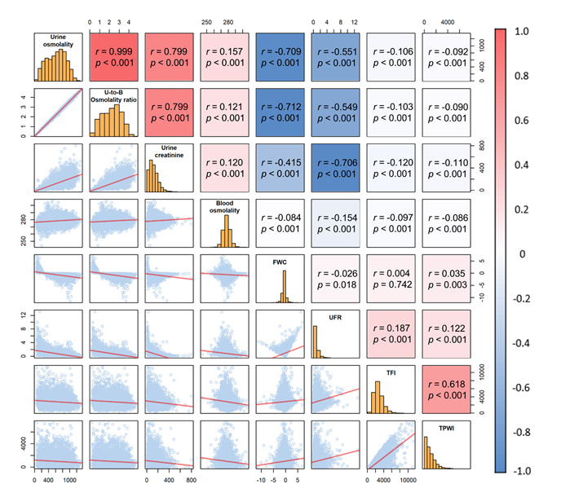

[1] Yeh HC, Lin YS, Kuo CC, Weidemann D, Weaver V, Fadrowski J, et al. Urine osmolality in the US population: implications for environmental biomonitoring. Environmental research. 2015;136:482-90.
[2] National Center for Health Statistics (NCHS). National Health and Nutrition Examination Survey Data. 2011 - 2012 Data Documentation, Codebook, and Frequencies: Prescription Medications (RXQ_RX_G). In: U.S. Department of Health and Human Services CfDCaP, editor. Hyattsville, MD2012.

