Supplementary material
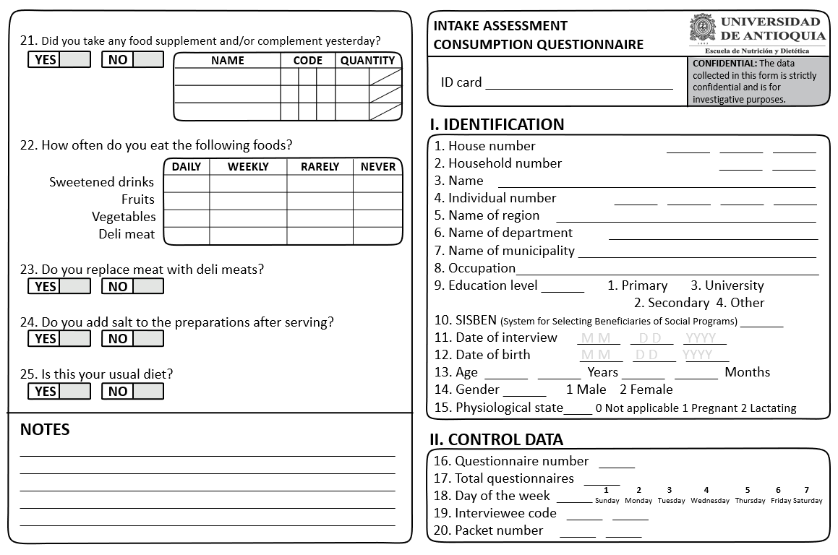
Supplementary Material 1. Food Diversity Questionnaire

Supplementary material 2. Codes for the Food Diversity Questionnaire

Group | Subgroup/Food | Model | Unit | Code
Grains | Arepas, all varieties | Circles | All | 51-57
 | Raw oats, rice, corn, pasta | Legumes | All | 76 - 78
 | Crackers, bread, toasted | Bread | All | 74 - 75
Roots, plantains, and tubers | Arracacha, yam, yuca | Sticks (Whole unit) | All | 64 - 70
 | Plantains, all kinds | Sticks (Whole unit) | All | 64 - 70
 | Potatoes, all kinds | Spheres | - | 37 - 43
Fruit, rich in vitamin A | Peach palm, peach, pink guava, mandarin, mango, passion fruit, tamarillo, groundcherry, sapote | Spheres | All | 37 - 43
 | Juices | Traditional glasses | All | 1 - 6
 |  | Cups | All | 7 - 9
 |  | Mugs | All | 10 - 17
 |  | Disposable cups | All | 27 - 29
Fruit, rich in vitamin C | Plums, strawberries, grapes | Spheres | - | 37 - 39
 | Juices | Traditional glasses | All | 1 - 6
 |  | Cups | All | 7 - 9
 |  | Mugs | All | 10 - 17
 |  | Disposable cups | All | 27 - 29
 | White guava, granadilla, fig, kiwi, lulo, apple, orange, pear | Spheres | - | 40 - 43
 | Juices | Traditional glasses | All | 1 - 6
 |  | Cups | All | 7 - 9
 |  | Mugs | All | 10 - 17
 |  | Disposable cups | All | 27 - 29
 | Banana, soursop, melon, blackberries, papaya, mountain papaya, pineapple, watermelon | Legumes | All | 76 - 78
 | Juices | Traditional glasses | All | 1 - 6
 |  | Cups | All | 7 - 9
 |  | Mugs | All | 10 - 17
 |  | Disposable cups | All | 27 - 29
Vegetables, rich in vitamin A | Chard, auyama (winter squash), kale, spinach, green beans, red pepper, tomato, carrot | Legumes | All | 76 - 78
Vegetables, rich in folate | Avocado, green peas, broccoli, cauliflower, lettuce, beets, cabbage | Legumes | All | 76 - 78
Milk and derivatives | Milk of all kinds, liquid, reconstituted or fermented | Traditional glasses | All | 1 - 6
 |  | Cups | All | 7 - 9
 |  | Mugs | All | 10 - 17
 |  | Disposable cups | All | 27 - 29
 | Cheeses, all types | Rectangles | All | 58 - 63
Meats | Cooked beef, pork, veal, lamb | Rectangles | All | 58 - 63
 |  | Spheres | - | 38 - 42
 |  | Circles | - | 51 - 55
 |  | Spoons | - | 21 - 23, 25-26
 | Cooked chicken, poultry, turkey | Rectangles | All | 58 - 63
 |  | Sticks | All | 64 - 70
 |  | Spoons | - | 19 - 23, 25
Fish and shellfish | Cooked fish, all types | Rectangles | All | 58 - 63
 |  | Spoons | - | 22 - 23, 25 - 26
 |  | Cans | Small | 114
 |  |  | Median | 115
 |  |  | Large | 116
 |  | Circles | - | 52 - 56
 |  | Sticks | All | 64 - 70
 | Shrimp, crab, lobster, prawn, oysters | Spoons | - | 25 -26
 |  | Sticks | All | 64 - 65
Viscera | Liver, all variety | Rectangles | All | 58 - 63
 | Blood sausage | Sticks | - | 64 - 67
 | Asadura (innards), spleen, tripe, heart, chunchullo (beef small intestine), intestines, tongue, offal, sweetbread, ear, pancreas, lung, kidney | Rectangles | All | 58 - 63
 |  | Spoons | - | 24 - 26
Eggs | Quail | Ball | - | 38
 | Chicken | Ball | - | 40
Legumes | Split peas, beans, chickpeas, beans, lentils, cooked soybeans | Legumes | All | 76 - 78
Nuts and Seeds | Almonds, chestnuts, macadamia, peanuts, cashews | Spoons | - | 25, 26
 |  | Standard unit | - | 102
 | Sesame, safflower, sunflower, flax, linseed | Spoons | - | 19, 22, 25 - 26
Supplements and complements | Any type of supplement or complementary food | Spoons | All | 18 - 26
 |  | Capsule | - | 102
Other | Water, oil, sugar, sweetened drinks, deli meats, sweets, desserts, snacks | Not quantified

