Supplementary Figure 1. Images with front-of-package labels displayed on screen during experimental task by country

GDAs, Guideline Daily Amounts; HSR, Health Star Rating; HWLs, Health Warning Label; OR, Odds Ratio; MTLs, Multiple Traffic Lights; HIWLs, ‘High-in’ Warning Label.

 | No Label (control) | GDAs | MTLs | HSR | HWLs | HIWLs
Australia (English) | 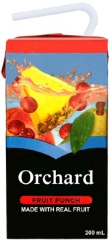 | 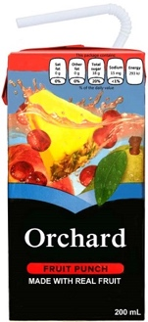 | 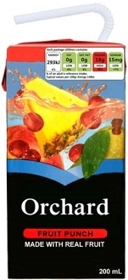 | 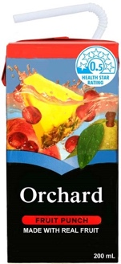 | 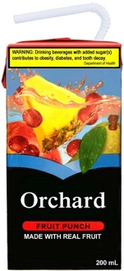 | 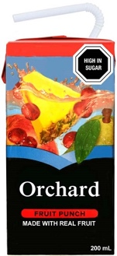
Canada (English) | 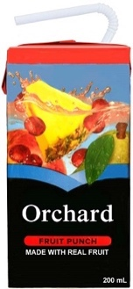 | 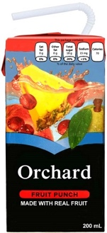 | 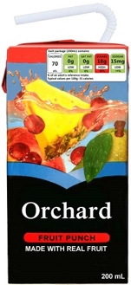 | 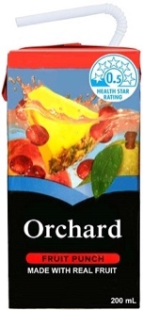 | 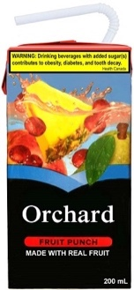 | 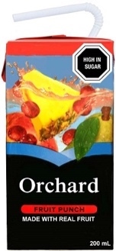
Canada  (French) | 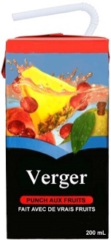 | 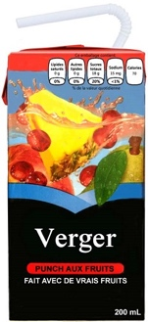 | 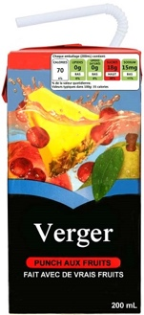 | 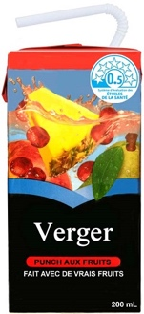 | 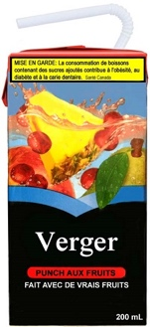 | 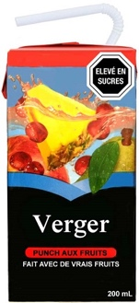
Mexico (Spanish) | 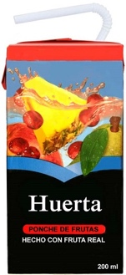 | 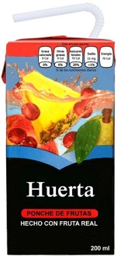 | 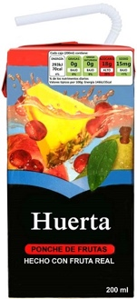 | 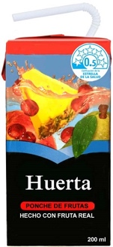 | 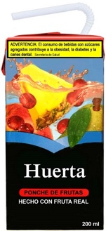 | 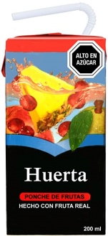
U.K.  (English) |  | 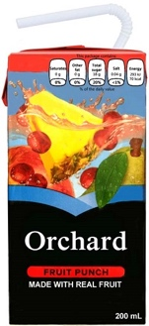 | 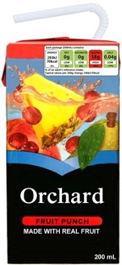
U.S. (English & Spanish) | 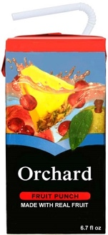 | 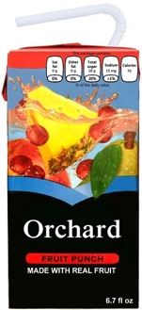 | 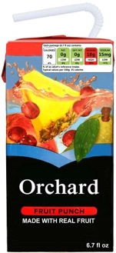 | 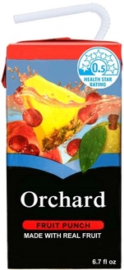 | 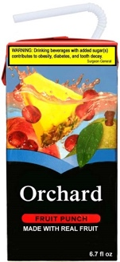 | 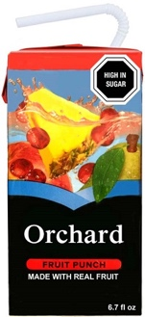

Supplementary Table 1. Nutrition information used in development of product FOP labels
Nutrient | Amount
Serving Size | 200 mL (1 package)
Energy | 70 kcal (292.88 KJ)
Fat | 0 g
Sodium | 15 mg
Carbohydrates | 18 g
Sugars | 18 g
Protein | 0.1 g
Vitamin C | 100% of daily value
Concentrated fruit and vegetable percentage | 5.0%

Supplementary Table 2. Demographic characteristics in the analytical sample and excluded participants
 | Analytic sample  (n=22,140) | Excluded  (n=634) | P value
 | % (95% CI) | % (95% CI)
Label condition
No label control | 16.2 (15.6-16.8) | 19.8 (16.5-23.6) | <0.001
GDA | 16.4 (15.8-17.0) | 17.9 (14.5-21.9)
MTL | 16.8 (16.3-17.4) | 13.2 (10.2-17.0)
HSR | 17.1 (16.5-17.7) | 17.9 (14.5-22.0)
HIWL | 16.6 (16.1-17.2) | 10.9 (8.3-14.1)
HWL | 16.8 (16.3-17.4) | 20.3 (16.8-24.3)
Country
Australia | 17.9 (17.4-18.5) | 19.4 (16.2-23.0) | <0.001
Canada | 19.5 (18.8-20.1) | 13.2 (10.3-16.7)
Mexico | 18.3 (17.7-19.0) | 11.5 (8.8-14.9)
United Kingdom | 23.9 (23.2-24.6) | 37.4 (33.1-41.9)
United States | 20.4 (19.8-21.0) | 18.5 (15.2-22.4)
Gender
Male | 48.5 (47.7-49.3) | 54.4 (49.8-58.9) | <0.001
Female | 51.5 (50.7-52.3) | 45.6 (41.1-50.2)
Ethnicity
Majority group | 80.0 (79.3-80.6) | 81.8 (77.4-85.6) | 0.044
Minority y group | 20.0 (19.4-20.7) | 18.2 (14.4-22.6)
Age group
18-29 | 22.5 (21.8-23.2) | 17.6 (14.4-21.3) | <0.001
30-39 | 18.3 (17.7-18.9) | 14.8 (12.0-18.1)
40-49 | 16.2 (15.6-16.8) | 14.8 (11.9-18.2)
50-59 | 18.0 (17.4-18.7) | 18.4 (14.9-22.6)
60-69 | 16.2 (15.6-16.7) | 19.9 (16.4-23.9)
70 and over | 8.8 (8.4-9.3) | 14.5 (11.7-17.9)
Education level
Low | 42.8 (42.0-43.7) | 51.8 (47.3-56.4) | 0.001
Medium | 22.2 (21.6-22.8) | 21.3 (18.1-25.0)
High | 35.0 (34.3-35.7) | 26.8 (23.5-30.5)
Income adequacy
Very difficult / Difficult | 30.7 (29.9-31.4) | 31.0 (26.7-35.6) | 0.832
Neither easy nor difficult | 36.7 (36.0-37.5) | 37.6 (33.1-42.8)
Easy/Very easy | 32.6 (31.9-33.3) | 31.5 (27.4-35.8)
Nutrition knowledge
Not at all or a little knowledgeable | 37.6 (36.8-38.4) | 60.3 (55.6-64.8) | <0.001
Somewhat knowledgeable | 43.1 (42.3-43.9) | 28.3 (24.4-32.4)
Very or extremely knowledgeable | 19.3 (18.7-19.9) | 11.5 (8.7-15.1)
Food shopping in your household |  |  | <0.001
Yes | 73.1 (72.4-73.8) | 64.3 (59.7-68.5)
No | 6.0 (5.6-6.4) | 12.4 (9.5-15.9)
Share | 20.9 (20.2-21.5) | 23.4 (19.8-27.4)
Frequency of using the nutrient facts table
Never/Rarely | 24.8 (24.1-25.5) | 41.6 (36.7-46.7) | <0.001
Sometimes | 31.8 (31.1-32.6) | 26.3 (22.1-30.9)
Often/All the time | 43.3 (42.6-44.1) | 32.1 (27.6-37.0)
BMI category^{b}
Underweight | 0.3 (0.3-0.4) | 0.3 (0.2-0.5) | <0.001
Normal weight | 34.8 (34.0-35.5) | 28.1 (24.2-32.2)
Overweight | 27.6 (26.9-28.3) | 22.7 (19.1-26.8)
Obesity | 20.7 (20.0-21.3) | 18.4 (15.0-22.3)
Don’t know or no response | 14.0 (13.4-14.6) | 27.9 (24.0-32.2)

Supplementary Table 3. Missing data in the outcome across label conditions

Label condition | N assigned | Excluded due to missing data in the outcome
 |  | n | %
No label control | 3,752 | 140 | 3.7
Guideline Daily Amounts | 3,758 | 111 | 3.0
Multiple Traffic Lights | 3,785 | 74 | 2.0
Health Star Rating | 3,846 | 111 | 2.9
Health Warning Label | 3,863 | 127 | 3.3
‘High-In’ Warning Label | 3,770 | 71 | 1.9
No condition assigned due to technical glitch | 50 | 50 | 100

Supplementary Table 4. Sensitivity analyses of the proportion and odds of considering the drink as healthy across countries^{1,2}.

 | Australia  n=3 964 |  | Canada  n=4311 |  | Mexico  n= 4 057 |  | United Kingdom  n= 5 290 |  | United States  n= 4 518
 | %  (99% CI) | OR  (99% CI) | %  (99% CI) | OR  (99% CI) | %  (99% CI) | OR  (99% CI) | %  (99% CI) | OR  (99% CI) | %  (99% CI) | OR  (99% CI)
No label control | 30.3  (25.1-36.0) | 1.00 | 30.4  (25.4-35.9) | 1.00 | 35.9  (30.2-41.2) | 1.00 | 46.1  (40.9-51.3) | 1.00 | 40.1  (34.5-46.1) | 1.00
GDAs | 30.5  (25.6-36.0) | 1.01 ª  (0.71-1.44) | 28.7  (23.4-34.6) | 0.92 ª  (0.64-1.33) | 35.0  (29.5-41.0) | 0.96 ^{a, b}  (0.67-1.38) | 39.8  (34.8-45.1) | 0.77 ª  (0.57-1.05) | 36.9  (31.8-42.4) | 0.87 ª  (0.63-1.22)
MTLs | 27.5  (22.6-33.0) | 0.87 ª  (0.60-1.25) | 27.7  (22.8-33.2) | 0.88 ª  (0.61-1.25) | 30.3  (25.2-35.9) | 0.77 ^{a, b, c}  (0.54-1.11) | 36.2  (31.5-41.4) | 0.67 ª  (0.49-0.90) | 37.3  (31.8-43.2) | 0.89 ª  (0.63-1.25)
HSR | 19.2  (15.1-24.0) | 0.54 ^{b}  (0.37-0.80) | 25.3  (20.6-30.6) | 0.78 ^{a,b}  (0.54-1.12) | 38.3  (32.7-44.3) | 1.11  (0.78-1.59)^{b} | 39.2  (34.1-44.5) | 0.75 ª  (0.56-1.02) | 35.7  (30.5-41.3) | 0.83 ª  (0.59-1.16)
HWLs | 29.2  (24.0-34.9) | 0.95  (0.65-1.37)ª | 23.2  (18.8-28.4) | 0.69 ^{a,b}  (0.48-1.00) | 27.5  (22.8-32.7) | 0.68 ^{a,c}  (0.47-0.97) | 32.8  (28.0-37.9) | 0.57 ª  (0.42-0.78) | 32.5  (27.2-38.2) | 0.72 ^{a,b}  (0.51-1.02)
HIWLs | 16.5  (12.5-21.4) | 0.45 ^{b}  (0.30-0.69) | 18.5  (14.1-23.8) | 0.52 ^{b}  (0.35-0.78) | 21.6  (17.1-26.9) | 0.49 ^{c}  (0.34-0.73) | 23.4  (19.2-28.0) | 0.36 ^{b}  (0.26-0.49) | 25.7  (20.9-31.2) | 0.52 ^{b}  (0.36-0.74)
CI, Confidence Interval; GDAs, Guideline Daily Amounts; HSR, Health Star Rating; HWLs, Health Warning Label; OR, Odds Ratio; MTLs, Multiple Traffic Lights; HIWLs, ‘High-in’ Warning Label.
Binary outcome of perceived healthiness (1=very healthy to a little healthy, 0= neither healthy nor healthy to very unhealthy)
¹ Bold face indicates statistically significant (p<0.01) effects compared to the control condition within each country.
² Similar superscripts within columns indicate that contrasts are not significantly different within countries (columns) (p<0.01).

