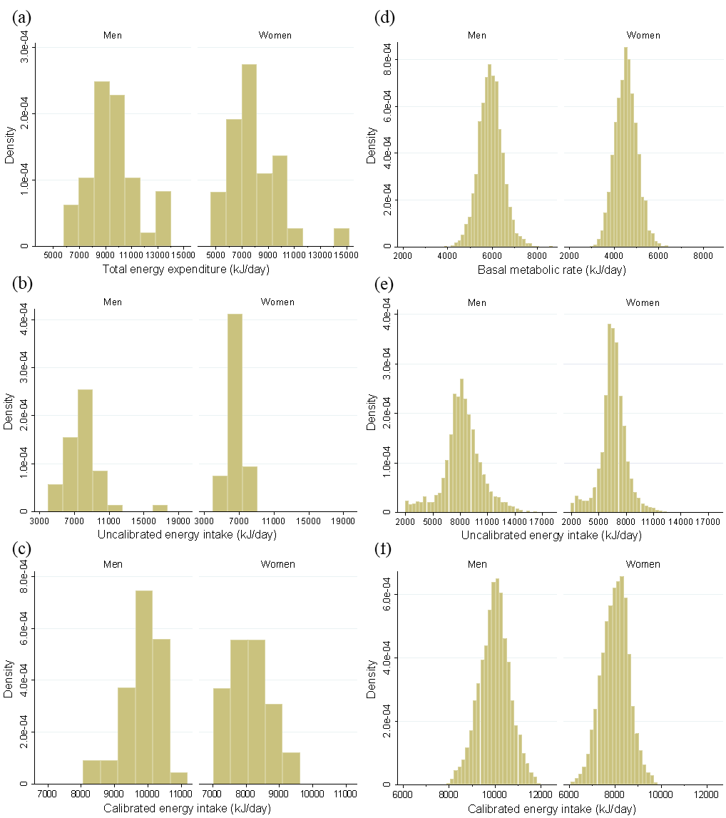
Figure S1 Distribution of total energy expenditure (TEE), uncalibrated and calibrated energy intake (EI), and basal metabolic rate according to sex in Japanese older adults. Sub cohort [n = 72]: (a) TEE, (b) uncalibrated EI, and (c) calibrated EI. Main cohort [n = 8058]: (d) basal metabolic rate, (e) uncalibrated EI, and (f) calibrated EI. The large main cohort data were normally distributed, according to the Jarque–Bera test, but the small sub cohort data were non-normally distributed, according to the Shapiro–Wilk test.

Table S1. Reproducibility of total energy expenditure measured using the doubly labelled water method
 | Total energy expenditure (kJ/d) |  |  | CV_{w} (%) | CV_{b} (%) | VR | ICC§
 | First† | Second† | Difference‡
 | Median (IQR) | Median (IQR) | Median (IQR)
Total (n = 72) | 8937  (8030 to 10203) | 8559  (7466 to 10118) | 459  (-442 to 1291) | 9.8 | 20.3 | 0.48 | 0.619*
Sex
Women (n = 31) | 8448  (7449 to 8857) | 7742  (6389 to 8859) | 555  (78 to 1337) | 10.9 | 20.3 | 0.54 | 0.501*
Men (n = 41) | 9579  (8891 to 10535) | 9489  (8401 to 10433) | 303  (-765 to 1265) | 9.0 | 16.9 | 0.53 | 0.531*
Age [years]
<75 (n = 47) | 9156  (7644 to 10539) | 8815  (7046 to 10185) | 445  (-521 to 1650) | 7.9 | 20.8 | 0.38 | 0.778*
≥75 (n = 25) | 8857  (8131 to 9441) | 8401  (7732 to 9619) | 616  (-362 to 930) | 10.9 | 19.4 | 0.56 | 0.265*
BMI [kg/m²]
<18.5 (n = 7) | 8395  (6945 to 10260) | 6728  (6370 to 8438) | 1006  (499 to 1996) | 12.3 | 21.5 | 0.57 | 0.841*
18.5-24.9 (n = 45) | 9043  (8448 to 10146) | 9288  (7439 to 10306) | 318  (-765 to 958) | 10.1 | 21.0 | 0.48 | 0.589*
≥25 (n = 20) | 8834  (8033 to 10191) | 8093  (7795 to 9109) | 420  (-442 to 1301) | 8.3 | 16.6 | 0.50 | 0.634*
BMI, body mass index; CV_{b}, coefﬁcient of between-person variation; CV_{w}, coefﬁcient of within-person variation; ICC, intraclass correlation coefficients; IQR, interquartile range; VR, within-person/between-person variance ratio. Energy intake conversion factor: 1 kJ=0.239 kcal.
† First and second surveys were conducted in May/June 2012 and August 2012, respectively. The variables are shown as median (IQR).
‡ The values are shown as median difference (IQR). Statistical analysis was conducted by using a Wilcoxon signed-rank test and asterisks are statistically significant (p<0.05).
§ Intraclass correlation coefficients were analyzed using Pearson’s correlation analysis and asterisks are statistically significant (p<0.05).

Table S2. Comparison of calibrated and uncalibrated energy intakes using a paired t-test in main cohort
 | Energy intake (kJ/d)† |  |  |  |  | Difference‡
 | Uncalibrated |  | Calibrated |  |  | Absolute (kJ/d) |  | Relative (%)
 | Mean | 95% CI | Mean | 95% CI |  | Mean | 95% CI | Mean | 95% CI
Total (n = 8058) | 7376 | 7330 to 7418 | 8924 | 8895 to 8949 |  | -1548 | -1581 to -1514* | -17.9 | -18.3 to -17.5*
Sex
Women (n = 4269) | 6568 | 6522 to 6610 | 7991 | 7974 to 8008 |  | -1422 | -1460 to -1384* | -18.1 | -18.6 to -17.7*
Men (n = 3789) | 8284 | 8217 to 8351 | 9970 | 9949 to 9995 |  | -1686 | -1744 to -1631* | -17.6 | -18.2 to -17.0*
Age [years]
<75 (n = 4935) | 7355 | 7301 to 7409 | 9229 | 9200 to 9263 |  | -1874 | -1916 to -1836* | -21.0 | -21.4 to -20.5*
≥75 (n = 3123) | 7405 | 7334 to 7476 | 8434 | 8397 to 8476 |  | -1029 | -1079 to -979* | -13.0 | -13.6 to -12.4*
BMI [kg/m²]
<18.5 (n = 623) | 7096 | 6953 to 7238 | 7937 | 7861 to 8012 |  | -840 | -949 to -732* | -11.1 | -12.4 to -9.7*
18.5-24.9 (n = 5906) | 7443 | 7388 to 7493 | 8895 | 8865 to 8924 |  | -1451 | -1489 to -1414* | -17.0 | -17.4 to -16.6*
≥25 (n = 1529) | 7225 | 7125 to 7326 | 9434 | 9380 to 9489 |  | -2209 | -2284 to -2133* | -24.1 | -24.9 to -23.2*
Energy intake conversion factor: 1 kJ=0.239 kcal.
† Values are expressed as mean (95% confidence interval [CI]).
‡ Comparison of the uncalibrated and calibrated energy intake using a paired t-test. * indicates statistical significance (p<0.05).

Table S3. Comparison of EI/pBMR values for calibrated and uncalibrated energy intakes
 | pBMR (kJ/d)† | EI/pBMR† |  |  | Difference‡
 |  | Uncalibrated | Calibrated
 | Median (IQR) | Median (IQR) | Median (IQR) |  | Median (IQR)
Total (n = 8058) | 5132 (4498 to 5882) | 1.43 (1.22 to 1.65) | 1.72 (1.62 to 1.83) |  | -0.30 (-0.44 to -0.14)*
Sex
Women (n = 4269) | 4537 (4201 to 4866) | 1.45 (1.25 to 1.66) | 1.76 (1.66 to 1.86) |  | -0.31 (-0.45 to -0.16)*
Men (n = 3789) | 5914 (5565 to 6254) | 1.39 (1.20 to 1.63) | 1.68 (1.59 to 1.78) |  | -0.28 (-0.43 to -0.12)*
Age [years]
<75 (n = 4935) | 5338 (4665 to 6027) | 1.38 (1.19 to 1.58) | 1.72 (1.63 to 1.82) |  | -0.35 (-0.47 to -0.21)*
≥75 (n = 3123) | 4796 (4226 to 5607) | 1.51 (1.30 to 1.74) | 1.72 (1.62 to 1.83) |  | -0.21 (-0.35 to -0.05)*
BMI [kg/m²]
<18.5 (n = 623) | 4146 (3883 to 4728) | 1.65 (1.44 to 1.85) | 1.84 (1.74 to 1.96) |  | -0.19 (-0.35 to -0.04)*
18.5-24.9 (n = 5906) | 5060 (4490 to 5818) | 1.45 (1.25 to 1.66) | 1.73 (1.64 to 1.83) |  | -0.29 (-0.42 to -0.13)*
≥25 (n = 1529) | 5720 (5067 to 6426) | 1.26 (1.09 to 1.44) | 1.64 (1.55 to 1.74) |  | -0.38 (-0.52 to -0.23)*
BMI, body mass index; EI, energy intake; IQR, interquartile range; pBMR, predicted basal metabolic rate. Energy intake conversion factor: 1 kJ=0.239 kcal.
† Values are expressed as median (IQR).
‡ Comparison of the uncalibrated and calibrated energy intake using a Wilcoxon signed-rank test. Asterisks indicate statistical significance (p<0.05).

Table S4. Correlations with age, body weight, and BMI depending on whether energy intake was calibrated
 | Spearman's CC† |  | p-value‡
 | Uncalibrated EI | Calibrated EI
Total (n = 8058)
Age [years] | 0.011 | -0.296 | <0.001
Body weight [kg] | 0.251 | 0.707 | <0.001
BMI [kg/m²] | 0.018 | 0.367 | <0.001
Women (n = 4269)
Age [years] | 0.012 | -0.531 | <0.001
Body weight [kg] | -0.021 | 0.590
BMI [kg/m²] | -0.034 | 0.557 | <0.001
Men (n = 3789)
Age [years] | 0.041 | -0.447 | <0.001
Body weight [kg] | -0.028 | 0.441 | <0.001
BMI [kg/m²] | -0.049 | 0.431 | <0.001
BMI, body mass index; CC, correlation coefficient; EI, energy intake.
† The values given are correlation coefficients.
‡ In statistical analysis, Spearman’s rank correlation coefficients for the associations between uncalibrated and calibrated EI and age, body weight, and BMI were compared using the formula of Meng et al. If the difference between two groups was significant using this formula, this was interpreted as not equivalent.

