Supplementary material
Table of Contents
Supplementary Appendix S1. Definition of store types included in the study, classified by the North American Industry Classification System, Canadian Version, 2012. 3
Supplementary Table S1. The definition of Supermarket, Pharmacy, and Supercentre in the study sample as described by NAICS Canada, 2012. 3
Supplementary Figure S1. Description of sampled stores and excluded stores from sampling frame in the Census Metropolitan Area of Montreal, Canada, 2012. 4
Supplementary Figure S2. Rasterized Gaussian kernel density of convenience stores (a) and supermarkets (b) with normalized density (colour key on the right) in the Census Metropolitan Area of Montreal, 2012. 5
Supplementary Appendix S2. List of keywords to classify products. 6
Supplementary Table S2. List of terms indicating flavoured yogurt items. 6
Supplementary Appendix S3. Calculation of store-level sales for each food categories 7
Supplementary Appendix S4. Additional description of the sales prediction model and area-level random effect. 8
Supplementary Appendix S5. Sensitivity analysis for the values of attraction and distance decay parameters. 10
Supplementary Appendix S6. Calculation of age-adjusted expected count of type 2 diabetes mellitus. 11
Supplementary Appendix S7. Additional description of diabetes disease mapping model 12
Supplementary Figure S3 a-d. Posterior standard deviation of area-level purchasing indicators and number of sampled stores with observed sales in each neighbourhood for a) soda, b) diet soda, c) flavoured yogurt, and d) plain yogurt. 13
Supplementary Figure S4. Posterior mean of area-level purchasing indicator for soda as generated by the Huff gravity model with varying value of parameter for store size ($γ$) and distance decay ($λ$). 14
Supplementary Figure S5. Posterior mean of area-level purchasing indicator of diet soda as generated by the Huff gravity model with varying value of parameter for store size ($γ$) and distance decay ($λ$). 15
Supplementary Figure S6. Posterior mean of area-level purchasing indicator for flavoured yogurt as generated by the Huff gravity model with varying value of parameter for store size ($γ$) and distance decay ($λ$). 16
Supplementary Figure S7. Posterior mean of area-level purchasing indicator for plain yogurt as generated by the Huff gravity model with varying value of parameter for store size ($γ$) and distance decay ($λ$). 17
Supplementary Table S3. Model fit of disease mapping model without and with area-level indicators of food purchasing generated by varying value of the Huff gravity model parameters. 18
Supplementary Figure S8. Posterior summaries of disease mapping model with purchasing indicators generated by varying value of Huff gravity model parameters. 19
Supplementary Figure S9. Comparison of the posterior mean of 193 area-level purchasing quantity per resident for a) soda, b) diet-soda, c) flavoured yogurt, and d) plain yogurt, where the area-level socio-demographic predictors were included in the sales model as the main analysis (y-axis) and excluded from the sales models as a sensitivity analysis (x-axis). 20
Supplementary Table S4. Posterior mean and 95% credible interval of exponentiated coefficients and model fit of neighbourhood-level (n=193) diabetes risk model, without the purchasing indicator (Model 1), with the purchasing indicators (Model 2), and with the purchasing indicators generated by sales models without area-level socio-demographic and economic predictors (model 3). 21
Supplementary Appendix S8. References for supplementary materials 22

Abbreviations:
CAR, Conditional Autoregressive
MCMC, Markov Chain Monte Carlo

Supplementary Appendix S1. Definition of store types included in the study, classified by the North American Industry Classification System, Canadian Version, 2012.

The sampling frame created by Nielsen included chain retail outlets with annual store-level revenue greater than 2 million dollars. Note that large retail formats selling a wide array of grocery and non-grocery items, frequently referred as supercentre or hypermarket, belong to the definition of department store in the Canadian version of the North American Industry Classification System (NAICS) shown below.⁽¹⁾ While the specific name of retail chain for each store in our transaction data was anonymized by Nielsen in the form of chain identification codes, we were provided with the list of chain names not linked with the chain identification codes. We verified that these retail chains in our data conform to the description of the retail formats below. Warehouse clubs are not included in our sample.

Supplementary Table S1. The definition of Supermarket, Pharmacy, and Supercentre in the study sample as described by NAICS Canada, 2012.
Store type and NAICS code | Definition
Supermarkets and other grocery (NAICS Canada Code 445110) | This Canadian industry comprises establishments, known as supermarkets and grocery stores, primarily engaged in retailing a general line of food, such as canned, dry and frozen foods; fresh fruits and vegetables; fresh and prepared meats, fish, poultry, dairy products, baked products and snack foods. These establishments also typically retail a range of non-food household products, such as household paper products, toiletries and non-prescription drugs.  Exclusion(s)  - Retailing a limited line of food and convenience items (see 445120 Convenience stores)  - Retailing prescription drugs in a supermarket, on a concession basis (see 446110 Pharmacies and drug stores)  - Retailing a general line of food products as well as a general line of non-food products (see 452910 Warehouse clubs)
Pharmacies and drug stores (NAICS Canada Code: 446110) | This Canadian industry comprises establishments, known as pharmacies and drug stores, primarily engaged in retailing prescription or non-prescription drugs and medicines.  Illustrative example(s)  - patent and proprietary medicines, retail  - pharmacies and drug stores (i.e., apothecary, dispensary), retail  Inclusion(s)  - Retailing of confectionery, tobacco products, novelties and giftware, and cameras and photographic supplies  - Retailing of snacks, cosmetics, personal hygiene products, greeting cards and stationery, and health aids  Exclusion(s)  - Retailing food supplement products, such as vitamins, nutrition supplements and body enhancing supplements (See 446191 Food (health) supplement stores)
Department stores (NAICS Canada code: 452110) | This Canadian industry comprises establishments primarily engaged in retailing a wide range of products, with each merchandise line constituting a separate department within the store. Selected departments may be operated by separate establishments, on a concession basis.  Exclusion(s)  - Warehouse-style stores engaged in retailing a general line of grocery items in combination with a general line of non-grocery items (see 452910 Warehouse clubs)

Sampling frame: 1,097 chain retail foot outlets in the Census Metropolitan Area of Montreal, Canada in 2012, excluding warehouses and convenience stores.

125/1,097 sampled stores by the Nielsen companies to collect grocery transactions.

972/1,097 out-of-sample stores missing soda sales transactions.

Exclusion of 786/1,097 stores belonging to all pharmacies and one supercentre chain that do not sell yogurt regularly.

Sampling frame for yogurt: 311/1,097 grocery stores and supercenters that belong to chain selling yogurt.

Soda and diet soda data
Generating predictive distribution of sales for 972/1,097 out-of-sample stores
Plain and flavored sales data
72/311 sampled stores recording transactions.

Generating predictive distribution of 239/311 out-of-sample stores
sales

Supplementary Figure S1. Description of sampled stores and excluded stores from sampling frame in the Census Metropolitan Area of Montreal, Canada, 2012.
Note: The sampling frame excludes warehouse stores. As well, convenience stores are not included in the study due to their location uncertainty.

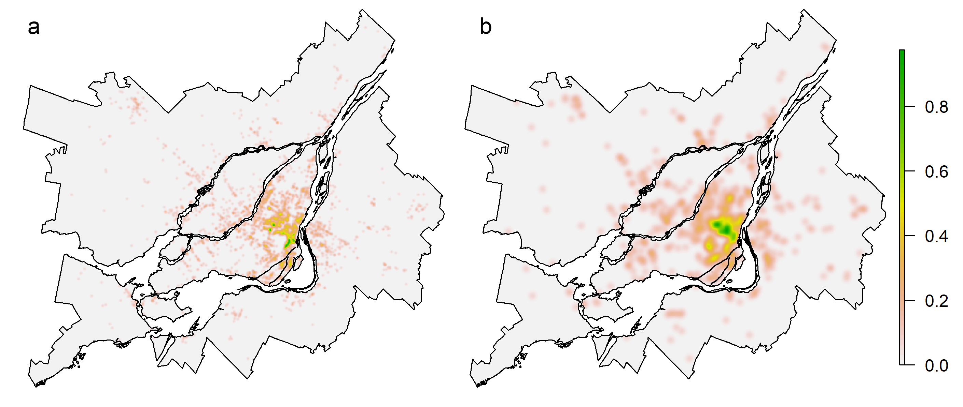

Supplementary Figure S2. Rasterized Gaussian kernel density of convenience stores (a) and supermarkets (b) with normalized density (colour key on the right) in the Census Metropolitan Area of Montreal, 2012.

Bandwidth of the kernel was fixed to 400m for convenience stores and 1,200m for supermarkets in accordance with a previous study⁽²⁾.

Supplementary Appendix S2. List of keywords to classify products.

We manually searched item name descriptors in the transactions of soda items and identified keywords indicating diet items with non-nutritive sweeteners as sugar substitutes. These are ‘DIET', 'ZERO', 'SUGR', 'SUGAR', 'SGR', ‘NO-SUGAR’.

Similarly, we manually searched keywords suggestive of flavoured yogurt products. The remaining list of item descriptors, preliminarily classified as plain (non-flavoured) yogurt, was manually inspected to identify items incorrectly classified as plain yogurt, and additional search terms were added if necessary. This process was repeated until all items containing terms indicative of flavoured items were exhausted. The resulting list of keywords is provided below. As well, any items containing the term ‘PLAIN’ were classified as plain yogurt.

Supplementary Table S2. List of terms indicating flavoured yogurt items.
Keywords to classify flavoured yogurt
'CHOCO',  'ORANGE',  'BERRY',  'BUTTER'  'VANILLA',  'VANILLA',  'BANANA',  'COFFEE',  'FLAVOURE',  'CAFE',  'PEAR',  'PEACH',  'MANGO',  'LIME',  'NUT',  'KIWI',  'APPLE',  'MAPLE',  'FIG',  'POME',  'LEMON',  'ERRY',  'PINA',  'CHEESE',  'MOCHA',  'PLUM',  'LATTE', | 'CINNAMON',  'ORCHRD',  'PCH',  'VNLA',  'HONEY',  'TROPICAL',  'RASP',  'BLBRY',  'BRRY',  'BRY',  'BERRI',  'NANAIMO',  'STR/',  'CHC/',  'APRICOT',  'FRUIT',  'ASSORT',  'MULTI',  'HONEY',  'DESSERT' | 'RSP',  'MINT',  'CAPPUCCI',  'CARAMEL',  'TEA',  'BUTTER',  'STRAW',  'MONKEY',  'VAN',  'GINGER',  'PRUNE',  'LEMN',  'EXOTIK',  'CITRUS',  'DATE',  'HAZEL',

Supplementary Appendix S3. Calculation of store-level sales for each food categories

In order to calculate area-level indicator of purchasing from store-level sales, we first defined the store-level sales as aggregated average weekly sales of individual food items in 2012 for each of the 4 food categories. Taking the soda category as an example, suppose that there were 300 individual soda items in a supermarket j. Weekly sale of each of these soda item h is denoted as as $q_{hjt}$, for $h=\{1, ..., 300\}$ for week $t=\{1, ..., 52\}$. Store-specific overall (category) sales of soda over 52 weeks in 2012, $Q_{j}$, were calculated from the aggregated sum of all individual soda items in a given store-week, as shown below. It is important to note that elements of the sales vector Q were missing for stores that were not sampled by the Nielsen company to collect sales data. Therefore, the value of $Q_{j}$ was defined as:
$$Q_{j}=\left\{\begin{aligned}1/52\sum_{t=1}^{52}{\sum_{h=1}^{300}{q_{hit}}} if store j was sampled , \\ NA otherwise.\end{aligned}\right.$$
Missing entries of sales in out-of-sample stores (NA) were predicted by the sales model as described in the main text. We repeated the same calculation to generate the store-level sales quantities for the other 3 food categories, namely diet soda, flavoured yogurt and plain yogurt.

Supplementary Appendix S4. Additional description of the sales prediction model and area-level random effect.

Geographically indexed measurements (e.g. store-level sales, disease occurrence, and etc) tend to exhibit positive spatial correlation over space. Thus, conditional independence of the outcomes typically requires an approach to account for spatial autocorrelation. The spatial random effect ${S=\left(S_{1}⋯,S_{n}\right)}^{T}$ in our sales prediction model captures the spatial dependency of sales across areas using a proper conditional autoregressive (CAR) prior as described by Banerjee, Carlin, and Alan.⁽³⁾ Spatial relationship of neighbourhoods was operationalized by a binary spatial weight matrix, where neighbourhoods that share boundaries are coded as 1 (i.e. defined as neighbour), and 0 otherwise. Note that self-neighbour (an area being its own neighbour), isolated area, and isolated subgraph (group of areas) are typically not allowed in the weight matrix of the CAR prior. The latter two conditions allow that all 193 neighbourhoods inhabited in 2012, even those isolated by the water (Figure 1) had at least one neighbour connected by a bridge. As well, the subgraphs (groups of neighbourhoods) such as the Island of Montreal was connected to the North Shore and the South Shore by bridges that were operational in 2012.

Prior distribution for regression parameters, $φ$ and $β_{0}$ was $Normal\left(0,100\right)$. The prior distribution for precision parameters for the chain random effect $σ_{ϕ}^{-2},$ store-level sales $Q_{ij}$, and the proper CAR prior was $Gamma\left(0.5,0.01\right)$. For the proper CAR prior, the range of the scaling parameter to control spatial dependency of sales across neighbourhoods was determined as the inverse of the minimum and maximum eigenvalues of $D_{w}^{-1/2}WD_{w}^{-1/2}$, where 𝑊 was the normalized adjacency weight matrix, and $D_{w}$ represents a diagonal matrix whose i th diagonal element is equal to the number of neighbourhoods sharing boundaries⁽³⁾.

For parameter estimation, we let the Markov Chain Monte Carlo (MCMC) run for 60,000 iterations, considered the first 10,000 as burn-in and stored every 20th iteration to avoid autocorrelation among the sampled values. Monte Carlo Standard Error was less than 5% of sample deviation. Trace plots of three MCMC chains starting with very different initial values were visually inspected to investigate convergence.

All the covariates in the sales models were standardized to have a zero mean and standard deviation of one. To improve the mixing of MCMC, we implemented hierarchical centering,⁽⁴⁾ such that the prior mean of the chain random effect is centered at the overall intercept, that is, $ϕ_{c[j]}\sim Normal\left(β_{0},σ_{ϕ}^{2}\right)$. Sampling from the posterior distribution of the parameters was done using OpenBUGS software.⁽⁵⁾ Code is provided in a separate file named as SupplementaryTextFile1_code_1.

Note that sales of the 4 food categories were not predicted jointly (i.e. not multivariate model), as different types of stores carried different foods (i.e. the yogurt models did not include sales from pharmacies and one supercentre chain), thus there were different underlying data from each type of store with which to learn the sales, as descried in Supplementary Figure S1.

Supplementary Appendix S5. Sensitivity analysis for the values of attraction and distance decay parameters.
In a resource rich setting, population-representative origin-destination survey for shopping trips is used to estimate the coefficient of store size $(γ)$ and distance decay $\left(λ\right)$ for the study region of interest. Because such data were not available in our study, we used commonly used and empirically established value of the parameters in terms of predicting the movement of shoppers for the main analysis presented in the texts, which is $γ =1.00$ and $λ=2.00$.⁽⁶⁾

Following a recent proposal to use a lower value of distance decay due to the improvements of road network and walkability that reduced deterrents of shopping travel since the introduction of the Huff gravity model, we also used the value of distance decay $λ=1.00$as a sensitivity analysis.⁽⁷⁾ As well, we used a recent estimates learned by a large number of travel records generated by mobile phones in 10 largest metropolitan areas in the U.S., which is $γ =0.72$ and $λ=0.81$.⁽⁸⁾ Finally, we used another recent estimate $γ =0.07$ and $λ=1.57$in a geographic region consisting of urban and rural areas.⁽⁹⁾

The lower values of the distance decay coefficient $λ$ implies that shoppers travel farther as the distance to stores is less of impediment to grocery shopping. The lower value of the store size coefficient $γ$ implies that shoppers are not necessarily attracted to the larger store (i.e. larger selection of items), if shoppers had a choice of two stores with an equal travel distance. In effect, the lower values of these coefficients result in a greater smoothing of the areal-level purchasing quantities generated from stores-level sales, which tends to reveal the macro-scale spatial trend of purchasing by smoothing out the local heterogeneity of purchasing across small areas. The comparison of the geographic distribution of the area-level purchasing indicators generated by these combinations of the gravity model parameters are presented in Supplementary Figures S4-7. The association of these indicators with neighbourhood-level risk of type 2 diabetes mellitus are presented in Supplementary Table S3 and Supplementary Figure S8.

Supplementary Appendix S6. Calculation of age-adjusted expected count of type 2 diabetes mellitus.
Age-adjusted expected count for area i was calculated by indirect standardization;
$e_{i}=\sum_{k=1}^{8}{N_{ik}}p_{k}$ ,
where $N_{ik}$ is the population size greater or equal to age two in area i at age stratum k. Age strata $k$ were defined as [2-20) [20-30) [30-40) [40-50) [50-60) [60-70) [70-80), and>=80 years old. Following the convention of disease mapping⁽¹⁰⁾, the reference age-specific disease prevalence of T2D was obtained from the entire study region of the CMA of Montreal. The reference (background) disease prevalence in age stratum $k$ in the CMA of Montreal was denoted as $p_{k}$ and calculated as the number of people having diabetes status in 2012 in stratum $k$ divided by the corresponding age stratum-specific total population with and without diabetes diagnosis. The count of cases and non-cases were determined from the provincial universal public health insurance registry, the Régie de l’assurance maladie du Québec.

Supplementary Appendix S7. Additional description of diabetes disease mapping model

As in the sales model, spatial autocorrelation of outcomes can be addressed by a spatially structured random effect (CAR prior) that includes neighbourhood relationship of areas as a spatial weight matrix. As well, we needed a non-spatial random effect to capture Poisson overdispersion of disease counts. The latent (residual) component of disease risk is typically captured by a mix of these two random effects in a single convolution prior as proposed by Besag-York-Mollie.⁽¹¹⁾ The random effect b in our disease mapping regression model follows the parametrization proposed by Rieblers et. al.⁽¹²⁾

Sampling from the posterior distribution of the parameters was performed by Hamiltonian Monte Carlo using the software package Stan.⁽¹³⁾ Convergence was examined via a trace plot of three independent chains. We discarded the first 5,000 samples as burn-in and retained the remaining 30,000 iterations as an inference sample to compute the posterior summary. The prior probability of the parameters was $γ,β\sim N\left(0,5^{2}\right)$ for each regression coefficient, $Uniform\left(0,1\right)$ for the mixing parameter of the random effects, and a zero-mean half-normal distribution with the variance $5^{2}$ for the common standard deviation of the random effects. Codes for the disease mapping model are provided in a separate file names as SupplementaryTextFile2_code_2.

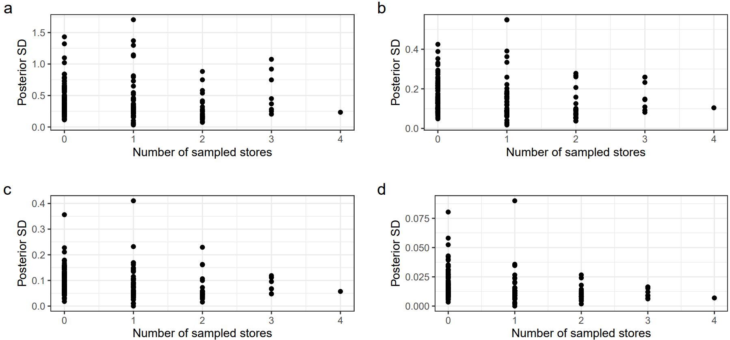

Supplementary Figure S3 a-d. Posterior standard deviation of area-level purchasing indicators and number of sampled stores with observed sales in each neighbourhood for a) soda, b) diet soda, c) flavoured yogurt, and d) plain yogurt.

Abbreviation: SD, posterior Standard Deviation

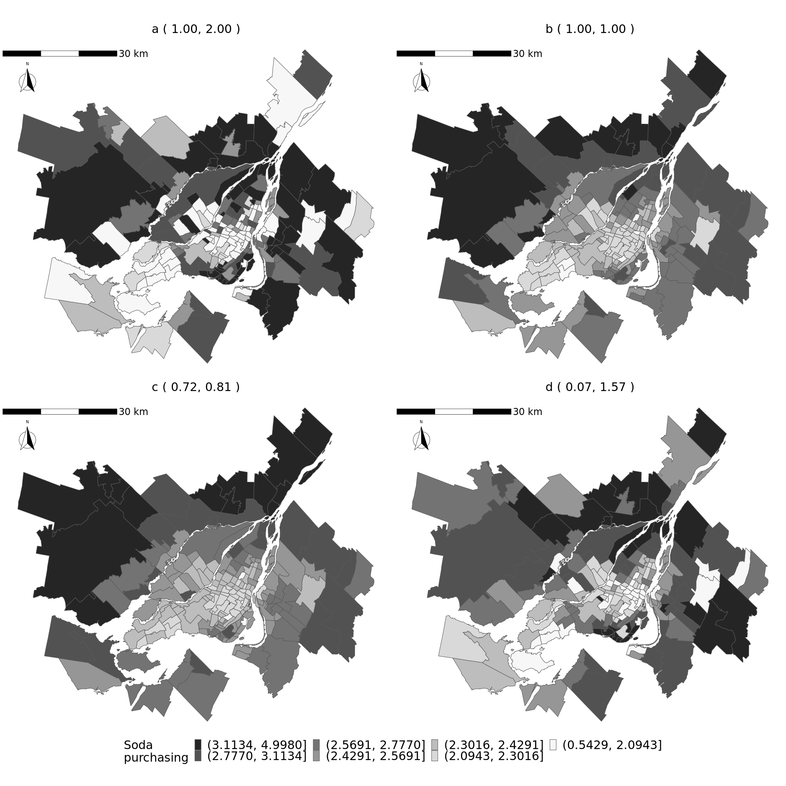

Supplementary Figure S4. Posterior mean of area-level purchasing indicator for soda as generated by the Huff gravity model with varying value of parameter for store size ($γ$) and distance decay ($λ$).
Panels are a ($γ$ = 1.00, $λ$= 2.00), b ($γ$ = 1.00, $λ$ = 1.00), c ($γ$ = 0.72, $λ$ = 0.81), and d ($γ$ = 0.07, $λ$ = 1.57).
Note that panel a) shows the results from the main analysis. The quantities in the greyscale key represent servings per resident standardized across the four maps.
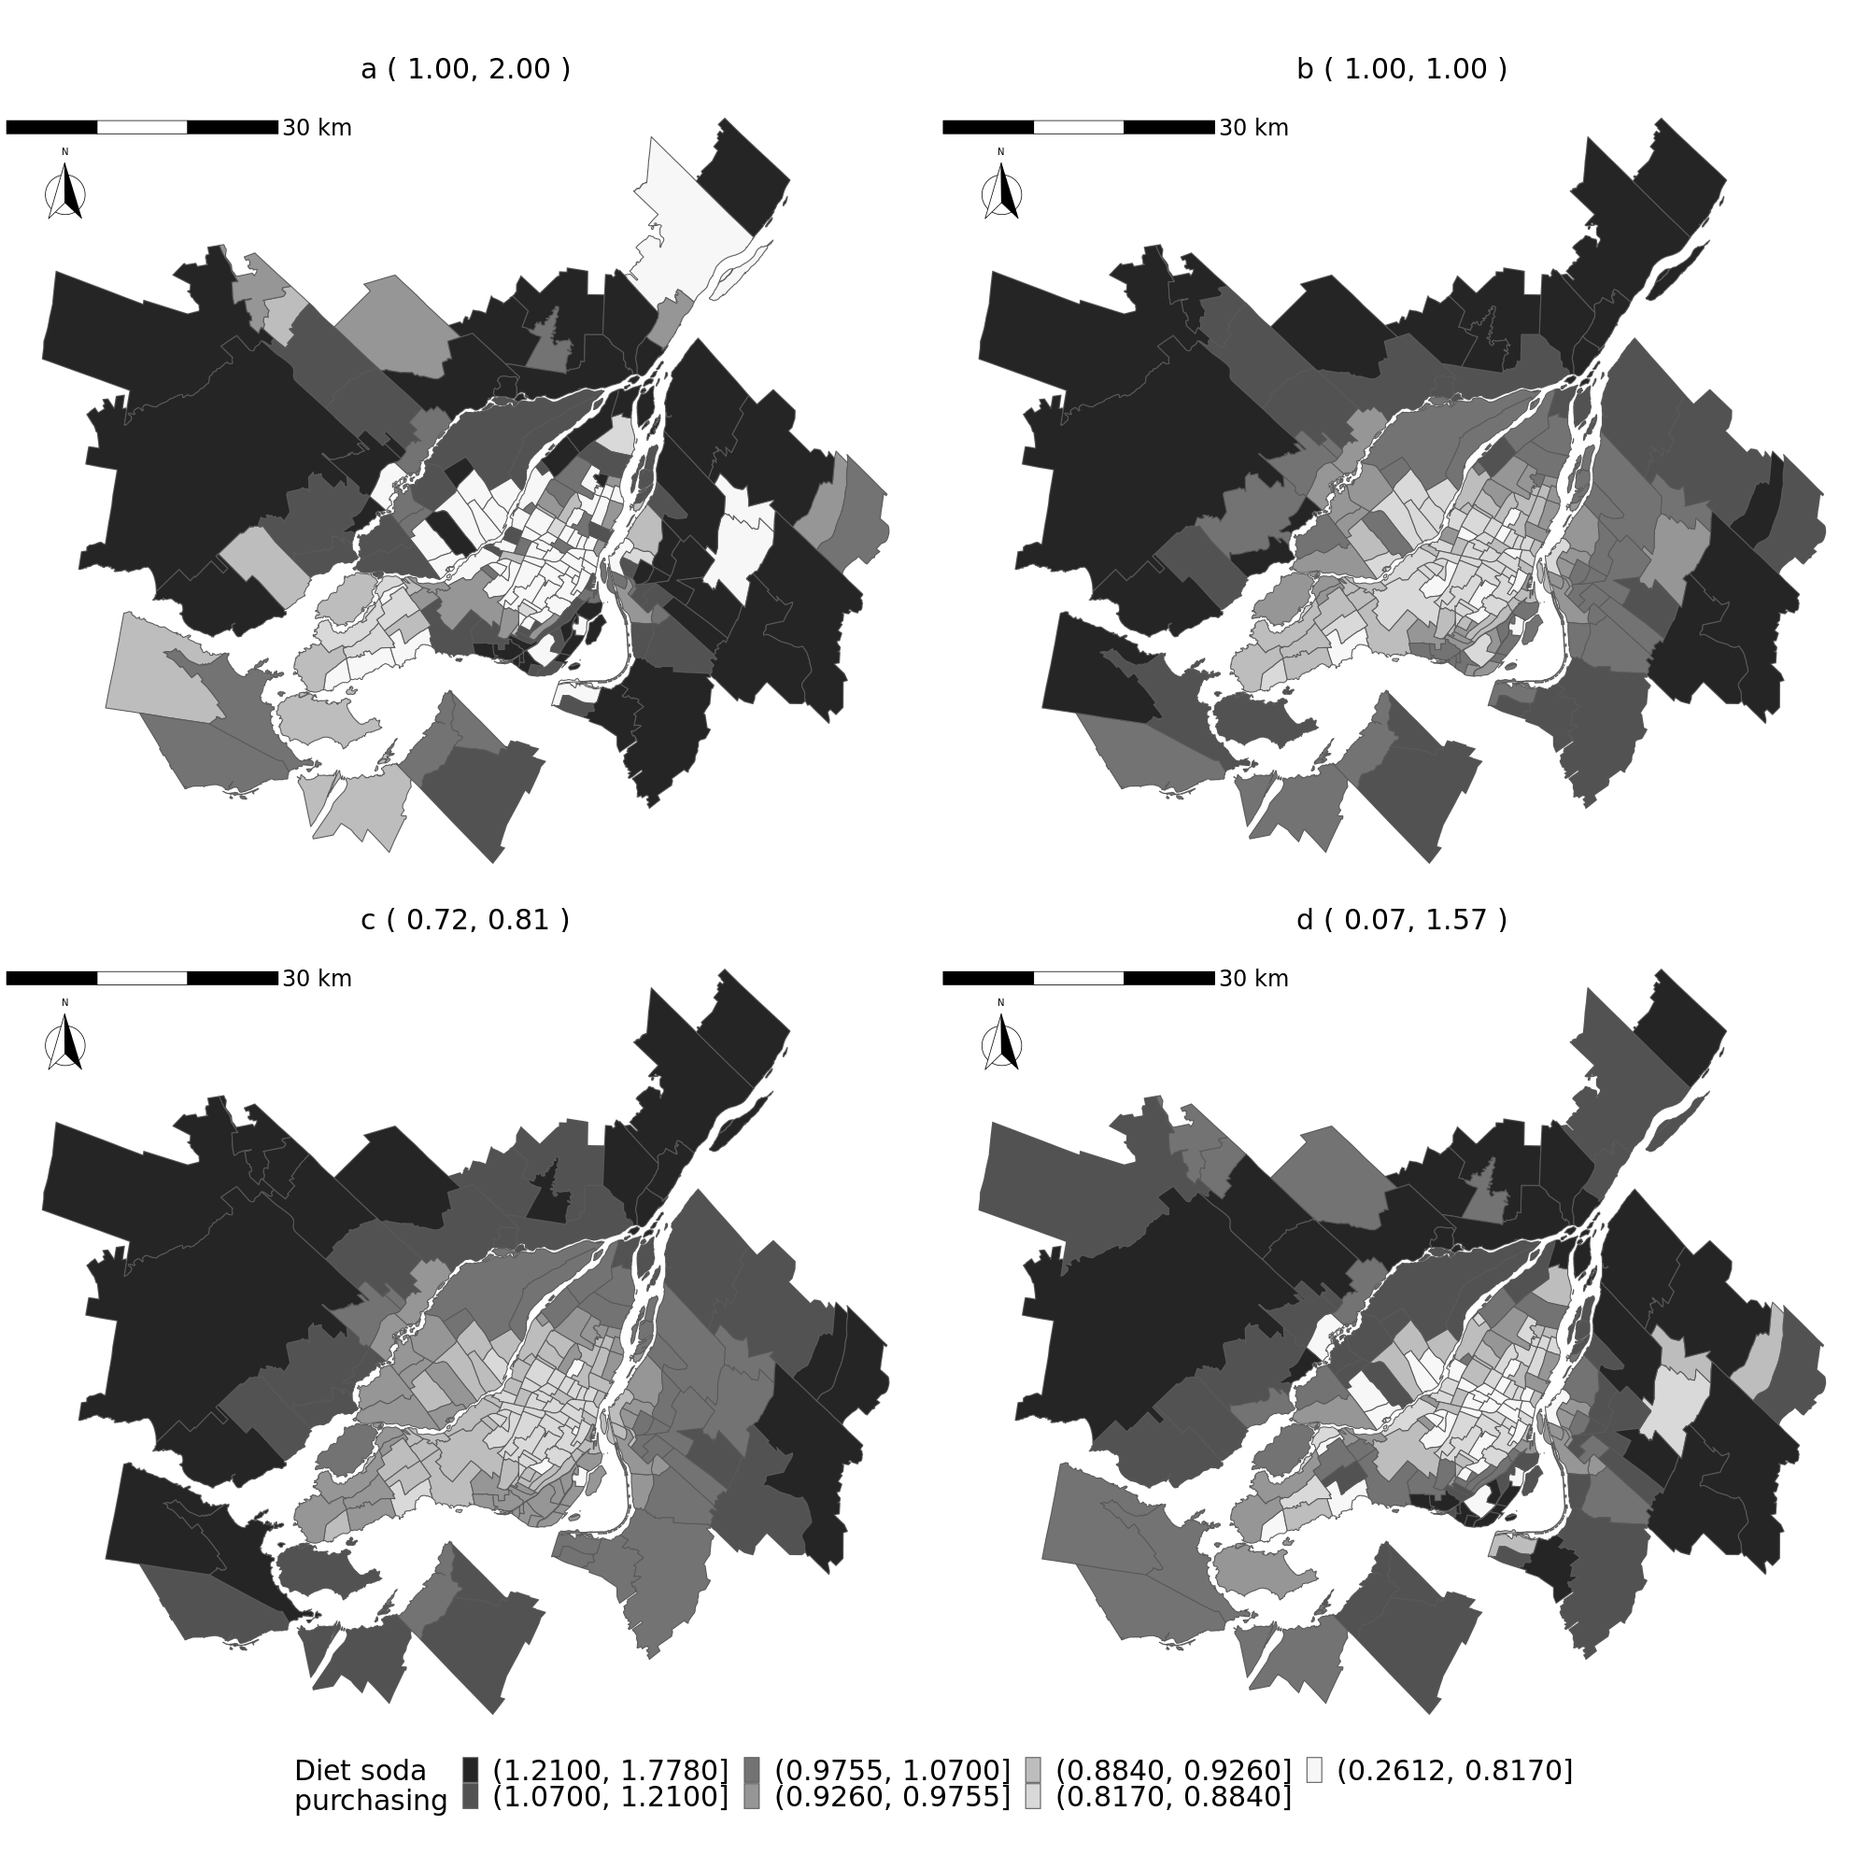

Supplementary Figure S5. Posterior mean of area-level purchasing indicator of diet soda as generated by the Huff gravity model with varying value of parameter for store size ($γ$) and distance decay ($λ$).
Panels are a ($γ$ = 1.00, $λ$= 2.00), b ($γ$ = 1.00, $λ$ = 1.00), c ($γ$ = 0.72, $λ$ = 0.81), and d ($γ$ = 0.07, $λ$ = 1.57).
Note that panel a) shows the results from the main analysis. The quantities in the greyscale key represent servings per resident standardized across the four maps.

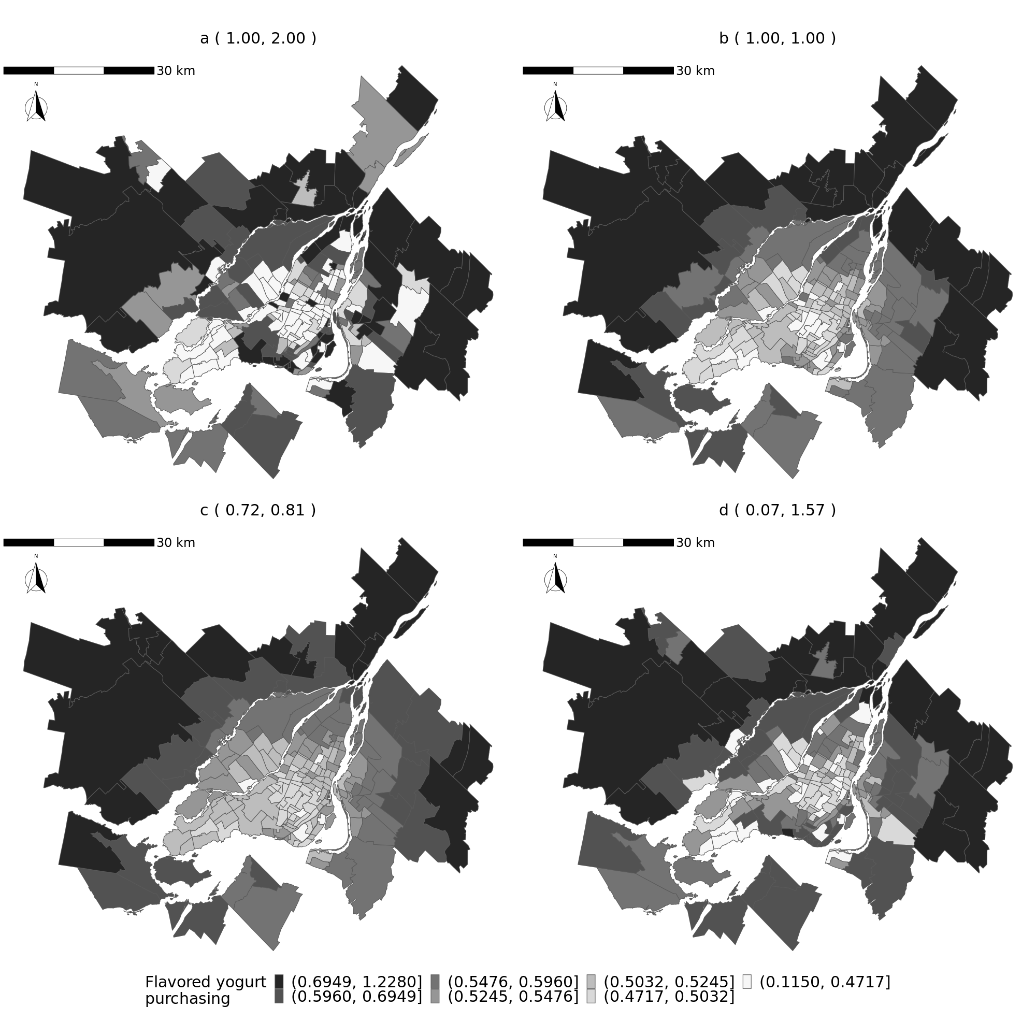

Supplementary Figure S6. Posterior mean of area-level purchasing indicator for flavoured yogurt as generated by the Huff gravity model with varying value of parameter for store size ($γ$) and distance decay ($λ$).
Panels are a ($γ$ = 1.00, $λ$= 2.00), b ($γ$ = 1.00, $λ$ = 1.00), c ($γ$ = 0.72, $λ$ = 0.81), and d ($γ$ = 0.07, $λ$ = 1.57).
Note that panel a) shows the results from the main analysis. The quantities in the greyscale key represent servings per resident standardized across the four maps.

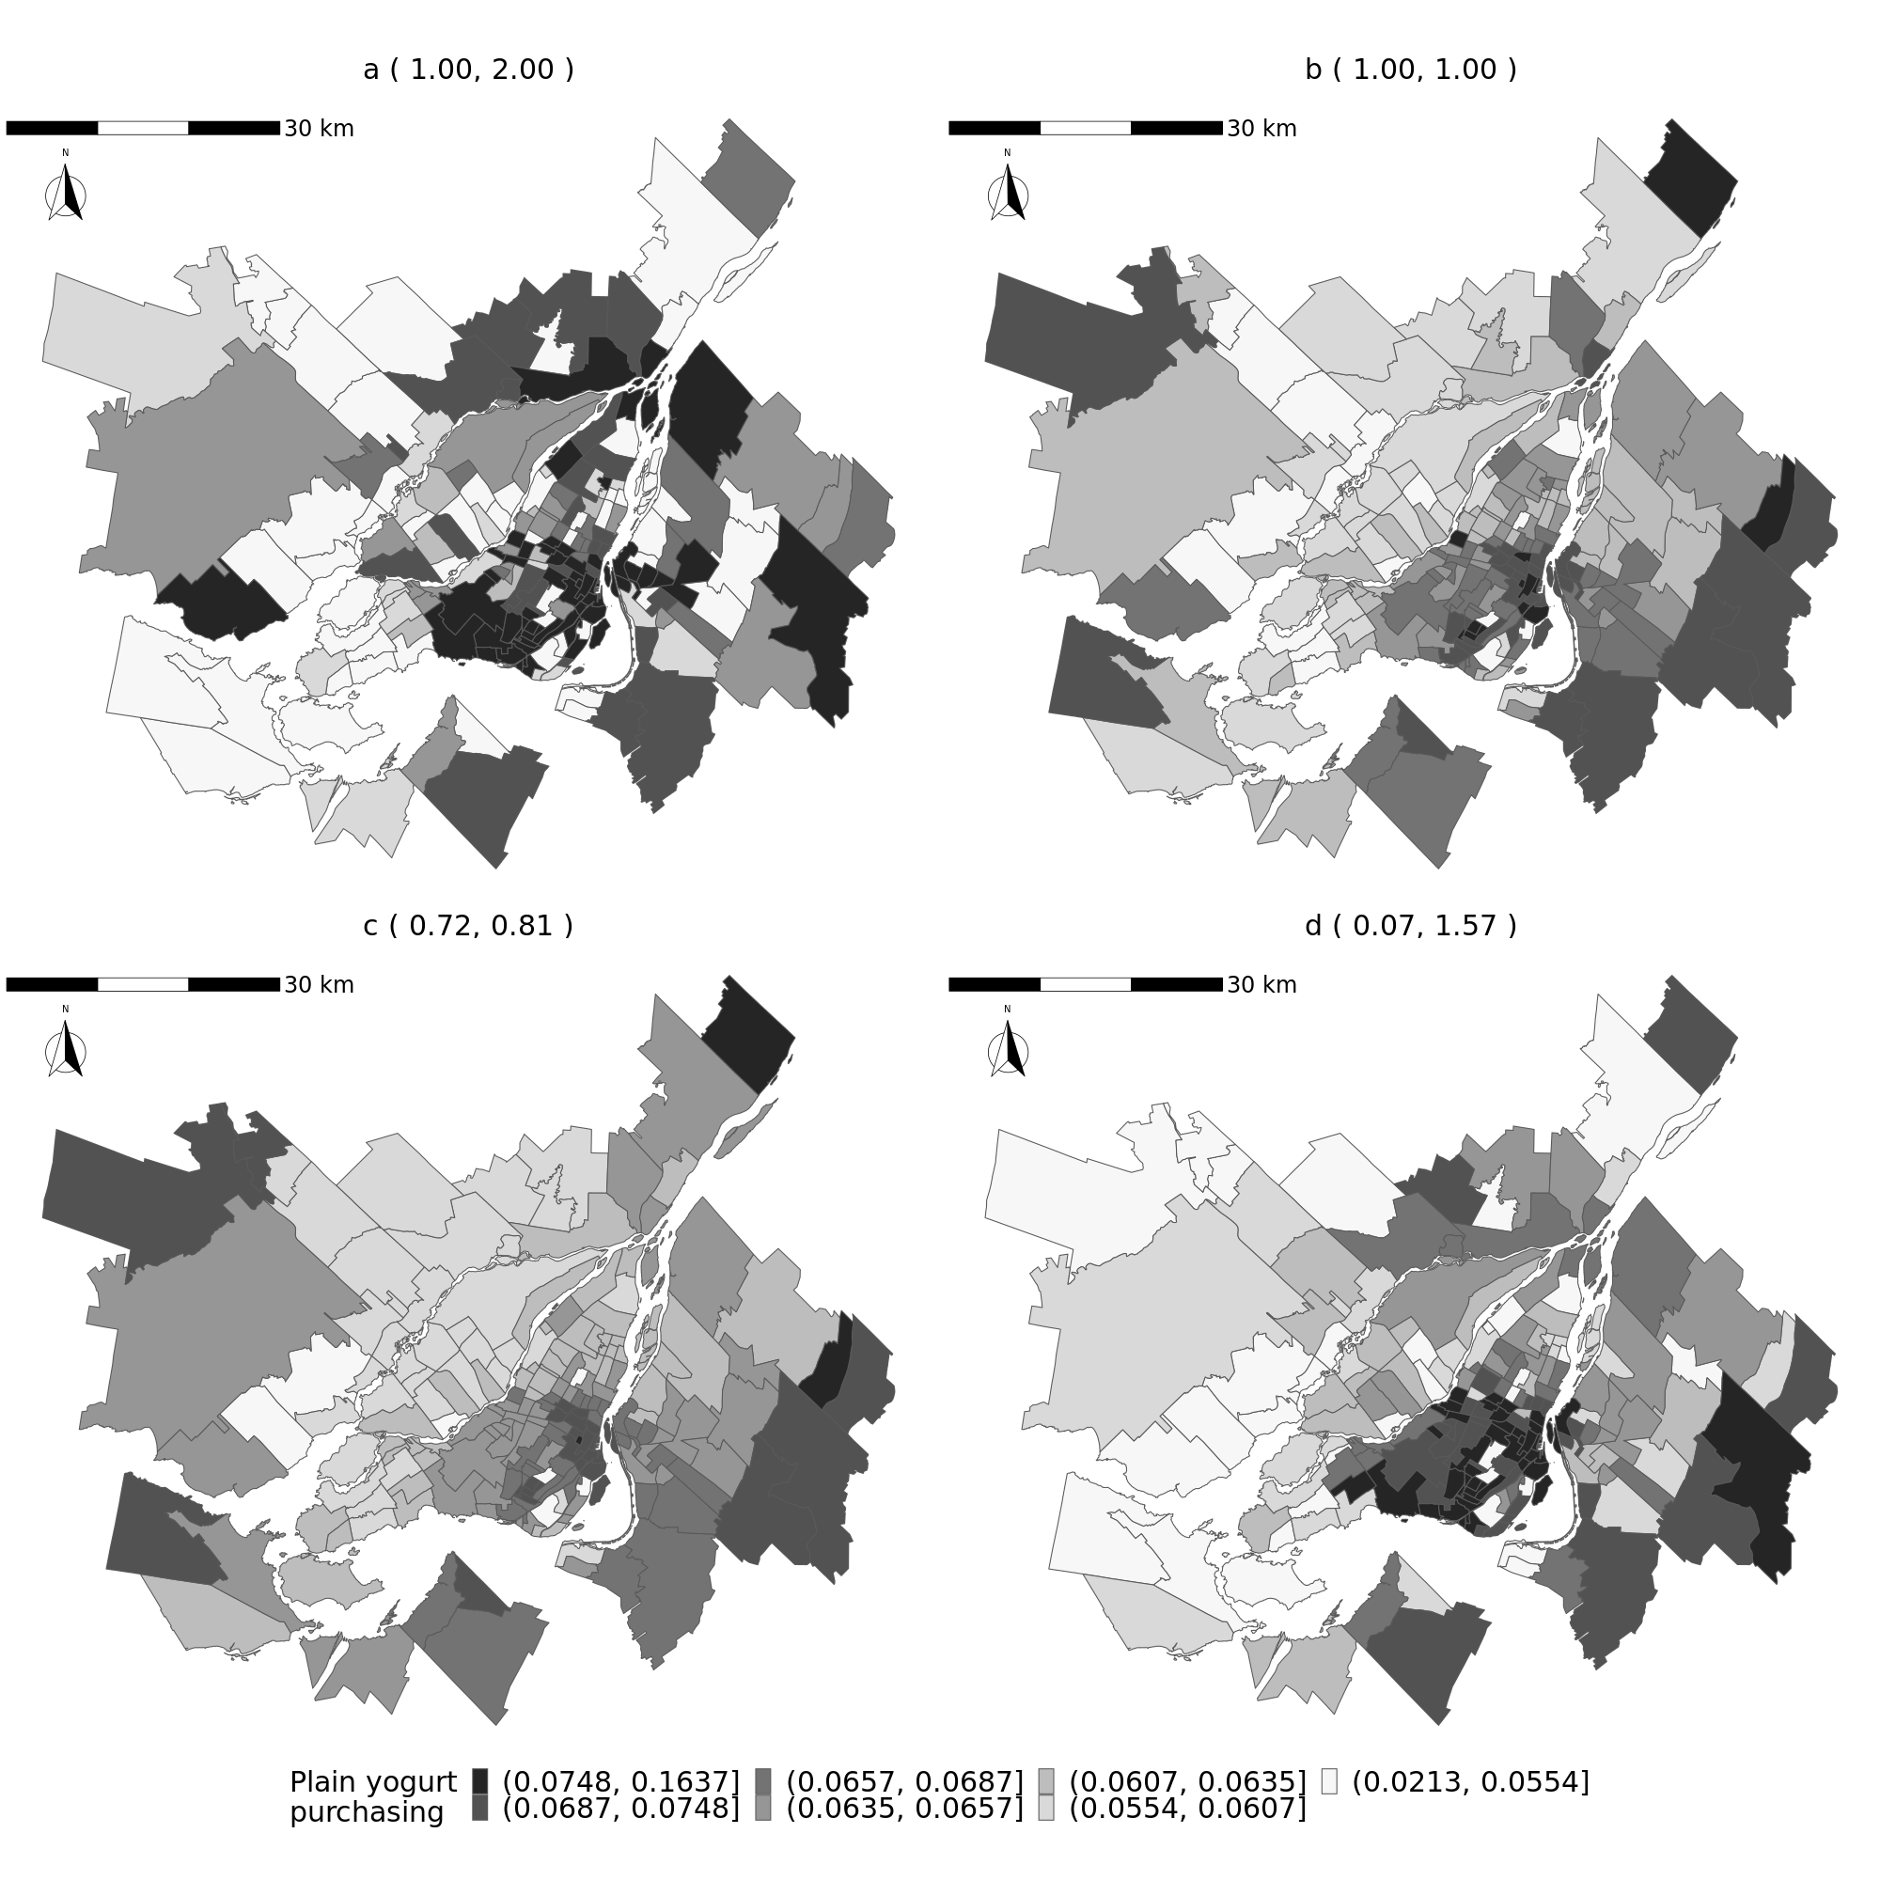

Supplementary Figure S7. Posterior mean of area-level purchasing indicator for plain yogurt as generated by the Huff gravity model with varying value of parameter for store size ($γ$) and distance decay ($λ$).
Panels are a ($γ$ = 1.00, $λ$= 2.00), b ($γ$ = 1.00, $λ$ = 1.00), c ($γ$ = 0.72, $λ$ = 0.81), and d ($γ$ = 0.07, $λ$ = 1.57).
Note that panel a) shows the results from the main analysis. The quantities in the greyscale key represent servings per resident standardized across the four maps.

Supplementary Table S3. Model fit of disease mapping model without and with area-level indicators of food purchasing generated by varying value of the Huff gravity model parameters.
 | No indicators | Indicators  ($γ$=1.00, $λ$=2.00) | Indicators  ($γ$=1.00,$λ$=1.00) | Indicators  ($γ$=0.72, $λ$=0.81) | Indicators  ($γ$=0.07, $λ$=1.57)
WAIC | 1772 | 1765 | 1769 | 1769 | 1767
LOO | 1885 | 1874 | 1874 | 1878 | 1875
Abbreviations: LOO, Leave-One-Out cross-validation, WAIC, Watanabe-Akaike Information Criterion.
Indicators Were Generated by Various Combinations Huff Gravity Model Coefficient for Attraction ($γ)$and Distance Decay ($λ\text{)}$.
The indicators generated by ($γ$=1.00, $λ$=2.00) represents the main analysis.

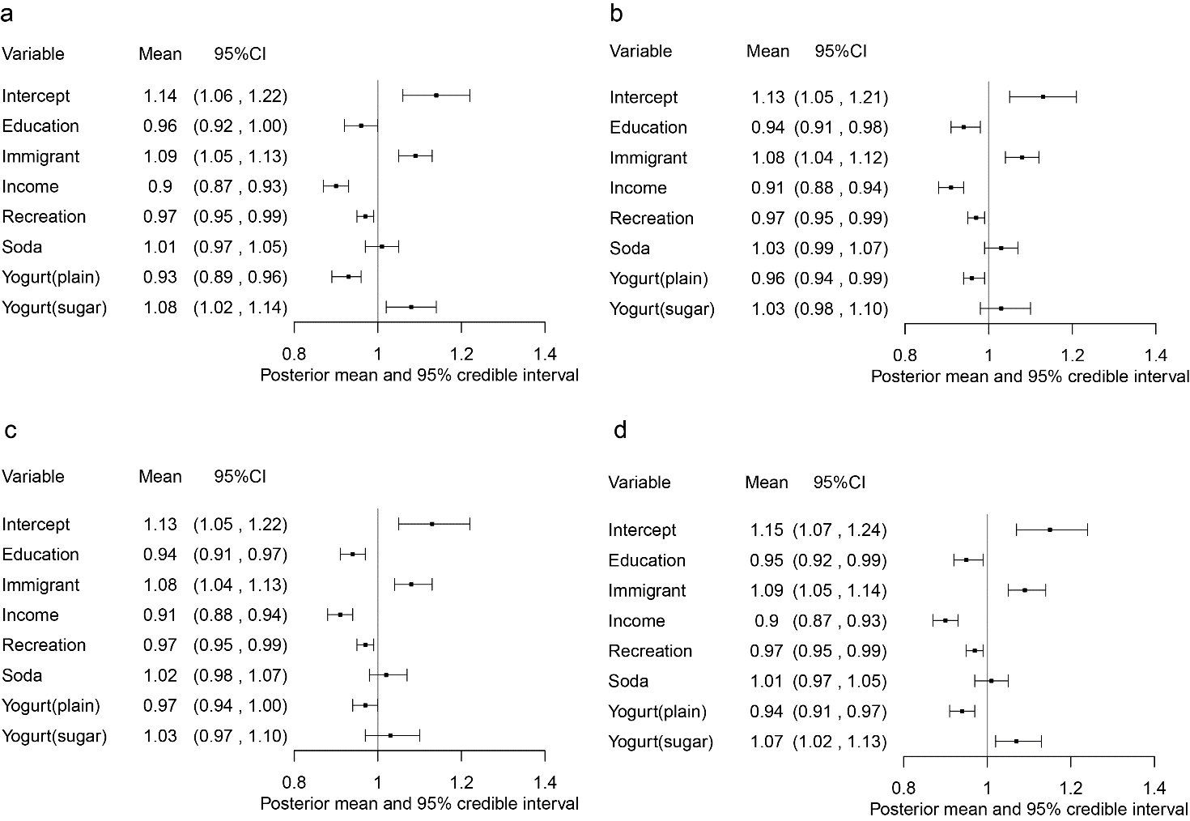

Supplementary Figure S8. Posterior summaries of disease mapping model with purchasing indicators generated by varying value of Huff gravity model parameters.

Parameters for store size ($γ$) and distance decay ($λ$) were; panel a ($γ$ = 1.00, $λ$ = 2.00), panel b ($γ$ = 1.00, $λ$ = 1.00), panel c ($γ$ = 0.72, $λ$ = 0.81), and panel d ($γ$ = 0.07, $λ$ = 1.57). Note that panel a) represents the results of main analysis.

Abbreviations: 95% CI, 95% credible interval; Mean, posterior mean; Recreation, recreational facility per resident.

All covariates were mean cantered and scaled to one standard deviation, and the regression coefficients were exponentiated. The value of coefficients represents an area-level relative risk of type 2 diabetes mellitus, which is the ratio of the risk at one unit increase of the covariates to the risk at mean value of the covariates.
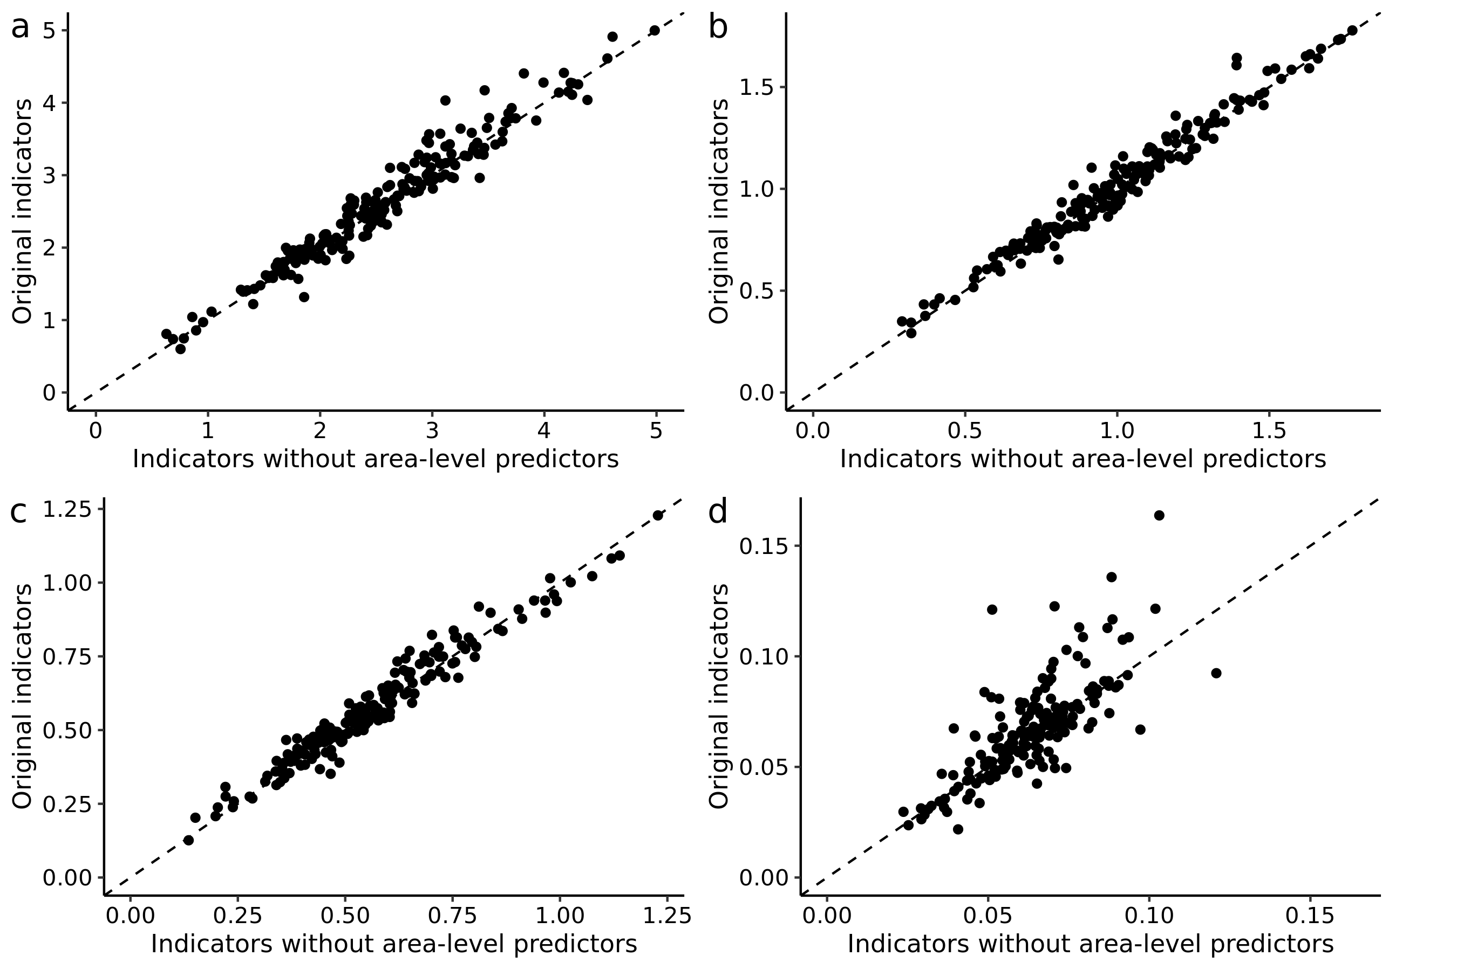

Supplementary Figure S9. Comparison of the posterior mean of 193 area-level purchasing quantity per resident for a) soda, b) diet-soda, c) flavoured yogurt, and d) plain yogurt, where the area-level socio-demographic predictors were included in the sales model as the main analysis (y-axis) and excluded from the sales models as a sensitivity analysis (x-axis).

Note that the results of the sales models (Figure 4, main document) indicate that neighbourhood income and education were weakly predictive of the sales of plain yogurt sales only, and their association were inconclusive (95% CI crossed zero) for the sales of the other food categories.
Axis scales differ across the categories.

Supplementary Table S4. Posterior mean and 95% credible interval of exponentiated coefficients and model fit of neighbourhood-level (n=193) diabetes risk model, without the purchasing indicator (Model 1), with the purchasing indicators (Model 2), and with the purchasing indicators generated by sales models without area-level socio-demographic and economic predictors (model 3).
Parameter |  | Model 1  Without purchasing indicators |  |  | Model 2  With purchasing indicators |  |  | Model 3  With purchasing indicators predicted without area-level fixed effects
 |  | Mean | 95%CI |  | Mean | 95%CI |  | Mean | 95%CI
Intercept |  | 1.1 | (1.03, 1.17) |  | 1.14 | (1.06, 1.22) |  | 1.11 | (1.04, 1.19)
Neighbourhood-level attributes
Education ª |  | 0.92 | (0.89, 0.95) |  | 0.96 | (0.92, 1.00) |  | 0.94 | (0.91, 0.97)
Immigrant ª |  | 1.06 | (1.03, 1.10) |  | 1.09 | (1.05, 1.13) |  | 1.07 | (1.03, 1.11)
Income ª |  | 0.93 | (0.90, 0.96) |  | 0.9 | (0.87, 0.93) |  | 0.91 | (0.88, 0.94)
Recreation ª |  | 0.98 | (0.96, 1.00) |  | 0.97 | (0.95, 0.99) |  | 0.96 | (0.96, 1.00)
Neighbourhood-level purchasing indicators
Soda ^{a, b} |  |  |  |  | 1.01 | (0.97, 1.05) |  | 1.02 | (0.97, 1.07)
Yogurt (plain) ^{a, b} |  |  |  |  | 0.93 | (0.89, 0.96) |  | 0.94 | (0.91, 0.98)
Yogurt (flavoured) ^{a, b} |  |  |  |  | 1.08 | (1.02, 1.14) |  | 1.07 | (1.00, 1.14)
Model fit
LOO |  | 1885 |  |  | 1874 |  |  | 1878
WAIC |  | 1772 |  |  | 1765 |  |  | 1770

Abbreviations: 95% CI, 95% credible interval; LOO, Abbreviation: CRPS, Continuously Ranked Probability Score
, leave-one-out cross-validation, Mean, posterior mean; Recreation, recreational facility per resident; WAIC, Watanabe-Akaike Information Criterion.

ª Variables were mean cantered and scaled to one standard deviation, and the regression coefficients were exponentiated. The value of coefficients represents neighbourhood-level relative risk of T2D, which is the ratio of the risk at one unit increase of the covariates to the risk at mean value of the covariates.

^{b} The value of the indicators represents neighbourhood-level purchasing quantity per resident. The indicator of diet soda was removed from the model due to its strong correlation with soda indicator.

Supplementary Appendix S8. References for supplementary materials
1. Statistics Canada, Government of Canada. North American Industry Classification System (NAICS) Canada 2012: Accessed 2015 Dec 30. http://www23.statcan.gc.ca/imdb/p3VD.pl?Function=getVD&TVD=118464
2. King TL, Bentley RJ, Thornton LE, et al. Using kernel density estimation to understand the influence of neighbourhood destinations on BMI. BMJ Open. 2016;6:e008878.
3. Banerjee S, Carlin B, Alan G. Hierarchical modeling and analysis for spatial data, second edition. 2nd ed. Boca Raton, FL: CRC Press; 2014.
4. Gelfand AE, Sahu SK, Carlin BP. Efficient parametrisations for normal linear mixed models. Biometrika. 1995;82:479–88.
5. Lunn D, Spiegelhalter D, Thomas A, et al. The BUGS project: Evolution, critique and future directions. Statistics in Medicine. 2009;28:3049–67.
6. Sandhu DS. Comparison of aggregate and disaggregate models in predicting shopping centre patronage [Internet] [Thesis]. Simon Fraser University; 1989 : Accessed 2020 May 28. http://summit.sfu.ca/item/4792
7. Kuai X. Examining healthy food accessibility in Baton Rouge, Louisiana using a Huff-modified 2SFCA method. 2015. https://digitalcommons.lsu.edu/cgi/viewcontent.cgi?article=5264&context=gradschool_theses
8. Liang Y, Gao S, Cai Y, et al. Calibrating the dynamic Huff model for business analysis using location big data. arXiv:2003.10857. 2020 : Accessed 2020 May 28. http://arxiv.org/abs/2003.10857
9. Suárez-Vega R, Gutiérrez-Acuña JL, Rodríguez-Díaz M. Locating a supermarket using a locally calibrated Huff model. International Journal of Geographical Information Science. 2015;29:217–33.
10. Waller L, Gotway C. Analyzing Public Health Data. In: Applied Spatial Statistics for Public Health Data. John Wiley & Sons, Ltd; 2004. p. 7–37. (Wiley Series in Probability and Statistics).
11. Besag J, York J, Mollié A. Bayesian image restoration, with two applications in spatial statistics. Ann Inst Stat Math. 1991;43:1–20.
12. Riebler A, Sørbye SH, Simpson D, et al. An intuitive Bayesian spatial model for disease mapping that accounts for scaling. arXiv:160101180. 2016 : Accessed 2019 May 6; http://arxiv.org/abs/1601.01180
13. Carpenter B, Gelman A, Hoffman MD, et al. Stan: a probabilistic programming language. Journal of Statistical Software. 2017;76:1–32.

