Supplementary material
Figure A Flowchart of the study’s participants

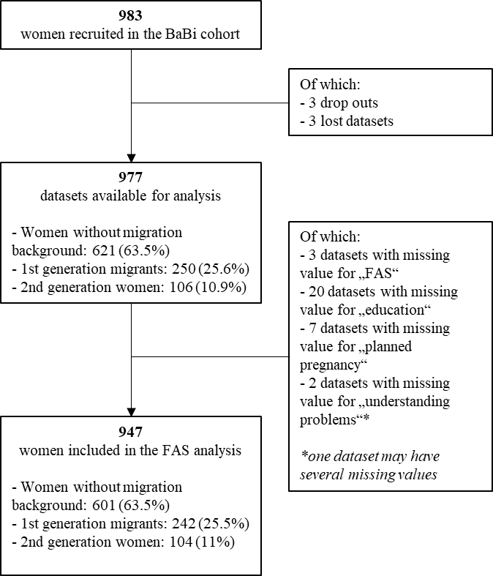

Table A Unadjusted and adjusted odds ratios (OR) of taking folic acid supplement before or during the first trimester of pregnancy (n=947) with interaction term (migration background*education), Bielefeld 2013-2016
Main effect | Unadjusted odds ratio (unOR) | 95% confidence interval |  | p-value | Adjusted odds ratio (aOR) | 95% confidence interval |  | p-value
Age (n=947) | 1.05 | 1.01 | 1.09 | 0.009 | 1.01 | 0.97 | 1.05 | 0.676
Primipara (n=366) (ref=no, n=581) | 1.04 | 0.77 | 1.57 | 0.583 | 0.95 | 0.64 | 1.40 | 0.787
Did not plan the pregnancy (n=201) (ref=planned the pregnancy, n=746) | 0.27 | 0.19 | 0.39 | <.0001 | 0.34 | 0.23 | 0.50 | <.0001
Formal education level (ref=Bachelor degree (or equivalent) and above, n=487)
High school (n=137) | 0.27 | 0.17 | 0.44 | <.0001 | 0.39 | 0.18 | 0.82 | 0.013
Vocational training/diploma (n=323) | 0.45 | 0.31 | 0.68 | 0.0001 | 0.50 | 0.30 | 0.85 | 0.010
Migration status (ref= no migration background, n=601)
2nd/3rd generation woman (n=104) | 1.11 | 0.63 | 1.95 | 0.706 | 1.15 | 0.35 | 3.73 | 0.820
1st generation migrant (n=242) | 0.58 | 0.40 | 0.84 | 0.004 | 0.89 | 0.39 | 2.03 | 0.784
Interaction terms education level*migration background

2nd/3rd gen. woman*low edu. (n=24) | - | - | - | - | 0.60 | 0.14 | 2.61 | 0.593
2nd/3rd gen. woman*middle edu. (n=46) | - | - | - | - | 1.11 | 0.27 | 4.70 | 0.297
1st generation migrant*low edu (n=58) | - | - | - | - | 0.55 | 0.23 | 1.31 | 0.548
1st generation migrant*middle edu (n=93) | - | - | - | - | 0.47 | 0.21 | 1.02 | 0.878
Not native German speaker (n=193) (ref= native speaker n=754) | 0.56 | 0.38 | 0.82 | 0.003 | 0.78 | 0.43 | 1.47 | 0.457
Had understanding problem during antenatal appointments (n=22) (ref= no problem n=925) | 0.42 | 0.17 | 1.04 | 0.061 | 0.86 | 0.28 | 2.64 | 0.799
Originally from Turkey (n=96) (ref= not from Turkey, n=851) | 0.56 | 0.34 | 0.92 | 0.023 | 0.69 | 0.35 | 1.37 | 0.289
In Germany since < 5 years (n=27) (ref=born in Germany or in Germany > 5 years, n=920) | 0.46 | 0.20 | 1.08 | 0.007 | 0.89 | 0.31 | 2.53 | 0.833

Table B Unadjusted and adjusted odds ratios (OR) of taking folic acid supplement before or during the first trimester of pregnancy among women without migration background (n=601), Bielefeld 2013-2016
Main effect | Unadjusted odds ratio (unOR) | 95% confidence interval |  | p-value | Adjusted odds ratio (aOR) | 95% confidence interval |  | p-value
Age (n=601) | 1.13 | 1.07 | 1.18 | <.0001 | 1.07 | 1.01 | 1.13 | 0.025
Primipara (n=263) (ref=no, n=338) | 0.77 | 0.49 | 1.21 | 0.250 | 0.82 | 0.49 | 1.36 | 0.440
Did not plan the pregnancy (n=106) (ref=planned the pregnancy n=495) | 0.17 | 0.11 | 0.28 | <.0001 | 0.22 | 0.12 | 0.38 | <.0001
Formal education level (ref=Bachelor degree (or equivalent) and above, n=362)
High school (n=55) | 0.21 | 0.11 | 0.41 | <.0001 | 0.70 | 0.30 | 1.63 | 0.406
Vocational training/diploma (n=184) | 0.44 | 0.26 | 0.73 | <.0001 | 0.58 | 0.33 | 0.99 | 0.048

Table C Unadjusted and adjusted odds ratios (OR) of taking folic acid supplement before or during the first trimester of pregnancy among women with a migration background (n=346), Bielefeld 2013-2016
Main effect | Unadjusted odds ratio (unOR) | 95% confidence interval |  | p-value | Adjusted odds ratio (aOR) | 95% confidence interval |  | p-value
Age (n=346) | 1.05 | 1.01 | 1.09 | 0.009 | 0.95 | 0.90 | 1.00 | 0.071
Primipara (n=103) (ref=no, n=243) | 1.04 | 0.78 | 1.57 | 0.583 | 1.37 | 0.70 | 2.65 | 0.356
Did not plan the pregnancy (n=95) (ref=planned the pregnancy, n=251) | 0.27 | 0.19 | 0.39 | <.0001 | 0.54 | 0.30 | 0.96 | 0.037
Formal education level (ref=Bachelor degree (or equivalent) and above, n=125)
High school (n=82) | 0.27 | 0.17 | 0.44 | <.0001 | 0.44 | 0.20 | 0.95 | 0.036
Vocational training/diploma (n=139) | 0.45 | 0.31 | 0.68 | 0.0001 | 0.50 | 0.25 | 0.99 | 0.050
Migration status (ref=2nd/3rd generation woman, n=104)
1st generation migrant (n=242) | 0.58 | 0.40 | 0.84 | 0.004 | 0.61 | 0.30 | 1.27 | 0.187
Not native German speaker (n=193) (ref= native speaker, n=153) | 0.56 | 0.38 | 0.82 | 0.003 | 0.88 | 0.43 | 1.69 | 0.675
Had understanding problem during antenatal appointments (n=22) (ref= no problem, n=324) | 0.42 | 0.17 | 1.04 | 0.061 | 0.70 | 0.23 | 2.11 | 0.526
Originally from Turkey (n=96) (ref= not from Turkey, n=250) | 0.56 | 0.34 | 0.92 | 0.023 | 0.85 | 0.43 | 1.69 | 0.646
In Germany since < 5 years (n=27) (ref=born in Germany or in Germany > 5 years, n=319) | 0.46 | 0.20 | 1.08 | 0.007 | 0.75 | 0.27 | 2.08 | 0.586

Table D Unadjusted and adjusted odds ratios (OR) of taking folic acid supplement before pregnancy, looking at country or region of origin (n=947), Bielefeld 2013-2016
Main effect | Unadjusted odds ratio (unOR) | 95% confidence interval |  | p-value | Adjusted odds ratio (aOR) | 95% confidence interval |  | p-value
Age | 1.05 | 1.01 | 1.09 | 0.009 | 1.00 | 0.97 | 1.04 | 0.769
Primipara (n=366) (ref=no, n=581) | 1.04 | 0.77 | 1.57 | 0.583 | 0.95 | 0.82 | 1.52 | 0.782
Did not plan the pregnancy (n=201) (ref=planned the pregnancy, n=746) | 0.27 | 0.19 | 0.39 | <.0001 | 0.34 | 0.23 | 0.50 | <.0001
Formal education level (ref=Bachelor degree (or equivalent) and above, n=487)
High school (n=137) | 0.27 | 0.17 | 0.44 | <.0001 | 0.43 | 0.25 | 0.74 | 0.002
Vocational training/diploma (n=323) | 0.45 | 0.31 | 0.68 | 0.0001 | 0.51 | 0.33 | 0.78 | 0.002
Country or region of origin (ref= no migration background, n=601)
Originally from Turkey (n=96) | 0.56 | 0.34 | 0.92 | 0.023 | 1.02 | 0.52 | 2.01 | 0.955
Aussiedler (n=96) | 1.19 | 0.66 | 2.16 | 0.561 | 1.34 | 0.67 | 2.66 | 0.406
Other (n=154) | 0.70 | 0.45 | 1.10 | 0.102 | 0.97 | 0.52 | 1.81 | 0.935
Not native German speaker (n=193) (ref= native speaker, n=754) | 0.56 | 0.38 | 0.82 | 0.003 | 0.75 | 0.41 | 1.37 | 0.345
Had understanding problem during antenatal appointments (n=22) (ref= no problem n=925) | 0.42 | 0.17 | 1.04 | 0.061 | 0.83 | 0.27 | 2.52 | 0.744
In Germany since < 5 years (n=27) (ref=born in Germany or in Germany > 5 years, n=920) | 0.46 | 0.20 | 1.08 | 0.007 | 0.65 | 0.29 | 2.28 | 0.692

Table E Unadjusted and adjusted odds ratios (OR) of taking folic acid supplement before pregnancy (n=947), Bielefeld 2013-2016
Main effect | Unadjusted odds ratio (unOR) | 95% confidence interval |  | p-value | Adjusted odds ratio (aOR) | 95% confidence interval |  | p-value
Age | 1.05 | 1.02 | 1.07 | 0.001 | 1.00 | 0.97 | 1.04 | 0.773
Primipara (n=366) (ref=no, n=581) | 1.34 | 1.03 | 1.75 | 0.028 | 1.12 | 0.82 | 1.52 | 0.484
Did not plan the pregnancy (n=201) (ref=planned the pregnancy, n=746) | 0.09 | 0.05 | 0.14 | <.0001 | 0.11 | 0.07 | 0.18 | <.0001
Formal education level (ref=Bachelor degree (or equivalent) and above, n=487)
High school (n=137) | 0.16 | 0.10 | 0.26 | <.0001 | 0.30 | 0.18 | 0.52 | <.0001
Vocational training/diploma (n=323) | 0.51 | 0.38 | 0.67 | <.0001 | 0.60 | 0.43 | 0.82 | 0.002
Migration status (ref= no migration background, n=601)
2nd/3rd generation woman (n=104) | 0.87 | 0.58 | 1.31 | 0.491 | 1.17 | 0.65 | 2.09 | 0.600
1st generation migrant (n=242) | 0.44 | 0.32 | 0.59 | <.0001 | 0.72 | 0.45 | 1.14 | 0.159
Not native German speaker (n=193) (ref= native speaker, n=754) | 0.37 | 0.27 | 0.53 | <.0001 | 0.66 | 0.39 | 1.12 | 0.126
Had understanding problem during antenatal appointments (n=22) (ref= no problem n=925) | 0.24 | 0.08 | 0.71 | 0.010 | 0.71 | 0.19 | 2.61 | 0.608
Originally from Turkey (n=96) (ref= not from Turkey, n=851) | 0.52 | 0.33 | 0.81 | 0.004 | 1.13 | 0.61 | 2.11 | 0.698
In Germany since < 5 years (n=27) (ref=born in Germany or in Germany > 5 years, n=920) | 0.24 | 0.09 | 0.65 | 0.005 | 0.65 | 0.21 | 2.09 | 0.474

Table F Unadjusted and adjusted odds ratios (OR) of taking folic acid supplement before or during the first trimester of pregnancy (n=947) controlling for the time at which participants answered the survey (during pregnancy vs. after birth), Bielefeld 2013-2016
Main effect | Unadjusted odds ratio (unOR) | 95% confidence interval |  | p-value | Adjusted odds ratio (aOR) | 95% confidence interval |  | p-value
Interviewed during pregnancy (n=300) (ref=Interviewed post-birth, n=647) | 1.34 | 0.91 | 1.97 | 0.132 | 0.92 | 0.61 | 1.40 | 0.735
Age (n=947) | 1.05 | 1.01 | 1.09 | 0.009 | 1.01 | 0.97 | 1.05 | 0.615
Primipara (n=366) (ref=no, n=581) | 1.04 | 0.77 | 1.57 | 0.583 | 0.94 | 0.64 | 1.39 | 0.769
Did not plan the pregnancy (n=201) (ref=planned the pregnancy n=746) | 0.27 | 0.19 | 0.39 | <.0001 | 0.33 | 0.22 | 0.49 | <.0001
Formal education level (ref=Bachelor degree (or equivalent) and above, n=487)
High school (n=137) | 0.27 | 0.17 | 0.44 | <.0001 | 0.45 | 0.26 | 0.79 | 0.005
Vocational training/diploma (n=323) | 0.45 | 0.31 | 0.68 | 0.0001 | 0.52 | 0.34 | 0.80 | 0.002
Migration status (ref= no migration background, n=601)
2nd/3rd generation woman (n=104) | 1.11 | 0.63 | 1.95 | 0.706 | 1.76 | 0.81 | 3.80 | 0.151
1st generation migrant (n=242) | 0.58 | 0.40 | 0.84 | 0.004 | 0.91 | 0.51 | 1.60 | 0.735
Not native German speaker (n=193) (ref= native speaker, n=754) | 0.56 | 0.38 | 0.82 | 0.003 | 0.80 | 0.44 | 1.49 | 0.484
Had understanding problem during antenatal appointments (n=22) (ref= no problem, n=925) | 0.42 | 0.17 | 1.04 | 0.061 | 0.88 | 0.29 | 2.71 | 0.830
Originally from Turkey (n=96) (ref= not from Turkey, n=851) | 0.56 | 0.34 | 0.92 | 0.023 | 0.73 | 0.37 | 1.42 | 0.351
In Germany since < 5 years (n=27) (ref=born in Germany or in Germany > 5 years, n=920) | 0.46 | 0.20 | 1.08 | 0.007 | 0.88 | 0.31 | 2.48 | 0.810

