Supplemental File.
Figure 1. The Keyhole

Reference: Swedish Food Agency. The Keyhole, https://www.livsmedelsverket.se/produktion-handel--kontroll/information-markning-och-pastaenden/nyckelhalet---foretagsinformation/nedladdning-av-nyckelhalet (accessed Jun 10, 2021).

Figure 2a). Temporal trends of unadjusted mean values of estimated percentage of energy intake of total carbohydrates, total fat and total protein by survey year and sex.
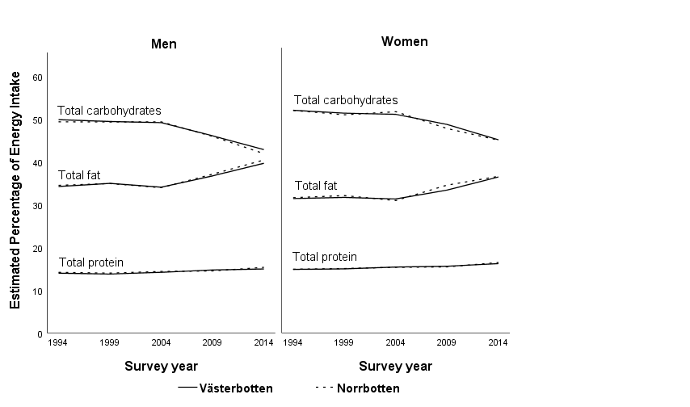

Figure 2b). Temporal trends of unadjusted mean values of Healthy Diet Score (HDS) by survey year and sex.

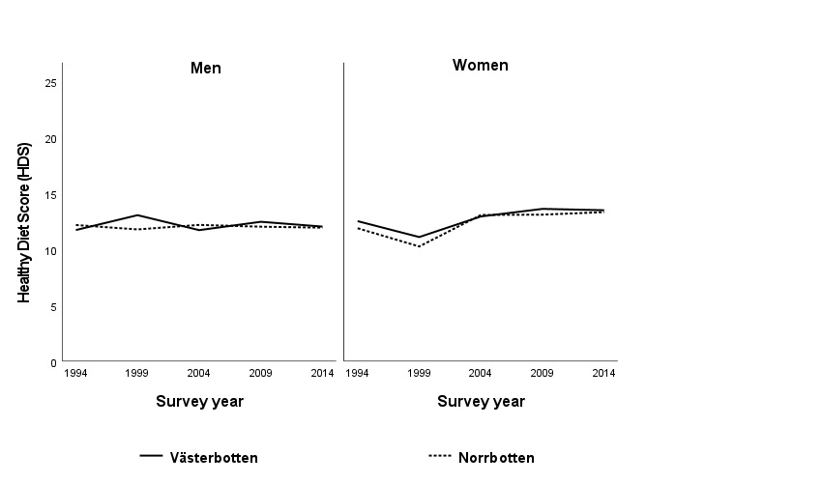

Figure 2c). Temporal trends of unadjusted mean values of intake (servings/day) of healthy food items by survey year and sex. 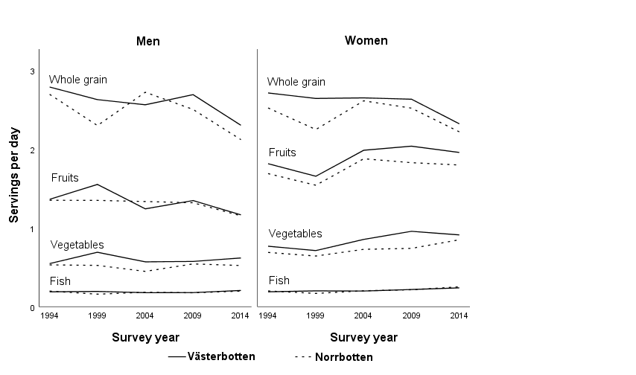

Figure 2d). Temporal trends of unadjusted mean values of intake (servings/day) of unhealthy food items by survey year and sex. 