Supplementary Table S1: COVID-19 Coding Protocol⁽¹⁾
Coding | Definition
Appropriating frontline workers | Frequency with which companies sought to link their products with the work of health professionals, emergency services and other front-line workers during the pandemic
Combatting the pandemic via promotions | As governments started to impose lockdown restrictions, food manufacturers and retailers faced unprecedented challenges –therefore ‘combatting the pandemic’ included:  - Linking increased consumption of food with a sense of civic duty e.g. supporting affected farmers or other workers  - COVID-19 inspired adaptations to marketing campaigns e.g. invoking patriotic duty by encouraging consumers to do their part  - Waiving delivery fees  - Making use of staying at home orders and good hygiene practices
Selling social distancing | Companies have sought to leverage opportunities associated with the distinctive social and economic context of the pandemic, with product promotions exploiting a focus on:  - social distancing  - utilising face masks as advertising space  - inserting brand images into online video communication platforms
Accelerating digitalisation | Companies used the changing social and economic context of lockdown to drive strategic changes in the marketing, promotion and distribution of their products via digital means  - Marketing efforts are made across digital, social and TV platforms for instance popular social media platforms such as ‘TikTok’ or popular games such as Nintendo®’s ‘Animal Crossing’.

Supplementary Table S2: Content analysis of predominant marketing strategies used in Instagram posts from 2019
Account name (Instagram handle) | Region | Top 3 most used marketing strategies |  |  | Marketing strategies (N=15), n | Informational posts, n (%) | Original posts, n (%) | Health claims, n (%)
 |  | 1 (n) | 2 (n) | 3 (n)
Uber Eats (@ubereats_aus) | AU | Product imagery (unbranded) (10) | Celebrities (4) | Sponsorships/partnerships AND  Links (2) | 4 | 10 (100%) | 10 (100%) | 0
Deliveroo (@deliveroo_au) | AU | Sponsorships/partnerships* (19) | Links* (19) | Product imagery (unbranded) (17) | 9 | 25 (100%) | 16 (64%) | 2 (8.0%)
Menulog (@menulog) | AU | Branding elements (6) | Sponsorships/partnerships (5) | Product imagery (unbranded) (4) | 10 | 7 (77.8%) | 8 (88.9%) | 0
Grubhub (@grubhub) | US | Product imagery (unbranded) (29) | Branding elements** (8) | Engagement** (8) | 5 | 37 (100%) | 27 (73.0%) | 0
DoorDash (@doordash) | US | Links (25) | Engagement (18) | Sponsorships/partnerships AND  Product imagery (unbranded) (15) | 10 | 29 (87.9%) | 28 (84.9%) | 0
Just Eat (@justeatuk) | UK | Image with no clear marketing strategy* (12) | Product imagery (unbranded)* (12) | N/A | 2 | 12 (100%) | 12 (100%) | 0
Deliveroo (@deliveroo) | UK | Links (62) | Product imagery (unbranded) (50) | Branding elements (18) | 11 | 67 (97.1%) | 25 (36.2%) | 1 (1.4%)
*Equal first, **Equal second
Supplementary Table S3: Content analysis of predominant marketing strategies used in Instagram posts from 2020
Account name (Instagram handle) | Region | Top 3 most used marketing strategies |  |  | Marketing strategies  (N=15), n | Informational posts, n (%) | Original posts, n (%) | Health claims, n (%)
 |  | 1 (n) | 2 (n) | 3 (n)
Uber Eats (@ubereats_aus) | AU | Sponsorships/partnerships (15) | Links (14) | Branding elements (11) | 8 | 12 (75%) | 16 (100%) | 0
Deliveroo (@deliveroo_au) | AU | Branding elements (14) | Links (11) | Sponsorships/  partnerships (10) | 10 | 19 (100%) | 19 (100%) | 1 (5.3%)
Menulog (@menulog) | AU | Branding elements (31) | Sponsorships/partnerships (24) | Videos/GIFs/boomerangs (19) | 12 | 11 (34.4%) | 32 (100%) | 0
Grubhub (@grubhub) | US | Links (44) | Product imagery (unbranded) (40) | Special price promotions (32) | 8 | 38 (84.4%) | 15(33.3%) | 0
DoorDash (@doordash) | US | Branding elements* (11) | Corporate social responsibility* (11) | Links (9) | 8 | 18 (100%) | 15(83.3%) | 0
Uber Eats (@ubereats) | US | Branding elements (30) | Links** (28) | Engagement** (28) | 11 | 40 (97.6%) | 30 (73.2%) | 0
Just Eat (@justeatuk) | UK | Corporate social responsibility (19) | Videos/GIFs/boomerangs (18) | Branding elements (14) | 11 | 3 (9.1%) | 30 (90.9%) | 0
Uber Eats (@ubereats_uk) | UK | Image with no clear marketing strategy (8) | Product imagery (unbranded)** (3) | Links** (3) | 5 | 6 (60%) | 9 (90%) | 0
Deliveroo (@deliveroo) | UK | Links (125) | Product imagery (unbranded) (106) | Branding elements (58) | 13 | 122 (70.9%) | 160 (93%) | 0
*Equal first, **Equal second

Supplementary Table S4: Reference to COVID-19 in Instagram posts from 2020
Account name (Instagram handle) | Region | COVID-19 related posts during study period | Total posts during study period | Percentage of posts referring to COVID-19
Uber Eats  (@ubereats_aus) | AUS | 2 | 16 | 12.5%
Deliveroo  (@deliveroo_au) | AUS | 14 | 19 | 73.7%
Menulog  (@menulog) | AUS | 8 | 32 | 25.0%
Grubhub  (@grubhub) | USA | 15 | 45 | 33.3%
DoorDash  (@doordash) | USA | 6 | 18 | 33.3%
Uber Eats  (@ubereats) | USA | 20 | 41 | 48.8%
Just Eat  (@justeatuk) | UK | 21 | 33 | 63.6%
Uber Eats  (@ubereats_uk) | UK | 2 | 10 | 20.0%
Deliveroo  (@deliveroo) | UK | 35 | 172 | 20.3%

Supplementary Table S5: COVID-19 Marketing Strategies – Case Studies
Note: all images are publicly available on the relevant Instagram account via the URL.
Strategy | Image 1 | Image 2
Combatting the pandemic | 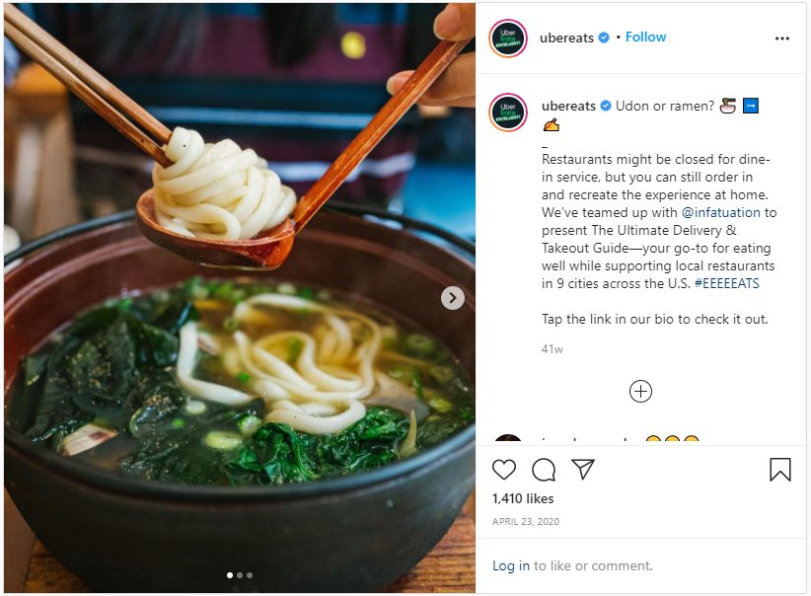  https://www.instagram.com/p/B_TEId2nRTY/ | 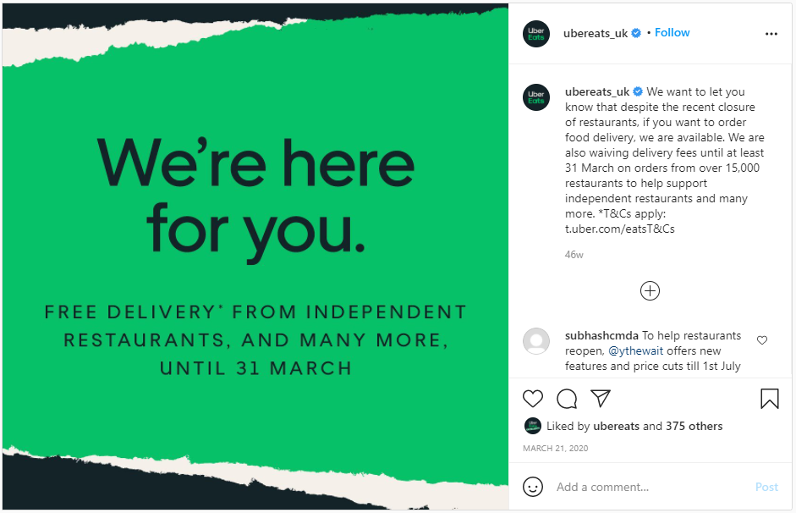  https://www.instagram.com/p/B9-HikxHDnf/
Selling social distancing | 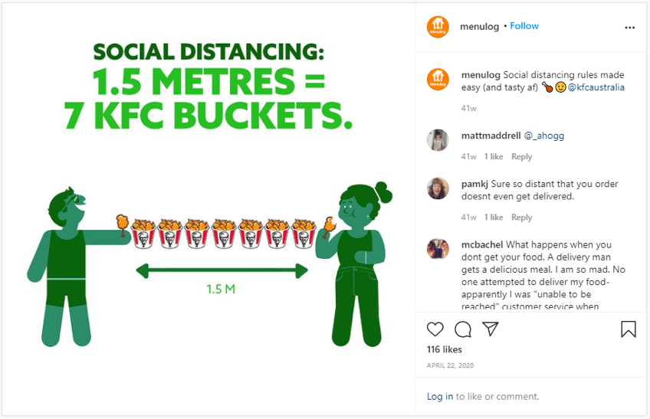  https://www.instagram.com/p/B_Rfdg-Cg1J/
Appropriating frontline workers | 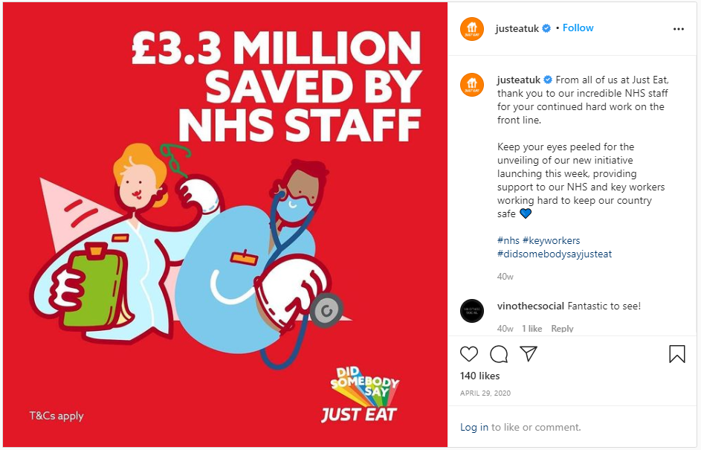  https://www.instagram.com/p/B_iC7OpnaaV/ | 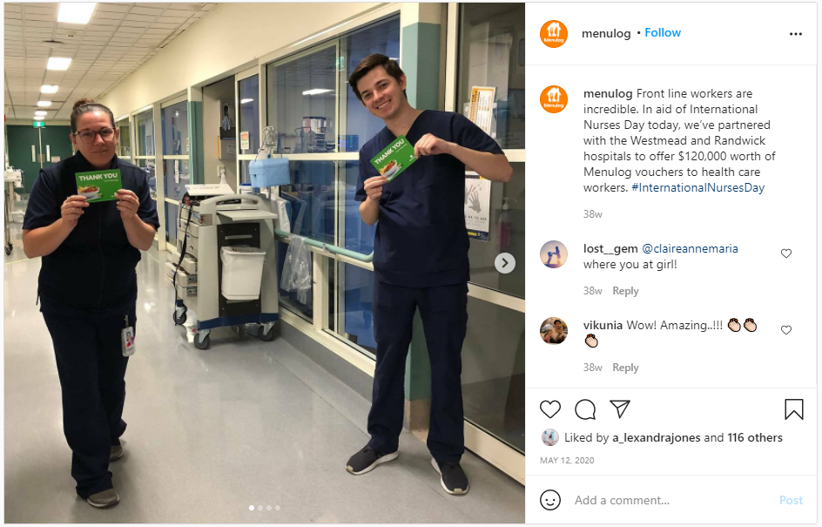  https://www.instagram.com/p/CAE2JSQg7kT/
Accelerating digitalisation | 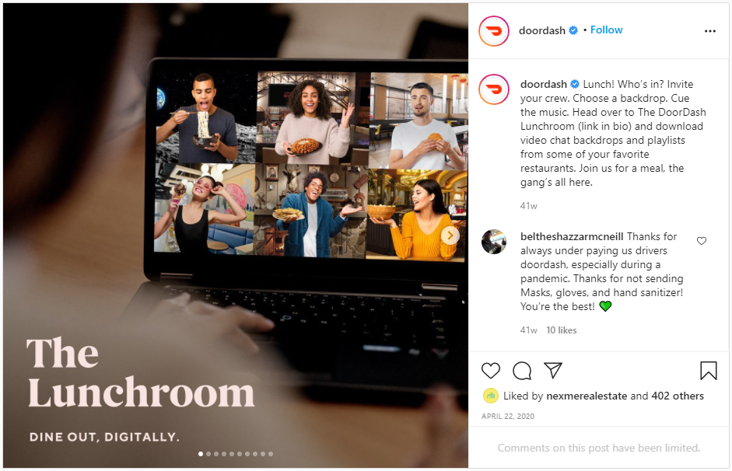  https://www.instagram.com/p/B_QOXI7Hmq0/ | 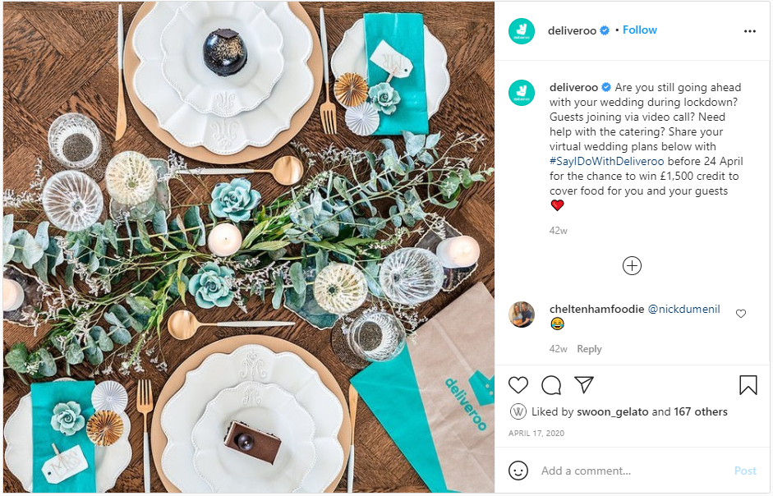  https://www.instagram.com/p/B_FALXYAn2k/
\

Supplementary Table S6: Proportion of Instagram posts with food items and >50% discretionary food items
 |  | 2019 |  | 2020
Account name (Instagram handle) | Region | Posts with at least one food item, n (%) | Posts displaying >50% discretionary food items, n (%) | Posts with at least one food item, n (%) | Posts displaying >50% discretionary food items, n (%)
Uber Eats (@ubereats_aus) | AUS | 10 (100) | 8 (80) | 11 (69) | 7 (64)
Deliveroo (@deliveroo_au) | AUS | 23 (92) | 12 (52) | 11 (58) | 11 (100)
Menulog (@menulog) | AUS | 6 (67) | 5 (83) | 14 (44) | 12 (86)
Grubhub (@grubhub) | USA | 30 (81) | 26 (87) | 38 (84) | 28 (74)
DoorDash (@doordash) | USA | 15 (45) | 8 (53) | 8 (44) | 3 (38)
Uber Eats (@ubereats) | USA | N/A | N/A | 12 (29) | 10 (83)
Just Eat (@justeatuk) | UK | 12 (100) | 1 (8) | 6 (18) | 4 (67)
Uber Eats (@ubereats_uk) | UK | N/A | N/A | 3 (30) | 2 (67)
Deliveroo (@deliveroo) | UK | 63 (91) | 40 (63) | 121 (70) | 77 (64)
TOTAL |  | 159 (82) | 100 (63) | 224 (58) | 154 (69)

