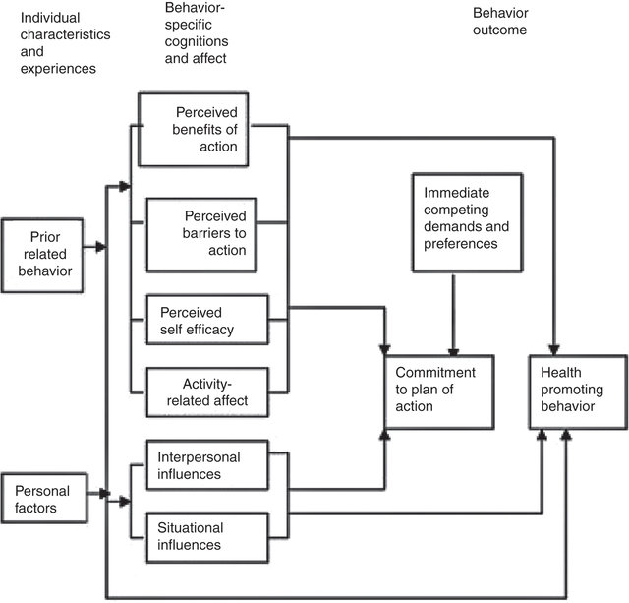

Figure S1. Pender Health Promotion Model

