Supplementary Files

Supplementary file 1. Advertisement images presented in Experimental Task 1

Fanta – No warning condition | Fanta – Warning condition
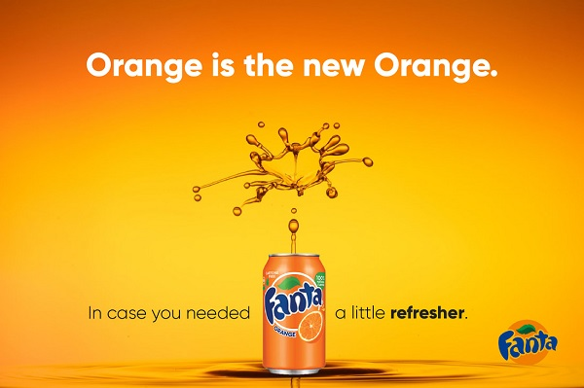 | 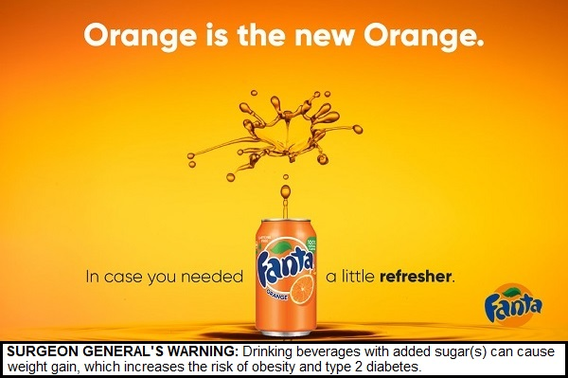
McDonald’s – No warning condition | McDonald’s – Warning condition
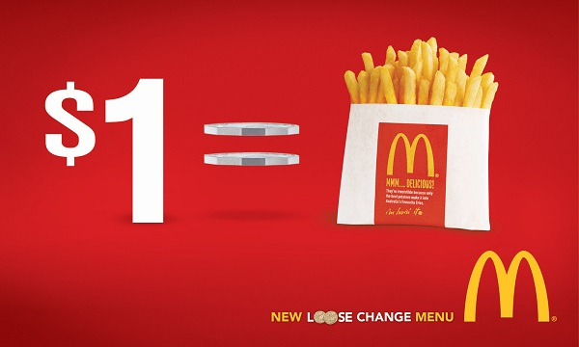

Chocolate Milk – No warning condition | Chocolate Milk – Warning condition
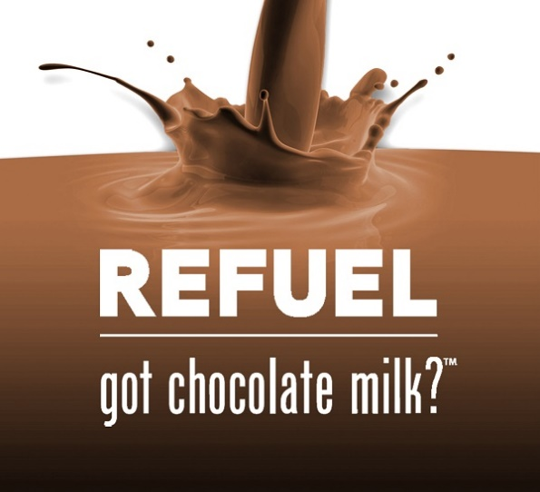 | 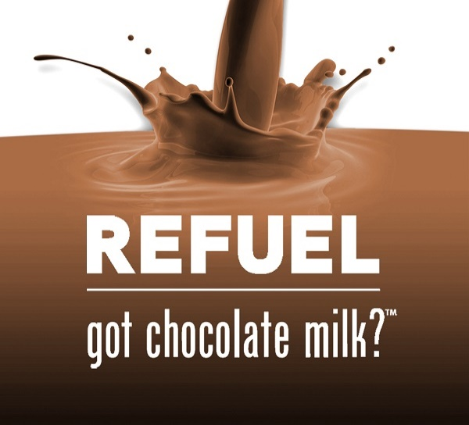
Sprite – No warning condition | Sprite – Warning condition
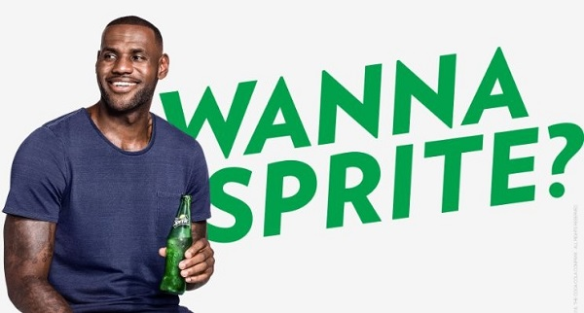 | 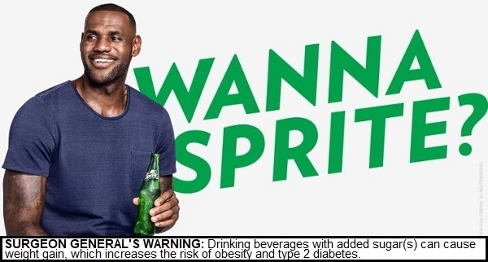
Oreo – No warning condition | Oreo – Warning condition
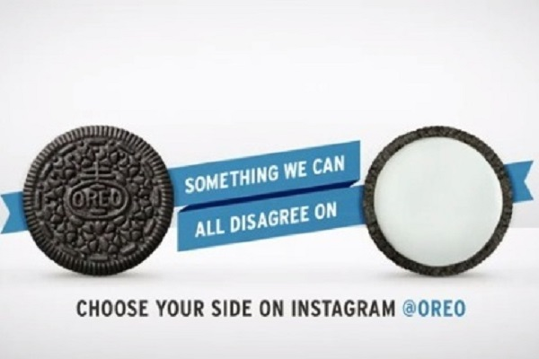

Coca Cola – No warning condition | Coca Cola – Warning condition
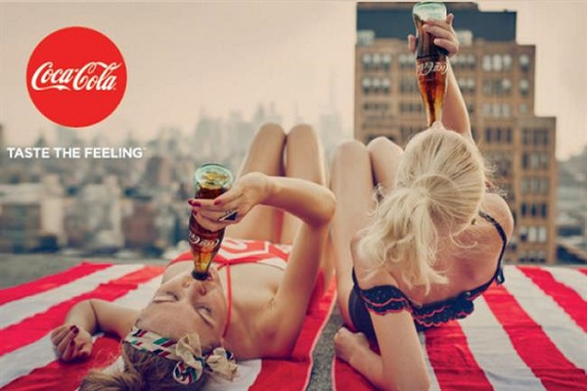 | 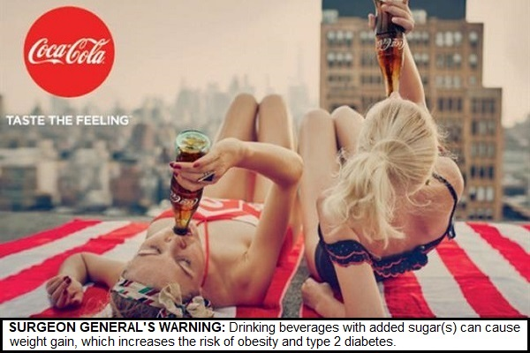
Jones – No warning condition | Jones – Warning condition
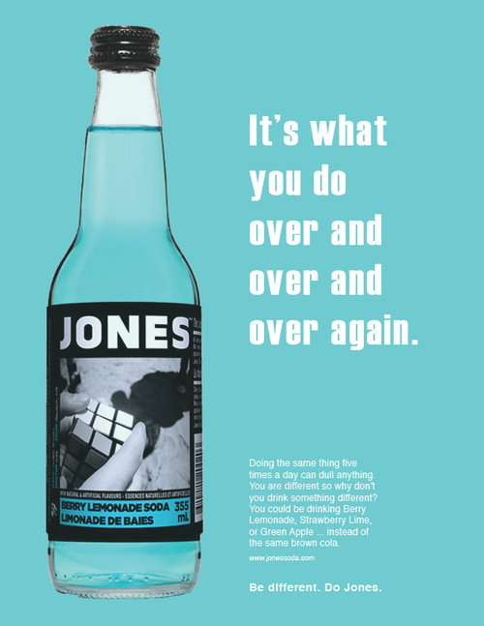 | 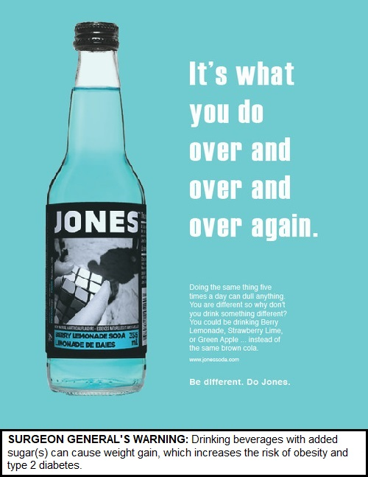
Mountain Dew – No warning condition | Mountain Dew – Warning condition
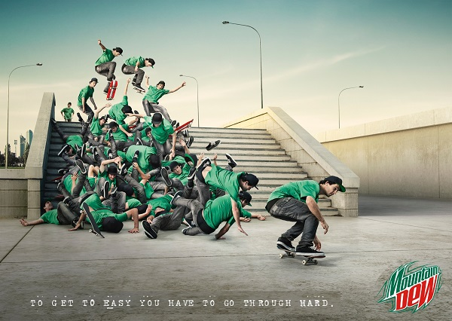 | 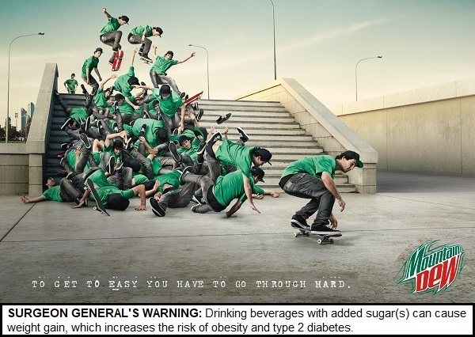
Pepsi – No warning condition | Pepsi – Warning condition
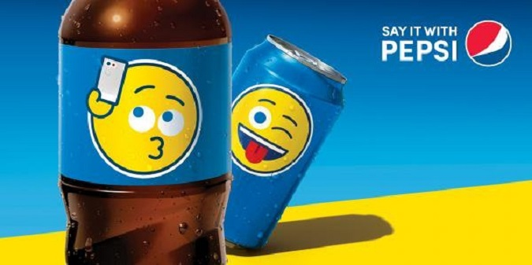 | 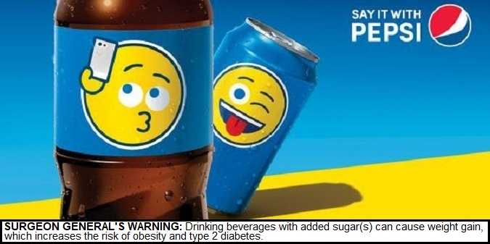

Supplementary file 2. Advertising attributes recalled from last advertisement viewed (Coca Cola or Pepsi)
“Please describe all of the pictures and images you remember seeing in the last ad.” | Overall  n=1,064 | No warning condition  n=541 | Warning condition |  | Noticed warning vs. No Warning Condition | Did not notice warning vs. No Warning Condition
 |  |  | Noticed warning  n=362 | Did not notice warning  n=161 | AOR (95% CI), p-value | AOR (95% CI), p-value
Attributes recalled – Coca Cola ad
“Women” | 21.6% (230) | 22.7% (123) | 24.6% (89) | 11.2% (18) | 1.11 (0.81, 1.52), 0.529 | 0.45 (0.26, 0.76), 0.003
“Buildings/city” | 4.6% (49) | 5.4% (29) | 5.2% (19) | 0.6% (1) | 0.97 (0.53, 1.78), 0.928 | 0.11 (0.01, 0.79), 0.107
“Towels” | 3.9% (42) | 4.8% (26) | 3.9% (14) | 1.2% (2) | 0.80 (0.41, 1.56), 0.503 | 0.27 (0.06, 1.14), 0.075
“Coca Cola bottle” | 8.3% (88) | 10.5% (57) | 7.5% (27) | 2.5% (4) | 0.68 (0.42, 1.10), 0.119 | 0.23 (0.08, 0.65), 0.005
“Roof” | 4.4% (47) | 5.4% (29) | 4.4% (16) | 1.2% (2) | 0.77 (0.41, 1.45), 0.421 | 0.23 (0.05, 0.96), 0.044
“Taste the feeling” | 0.4% (4) | 0.6% (3) | 0.3% (1) | 0.0% (0) | 0.44 (0.05, 4.30), 0.480 | ª
“Coca Cola logo” | 12.6% (134) | 14.3% (77) | 11.0% (40) | 10.6% (17) | 0.74 (0.49, 1.12), 0.157 | 0.72 (0.41, 1.27), 0.257
Attributes recalled – Pepsi ad
“Emoji” | 13.9% (148) | 14.0% (76) | 16.9% (61) | 6.8% (11) | 1.23 (0.85, 1.79), 0.265 | 0.46 (0.24, 0.89), 0.022
“Pepsi can/bottle” | 4.0% (42) | 3.9% (21) | 5.0% (18) | 1.9% (3) | 1.31 (0.69, 2.52), 0.413 | 0.50 (0.15, 1.70), 0.263
“Say it with Pepsi” | 0.4% (4) | 0.4% (2) | 0.6% (2) | 0.0% (0) | 1.59 (0.22, 11.61), 0.645 | ª
“Pepsi logo” | 10.6% (113) | 10.5% (57) | 11.6% (42) | 8.7% (14) | 1.11 (0.73, 1.70), 0.632 | 0.84 (0.46, 1.57), 0.591
“Background colours” | 3.7% (39) | 4.4% (24) | 3.6% (13) | 1.2% (2) | 0.78 (0.39, 1.55), 0.474 | 0.27 (0.06, 1.17), 0.079
Sample size was 540 for ‘No warning condition’ for ‘Coca Cola logo’ (n=1 refused to answer) and 361 for ‘Noticed warning’ condition for ‘Pepsi can/bottle (n=1 refused to answer). Logistic regression models tested for odds of recalling each brand attribute, adjusted for sex, age group, education and ethnicity.
ª No testing conducted due to small cell sizes.

Supplementary file 3. Advertisement images presented in Experimental Task 2

Sam’s – No warning condition | Sam’s – Warning condition
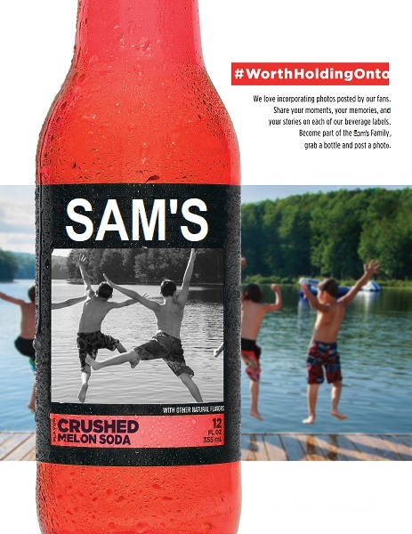 | 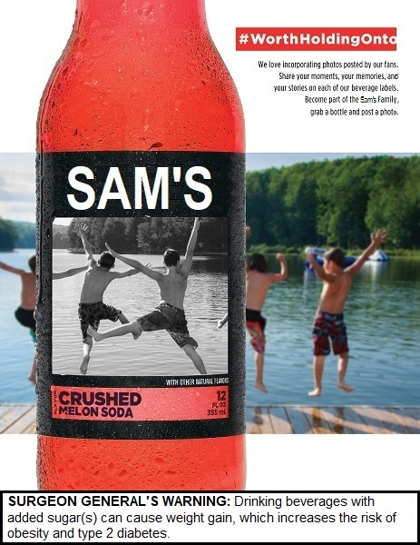

Supplementary file 4. Advertisement viewing time (seconds)
Advertisement | Overall  n=1,064 | No warning condition | Warning condition |  | Noticed warning vs. No Warning Condition | Did not notice warning vs. No Warning Condition
 |  | n=541 | Noticed warning  n=362 | Did not notice warning  n=161 | B (95% CI), p-value | B (95% CI), p-value
 | Mean (SD) | Mean (SD) | Mean (SD) | Mean (SD)
Fanta | 6.0 (3.0) | 5.7 (2.8) | 7.0 (3.0) | 4.6 (2.8) | 1.32 (0.97, 1.68), <0.001 | -0.10 (-1.47, -0.52), <0.001
McDonalds | 4.4 (2.7) | 4.2 (2.4) | 5.4 (2.8) | 3.1 (2.4) | 1.22 (0.89, 1.54), <0.001 | -0.96 (-1.39, -0.52), <0.001
Chocolate milk | 3.8 (2.2) | 3.7 (2.2) | 4.2 (2.3) | 3.2 (2.2) | 0.49 (0.20, 0.77), 0.001 | -0.49 (-0.87, -0.12), 0.010
Sprite | 3.7 (2.4) | 3.3 (1.9) | 4.8 (2.7) | 2.8 (2.1) | 1.60 (1.31, 1.89), <0.001 | -0.42 (-0.80, -0.03), 0.035
Oreos | 4.1 (2.8) | 4.0 (2.7) | 4.9 (2.9) | 2.8 (2.5) | 0.97 (0.62, 1.31), <0.001 | -1.09 (-1.55, -0.63), <0.001
Pepsi ad (shown 6th)† | 3.7 (2.3) | 3.4 (2.1) | 4.5 (2.5) | 2.6 (2.0) | 1.08 (0.67, 1.49), <0.001 | -0.81 (-1.35, -0.26), 0.004
Coca Cola ad (shown 6th)† | 3.6 (2.5) | 3.4 (2.2) | 4.3 (2.7) | 2.5 (2.2) | 0.94 (0.51, 1.38), <0.001 | -0.64 (-1.21, -0.07), 0.027
Jones | 5.4 (3.1) | 5.2 (3.1) | 6.2 (3.1) | 3.8 (2.6) | 1.01 (0.64, 1.39), <0.001 | -1.25 (-1.75, -0.76), <0.001
Mountain Dew | 4.1 (2.8) | 4.1 (2.8) | 4.7 (2.9) | 2.9 (2.2) | 0.56 (0.21, 0.91), 0.002 | -1.12 (-1.58, -0.65), <0.001
Pepsi ad (shown 9th)† | 3.1 (2.2) | 3.1 (2.2) | 3.5 (2.2) | 2.2 (1.9) | 0.41 (0.02, 0.80), 0.040 | -0.69 (-1.20, -0.18), 0.008
Coca Cola ad (shown 9th)† | 3.6 (2.4) | 3.6 (2.3) | 3.9 (2.5) | 2.7 (2.1) | 0.32 (-0.09, 0.74), 0.129 | -0.91 (-1.47, -0.35), 0.001
†Respondents viewed the Pepsi and Coca Cola ads 6th in the list of 9 warnings, while the other half viewed Pepsi. Linear regression models testing differences in mean viewing time, adjusted for sex, age group, education and ethnicity.

