**Testing linearity assumptions between DDS and Gross motor skills domain**

K-density Vs normal density estimates for the residuals Q-norm



Whites test: Output from the White’s test for heteroscedasticity; p value >0.05 (p=0.5504) in favour of the null hypothesis of homogenous variance of the residuals

P-norm

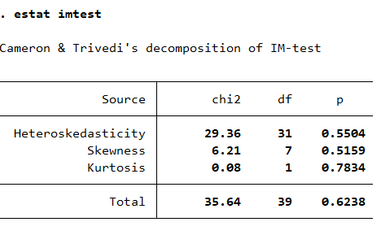

Shapiro-Wilk test for normality of residuals, gross motor

Acpr-lowess plot for linearity between DDS and gross motor domain

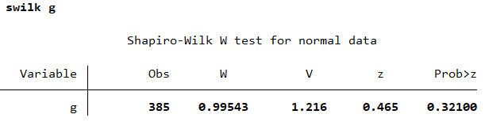



**Testing linearity assumptions between DDS and communication skills domain**

:

K-density Vs normal density estimates for the residuals Q-norm plot

Whites test: Output from the White’s test for heteroscedasticity; p value >0.05 (p=0.3711) in favour of the null hypothesis of homogenous variance of the residuals

P-norm plot

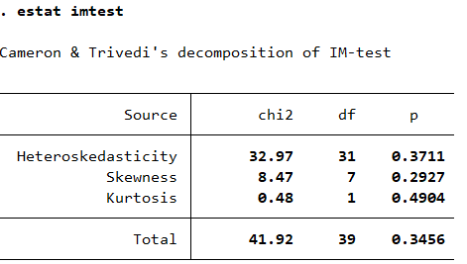

Acpr-lowess plot for linearity between DDS and communication domain

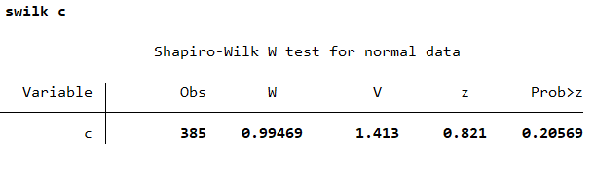Shapiro-Wilk test for normality of residuals, communication

**Testing linearity assumptions between DDS and Fine motor skills domain**

Fine motor

K-density Vs normal density estimates for the residuals Q-norm plot



Whites test: Output from the White’s test for heteroscedasticity; p value >0.05 (p=0.4299) in favour of the null hypothesis of homogenous variance of the residuals

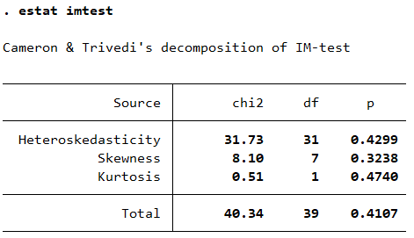P-norm plot for residuals

Acpr-lowess plot for linearity between DDS and fine motor domain

Shapiro-Wilk test for normality of residuals, fine motor

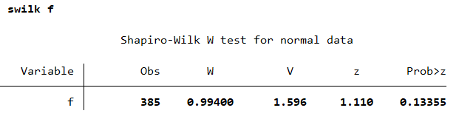

**Testing linearity assumptions between DDS and Personal social skills domain**

K-density Vs normal density estimates for the residuals Q-norm plot



Whites test: Output from the White’s test for heteroscedasticity; p value >0.05 (p=0.6423) in favour of the null hypothesis of homogenous variance of the residuals

P-norm plot for residuals

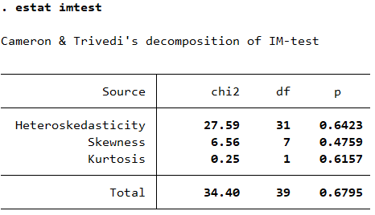

Acpr-lowess plot for linearity between DDS and personal social domain

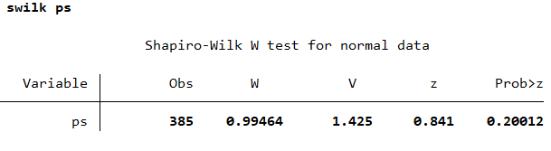Shapiro-Wilk test for normality of residuals, personal social

**Testing linearity assumptions between DDS and Problem solving skills domain**

K-density Vs normal density estimates for the residuals



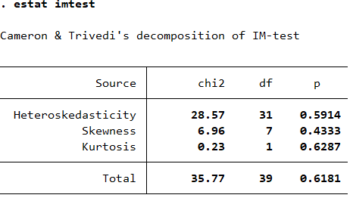P-norm plot for residuals

Whites test: Output from the White’s test for heteroscedasticity; p value >0.05 (p=0.5914) in favour of the null hypothesis of homogenous variance of the residuals

acpr-lowess plot for linearity between DDS and problem solving domain

Shapiro-Wilk test for normality of residuals, problem solving



