Supplementary files

Survey Tool
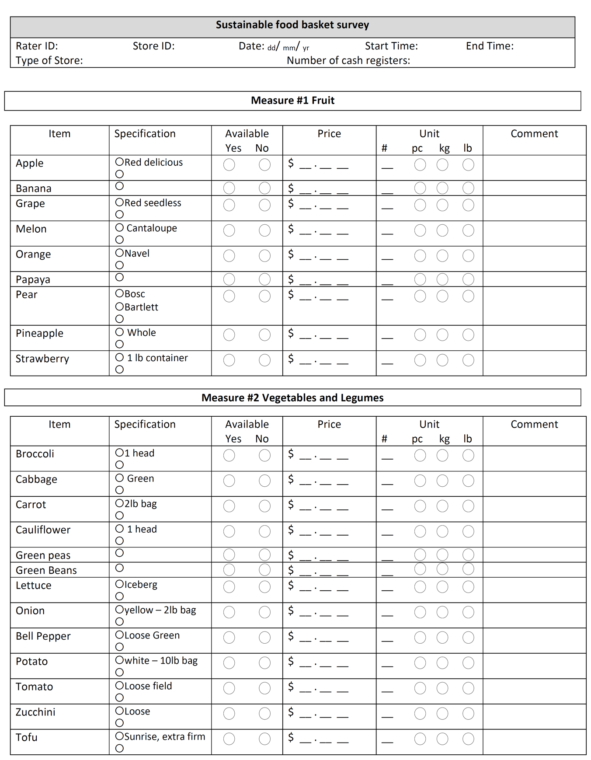
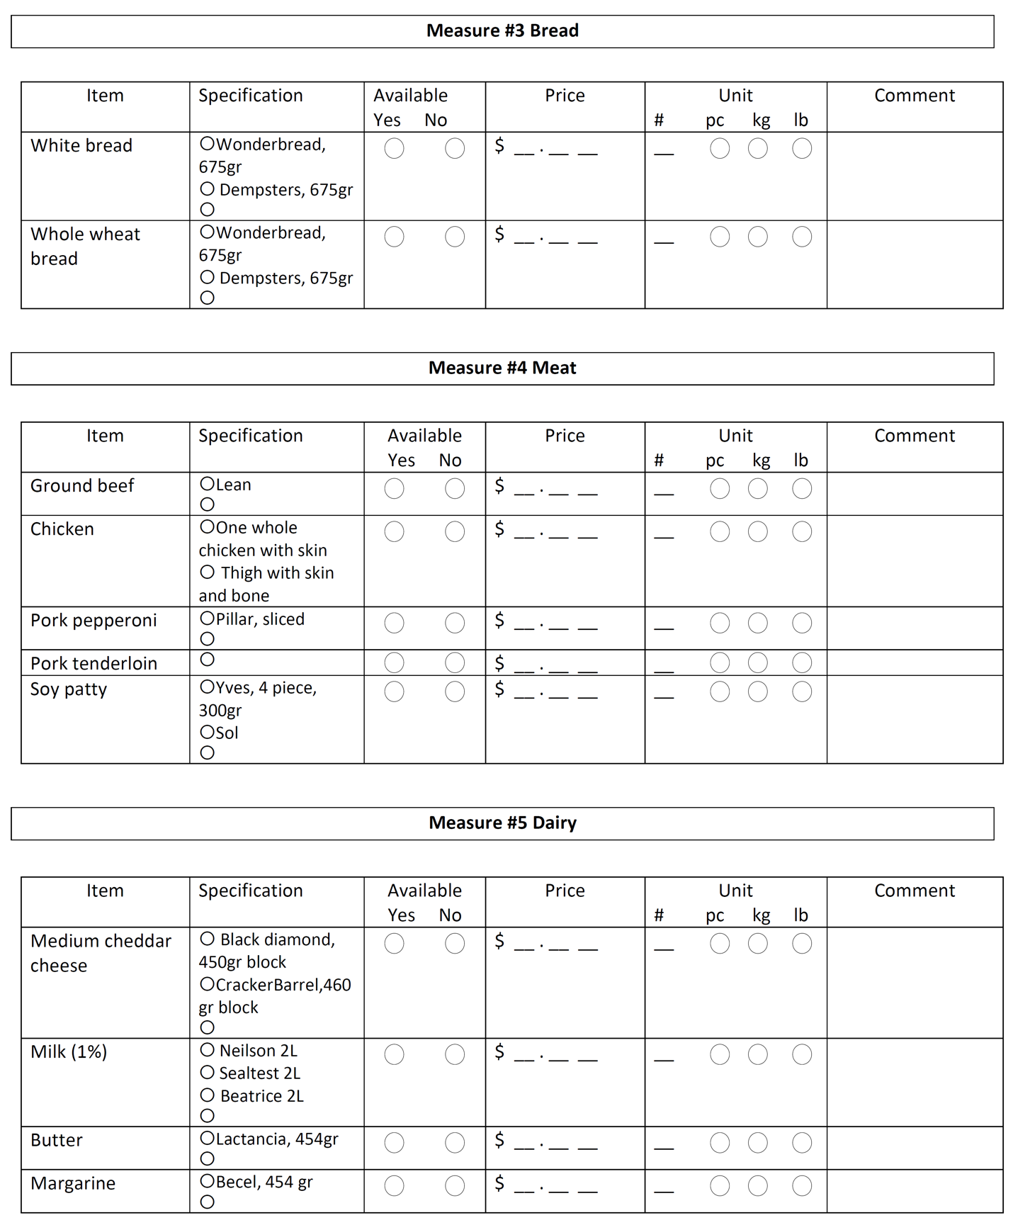

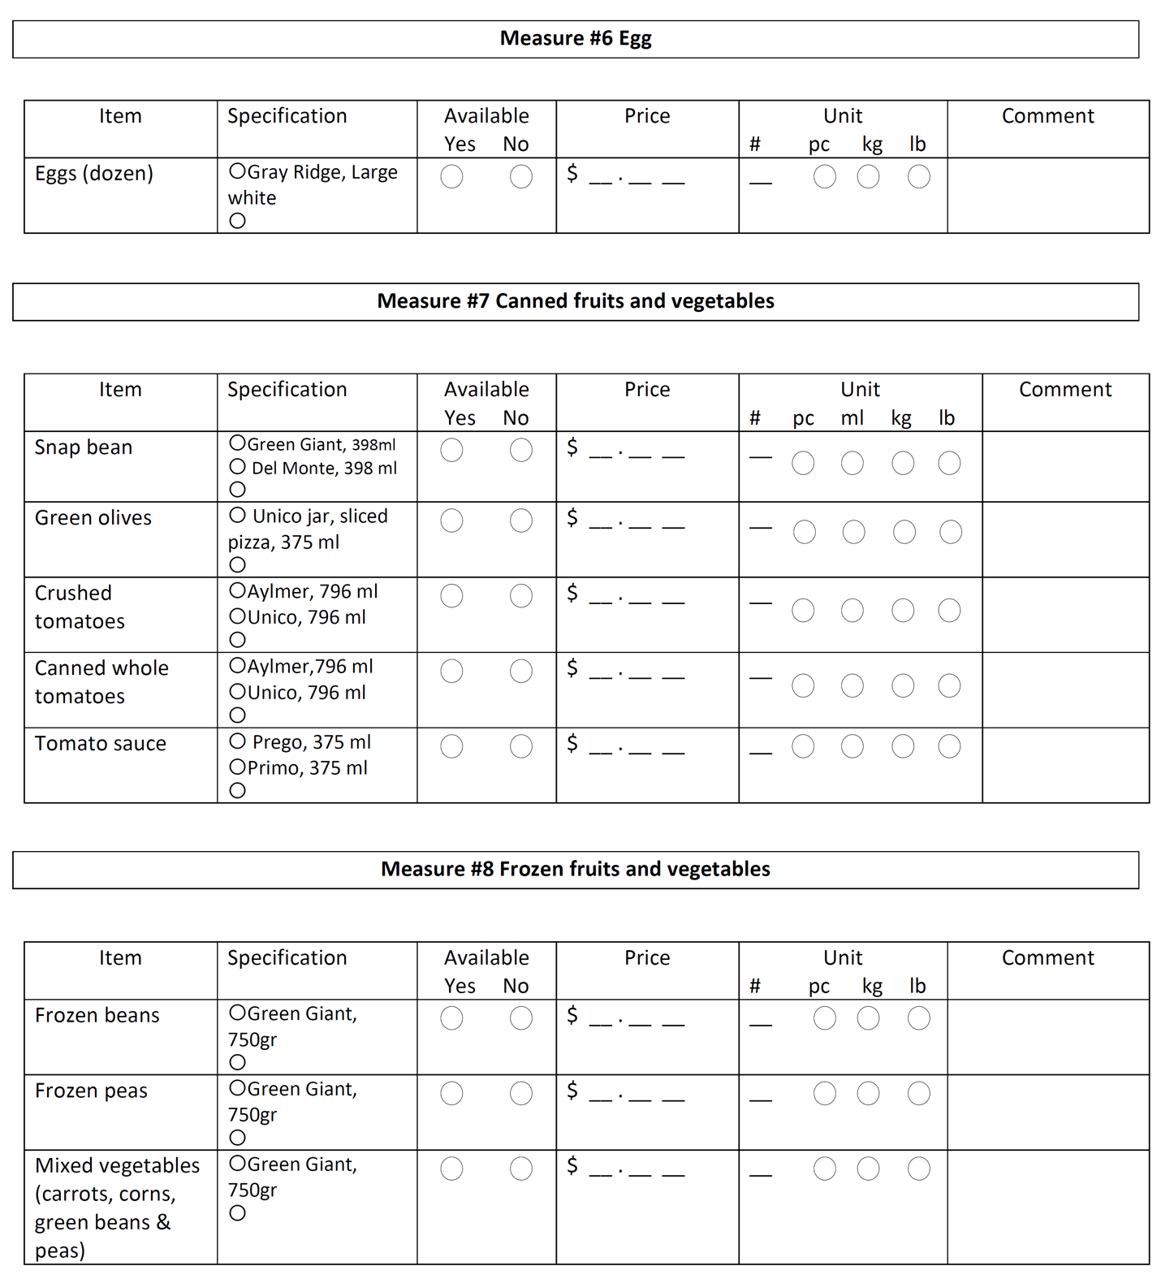

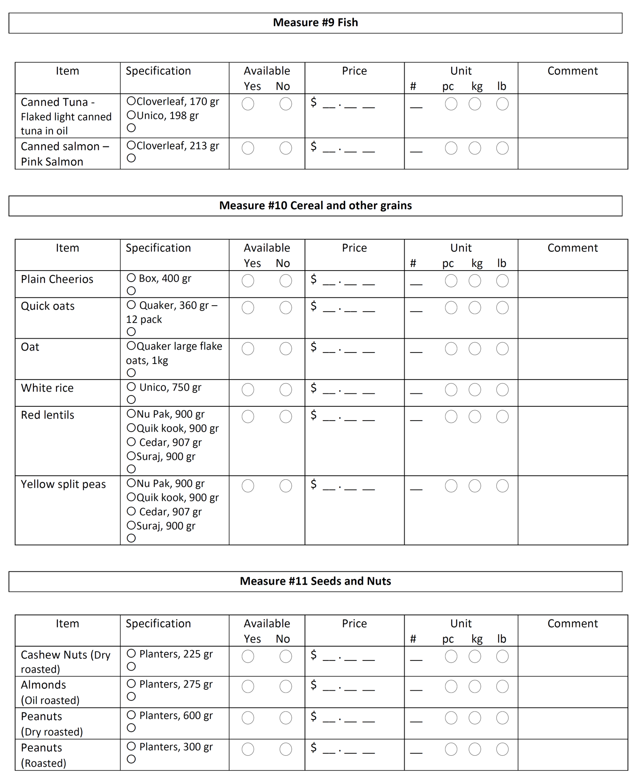

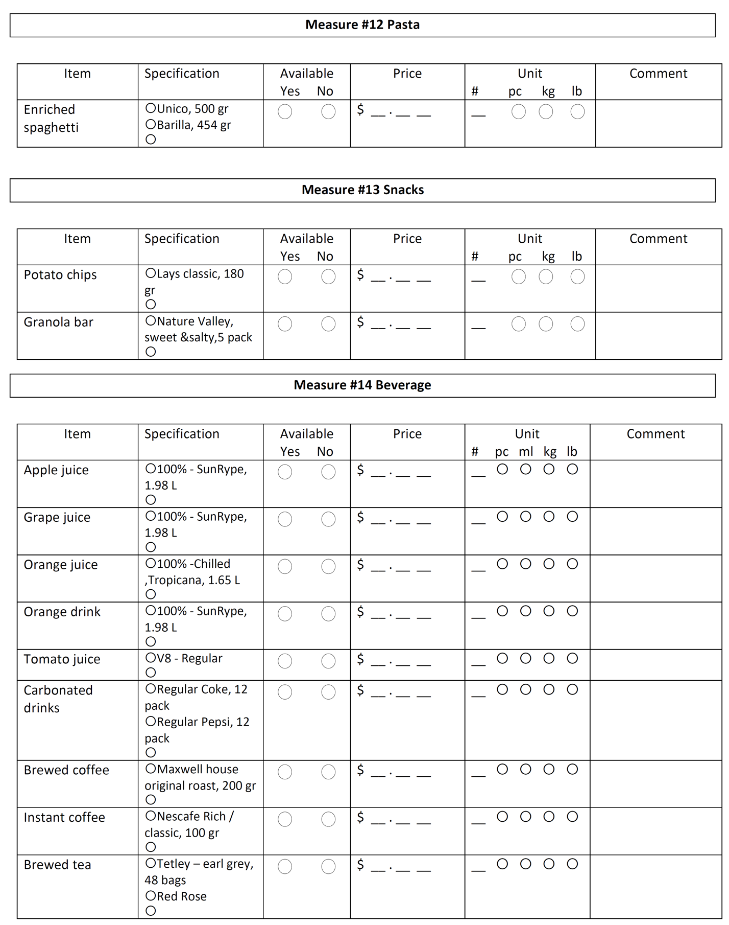

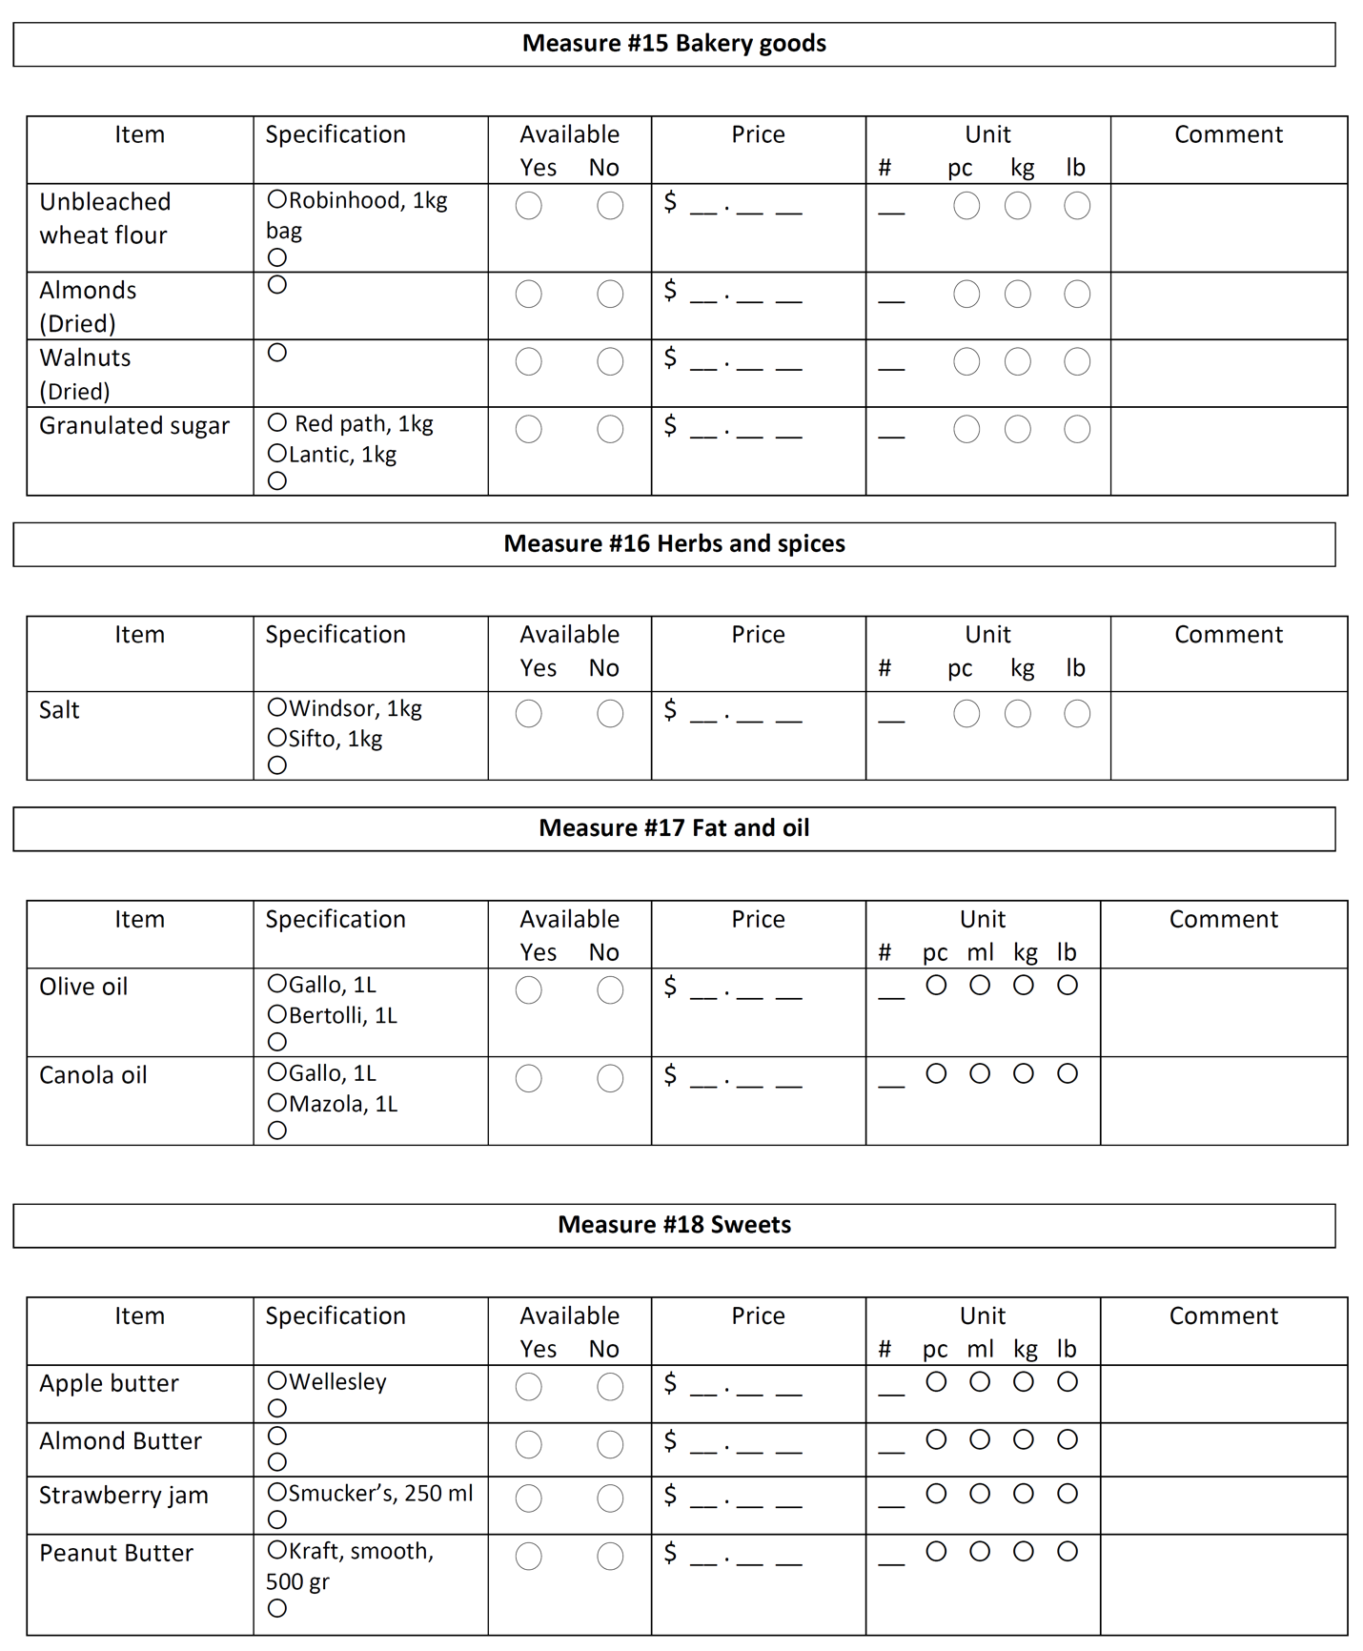

Survey Protocol
Survey Instructions
These measures are designed to price a sustainable food basket for different dietary patterns and assess its affordability.
Instructions
The basic principle of these measures is to gather information on prices of items across stores and types of food, so when possible, rate items within the same brand or exactly as specified.
Time
- Complete grocery store measures between 9 am and 4 pm. (This helps to ensure that items have been stocked for the day and are not sold out.)

Availability
- Before recording any information, first look for the preferred brand or instructed item
- If not available look for the cheapest alternate.
- If an item is sold out, write “sold out” in the Comments section and record any available information. Continue down the list until an item is available or the list has been exhausted

Pricing
- If price is not available, ask an employee at the cash register or at customer service. Wait until all of the measures have been completed before asking the price of the items that are needed. There may be exceptions to this (i.e., you are in the produce section and there is no price shown but an employee is working there), so use your judgment.
- Do not use a sale price unless it is the only price posted and write “sale price” in comments.
- Do not use club card/loyalty card prices unless specifically noted. If used, record both prices if possible

Preparation
At the top of each page, fill in the following:
  - Rater ID
  - Store ID
  - Type of grocery store:
    - D - Discount grocery stores include Food Basics, No Frills, FreshCo, Giant Tiger, Walmart and other stores that heavily market the low prices.
    - R - Regular grocery stores include: Loblaws, Metro, Sobeys, and other grocery stores that do not appear to be “discount stores”.
    - E - Ethnic grocery stores include: T&T and any other store that caters to a specific ethnic or cultural group (often signs are written in English as well as another language)
    - F – farmers markets or daily local markets
    - O - Other grocery stores include: Any grocery store that does not fit in one of the other categories
  - Record whether the store is a chain (C) or independently owned (I).
  - Date
- Start time (when you enter the store)
- End time (when you have finished the measures and reviewed them for completeness)

General guidelines
- Look for the brand indicated in either the protocol or the survey list. If not available choose the alternate suggested brands
- If the indicated brands are not available, look for the cheapest brand. When two or more brands have the same price, choose the one with the most shelf space.
- Make sure the name of any alternate brand is recorded in the comments section.
- When a specific size is indicated, record the price of the pack not price per gr or ml.
- If the indicated size is no available or no size is indicated, record the price of the smallest package available.
- Choose items with their regular price; if an item is on sale calculate the regular price and mention x% sale in the comments section.
- Only if the exact indicated brand and size is available, mark “yes” for availability; if not mark “no”.
- If no specific brand is indicated mark “no” for availability.
- If only a brand name is indicated make sure to record the weight in comments section.
- If no specific brand is indicated, choose the one with the lowest price and the most shelf space.

Measure #1 Fruit
- Find the produce department in the store.
- Look for the fruit listed. If it is available, mark the bubble next to it.
- If it is not available and there is a line below it for an alternate item, look for the cheapest similar alternate. Write it down and mark the bubble next to it. For example, if there are no Red delicious apples and Gala apples are the cheapest alternate, write “Gala” on the line below “Red delicious”.
- If the fruit or alternate is available, mark “yes”. If it is not available, mark “no”. If the item is sold out, write “sold out” in comments and record the available information.
- If the fruit is only available as pre-sliced and in a container, still mark “yes” for available and write “pre-cut in container” and any size information in comments.
- If the fruit is available but mixed with other fruit in a container, mark “no” for available but note the fruit cup contents, price and size in comments.
- Record the regular price of the fruit. If it is on sale and the regular price is not posted, see if it can be calculated based on the sale price label (i.e., add the sales price and the “you save” price) and record it. If the regular price cannot to be calculated based on the sale price label, just record the sale price.
- Always choose the price per kilogram if there is an option.
- Write the quantity (#) of the fruit that is listed for the price. For example, if the sign says 2 for $1.00, write “2” for the quantity. If the sign says 3 lbs for 99¢, write “3” for the quantity.
- If the fruit is not loose but packaged (e.g., pint or container), count the quantity as “1” and write the quantity of the package in comments.
- Indicate if the price of the fruit is calculated by the piece or Kilogram by marking “pc” or “kg”. For example, if the sign says 2 for $1.00, mark “pc” for piece. If the sign says $1.00/kg mark “kg” for kilogram
- If packaging is other than pc/kg (e.g., per pint or bunch), mark “pc” and note under comments.

Measure #2 Vegetables and Legumes
- Find the produce department in the store.
- Look for the vegetables listed. If it is available, mark the bubble next to it.
- If it is not available and there is a line below it for an alternate item, look for a similar alternate. Write it down and mark the bubble next to it. For example, if there are no 2 lb bags of whole carrots but there are 1 lb bags, write “1 lb bag” on the line below “2 lb bag”.
  - For carrots, look for whole carrots. Only select baby or precut carrots as a last resort and make a note in comments.
  - For tomatoes, look for the loose field tomatoes (regular size) first. If not available, look for alternate loose tomatoes. Choose tomatoes on the vine or cherry tomatoes as a last resort and make a note in comments.
- If the vegetable or alternate is available, mark “yes”. If it is not available, mark “no”. If the item is sold out, write “sold out” in comments and record the available information.
- Record the regular price of the vegetable. If it is on sale and the regular price is not posted, see if it can be calculated based on the sale price label (i.e., add the sales price and the “you save” price) and record it. If the regular price cannot to be calculated based on the sale price label, just record the sale price.
  - If the vegetable is not specifically listed as packaged (e.g., okra or bok choy) but is sold as packaged or loose, record the price of the one that is cheapest.
- Write the quantity (#) of the item that is listed for the price. For example, if the sign says 2 for $1.00, write “2” for the quantity. If the sign says $1.00/kg write “1” for the quantity.
  - If the item is sold by the package (e.g., corn), count the quantity as “1” and write the number of the item included in the package in comments (e.g., 3 in package).
- Always choose the price per kilogram if there is an option.
- Indicate if the price of the item is by the piece or pound by marking “pc” or “lb”. For example, if the sign says 2 for $1.00, mark “pc” for piece. If the sign says $1.00/kg, mark “kg” for kilogram.
  - If packaging is other than pc/lb (e.g., per pint or bunch), mark “pc” and note in comments.
  - If an item is packaged and its size is listed in pounds, mark “lb” for kilogram.

Measure #3 Bread
- Find the bread aisle in the store.
- If Wonderbread 100% whole wheat bread is available mark "yes".
- Record the loaf size in grams and price of the loaf. (mark one piece in survey sheets and record the weight of the loaf in comments.)
- If Wonderbread is not available, look for Dempsters 100% Whole Wheat Bread. If that is available, mark “yes” and record the size and price.
- If Dempsters is not available, mark “no” and choose the brand with the lowest price and most shelf space. If there is equal shelf space for different brands, select the one that has a brand name closest to the beginning of the alphabet (e.g., Colonial instead of Sunbeam).
- Write its name, size and price.
- Repeat steps 2-6 for white toast.

Measure #4 Meat
  - Find the fresh meat case in the store.
  - Most stores sell only their own ground beef. If there is meat with a brand name, choose the store brand first.
  - Preferably, locate the lean ground beef with ≤ 17 % fat, it should be labeled Lean. If available, mark yes. Choose the package of lean ground beef closest to 500 grams. Record the prices per kg listed and not the actual price of the package of meat (i.e., the label should have a price/kg and price. Record the price/kg.). Mark “N/A” for the alternate items.
  - If no lean ground beef with ≤ 17% fat is available, mark “no” and look for lean ground beef with ≤ 10% fat usually marked extra-lean. If available, write in the % fat (e.g., 7), mark “yes” and record the price per kg listed. Mark “N/A” for the remaining alternate item.
  - If no lean or extra-lean ground beef is available, look for other ground beef choices. Record details (e.g., regular ground beef) in the comments.

For Tofu and Soy patty:
- Locate the vegetarian section.
- Choose the smallest size possible for each item. Record the weight in comments section.
- Record the price
- If soy patty is not available record the price of an alternative vegetarian patty.

Measure # 5 Dairy
Milk Definitions
- Partly Skimmed: 1% fat
For Milk:
- In the milk aisle, look for Neilsen, Beatrice OR Sealtest as they are the most common brands. If available, record which brand has the most shelf space. Use this brand for all price data.

- If these brands are unavailable, mark “no” and look for the brand with the most shelf space. If there is equal shelf space for different brands, select the one that has a brand name closest to the beginning of the alphabet. Write the name of the brand in the space provided. This brand is now the reference brand for this measure since the preferred was not available.
- Using the reference brand, look for partly skimmed milk. If not available, look for skimmed milk (0% fat) or whole milk. Make sure to record the fat content.
- Record the price of 1L carton of whole milk of the reference brand.
  - If the reference brand does not have milk available in the 1L carton size, select another brand similar in price and write its name in comments.
For Butter and Margarine:
- Find the butter section of the store.
- Locate the Becel margarine.
- Choose the smallest size possible. Record the weight in comments section.
- Record the price
- Repeat the previous steps for unsalted Lactancia butter.

Measure #6 Egg
- Find the eggs section of the store. Look for the products listed.
- Locate the pack of Gray Ridge large white 12 eggs.
- If a 12 pack is not available, choose the smallest package available.
- If possible weight 3 or 4 eggs to calculate the average weight of an egg. If not possible record the weight on the box.

Measure #7 Canned fruit and vegetables
- Find the canned fruit/ vegetables section of the store. Look for the products listed.
- If the listed product is not available look for an alternate brand of the same fruit/ vegetable. Look for the cheapest alternate brand. Look for the cheapest alternate brand. Mark the "other" bubble and write down the brand name.
- If the listed canned fruit or alternate is available, mark "yes". If not available mark "no". If the item is sold out, write "sold out" in comments and record the available information.
- Record the regular price of the canned fruit. If it is on sale and the regular price is not posted, see if it can be calculated based on the sale price label (i.e., add the sale price and the "you save" price) and record it. If the regular price cannot be calculated based on the sale price just record the sale price and note it in the comment section.
- Record the net weight of each can.

Measure #8 Frozen Fruits and Vegetables
- Find the frozen vegetables section of the store.
- Locate the 750 gr pack of frozen peas.
- If the indicated size or brand is not available, look for the smallest pack available from the same brand or the cheapest brand with the most shelf space.
- Record the price.
- Repeat the previous steps for frozen beans and mixed vegetables (carrot, corn, green peas and beans).

Measure #9 Fish
- Find the canned fish section of the store.
- Locate Clover leaf flaked light canned tuna in oil.
- Record the price of one can, if Clover Leaf was not available, look for the cheapest available brand with the most shelf space.
- Make sure to record the net weight of one can in comments.
- Repeat the same steps for Clover leaf canned pink salmon in oil.

Measure #10 Cereal and other grains
For Cereal:
- Look for plain Cheerios.
- Record the smallest size box of Cheerios available in grams listed on the bottom front of the box.
- Record the price.
- If they are not available, look for an alternate. Write its name, marking “yes” under available and follow steps 3-4 for size and price.

For Quick Oat:
- Look for Quaker quick oat and normal oat.
- Record the smallest size box available in grams listed on the bottom front of the box.
- Record the price.
- If they are not available, look for an alternate. Write its name, marking “yes” under available and follow steps 3-4 for size and price.

For Oat:
- Look for the 1kg pack of Quaker oats, not the small packages in one box.
- Record the price.
For Rice:
- Look for long grain white rice.
- Record the smallest size box available in grams listed on the bottom front of the box.
- Record the price.

For Lentil, beans and split peas:
- Record the smallest size available in grams listed on the packaging.
- Record the price.

Measure # 11 Seeds and Nuts
- Look for the seeds and nuts section of the store.
- Look for the different types of nuts indicated in the tool. Make sure to select the correct type of roast or dried nut.
- Find the smallest size box available in grams listed on the bottom front of the box.
- Record the price.
- If they are not available, look for an alternate. Write its name, marking “yes” under available and follow steps 3-4 for size and price

Measure #12 Pasta
- Look for Unico spaghetti.
- Record the smallest size box available in grams listed on the bottom front of the box.
- Record the price.
- If they are not available, look for an alternate.

Measure #13 Snacks
- For grocery stores, go to the MAIN chips/snacks aisle.
- Locate Lays® Potato Chips Classic and mark the 180 g size if available. (Do not choose chips that come in multi-packs). If the 180 g size is not available, mark “other” and write the size that is available.
- If Lays® Potato Chips Classic is not available, mark “no” and look for an alternate classic chips item that is 180g. If the 180 g size is not available, mark “other” and write the size that is available.
- Record the price of the Baked Lays® or the alternate item.

For Granola Bar:
- Locate the 5 pack of sweet& salty Nature Valley granola bars.
- If not available look for another type of granola bars from the same brand.
- If Nature Valley was not available, look for sweet & salty granola bars from the brand with the cheapest price and the most shelf space
- Record the price.

Measure #14 Beverage
Beverage Definitions
- Diet soda - 0 kcal
- Sugared soda – Regular
- 100% juice – Natural fruit juice with no added sugars. Container must say 100% fruit juice on label.
- Juice drink/beverage – Fruit juice with added sugar and water
For fruit/ vegetable juice, and soda:
- Find the shelf-stable beverage section of the store.
- Locate the 12 pack of regular can/ bottle size (330 ml). If not available choose the smallest size.
- Look for the diet soda. If not available choose the regular.
- Repeat the previous steps for fruit/ vegetable juice.
- For the juices look for 100% natural juice. If not available choose the closest option.
- For Orange drink look for 100% chilled Tropicana 1.65 L.

For Tea:
- Find the tea section of the store.
- Locate the Tetley tea bag, original black tea. Choose the 48 tea bags package .
- If Tetley is not available, look for Red Rose or Lipton.
- Record the price

For Coffee:
- Find the Coffee section of the store.
- Locate the Nescafe instant coffee. Choose the 100 gr jar.
- Record the price.
- Repeat the previous step for Maxwell house original roast brewed coffee. Choose the 200 gr pack.

Measure #15 Baking Goods
For Flour:
- Find the flour section of the store.
- Locate the Red Rosses wheat flour and choose the 1 kg size.
- If the indicated size is not available choose the smallest size possible. Record the weight in comments section.
- Record the price.

For Sugar:
- Locate the 1kg granulated sugar.
- If the indicated size is not available choose the smallest size possible. Record the weight in comments section.
- Record the price.

For Nuts:
- Look for the dried almonds and walnuts.
- Find the smallest size pack available in grams listed on the bottom front of the box.
- Record the price.

Measure #16 Herbs and spies
- Find the Spices section of the store.
- Locate the salt and choose the 1 kg size.
- If the indicated size is not available choose the smallest size possible. Record the weight in comments section.
- Record the price.

Measure #17 Fat and oil
For oil:
- Find the Oil section of the store.
- Locate 1L Gallo olive oil.
- If the indicated size is not available choose the smallest size possible. Record the weight in comments section.
- Record the price.
- Repeat the previous steps for 1L Gallo Canola oil.

Measure #18 Sweets
For Jam:
- Find the Jam section of the store.
- Locate the Smucker’s strawberry jam. Choose the 250 ml jar.

- If the indicated size is not available choose the smallest size possible (not the single portion jars). Record the weight in comments section.
- Record the price.

For Fruit Butter:
- Locate the Wellesley apple butter.
- If the indicated size is not available choose the smallest size possible. Record the weight in comments section.
- Record the price

Additional Tables
Table 1 - Average, Minimum and Maximum Prices of Food Groups For Discount And Regular Stores, And The Price Difference Between The Averages (In Canadian Dollars For 2017). Prices Are Per Kg or L (For Liquid Food Items).
Food Group | Regular Stores Prices ª |  |  | Discount Stores Prices
 | Min | Max | Mean | Min | Max | Mean
Vegetables and fruits
Fresh | 3.36 | 6.75 | 4.94 | 2.46 | 8.40 | 4.94
Canned | 3.03 | 5.04 | 4.12 | 2.83 | 5.25 | 3.97
100% Juice | 2.72 | 3.45 | 3.12 | 1.42 | 3.57 | 2.86
Frozen | 4.65 | 5.59 | 5.22 | 3.52 | 5.72 | 4.77
Grain Products
Flour | 2.40 | 4.64 | 3.56 | 1.90 | 4.29 | 3.03
Bread | 4.87 | 5.17 | 4.96 | 2.92 | 6.36 | 4.48
Pasta (spaghetti) | 4.14 | 8.79 | 6.35 | 1.41 | 7.36 | 5.03
Others ^{b} | 6.60 | 7.77 | 7.56 | 4.64 | 8.59 | 7.01
Milk and alternatives
Milk | 0.75 | 2 | 1.67 | 1.84 | 2.75 | 2.07
Cheese | 13.31 | 18.65 | 16.87 | 11.04 | 19.05 | 15.62
Oil and Fats
Oils and margarine | 7.65 | 9.53 | 8.58 | 5.75 | 10.68 | 8.11
Butter | 12.75 | 14.74 | 13.67 | 8.74 | 21.96 | 13.37
Drinks
Tea & coffee | 44.19 | 64.12 | 54.27 | 20.64 | 60.36 | 43.39
Soft drinks and juice drinks | 1.52 | 2.70 | 2.11 | 1.19 | 2.73 | 1.82
Snacks, sweets, and salt | 10.55 | 13.22 | 12.19 | 6.99 | 13.97 | 10.89
Meat and alternatives
Meats
Beef | 9.46 | 17.51 | 14.95 | 6.35 | 16.76 | 12.63
Pork | 17.38 | 21.85 | 20.27 | 12.84 | 26.65 | 19.58
Chicken | 4.94 | 9.02 | 6.64 | 4.39 | 11.65 | 7.23
Fish (Canned) | 11.08 | 22.27 | 15.95 | 10.39 | 20.97 | 14.59
Nuts and nut butters | 17.25 | 29.23 | 25.19 | 14.87 | 31.88 | 23.15
Pulses | 6.82 | 10.70 | 8.48 | 4.67 | 11.31 | 7.83
Egg | 2.93 | 4.63 | 3.24 | 2.32 | 5.64 | 3.48

ª Prices are per unit (per 1kg or per 1L)
^{b} Cereal, rice, oats and quick oats

Table 2- Prices of Food Groups For Urban and Rural Areas, and The Price Difference Between The Means (In Canadian Dollars For 2017). Negative Numbers Indicate That Rural Store Prices Were Higher Than Urban Store Prices.
Food Group | Urban Prices |  |  | Rural Prices
 | Min | Max | Mean | Min | Max | Mean
Vegetables and fruits
Fresh | 2.73 | 7.39 | 4.67 | 2.59 | 8.39 | 5.27
Canned | 2.65 | 5.31 | 3.95 | 2.82 | 5.29 | 4.09
100% Juice | 1.71 | 3.57 | 2.83 | 1.14 | 3.57 | 3.05
Frozen | 3.52 | 5.59 | 4.73 | 3.99 | 5.72 | 5.10
Grain Products
Flour | 2.00 | 5.49 | 3.22 | 1.79 | 4.29 | 3.25
Bread | 3.53 | 6.36 | 4.74 | 2.92 | 5.48 | 4.59
Pasta (spaghetti) | 3.45 | 8.79 | 5.64 | 1.41 | 8.79 | 5.39
Others | 4.61 | 8.56 | 7.03 | 5.88 | 8.41 | 7.42
Milk and alternatives
Milk | 0.75 | 2.05 | 1.75 | 1.84 | 3.00 | 2.21
Cheese | 12.82 | 19.54 | 15.32 | 11.04 | 19.54 | 16.98
Oil and Fats
Oils and margarine | 6.49 | 9.53 | 8.10 | 5.59 | 10.68 | 8.61
Butter | 8.47 | 21.96 | 13.44 | 9.45 | 17.16 | 13.77
Drinks
Tea & coffee | 22.15 | 69.77 | 48.70 | 18.66 | 62.39 | 45.66
Soft drinks and juice drinks | 1.13 | 2.87 | 1.94 | 1.15 | 2.56 | 1.93
Snacks, sweets, and salt | 9.23 | 13.86 | 11.68 | 6.15 | 13.58 | 11.63
Meat and alternatives
Meats
Beef | 6.35 | 18.51 | 13.18 | 9.16 | 16.53 | 13.68
Pork | 14.24 | 25.26 | 19.32 | 12.83 | 25.94 | 20.60
Chicken | 5.49 | 9.90 | 7.15 | 4.39 | 13.39 | 7.33
Fish (Canned) | 9.62 | 21.11 | 14.44 | 11.53 | 22.57 | 16.20
Nuts and nut butters | 16.56 | 30.18 | 24.17 | 13.42 | 31.78 | 24.39
Pulses | 4.67 | 9.98 | 7.74 | 5.98 | 11.31 | 8.93
Egg | 2.93 | 6.38 | 3.39 | 1.71 | 4.90 | 3.53

Table 3 – Average, Minimum and Maximum Prices of Food Groups for Stores In Northern and Southern Ontario, and The Price Difference Between The Averages (In Canadian Dollars For 2017).
Food Group | North Prices |  |  | South Prices
 | Min | Max | Mean | Min | Max | Mean
Vegetables and fruits
Fresh | 2.82 | 7.38 | 5.15 | 2.50 | 8.22 | 4.86
Canned | 2.83 | 5.29 | 4.14 | 2.65 | 5.37 | 3.94
100% Juice | 1.14 | 3.57 | 2.83 | 1.71 | 3.57 | 2.99
Frozen | 3.99 | 5.72 | 4.95 | 3.52 | 5.72 | 4.88
Grain Products
Flour | 2.20 | 4.29 | 3.22 | 1.79 | 5.49 | 3.18
Bread | 3.99 | 5.48 | 4.95 | 2.92 | 5.17 | 4.46
Pasta (spaghetti) | 3.98 | 8.79 | 5.96 | 1.41 | 8.79 | 5.16
Others | 6.01 | 8.41 | 7.07 | 4.58 | 8.77 | 7.23
Milk and alternatives
Milk | 0.75 | 2.35 | 1.82 | 1.45 | 3.00 | 2.02
Cheese | 13.31 | 19.54 | 16.12 | 11.04 | 19.54 | 15.93
Oil and Fats
Oils and margarine | 6.22 | 9.86 | 8.13 | 6.17 | 10.68 | 8.32
Butter | 9.89 | 15.40 | 13.03 | 8.74 | 21.96 | 13.69
Drinks
Tea & coffee | 20.62 | 64.04 | 43.37 | 20.72 | 69.77 | 48.48
Soft drinks and juice drinks | 1.29 | 2.62 | 1.91 | 1.04 | 2.99 | 1.91
Snacks, sweets, and salt | 8.03 | 13.27 | 10.81 | 9.98 | 14.03 | 12.04
Meat and alternatives
Meats
Beef | 9.90 | 16.52 | 12.73 | 6.35 | 18.51 | 13.61
Pork | 12.29 | 25.29 | 19.83 | 15.12 | 27.26 | 19.72
Chicken | 4.39 | 9.90 | 6.63 | 4.39 | 13.39 | 7.27
Fish (Canned) | 9.62 | 20.51 | 13.86 | 10.23 | 21.11 | 15.62
Nuts and nut butters | 16.71 | 31.31 | 24.76 | 13.44 | 30.34 | 23.39
Pulses | 5.34 | 9.78 | 7.41 | 5.56 | 11.31 | 8.40
Egg | 2.93 | 4.46 | 3.33 | 1.71 | 6.38 | 3.45

