Supplementary Materials
Supplementary Table 1: Examples of types of Packaged Food Products (PFPs) included in each food group outcome
Food group | Examples of PFPs
Fruits | - Fresh fruit (fruit salads, bags of fruit)  - Frozen fruit  - Canned fruit  - Dried fruit (e.g., cranberries, dates, prunes, raisins)
Non-starchy vegetables | - Fresh vegetables (e.g., carrots, cauliflower, lettuce, precut fresh salad mix, herbs)  - Frozen vegetables (e.g., broccoli, carrots, mixed, frozen vegetables in sauce)  - Canned vegetables (e.g., pickles, canned green beans, tomato paste, sauerkraut)  Excludes: corn, potatoes, legumes
Processed meats and seafood | - Canned processed meats (e.g., corned beef, canned sausage, canned lunch meat)  - Frozen breaded seafood  - Refrigerated processed meats (e.g., bacon, bratwurst, frankfurters, lunch meat, sausage, corn dogs, taco filling)  Excludes: canned seafood and chicken, unbreaded frozen seafood, frozen meat, fresh eggs
Sugar-sweetened beverages | - Soda, sports drinks, energy drinks, caloric coffee/tea/water exceeding 7 kcal per 100 mL
Junk foods | - Grain-based desserts (e.g., baking mixes and fillings, fresh and packaged pastries, cookies, pudding, gelatin)  - Salty snacks (e.g., crackers, rice cakes, pretzels, chips, popcorn, trail mixes)  - Sweeteners (e.g., sugar, molasses, honey)  - Toppings (e.g., whipping cream, frosting, syrup, fruit spreads)  - Candy (e.g., chocolate, candy, gum, baking chocolate)

Supplementary Table 2a: Survey-weighted averages of sample characteristics across all yearsª, 2008-2018, mean(SE)
 |  |  | 2008 |  |  | 2009 |  |  | 2010 |  |  |  | 2011 |  |  | 2012 |  |  |  | 2013 |  |  |  | 2014
# households excluded^{b} |  |  | 446 |  |  | 707 |  |  | 673 |  |  |  | 416 |  |  | 356 |  |  |  | 332 |  |  |  | 251
# households in final sample |  |  | 61,091 |  |  | 59,677 |  |  | 60,432 |  |  |  | 61,657 |  |  | 60,167 |  |  |  | 60,750 |  |  |  | 61,294
Demographics |  |  | mean | SE^{c}
Education | High school or less |  | 30.6% | 0.3% |  | 29.9% |  | 0.3% | 30.4% |  | 0.3% |  | 30.3% |  | 0.3% | 29.6% | 0.3% |  | 29.1% |  |  | 0.3% |  | 28.5% | 0.3%
 | Some college |  | 32.2% | 0.3% |  | 32.2% |  | 0.3% | 32.0% |  | 0.3% |  | 32.1% |  | 0.3% | 32.5% | 0.3% |  | 32.4% |  |  | 0.3% |  | 32.3% | 0.3%
 | College graduate |  | 25.1% | 0.3% |  | 25.6% |  | 0.3% | 25.1% |  | 0.3% |  | 25.1% |  | 0.3% | 25.7% | 0.3% |  | 26.2% |  |  | 0.3% |  | 26.0% | 0.3%
 | Post college graduate |  | 12.2% | 0.2% |  | 12.3% |  | 0.2% | 12.5% |  | 0.2% |  | 12.6% |  | 0.2% | 12.2% | 0.2% |  | 12.2% |  |  | 0.2% |  | 13.2% | 0.2%
Race/ ethnicity | Hispanic |  | 11.7% | 0.3% |  | 11.9% |  | 0.3% | 12.2% |  | 0.3% |  | 12.3% |  | 0.3% | 12.9% | 0.3% |  | 13.0% |  |  | 0.3% |  | 13.4% | 0.3%
 | NH White |  | 71.4% | 0.3% |  | 70.9% |  | 0.4% | 70.2% |  | 0.4% |  | 70.0% |  | 0.4% | 69.7% | 0.3% |  | 69.0% |  |  | 0.3% |  | 68.4% | 0.3%
 | NH Black |  | 11.5% | 0.2% |  | 11.5% |  | 0.2% | 11.3% |  | 0.2% |  | 11.4% |  | 0.2% | 11.5% | 0.2% |  | 11.8% |  |  | 0.2% |  | 11.8% | 0.2%
 | NH Asian |  | 2.8% | 0.1% |  | 3.1% |  | 0.1% | 3.4% |  | 0.1% |  | 3.6% |  | 0.1% | 3.2% | 0.1% |  | 3.4% |  |  | 0.1% |  | 3.6% | 0.1%
 | NH Other |  | 2.5% | 0.1% |  | 2.6% |  | 0.1% | 2.9% |  | 0.1% |  | 2.8% |  | 0.1% | 2.7% | 0.1% |  | 2.8% |  |  | 0.1% |  | 2.9% | 0.1%
Nominal household income | Average ratio to FPL |  | 3.65 | 0.02 |  | 3.56 |  | 0.02 | 3.59 |  | 0.02 |  | 3.55 |  | 0.02 | 3.30 | 0.01 |  | 3.21 |  |  | 0.01 |  | 3.25 | 0.01
 | <185% FPL |  | 25.9% | 0.3% |  | 25.8% |  | 0.3% | 25.2% |  | 0.3% |  | 25.5% |  | 0.3% | 29.8% | 0.3% |  | 31.2% |  |  | 0.3% |  | 29.7% | 0.3%
 | 185-400% FPL |  | 33.9% | 0.3% |  | 38.5% |  | 0.3% | 38.6% |  | 0.4% |  | 38.5% |  | 0.3% | 37.1% | 0.3% |  | 35.6% |  |  | 0.3% |  | 35.1% | 0.3%
 | >400% FPL |  | 40.2% | 0.3% |  | 35.6% |  | 0.3% | 36.2% |  | 0.4% |  | 36.0% |  | 0.3% | 33.1% | 0.3% |  | 33.3% |  |  | 0.3% |  | 35.3% | 0.3%
Income adjusted for the cost of living^{d} | Average ratio to FPL |  | 3.63 | 0.02 |  | 3.54 |  | 0.02 | 3.58 |  | 0.02 |  | 3.54 |  | 0.02 | 3.30 | 0.01 |  | 3.20 |  |  | 0.01 |  | 3.25 | 0.01
 | <185% FPL |  | 24.9% | 0.3% |  | 26.1% |  | 0.3% | 25.4% |  | 0.3% |  | 25.9% |  | 0.3% | 29.3% | 0.3% |  | 31.2% |  |  | 0.3% |  | 30.3% | 0.3%
 | 185-400% FPL |  | 35.8% | 0.3% |  | 37.3% |  | 0.3% | 37.1% |  | 0.4% |  | 37.6% |  | 0.3% | 38.6% | 0.3% |  | 37.9% |  |  | 0.3% |  | 37.3% | 0.3%
 | >400% FPL |  | 39.2% | 0.3% |  | 36.6% |  | 0.3% | 37.5% |  | 0.4% |  | 36.5% |  | 0.3% | 32.1% | 0.3% |  | 30.9% |  |  | 0.3% |  | 32.4% | 0.3%
 |  |  |  |  | 2015 |  |  |  |  | 2016 |  |  |  | 2017 |  |  |  | 2018
# households excluded^{b} |  |  |  |  | 244 |  |  |  |  | 254 |  |  |  | 236 |  |  |  | 270
# households in final sample |  |  |  |  | 61,121 |  |  |  |  | 62,949 |  |  |  | 62,581 |  |  |  | 61,102
Demographics |  |  |  |  | Mean |  | SE
Education |  | High school or less |  |  | 28.1% |  | 0.3% |  |  | 27.7% |  | 0.3% |  | 26.4% |  | 0.3% |  | 27.2% |  |  | 0.3%
 |  | Some college |  |  | 32.2% |  | 0.3% |  |  | 31.8% |  | 0.3% |  | 31.9% |  | 0.3% |  | 31.3% |  |  | 0.3%
 |  | College graduate |  |  | 25.9% |  | 0.2% |  |  | 26.2% |  | 0.2% |  | 27.0% |  | 0.2% |  | 26.5% |  |  | 0.3%
 |  | Post college graduate |  |  | 13.7% |  | 0.2% |  |  | 14.3% |  | 0.2% |  | 14.7% |  | 0.2% |  | 15.0% |  |  | 0.2%
Race/ ethnicity |  | Hispanic |  |  | 13.4% |  | 0.2% |  |  | 13.5% |  | 0.2% |  | 13.8% |  | 0.2% |  | 14.0% |  |  | 0.2%
 |  | NH White |  |  | 68.2% |  | 0.3% |  |  | 67.8% |  | 0.3% |  | 67.2% |  | 0.3% |  | 66.8% |  |  | 0.3%
 |  | NH Black |  |  | 11.8% |  | 0.2% |  |  | 11.7% |  | 0.2% |  | 11.8% |  | 0.2% |  | 11.6% |  |  | 0.2%
 |  | NH Asian |  |  | 3.8% |  | 0.1% |  |  | 3.9% |  | 0.1% |  | 4.1% |  | 0.1% |  | 4.4% |  |  | 0.1%
 |  | NH Other |  |  | 2.9% |  | 0.1% |  |  | 3.0% |  | 0.1% |  | 3.1% |  | 0.1% |  | 3.2% |  |  | 0.1%
Nominal household income |  | Average ratio to FPL |  |  | 3.27 |  | 0.01 |  |  | 3.31 |  | 0.01 |  | 3.33 |  | 0.01 |  | 3.40 |  |  | 0.01
 |  | <185% FPL |  |  | 28.5% |  | 0.3% |  |  | 27.6% |  | 0.3% |  | 26.9% |  | 0.3% |  | 25.2% |  |  | 0.3%
 |  | 185-400% FPL |  |  | 34.8% |  | 0.3% |  |  | 35.5% |  | 0.3% |  | 34.8% |  | 0.3% |  | 41.6% |  |  | 0.3%
 |  | >400% FPL |  |  | 36.6% |  | 0.3% |  |  | 36.9% |  | 0.3% |  | 38.2% |  | 0.3% |  | 33.2% |  |  | 0.3%
Income adjusted for the cost of living |  | Average ratio to FPL |  |  | 3.27 |  | 0.01 |  |  | 3.31 |  | 0.01 |  | 3.33 |  | 0.01 |  | 3.39 |  |  | 0.01
 |  | <185% FPL |  |  | 29.6% |  | 0.3% |  |  | 28.8% |  | 0.3% |  | 27.7% |  | 0.3% |  | 26.6% |  |  | 0.3%
 |  | 185-400% FPL |  |  | 37.2% |  | 0.3% |  |  | 37.0% |  | 0.3% |  | 37.4% |  | 0.3% |  | 37.3% |  |  | 0.3%
 |  | >400% FPL |  |  | 33.1% |  | 0.3% |  |  | 34.2% |  | 0.3% |  | 34.9% |  | 0.3% |  | 36.1% |  |  | 0.3%
NH: Non-Hispanic; FPL: Federal Poverty Level
a: Estimates are not adjusted for household characteristics but are adjusted using survey weights to obtain nationally-representative estimates.
b: Households were excluded if they were not “reliable food reporters,” i.e., did not meet a minimum threshold for food purchases for all quarters in a calendar year.
c: Since values are calculated using Nielsen’s survey weights, standard errors are presented rather than standard deviations.
d: Income adjusted for the cost of living is categorized into tertiles for use in regression analysis. In this table, nominal household income and adjusted household income are presented relative to the FPL for ease of comparison

Nielsen disclaimer: Calculations based in part on data reported by Nielsen through its Homescan Services for all food categories, including beverages and alcohol for the 2008-2018 periods across the U.S. market. The Nielsen Company, 2018. The conclusions drawn from the Nielsen data do not reflect the views of Nielsen. Nielsen is not responsible for and had no role in, and was not involved in, analyzing and preparing the results reported herein.

Supplementary Table 2b: Survey-weighted averages of nutritional outcomes across all yearsª, 2008-2018, mean(SE)
 |  | 2008 |  | 2009 |  | 2010 |  | 2011 |  | 2012 |  | 2013 |  | 2014
Nutritional Outcomes |  | mean | SE^{b}
 | Total calories^{c} | 1,374 | 5.8 | 1,370 | 5.9 | 1,348 | 6.1 | 1,284 | 5.5 | 1,281 | 5.2 | 1,274 | 5.5 | 1,258 | 4.8
Healthy Groups | Fruit, kcal | 21 | 0.2 | 20 | 0.2 | 20 | 0.2 | 20 | 0.2 | 20 | 0.2 | 18 | 0.2 | 18 | 0.1
 | NS Vegetables, kcal^{d} | 16 | 0.1 | 16 | 0.1 | 16 | 0.1 | 16 | 0.1 | 16 | 0.1 | 17 | 0.1 | 17 | 0.1
Unhealthy Groups | Processed meat, kcal | 53 | 0.4 | 51 | 0.4 | 51 | 0.5 | 50 | 0.4 | 50 | 0.4 | 49 | 0.4 | 49 | 0.3
 | SSBs, kcal | 72 | 0.7 | 69 | 0.7 | 68 | 0.7 | 64 | 0.7 | 62 | 0.6 | 60 | 0.6 | 58 | 0.5
 | Junk foods, kcal | 351 | 1.7 | 347 | 1.7 | 345 | 1.8 | 331 | 1.7 | 334 | 1.8 | 335 | 2.6 | 328 | 1.5
Nutrients of Concern | Saturated fat, g | 17 | 0.1 | 18 | 0.1 | 17 | 0.1 | 17 | 0.1 | 17 | 0.1 | 17 | 0.1 | 17 | 0.1
 | Sugar, g | 90 | 0.4 | 89 | 0.4 | 87 | 0.4 | 83 | 0.4 | 82 | 0.4 | 81 | 0.4 | 79 | 0.4
 | Sodium, mg | 2,665 | 14.4 | 2,699 | 15.2 | 2,650 | 15.2 | 2,542 | 13.9 | 2,490 | 13.6 | 2,410 | 12.1 | 2,376 | 11.6
 | Saturated fat, % of kcals | 26% | 0.1% | 26% | 0.1% | 26% | 0.1% | 26% | 0.1% | 26% | 0.0% | 25% | 0.0% | 25% | 0.0%
 | Sugar, % of kcals | 11% | 0.0% | 12% | 0.0% | 12% | 0.0% | 12% | 0.0% | 12% | 0.0% | 12% | 0.0% | 12% | 0.0%

 |  | 2015 |  | 2016 |  | 2017 |  | 2018
Nutritional Outcomes |  | mean | SE
 | Total calories | 1,246 | 4.8 | 1,248 | 4.6 | 1,220 | 4.6 | 1,201 | 4.7
Healthy Groups | Fruit, kcal | 22 | 0.2 | 22 | 0.2 | 22 | 0.2 | 22 | 0.2
 | NS Vegetables, kcal | 17 | 0.1 | 17 | 0.1 | 18 | 0.1 | 18 | 0.1
Unhealthy Groups | Processed meat, kcal | 55 | 0.4 | 54 | 0.4 | 53 | 0.4 | 53 | 0.4
 | SSBs, kcal | 56 | 0.5 | 55 | 0.5 | 52 | 0.5 | 49 | 0.5
 | Junk foods, kcal | 319 | 1.5 | 320 | 1.5 | 313 | 1.4 | 306 | 1.5
Nutrients of Concern | Saturated fat, g | 18 | 0.1 | 18 | 0.1 | 18 | 0.1 | 18 | 0.1
 | Sugar, g | 77 | 0.3 | 76 | 0.3 | 73 | 0.3 | 71 | 0.3
 | Sodium, mg | 2,326 | 11.4 | 2,323 | 10.6 | 2,321 | 11.5 | 2,300 | 11.8
 | Saturated fat, % of kcals | 25% | 0.0% | 24% | 0.0% | 24% | 0.0% | 24% | 0.0%
 | Sugar, % of kcals | 13% | 0.0% | 13% | 0.0% | 13% | 0.0% | 13% | 0.0%
NH: Non-Hispanic; NS: non-starchy; SSBs: sugar-sweetened beverages
a: Estimates are not adjusted for household characteristics but are adjusted using survey weights to obtain nationally-representative estimates.
b: Since values are calculated using Nielsen’s survey weights, standard errors are presented rather than standard deviations.
c: Total calories and all food groups are expressed in units of calories purchased per capita per day. Nutrients presented in grams or milligrams are also expressed in units per capita per day. Percentages are calculated by converting grams of saturated fat (or sugar) purchased in a year to calories from saturated fat (or sugar) and dividing by total calories for the same year.
d: Vegetables refer to packaged non-starchy vegetables. Mixed dishes include foods like canned soups and frozen entrees. Junk foods include salty snacks, grain and dairy-based desserts, sweeteners, toppings, candy and chocolate.

Nielsen disclaimer: Calculations based in part on data reported by Nielsen through its Homescan Services for all food categories, including beverages and alcohol for the 2008-2018 periods across the U.S. market. The Nielsen Company, 2018. The conclusions drawn from the Nielsen data do not reflect the views of Nielsen. Nielsen is not responsible for and had no role in, and was not involved in, analyzing and preparing the results reported herein.

Supplementary Figure 1: Sodium per capita per day purchased from packaged food and beverage purchases 2008-2018, by income tertileª
a: Models were survey-adjusted and controlled for education, race/ethnicity, household composition and year, with an interaction between education and year when significant
** Significant difference between 2008 and 2018 for given income group, p<0.001

Nielsen disclaimer: Calculations based in part on data reported by Nielsen through its Homescan Services for all food categories, including beverages and alcohol for the 2008-2018 periods across the U.S. market. The Nielsen Company, 2018. The conclusions drawn from the Nielsen data do not reflect the views of Nielsen. Nielsen is not responsible for and had no role in, and was not involved in, analyzing and preparing the results reported herein.

Supplementary Figure 2: Calories per capita per day purchased from selected healthy and unhealthy packaged food and beverage categories 2008-2018, by educational attainmentª
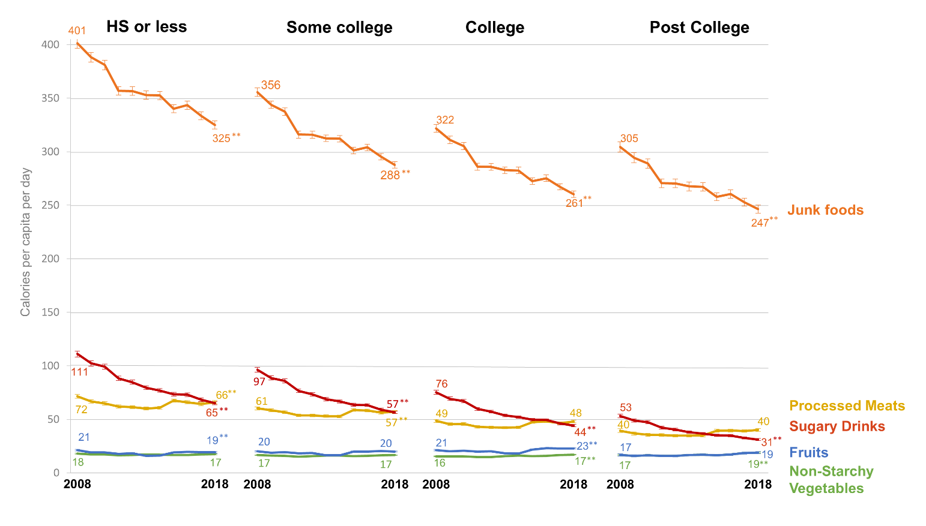
a: Models were survey-adjusted and controlled for income tertile, race/ethnicity, household composition and year, with an interaction between education and year when significant

* Significant difference between 2008 and 2018 for given education group, p<0.01
** Significant difference between 2008 and 2018 for given education group, p<0.001

Nielsen disclaimer: Calculations based in part on data reported by Nielsen through its Homescan Services for all food categories, including beverages and alcohol for the 2008-2018 periods across the U.S. market. The Nielsen Company, 2018. The conclusions drawn from the Nielsen data do not reflect the views of Nielsen. Nielsen is not responsible for and had no role in, and was not involved in, analyzing and preparing the results reported herein.

Supplementary Figure 3: Nutrients from packaged food and beverage purchases 2008-2018, by educational attainmentª
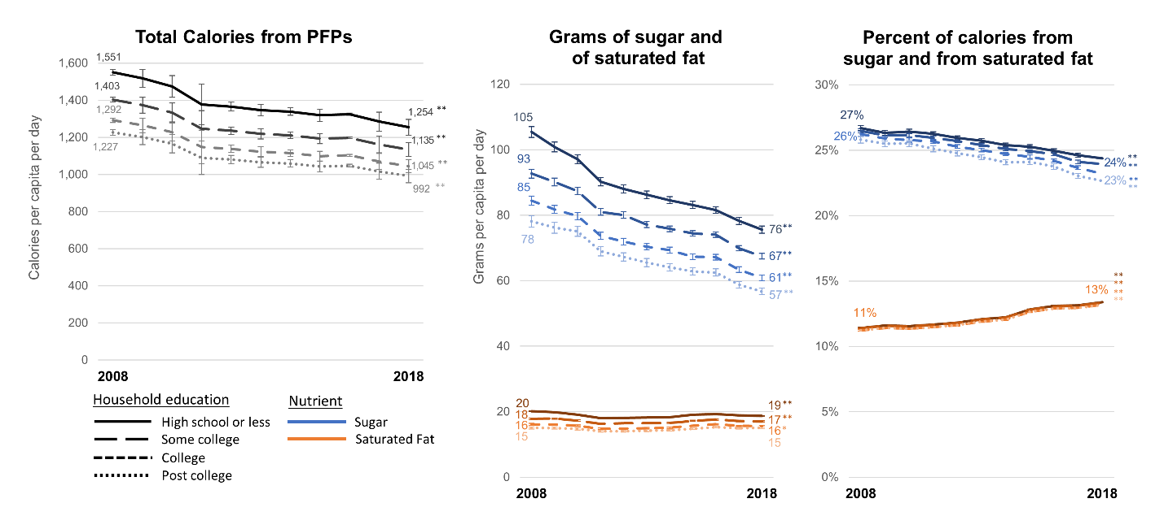
a: Models were survey-adjusted and controlled for income tertile, race/ethnicity, household composition and year, with an interaction between education and year when significant
* Significant difference between 2008 and 2018 for given education group, p<0.01
** Significant difference between 2008 and 2018 for given education group, p<0.001

Nielsen disclaimer: Calculations based in part on data reported by Nielsen through its Homescan Services for all food categories, including beverages and alcohol for the 2008-2018 periods across the U.S. market. The Nielsen Company, 2018. The conclusions drawn from the Nielsen data do not reflect the views of Nielsen. Nielsen is not responsible for and had no role in, and was not involved in, analyzing and preparing the results reported herein.

Supplementary Figure 4: Sodium per capita per day purchased from packaged food and beverage purchases 2008-2018, by educational attainmentª
a: Models were survey-adjusted and controlled for education, race/ethnicity, household composition and year, with an interaction between education and year when significant
** Significant difference between 2008 and 2018 for given education group, p<0.001

Nielsen disclaimer: Calculations based in part on data reported by Nielsen through its Homescan Services for all food categories, including beverages and alcohol for the 2008-2018 periods across the U.S. market. The Nielsen Company, 2018. The conclusions drawn from the Nielsen data do not reflect the views of Nielsen. Nielsen is not responsible for and had no role in, and was not involved in, analyzing and preparing the results reported herein.

Supplementary Figure 5: Calories per capita per day purchased from selected healthy and unhealthy packaged food and beverage categories 2008-2018, by race/ethnicityª
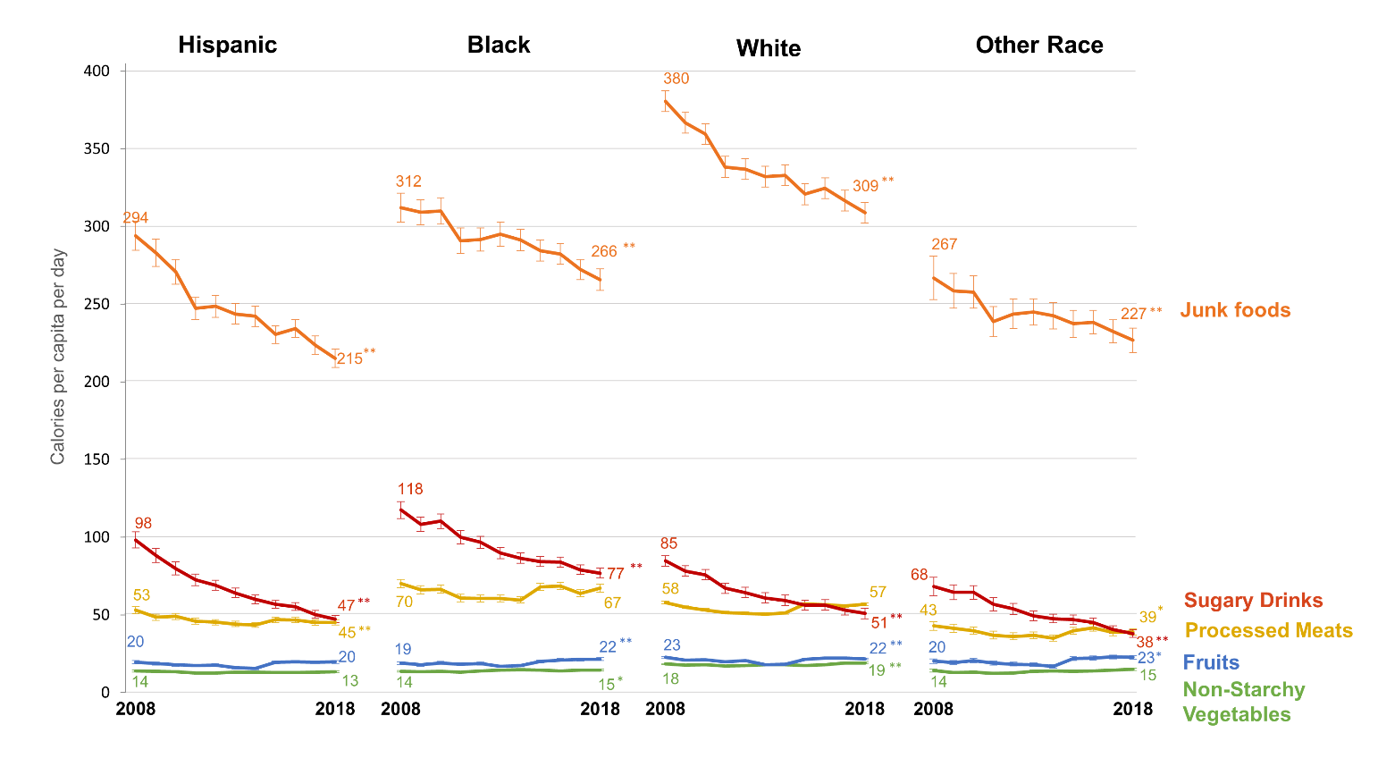
a: Models were survey-adjusted and controlled for income tertile, education, household composition and year, with an interaction between race/ethnicity and year in all models

* Significant difference between 2008 and 2018 for given race/ethnic group, p<0.01
** Significant difference between 2008 and 2018 for given race/ethnic group, p<0.001

Nielsen disclaimer: Calculations based in part on data reported by Nielsen through its Homescan Services for all food categories, including beverages and alcohol for the 2008-2018 periods across the U.S. market. The Nielsen Company, 2018. The conclusions drawn from the Nielsen data do not reflect the views of Nielsen. Nielsen is not responsible for and had no role in, and was not involved in, analyzing and preparing the results reported herein.

Supplementary Figure 6: Selected nutrients from packaged food and beverage purchases 2008-2018, by race/ethnicityª
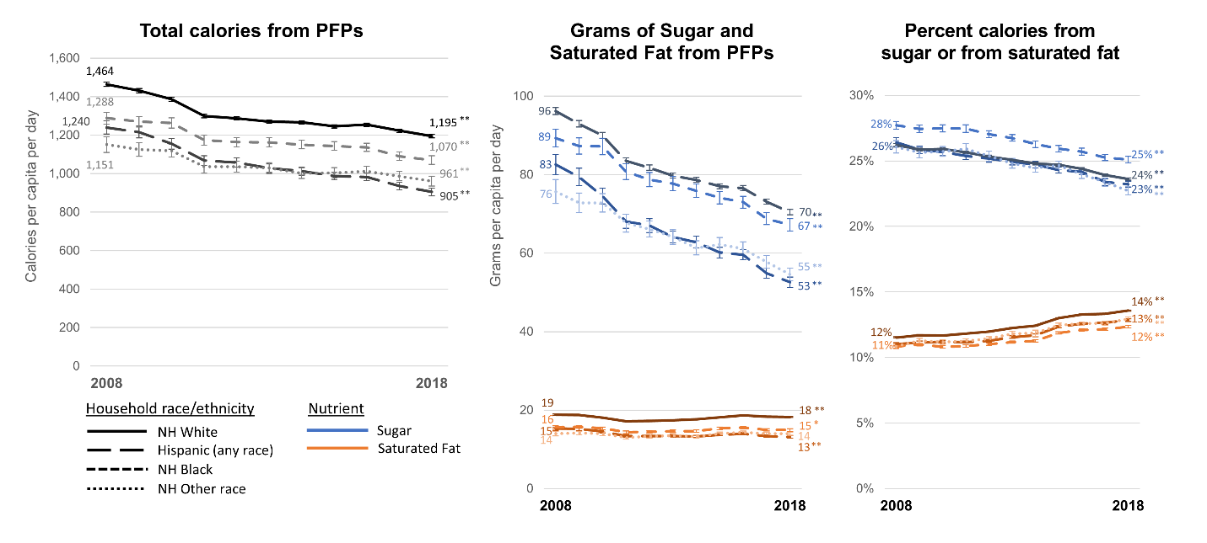
a: Models were survey-adjusted and controlled for income tertile, education, household composition and year, with an interaction between race/ethnicity and year in all models

* Significant difference between 2008 and 2018 for given race/ethnic group, p<0.01
** Significant difference between 2008 and 2018 for given race/ethnic group, p<0.001

Nielsen disclaimer: Calculations based in part on data reported by Nielsen through its Homescan Services for all food categories, including beverages and alcohol for the 2008-2018 periods across the U.S. market. The Nielsen Company, 2018. The conclusions drawn from the Nielsen data do not reflect the views of Nielsen. Nielsen is not responsible for and had no role in, and was not involved in, analyzing and preparing the results reported herein.

Supplementary Figure 7: Sodium per capita per day purchased from packaged food and beverage purchases 2008-2018, by race/ethnicityª
a: Models were survey-adjusted and controlled for income tertile, education, household composition and year, with an interaction between race/ethnicity and year in all models
** Significant difference between 2008 and 2018 for given education group, p<0.001

Nielsen disclaimer: Calculations based in part on data reported by Nielsen through its Homescan Services for all food categories, including beverages and alcohol for the 2008-2018 periods across the U.S. market. The Nielsen Company, 2018. The conclusions drawn from the Nielsen data do not reflect the views of Nielsen. Nielsen is not responsible for and had no role in, and was not involved in, analyzing and preparing the results reported herein.

