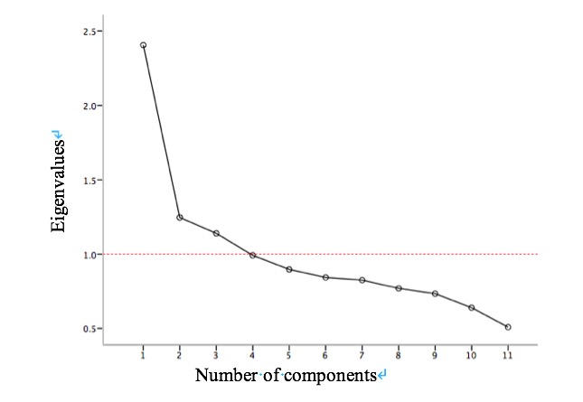
Figure S1. Scree plot of dietary patterns from exploratory factor analysis.

