Supplementary material

Further introduction
Cook Islands SSB taxes were evaluated because of the increases in SSB taxes were greater than the 10% level, trade data were available and relationships were able to be established.
The Cook Islands are closely affiliated with New Zealand which is their main trading partner. Tourism is the major contributor to the economy with 161,000 visitors to the Cook Islands in 2017 (Statistics Division, Ministry of Finance and Economic Management [MFEM], Cook Islands).

Based on economic theory, it was expected that tariff increases in 2008 and 2012 would increase the shelf price of taxed beverages more than existing trends; and subsequently decrease the importation and sales volumes of taxed beverages. Little change was expected after the revenue neutral excise introduction in 2014, except for an increase in ASB sales given the removal of SSB tax on these products.

Further methods

Litter survey
As part of the field work in Rarotonga in July 2018, a litter survey was carried out at three different beaches and three different roadside transects by the first author (AT). Locations were selected by prioritising frequently used areas and excluding beaches that were known to be regularly cleaned (eg, Muri beach) (Figure S1).

Information was collected on each survey location (via GPS recording) and for each type of litter (eg, via photographs) using study protocols, which has been published elsewhere [manuscript under review].

Figure S1: Litter survey sites examined in July 2018 in Rarotonga, Cook Islands (from above) and in the capital of the Cook Islands, Avarua township (zoomed in below)
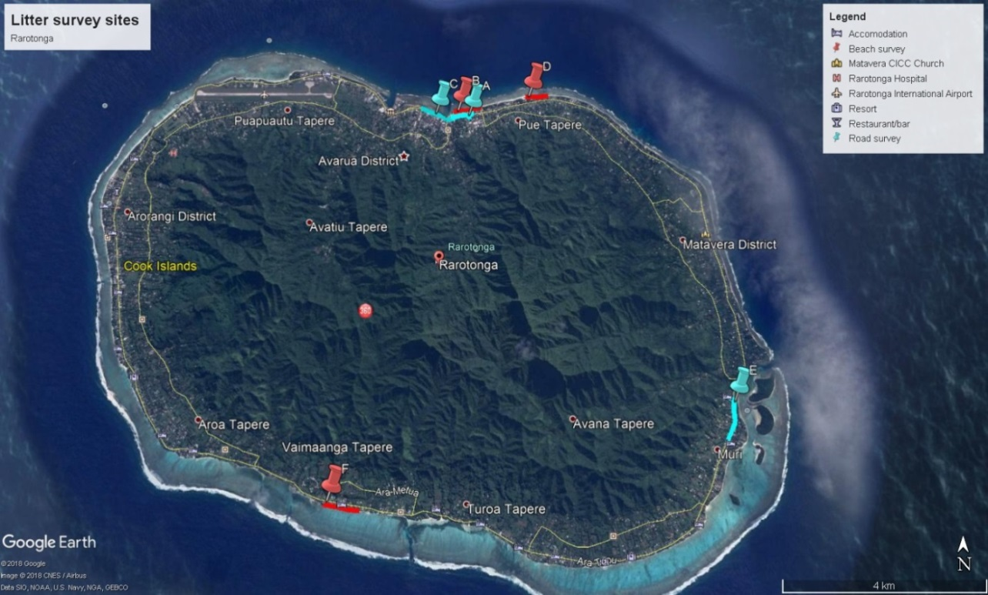
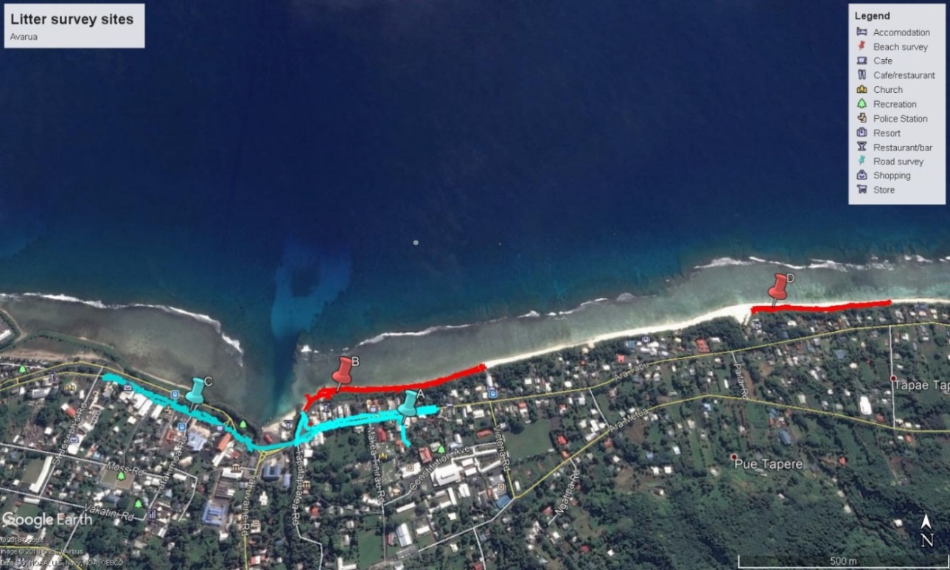

Results
Overall 88 beverage containers were collected per kilometre of beach and 97 containers were collected per kilometre of road. Over a third (39%) of the total beverage container litter was from SSBs (soft drinks, energy drinks, flavoured milk and other sugar-sweetened drinks) and 35% was from alcoholic beverages (beer, wine, drink mixes and spirits). Litter from water containers (10%), juice (5%), ASBs (1%) and unknown types (10%, such as plastic or paper cups) was also present. The distribution of the litter differed by location type. Roadsides had a greater proportion of SSB litter (43%) and beaches had more alcohol beverage litter (40%). Results also differed between sites (Figure S2), suggesting that site specific factors were important, such as the level of beach use and frequency of cleaning. The beach that was used for swimming and located close to tourist accommodation had a much lower level of litter (site F). It is possible that this beach is more frequently cleaned by local tourist operators compared to the other beaches that were not in tourist areas. The main street in Avarua (site C) had the least litter compared to the other roads and this may be because it is regularly cleaned by government workers.

Country of origin of beverage manufacture could be identified for 85% of the litter collected (n=240/284). Of these containers, 17% were manufactured in the Cook Islands and the rest were from elsewhere, including 74% from New Zealand and none from PICTA countries. Looking at specific categories of beverages, 24% of SSBs collected were produced in the Cook Islands, 56% of water, 0% of juice and 1% of alcohol litter; compared to 63% of SSBs collected that were produced in New Zealand, 93% of juice, 44% of water and 91% of alcohol litter.

Figure S2: Beverage container litter density from systematic surveys of three beaches and three roadsides in Rarotonga, Cook Islands, July 2018 (n=284 containers found in 3.05 km length of road or beach)

Note: Sugar-sweetened beverages (SSBs) included soft drinks, energy drinks, flavoured milk and other sugar-sweetened drinks; artificial-sweetened beverages (ASBs) comprised zero-sugar soft drinks; unknown beverages were largely cups and some unlabelled containers from which the product could not be identified. Six specific sites in Rarotonga were surveyed for litter in July 2018, including frequently-used streets (kerbs on both sides) and public beaches close to Avarua or tourist areas. The number of containers was reported per kilometre of street or beach surveyed.

Discussion
The beverage waste documented here is a problem given its environmental impacts (on land and in the water), adverse health impacts (eg, receptacles for mosquito larvae), adverse implications for tourism and the associated revenue for the government, the island’s limited landfill space and dependence on offshore recycling for metal and plastics. Nearly three times more litter was identified on the beaches sampled in Rarotonga than a recent survey of beverage litter in New South Wales, Australia. The latter found just 14 plastic containers per kilometre of beach ¹ compared to 39 plastic containers per kilometre found on Rarotonga beaches. Beverage litter density on popular roadsides in Rarotonga was 2.5 times that found in a New Zealand litter survey of eight urban areas (16 containers per 1000m² in Rarotonga [assuming an average kerbside width of 3m] vs 6 items of drink packaging per 1000m² in New Zealand). All the roadsides sampled in Rarotonga were adjacent to small convenience stores selling SSBs and other non-alcoholic beverages. These stores were common around the island and are likely to have contributed to the volume of litter identified. There are potential policy synergies between the Cook Islands Ministry of Health and Infrastructure Cook Islands Water and Sanitation Division (WATSAN) that could help to address environment and health goals, such as a WATSAN proposed Advance Disposal Fee. This proposal would add a sum of money onto an imported product to pay for its disposal when it reaches the end of its life (http://www.cookislandsnews.com/national/local/item/50105-finding-a-new-landfill/50105-finding-a-new-landfill?tmpl=component&print=1).

Market share
The litter survey indicated that littered containers of sweetened beverages in the Cook Islands were mainly of imported products (76%) with the rest (24%) being locally manufactured (Vaiora). However, it is unclear if this figure was less in the decade up to 2018. The current study analysis is focussed on import volumes given these products were targeted by tariff increases and even though they appeared to be less than the 90%+ market share specified in the study protocol. Changes in production of local soft drinks could have an important influence on overall consumption but could not be measured here. The litter survey also suggested that juice was all imported with no local manufacturing (although the origin of local juices that are known to be sold in cups could not be identified). For bottled water container litter, 44% of products were imported and 56% were locally produced; and thus water import trends were not useful for this analysis and were excluded.

Variable definitions
Variable definitions are outlined in Table S2 and sales beverage products in Table S3. Time series trends for each variable were examined to assess data quality and identify any missing information or changes that might indicate data errors or changes in measurement. A comprehensive set of data were available from 2001 to 2017 and thus this period was selected for analysis.
Table S2: Cook Islands variable definitions
Residential population | Estimate residential population; http://www.mfem.gov.ck/statistics/social-statistics/vital-stats-pop-est  Updated population estimate provided by Anne Tangimetua at Department of Statistics on 9 April 2019. The updated file changes population numbers back from Q2 2013 to 2018. Note 2018 figures are provisional only. Quarterly data were transformed into monthly data using the moving average of quarterly data.
GDP per capita | Cook Islands GDP in 2016 NZ$, quarterly data available from 2008 to 2017 and annually before that back to 2001 from MFEM and online (http://www.mfem.gov.ck/statistics/economic-statistics/national-accounts). Accessed 20 September 2018 and 7 April 2019.  Data were used from ‘Table: Gross Domestic Product at 2016 Prices ($'M)’. The earlier data were transformed from 2006 to 2016 current prices using the official inflation index. The annual 2001 to 2007 data were converted into quarterly data using the same pattern as 2008 to 2015 quarters as an average over this time period. Monthly data were calculated as a moving average of the quarterly data.  GDP was divided by the residential population to give per capita values.
International visitor numbers | Visitor arrivals, provisional in last five years 2013-2017, http://www.mfem.gov.ck/statistics/economic-statistics/key-economic-indicators Ministry of Finance and Economic Management Government of the Cook Islands (2017). "Cook Islands Statistical Bulletin: Migration Statistics” May 2017. Available monthly and summed to give quarterly data.
Season | 1 to 4 for each quarter or 1 to 12 for each month in monthly analyses

Table S3: Products included in sales beverage analysis
Analysis category | Beverage category | Included products
Full-sugar beverages | Carbonated full-sugar | Coca-Cola range 330ml
 |  | Coca-Cola range 1.5L
 |  | Coca-Cola range 600ml
 |  | Coca-Cola range 355ml
 | Energy drink full-sugar | Monster Original 500ml
 |  | Monster Sunrise 500ml
 |  | Mother 500ml
 |  | Powerade 750ml
Low-sugar beverages | Carbonated low-sugar | Coca-Cola range low-sugar 1.5L
 |  | Coca-Cola range low-sugar 600ml
 |  | Coca-Cola range low-sugar 355ml
 | Energy drink low-sugar | Monster Zero Ultra 500ml
 |  | Powerade Zero
 | Flavoured water | Pumped Flavours 750ml
Water | Imported water | Pump 400ml
 |  | Pump 750ml
 |  | Pump 1.25L
 |  | Kiwi Sparkling 450ml
 |  | Kiwi Sparkling 1.25L
 |  | Kiwi Blue 1.5L
 |  | Water 6L
 |  | Water 4L
 | Local water | Vaima 1.5L
 |  | Vaima 3L
 |  | Vaima 15L
 |  | Vaima 600ml
 |  | Vaima 800ml
Source: Cook Islands Trading Company

Primary model
The Cook Islands model from the primary trade analysis with three tax changes:
$$Trade\left(L/{population}\right)=β_{0} + β_{1}.{time}_{t}+ β_{2}.{tax_{1}}_{t}+ β_{3}.{trend}_{1t}+ β_{4}.{tax2}_{t}+ β_{5}.{trend2}_{t}+ β_{6}.{tax3}_{t}+ β_{7}.{trend3}_{t}+ β_{8}.{GDP}_{t}+ β_{9}.{visitors}_{t}+ β_{10}.{season}_{t}+ ∈_{t}$$
(1)
Where;
$$β_{0}=intercept$$
$$β_{1}=prexisting trend before the intervention$$
$$β_{2}=level change after the 2008 tariff change compared to prexisting level of trade$$
$$β_{3}=trend change after the 2008 tariff change compared to prexisting trend$$
$$β_{4}=level change after the 2012 tariff change$$
$$β_{5}=trend change after the 2012 tariff change$$
$$β_{6}=level change after the 2014 excise introduction$$
$$β_{7}=trend change after the 2014 excise introduction$$
$$β_{8}=association between GDP per capita and trade$$
$$β_{9}=association between visitor numbers and trade$$
$$β_{10}=association between season and trade$$
$$∈ =error term$$

Controlled analyses
Controlled analyses were not selected for the main analysis given the limitations trying to find available data from a Pacific Island country without SSB taxes and an appropriate in-country control.
An ideal control would be a neighbouring jurisdiction with very similar socio-economic/cultural context and all the required available data, where no SSB tax was introduced during the study time period. A limited amount of data from control countries limited the application of this approach in this study.

Also, it was difficult to identify a food category that was largely imported from New Zealand, similar to SSBs, but not potentially/theoretically susceptible to the SSB tax changes. Untaxed beverages were not a suitable control because they might respond to the SSB tax changes as substitutes and trade volumes of these beverages may increase. A group of discretionary and sweetened foods was selected as a within country control to compare with SSB trends as a sensitivity test for the main results. The sugary snack categories comprised ice cream, chocolate, sweets, crackers/biscuits and cake. There is limited evidence of any relationship between SSB taxes and substitution effects to sugary snack foods.²⁻⁴ If there is an affect it appears to be quite small eg, sweets/desserts/chocolate/chewing gum (cross price elasticity 0.03, p<0.001),⁴ and cookies/other snacks (cross price elasticity 0.01, p<0.001).⁴ However, because of the risk that sugary snacks could be a substitute, the default analyses did not include the sugary snack control.

Here is a summary of the regression model specifications where the outcome is compared to a control group (eg sugary food imports):
$$Trade\left(L/{pop}\right)=β_{0} + β_{1}.{time}_{t}+ β_{2}.{group}_{k}+ β_{3}.{group}_{k}.{time}_{t}+ β_{4}.{tax}_{t}+ β_{5}.{trend}_{jt}+ β_{6}.{{group}_{k}.tax}_{t}+ β_{7}.{group}_{k}.{trend}_{jt}+ β_{8}.{tax2}_{t}+ β_{9}.{trend2}_{jt}+ β_{10}.{{group}_{k}.tax2}_{t}+ β_{11}.{group}_{k}.{trend2}_{jt}+ β_{12}.{tax3}_{t}+ β_{13}.{trend3}_{jt}+ β_{14}.{{group}_{k}.tax3}_{t}+ β_{15}.{group}_{k}.{trend3}_{jt}+β_{16}.{GDP}_{t}+ β_{17}.{visitors}_{t}+ β_{18}.{season}_{t}+ ∈_{jkt}$$
(2)
Where;
$$β_{0}=intercept$$
$$β_{1}=prexisting trend in the control group before the intervention$$
$$β_{2}=difference in level of trade in the intervention group compared to the control$$
$$β_{3}=difference in the presixting trend in the intervention group compared to the control$$
$$β_{4}=level change in the control group after the 2008 tariff change$$
$$β_{5}=trend change in the control group after the 2008 tariff change$$
$$β_{6}=level change in the intervention group compated to the control group$$
$$β_{7}=trend change in the intervention group compared to the control group$$
…
$$β_{16}=association between GDP per capita and trade$$
$$β_{17}=association between visitor numbers and trade$$
$$β_{18}=association between season and trade$$
$$∈ =error term$$

Monte Carlo simulation
Monte Carlo simulation was used to calculate 95% confidence intervals. The distribution of each model coefficient and its standard error were sampled 100,000 times to produce predicted and counterfactual values. These values were used to calculate simulated absolute and relative differences for each year. The 2.5th and the 97.5th percentile of the simulated outcome measures provided the upper and lower limits for a 95% confidence interval (CI). This method allows for the correlation between variables and their variances in the model.

Sensitivity tests
A set of pre-specified sensitivity tests were used to assess the robustness of the key SSB trade results. Further details on each these analyses are described below.

Time lag: This analysis allowed for a three month lag time in the changes to import data, reflecting the time it could theoretically take to run out of stock, place new orders and for these to arrive. Personal communication with key informants indicated that the effect of SSB tax on price was noticed within three months, so the default analysis did not include any time lag. Pre-existing trends will be calculated using the same data, thus the first quarter post-tax will drop out of the model and analysis.

Shorter lead-in period: A three year pre-tax time period was selected (ie, to shorten lead-in but retain statistical power) to investigate the impact of removing time points a long time away from the tax change, which may be more susceptible to external non-SSB tax factors. This is particularly important if historical trends have changed over time.⁵ The default analysis includes all available data to maximise study power.

Weighting: This was to test the robustness of the export weighting, by limiting the study to New Zealand export volumes alone (rather than weighting New Zealand export volumes up to make them represent worldwide exports to the Cook Islands). The UN Comtrade data, from where the weights were sourced, included some missing data, so this analysis tested the impact of the weights on study results.

Cyclones: This was to allow for the impact of major cyclones to see if any significant changes occurred eg, Cook Islands in 2005. If this made a significant impact then this additional variable would be included in the final model. A dummy variable was added to the model, for the month of major cyclone damage in the island nation of the study and the month following and otherwise the variable was coded zero.

Autocorrelation: This was to examine the impact of removing autocorrelation from the model to compare study outcomes.

Confounding: This was to examine the impact of removing all confounders from the model on study outcomes.

Quadratic: This was to examine the impact of modelling time as time squared to test if there were any quadratic effects over time.

Population change: This was to examine the impact of keeping the population a fixed size to understand the influence of population change on study outcomes, which were measured per capita.

Quarterly: Price and trade analyses were carried out using a quarterly time period to assess the impact of using more aggregated time series outcomes on the model. Season was coded into four categories.

Further results
Table S4: Changes in the average quarterly price (NZ$ per item) of a taxed indicator soft drink in the first and second year post introduction of sweetened beverage taxes in the Cook Islands, time series analysis 2001-2017
Tax change | Follow-up |  | Tax change  (% points) |  | Observed price (NZ$) |  | Counter-factual price (NZ$) | Absolute difference  NZ$ (95% CI) |  | Percentage change in price (95% CI)
TAXED BEVERAGES
2008  tariff 40% →60% | First year |  | 20% |  | 1.74 |  | 1.62 | 0.12 (0.10 to 0.13) |  | 7.3% (6.3 to 8.3)
 | Second year |  |  |  | 2.07 |  | 1.70 | 0.37 (0.36 to 0.38) |  | 21.7% (20.8 to 22.6)
 | Combined |  |  |  | 1.90 |  | 1.66 | 0.24 (0.23 to 0.26) |  | 14.7% (13.8 to 15.6)
2012  tariff 60% →75% | First year |  | 15% |  | 2.48 |  | 2.88 | -0.40 (-0.43 to -0.37) |  | -13.9% (-14.9 to -12.8)
 | Second year |  |  |  | 2.99 |  | 3.23 | -0.25 (-0.29 to -0.20) |  | -7.6% (-9.0 to -6.3)
 | Combined |  |  |  | 2.73 |  | 3.06 | -0.32 (-0.34 to -0.31) |  | -10.5% (-11.0 to -10.2)
2014  tariff 77% → excise NZ$9.37/kg of sugar | First year |  | -11% AVE |  | 2.52 |  | 3.30 | -0.78 (-0.88 to -0.68) |  | -23.6% (-26.0 to -21.1)
 | Second year |  |  |  | 2.65 |  | 3.81 | -1.16 (-1.32 to -1.00) |  | -30.4% (-33.3 to -27.3)
 | Combined |  |  |  | 2.59 |  | 3.55 | -0.97 (-1.10 to -0.84) |  | -27.3% (-29.9 to -24.4)
Notes: The counterfactual is what was expected based on existing trends; ad valorem equivalent (AVE) was calculated by applying excise rates to import unit values (NZ$/L). Price data were provided by the Cook Islands Statistics Division, MFEM. Time series difference estimates were adjusted for autocorrelation, international visitors, GDP per capita and season.

Table S5: Impact of SSB tax changes on taxed sweetened beverages (HS 2202) import volumes (litres a year per population), Cook Islands 2001-2017
Date of tax change | Specific tax changes | Follow-up period | Observed (L/p/y) | Counter-factual (L/p/y) | Absolute difference  L/p/y (95% CI) | Percentage change in import volumes  (95% CI) | Estimated elasticity
13 August  2008 | tariff 40% →60% | First year | 149.7 | 172.4 | -22.7 (-72.4 to 27.2) | -13.2% (-38.1 to 17.8) | -0.66 (-1.91 to 0.89)
 |  | Second year | 153.0 | 194.4 | -41.4 (-88.5 to 6.0) | -21.3% (-40.4 to 3.6) | -1.07 (-2.02 to 0.18)
 |  | Combined | 151.3 | 183.4 | -32.1 (-79.3 to 15.4) | -17.5% (-38.4 to 9.8) | -0.87 (-1.92 to 0.49)
End July 2012 | tariff 60% →75% | First year | 128.2 | 132.1 | -3.8 (-70.5 to 62.9) | -2.9% (-41.6 to 72.5) | -0.19 (-2.77 to 4.83)
 |  | Second year | 140.9 | 131.6 | 9.3 (-75.6 to 94.0) | 7.1% (-40.1 to 150.8) | 0.47 (-2.67 to 10.05)
 |  | Combined | 134.6 | 131.8 | 2.7 (-67.1 to 72.3) | 2.1% (-36.3 to 99.6) | 0.14 (-2.42 to 6.64)
1 July 2014 | 2014 tariff 77% → excise NZ$9.37/kg of sugar content | First year | 161.6 | 154.6 | 7.0 (-91.8 to 106.0) | 4.5% (-39.5 to 156.0) | -0.42 (3.69 to -14.58)
 |  | Second year | 151.2 | 177.5 | -26.3 (-176.0 to 123.8) | -14.8% (-57.6 to 278.1) | 1.38 (5.39 to -25.99)
 |  | Combined | 156.4 | 166.0 | -9.6 (-132.1 to 112.4) | -5.8% (-47.8 to 216.7) | 0.54 (4.47 to -20.25)
Notes: Results are calculated from a generalised least squares model, with Monte Carlo simulation of model outputs and their errors to calculate 95% confidence intervals for the rate difference (RD) and the percentage change (%) compared to baseline. Outcome measures are adjusted for autocorrelation, international visitor numbers (Statistics Division, MFEM), GDP per capita and season. Elasticity = % change / tax change.

Table S6: Impact of SSB tax changes on untaxed beverage import volumes (litres a year per person) to test for potential substitution, Cook Islands 2001-2017
Date of tax change | Beverage category (codes) | Follow-up period | Observed (L/p/yr) | Counter-factual (L/p/yr) | Absolute difference  L/p/yr (95% CI) | Percentage change  (95% CI) | Cross price elasticity
13 August  2008 | Milk  HS 0401.10 & 0401.20 | First year | 26.8 | 28.2 | -1.4 (-4.0 to 1.2) | -5.0% (-13.6 to 4.5) | -0.25 (-0.68 to 0.22)
 |  | Second year | 28.7 | 31.0 | -2.2 (-4.2 to -0.2) | -7.2% (-12.9 to -0.8) | -0.36 (-0.64 to -0.04)
 |  | Combined | 27.8 | 29.6 | -1.8 (-4.1 to 0.4) | -6.2% (-13.1 to 1.6) | -0.31 (-0.65 to 0.08)
 | Juice  HS 20.09 | First year | 40.6 | 52.2 | -11.6 (-22.9 to -0.4) | -22.2% (-40.1 to -0.8) | -1.11 (-2.00 to -0.04)
 |  | Second year | 39.7 | 58.9 | -19.2 (-29.9 to -8.6) | -32.6% (-45.5 to -16.7) | -1.63 (-2.28 to -0.84)
 |  | Combined | 40.1 | 55.5 | -15.4 (-26.1 to -4.7) | -27.8% (-42.3 to -9.7) | -1.39 (-2.11 to -0.48)
End July 2012 | Milk  HS 0401.10 & 0401.20 | First year | 33.1 | 28.9 | 4.2 (-0.3 to 8.7) | 14.7% (-0.9 to 32.9) | 0.98 (-0.06 to 2.19)
 |  | Second year | 31.3 | 30.4 | 0.9 (-3.8 to 5.6) | 3.0% (-11.3 to 20.5) | 0.20 (-0.76 to 1.37)
 |  | Combined | 32.2 | 29.6 | 2.6 (-1.3 to 6.4) | 8.7% (-4.0 to 24.2) | 0.58 (-0.27 to 1.62)
 | Juice  HS 20.09 | First year | 24.7 | 27.4 | -2.7 (-17.6 to 12.1) | -10.0% (-49.9 to 70.1) | -0.66 (-3.32 to 4.68)
 |  | Second year | 24.6 | 25.2 | -0.6 (-19.8 to 18.7) | -2.3% (-52.7 to 190.8) | -0.15 (-3.51 to 12.72)
 |  | Combined | 24.6 | 26.3 | -1.7 (-17.3 to 14.2) | -6.3% (-45.7 to 108.8) | -0.42 (-3.04 to 7.25)
1 July 2014 | Milk  HS 0401.10 & 0401.20 | First year | 38.4 | 30.2 | 8.2 (-1.1 to 17.6) | 27.1% (-3.1 to 77.2) | -2.53 (0.29 to -7.22)
 |  | Second year | 48.4 | 28.7 | 19.7 (6.8 to 32.8) | 68.9% (16.6 to 207.9) | -6.44 (-1.55 to -19.43)
 |  | Combined | 43.4 | 29.4 | 14.0 (3.1 to 25.0) | 47.4% (7.7 to 129.8) | -4.43 (-0.72 to -12.13)
 | Juice  HS 20.09 | First year | 19.5 | 25.0 | -5.6 (-27.7 to 16.6) | -22.2% (-69.5 to 226.4) | 2.08 (4.92 to -17.83)
 |  | Second year | 35.8 | 28.9 | 6.9 (-26.6 to 40.5) | 23.8% (-644.0 to 864.3) | -2.23 (60.18 to -80.77)
 |  | Combined | 27.6 | 27.0 | 0.7 (-26.6 to 27.9) | 2.5% (-62.1 to 522.1) | -0.23 (5.80 to -48.79)
Notes: Results are calculated from a generalised least squares model, with Monte Carlo simulation of model outputs and their errors to calculate 95% confidence intervals for the rate difference (RD) and the percentage change (%) compared to baseline. Results were adjusted for autocorrelation, international visitor numbers, GDP per capita and season.

Figure S3: Impact of the Cook Islands import tariff increase on New Zealand reported untaxed beverage exports (juice and milk) to Cook Islands from 2001 to 2017.
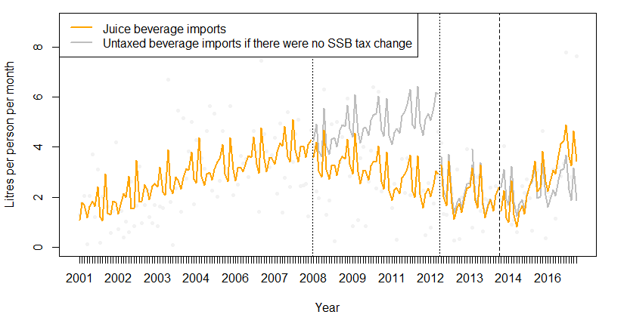
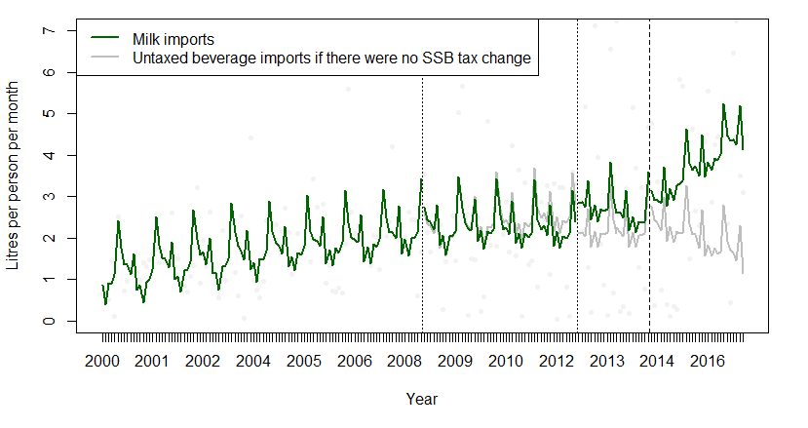
Notes: Milk (HS 0401.10 and 0401.20), juice (HS 2009). Analysis was adjusted for existing time trends, autocorrelation, GDP per capita, international visitor numbers and seasonality. Dotted vertical lines indicate tariff increases of 20% and 15% points in 2008 and 2012 respectively. The dashed vertical line was the introduction of the excise with a decrease of 11% points in SSB tax level. Source: Statistics New Zealand

Figure S4: Impact of the Cook Islands import tariff increase on New Zealand reported untaxed beverage exports (water) to Cook Islands from 2000 to 2012
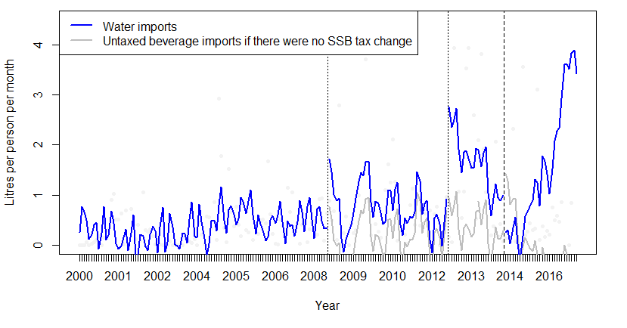

Table S7: Control and sensitivity tests comparing the % change in sweetened beverage import volumes in the first year after the 2008, 2012 and 2014 SSB tax changes in the Cook Islands
 | Year of SSB tax change | 2008 | 2012 | 2014
 |  | % change (95% CI) | % change (95% CI) | % change (95% CI)
Primary analysis | Primary analysis, pre-post tax comparison, monthly | -13.2% (-38.1 to 17.8) | -2.9% (-41.6 to 72.5) | 4.5% (-39.5 to 156.0)
Controlled analysis | Pre-post tax comparison, monthly, compared to post-tax changes in sugar snack foods | -24.8% (-36.9 to -9.8) | -10.2% (-37.1 to 37.5) | -2.7% (-39.4 to 100.2)
Sensitivity tests (as planned) | Three month lag in effect, with 9 months follow-up for 2016 & 17 taxes | -10.9% (-33.7 to 18.5) | 19.8% (-25.2 to 123.1) | 32.7% (-44.7 to 636.6)
 | Maximum lead in period of three years | 55.1% (14.4 to 133.8) | -0.6% (-19.8 to 23.4) | -1.9% (-27.6 to 42.3)
 | No weighting, limiting to NZ import trends only | -9.3% (-32.5 to 20.5) | -3.1% (-38.9 to 62.0) | -2.0% (-40.9 to 111.1)
 | Adjustment for Cyclone Pat (Feb, Mar 2010, Rarotonga) | -13.1% (-36.1 to 16.3) | -2.0% (-38.4 to 64.9) | 4.5% (-37.5 to 133.2)
 | Without adjusting for autocorrelation | -12.3% (-35.1 to 16.8) | -2.7% (-38.6 to 62.7) | 4.2% (-37.4 to 128.9)
 | Without adjusting for confounding | -13.7% (-36.0 to 15.1) | -6.5% (-41.3 to 53.9) | -0.3% (-39.1 to 108.8)
Further tests (post hoc) | Quadratic term; time squared added as a covariate to the model | 14.7% (-26.2 to 110.8) | 15.6% (-31.2 to 127.7) | 12.7% (-34.0 to 169.0)
 | Remove effect of population change, fixed population of 14,000 | -1.2% (-33.7 to 59.6) | -7.8% (-40.9 to 48.1) | -0.9% (-40.3 to 114.1)
 | Quarterly analysis with quarterly outcome and covariate data | -11.1% (-35.3 to 21.0) | 0.5% (-38.5 to 76.2) | 6.3% (-37.3 to 149.9)
Notes: Adding a covariate for the number of young adults in the population was also tested as a sensitivity test however this model could not be run due to convergence. Larger declines (eg, more than a third different) were coloured orange in bold and smaller declines (or bigger increases) were coloured blue in italics.

Figure S5: Sweetened beverage imports into the Cook Islands before and after SSB tax changes compared to changes in other sugary food imports (control) 2001-2017
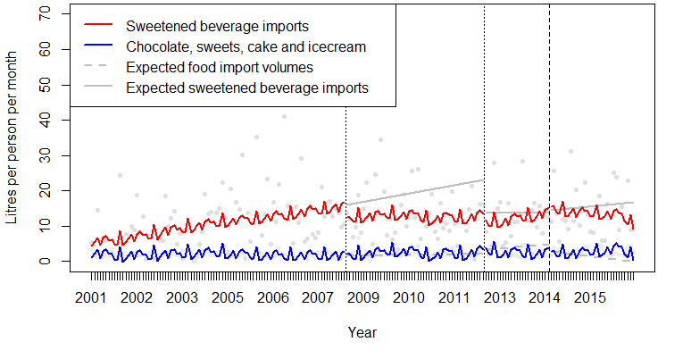Notes: Adjusted for existing trends, autocorrelation, GDP per capita, season and international visitor numbers. The counterfactuals (grey) are presented as straight lines, but also would vary between months like the modelled data.

Figure S6: Annual sales per population before and after the Cook Islands excise tax introduction which decreased tax levels on full-sugar soft drinks by 11% points and decreased the tax level on low-sugar products by 77% points, 2012-2017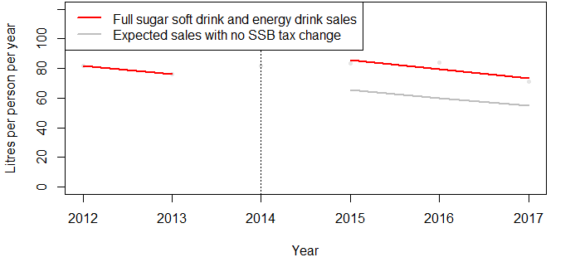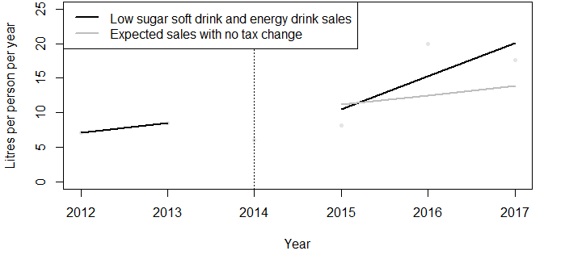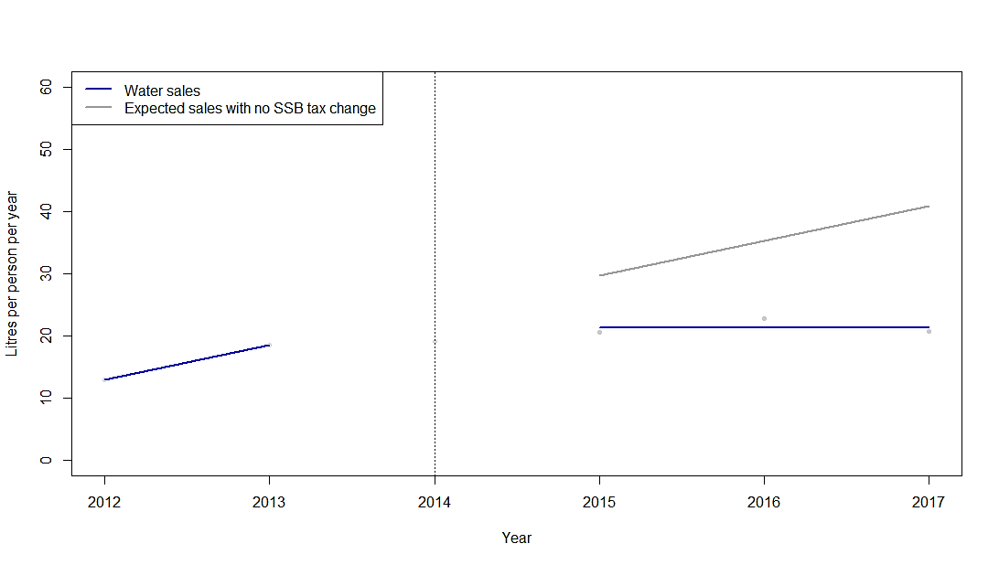
Notes: No adjustment for confounding was possible due to small numbers. There was very large uncertainty in both these models due to limited pre- and post-tax data points.

Further discussion
Of note, the observed per capita import rates in the Cook Islands were very high at approximately 150L a year, three fold greater than the approximately 40 L/year observed in Tonga. Contributing to this is likely to be the high number of tourists, which although changes in international visitor numbers are accounted for in the modelling, their consumption is not accounted for in the per capita import rates. Even if population figures and visitor numbers used here were underestimates of true residential number (eg by half), there is still a very high volume of sweetened beverage imports to the Cook Islands.

There was no suggestion from UN Comtrade data that cheaper sweetened beverages were being imported or that they contributed to the changes around 2009 and 2010.

Substitution to sugary snack foods has been found to be small or non-existent in other studies,²⁻⁴ however if present, controlled analysis declines could have been overestimated.

Nutrient-specific SSB tax designs are considered more effective than product-specific ad valorem or volumetric tax designs,⁶ however we could not evaluate this directly in the Cook Islands due to the associated decline in tax rates when the nutrient-specific tax was introduced in 2014.

At the same time as the 2014 excise change there was a small increase in consumption tax (VAT) which could have an opposite effect to the other tax review changes.⁷

Untaxed beverages
Untaxed beverage import findings were mixed in response to SSB tariff increases and changes were frequently small. Milk imports decreased slightly after the 2008 tariff (-1%) and increased slightly after the 2012 tariff (4%), whereas juice decreased significantly after the 2008 tariff (-12%) and decreased slightly after the 2012 tariff (-3%). This change in milk and juice was similar to changes in sweetened beverages, although the former two were not taxed. Bottled water imports were not examined here in detail given the low market share but import volumes (Figure S4) appeared to increase after both tariff increases and decrease after the SSB excise decrease in 2014. Sales of bottled water (local and imported) at the major grocery chain decreased (-21%) after the SSB excise introduction when the level of SSB tax decreased. Bottled water results therefore appeared to be consistent with previous studies that have shown substitution to bottled water with increased SSB tax,⁸ with the opposite affect for a tax decrease. Sales of ASBs also began to increase in the second year after the SSB excise introduction, while less hazardous than full-sugar varieties, ASBs are not as preferable as water from a health perspective.⁹ There was no evidence of substitution to imports of milk or juice.

Strengths and limitations
Other factors may also have affected results such as changes in weather and temperature patterns, price promotions, advertising and sponsorship, shelf space and availability of taxed and untaxed beverages. The import and price models adjusted for the impact of population change, season, large increases in international visitor numbers and GDP per capita on increased sweetened beverage imports, but residual confounding may also have remained, especially for sales data. The global financial crisis effects are somewhat accounted for in GDP adjustments, but may have had broader impacts that we could not measure.

Further potential implications
There are several lessons from the Cook Islands analysis that could be used to strengthen the potential diet and health impacts of other SSB taxes. The WHO recommends at least 20% SSB tax increases for positive behavioural change, which is larger than the Cook Islands excise change. Taxes on locally-manufactured sweetened beverages may require additional resources to implement to ensure that these products are taxed at the same level as imported beverages and to avoid substitution to cheaper locally produced soft drinks. Similarly, SSB taxes should include all SSBs such as flavoured milk, powdered drink sachets, fruit juices and soft drinks made from syrups to avoid substitution to these products. SSB tax changes can be used as an opportunity to increase population awareness about the harms of SSB consumption. For greater public acceptability and improved health and equity outcomes, SSB tax revenue can be earmarked and invested for safe drinking water access, obesity prevention, health system capacity and other interventions that benefit low income households and communities. Healthy substitution could be promoted by providing safe public drinking water fountains and water only policies in schools; increasing availability of healthier beverages such as coconut water for sale such as in small dairies/shops, beaches and public areas; fluoridation to reduce tooth decay, testing and treatment of reticulated water in towns to make it safe for drinking and improved access to safe drinking water in remote areas. Bans could also be considered on SSB sports sponsorship and marketing to children. Greater collaboration with nutrition, health and agriculture experts is likely to contribute to improved SSB tax design.¹⁰ Ongoing monitoring of SSB tax implementation and impact (eg, beverage imports, local manufacturing and revenue) can inform further SSB tax policy improvements.

References
1. Smith SDA, Banister K, Fraser N, Edgar RJ. Tracing the source of marine debris on the beaches of northern New South Wales, Australia: The Bottles on Beaches program. Mar Pollut Bull 2018;126:304-307.
2. Finkelstein EA, Zhen C, Bilger M, Nonnemaker J, Farooqui AM, Todd JE. Implications of a sugar-sweetened beverage (SSB) tax when substitutions to non-beverage items are considered. J Health Econ 2013;32(1):219-39.
3. Waterlander WE, Ni Mhurchu C, Steenhuis IH. Effects of a price increase on purchases of sugar sweetened beverages. Results from a randomized controlled trial. Appetite 2014;78:32-39.
4. Guerrero-Lopez CM, Unar-Munguia M, Colchero MA. Price elasticity of the demand for soft drinks, other sugar-sweetened beverages and energy dense food in Chile. BMC Public Health 2017;17(1):180.
5. Lopez Bernal J, Cummins S, Gasparrini A. Interrupted time series regression for the evaluation of public health interventions: a tutorial. Int J Epidemiol 2017;46(1):348-355.
6. Grummon AH, Lockwood BB, Taubinsky D, Allcott H. Designing better sugary drink taxes: Tax the sugar, not the liquid. Science 2019;365(6457):989-990.
7. Cook Islands Government. Cook Islands Government 2013 Tax Review; 2013 September.
8. Teng AM, Jones AC, Mizdrak A, Signal L, Genc M, Wilson N. Impact of sugar-sweetened beverage taxes on purchases and dietary intake: Systematic review and meta-analysis. Obes Rev 2019;20(9):1187-1204.
9. Mandrioli D, Kearns CE, Bero LA. Relationship between Research Outcomes and Risk of Bias, Study Sponsorship, and Author Financial Conflicts of Interest in Reviews of the Effects of Artificially Sweetened Beverages on Weight Outcomes: A Systematic Review of Reviews. PLoS One 2016;11(9):e0162198.
10. Thow AM, Quested C, Juventin L, Kun R, Khan AN, Swinburn B. Taxing soft drinks in the Pacific: implementation lessons for improving health. Health Promot Int 2011;26(1):55-64.

