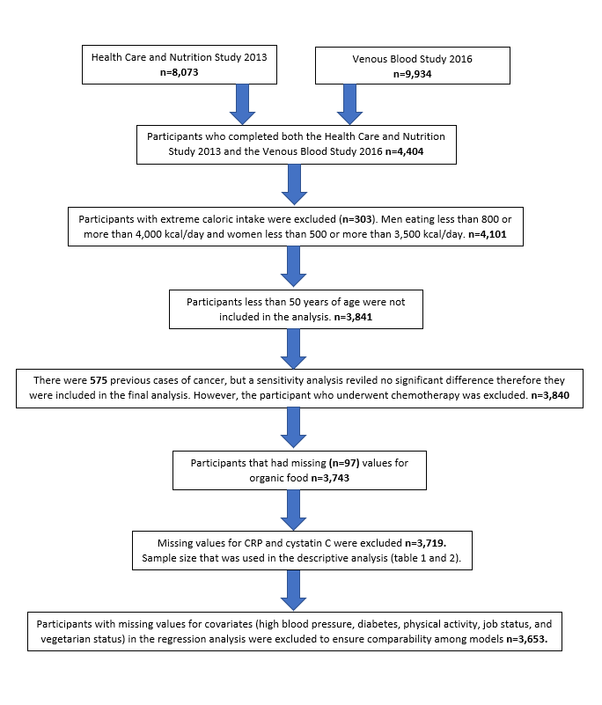
Supplemental Figure 1 Sample Size Flow Diagram
Participants with CRP>10 (n=319) excluded for CRP regression analysis n=3,334
Participants in the cystatin C regression analysis n=3,653
Supplemental Table 1 Linear regression analysis for the association between organic food consumption and log CRP(n=3,175)/log CysC (n=3,481) excluding participants that had their organic food variable recoded.
Predictor |  | Organic Foods Consumption | 95% Confidence Interval | Vegetarian | 95% Confidence Interval | Alternative Mediterranean diet score | 95% Confidence Interval
CRP | Model 1¹ | -0.174 | (-0.240, -0.108) | - | - | - | -
 | Model 2² | -0.107 | (-0.174, -0.040) | - | - | - | -
 | Model 3³ | -0.098 | (-0.166, -0.031) | -0.138 | (-0.297, 0.021) | - | -
 | Model 4⁴ | -0.092 | (-0.160, -0.024) | - | - | -0.018 | (-0.035, -0.001)
CysC | Model 1¹ | -0.104 | (-0.127, -0.080) | - | - | - | -
 | Model 2² | -0.040 | (-0.058, -0.021) | - | - | - | -
 | Model 3³ | -0.042 | (-0.061, -0.023) | 0.031 | (-0.026, 0.088) | - | -
 | Model 4⁴ | -0.026 | (-0.046, -0.006) | - | - | -0.017 | (-0.022, -0.012)
¹Model 1: unadjusted; all values are weighted for the complex sample design.
²Model 2: Adjusted for age, BMI, gender, race, blood pressure, diabetes, alcohol consumption, physical activity, job status, total net worth, education, and daily caloric intake; all values are weighted for the complex sample design.
³Model 3: Adjusted for age, BMI, gender, race, blood pressure, diabetes, alcohol consumption, physical activity, job status, total net worth, education, daily caloric intake, and vegetarian status; all values are weighted for the complex sample design.
⁴Model 4: Adjusted for age, BMI, gender, race, blood pressure, diabetes, alcohol consumption, physical activity, job status, total net worth, education, daily caloric intake, and A-MedDiet; all values are weighted for the complex sample design.

Supplemental Table 2 The Alternative Mediterranean diet gender-specific median cut points
Component (servings/day) | Criteria for Maximum Score (1)
 | Men | Women
Fruit | >1.46 | >1.65
Vegetables | >2.02 | >2.28
Whole grains | >0.67 | >0.67
Red/processed meats | <0.81 | <0.60
Alcohol | >.5, <=2 | >.5, <=1.5
Nuts | >0.47 | >0.42
Legumes | >0.22 | >.23
Fish | >0.13 | >.11
MUFA¹/SFA² | >1.06 | >1.04
¹MUFA: monounsaturated fats
²SFA: saturated fats

Supplemental Figure 2 Overlaid histograms of Log CRP and Log Cystatin C for those who consume and don’t consume organic foods

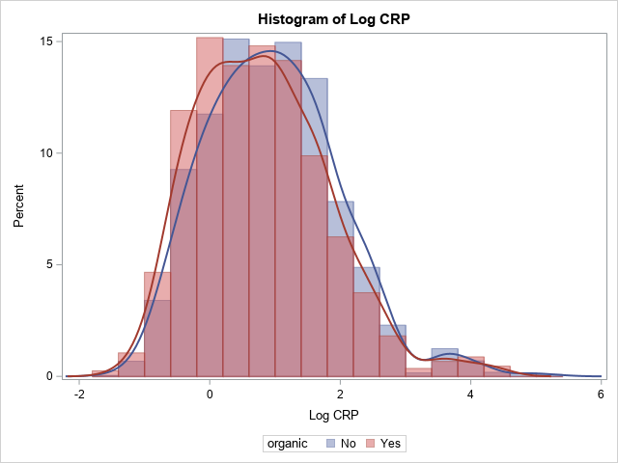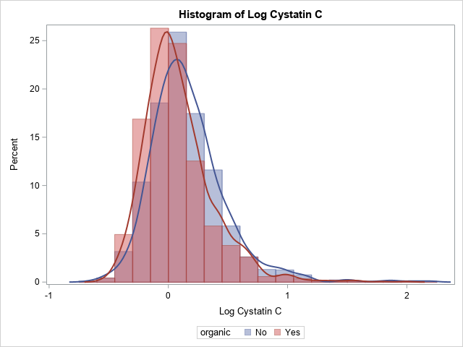

Supplemental Table 3 Linear regression analysis for the association between organic food consumption and log CRP / log CysC (n=3,653).
Predictor |  | Organic Foods Consumption | 95% Confidence Interval | Vegetarian | 95% Confidence Interval | Alternative Mediterranean diet score | 95% Confidence Interval
CRP | Model 1¹ | -0.165 | (-0.240, -0.089) | - | - | - | -
 | Model 2² | -0.083 | (-0.154, -0.013) | - | - | - | -
 | Model 3³ | -0.076 | (-0.147, -0.006) | -0.123 | (-0.270, 0.024) | - | -
 | Model 4⁴ | -0.062 | (-0.133, 0.009) | - | - | -0.029 | (-0.046, -0.013)
CysC | Model 1¹ | -0.092 | (-0.1160, -0.0683) | - | - | - | -
 | Model 2² | -0.033 | (-0.051, -0.015) | - | - | - | -
 | Model 3³ | -0.034 | (-0.053, -0.016) | 0.025 | (-0.031, 0.081) | - | -
 | Model 4⁴ | -0.019 | (-0.039, 0.000) | - | - | -0.019 | (-0.024, -0.013)
¹Model 1: unadjusted.
²Model 2: Adjusted for age, BMI, gender, race, blood pressure, diabetes, alcohol consumption, physical activity, job status, total net worth, education, and daily caloric intake.
³Model 3: Adjusted for age, BMI, gender, race, blood pressure, diabetes, alcohol consumption, physical activity, job status, total net worth, education, daily caloric intake, and vegetarian status.
⁴Model 4: Adjusted for age, BMI, gender, race, blood pressure, diabetes, alcohol consumption, physical activity, job status, total net worth, education, daily caloric intake, and A-MedDiet.

Supplemental Table 4 Linear regression analysis for the association between organic food consumption and log CRP (n=3,333) /log CysC (n=3,649) without influential points.
Predictor |  | Organic Foods Consumption | 95% Confidence Interval | Vegetarian | 95% Confidence Interval | Alternative Mediterranean diet score | 95% Confidence Interval
CRP | Model 1¹ | -0.155 | (-0.219, -0.091) | - | - | - | -
 | Model 2² | -0.100 | (-0.164, -0.035) | - | - | - | -
 | Model 3³ | -0.092 | (-0.158, -0.026) | -0.133 | (-0.289, 0.023) | - | -
 | Model 4⁴ | -0.085 | (-0.151, -0.019) | - | - | -0.020 | (-0.036, -0.003)
CysC | Model 1¹ | -0.097 | (-0.120, -0.073) | - | - | - | -
 | Model 2² | -0.039 | (-0.056, -0.021) | - | - | - | -
 | Model 3³ | -0.041 | (-0.058, -0.023) | 0.030 | (-0.025, 0.085) | - | -
 | Model 4⁴ | -0.026 | (-0.045, -0.007) | - | - | -0.018 | (-0.023, -0.013)
¹Model 1: unadjusted; all values are weighted for the complex sample design.
²Model 2: Adjusted for age, BMI, gender, race, blood pressure, diabetes, alcohol consumption, physical activity, job status, total net worth, education, and daily caloric intake; all values are weighted for the complex sample design.
³Model 3: Adjusted for age, BMI, gender, race, blood pressure, diabetes, alcohol consumption, physical activity, job status, total net worth, education, daily caloric intake, and vegetarian status; all values are weighted for the complex sample design.
⁴Model 4: Adjusted for age, BMI, gender, race, blood pressure, diabetes, alcohol consumption, physical activity, job status, total net worth, education, daily caloric intake, and A-MedDiet; all values are weighted for the complex sample design.

