Supplementary material

Table 1: Rationale for changes of the opt-out letter
Main theme | Definition | Subthemes | Examples by LGA
Clarifications (References [R] = 19) | Changes to clarify the process of the NCMP. | Date, opt-out | “Add an opt-out section at the end of the letter...”
Language  (R = 24) | Changes to modify the language of the opt out letters, change the tone, or improve readability. | Make friendly, personalised, Improve readability | “Make it more personal and user friendly...”; “To improve readability for parents.”; “language is slightly modified to be a bit more friendly and less formal”
Localisations  (R = 46) | Changes to “localise” letter to a given area. | Contacts, design, other screening, services | “The letter is locally tailored as for the Reception age”; “To fit with local commissioned services...”; “We also branded our services and used the strapline...”
User driven  (R = 13) | Changes due to feedback from users. | Parents, public health director | “Based on feedback from parents who have previously complained about the letter and the NCMP programme.”; “(wording)...Director of Public Health is comfortable to use.”
*R = References

Table 2: Rationale for changes of the result letter
Main theme | Definition | Subthemes | Examples by LGA
Clarifications (R = 10) | Changes to clarify results letter and the process of the NCMP. | Confidentiality, results | “...reiterate information on confidentiality.”; “The tailored letter adds further information, including ‘hat 'some medical treatments can mean that BMI centile is not the best way to measure your ’child'”; “To give more information about the weight categories”
Design  (R = 5) | Changes to modify the design of the result letter. | Nudge, printing costs, visuals | “...apply 'nudge theory' to the letter - the information remains the same but is presented and structured differently to the standard letter.”; “We also send a growth chart to indicate visually to parent the degree of difference from percentile...”
Language  (R = 20) | Changes to modify the language of the result letters, change the tone, or improve readability. | Emphasise health issues, make friendly, neutralise, personalise, Improve readability | “Added in a little more information about how obesity can cause health problems...”; “To make the wording more user friendly.”; “It was agreed to soften the language...”; “Trying to make it a more personal”; “...to be more readable.”
Localisations  (R = 50) | Changes to “localise” letter to a given area. | Contacts, other screening, services | “...local number and information.”; “...provide information on dental health.”; “To promote local weight management services.”
User driven  (R = 19) | Changes due to feedback from users. | Parents, public health director, school nurses | “The provider received a number of complaints from parents regarding the suggestion that their child was overweight.”; “We have significantly changed the results letter following focus group activity with parents. Many parents told us the language was not engaging and felt blaming.”; “...wording approved by programme leads and Director of public health.”; “We decided to change our letters in consultation with our school nurses as they had expressed a concern that some parents felt offended by the letter.”
*R = References

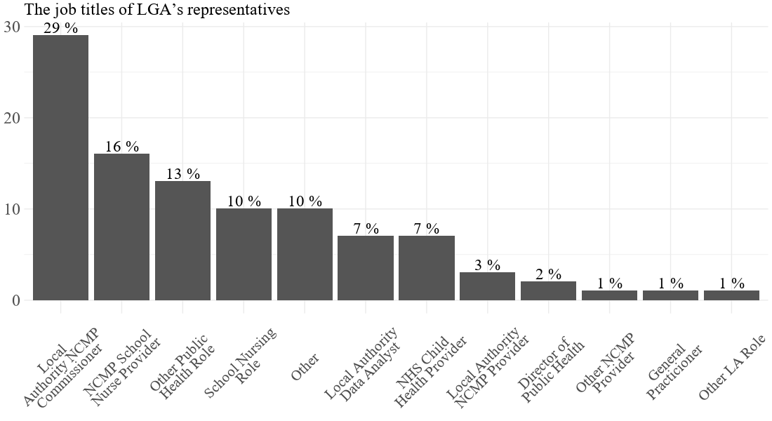
Figure 1: Job titles of LGA’s representatives (respondents)

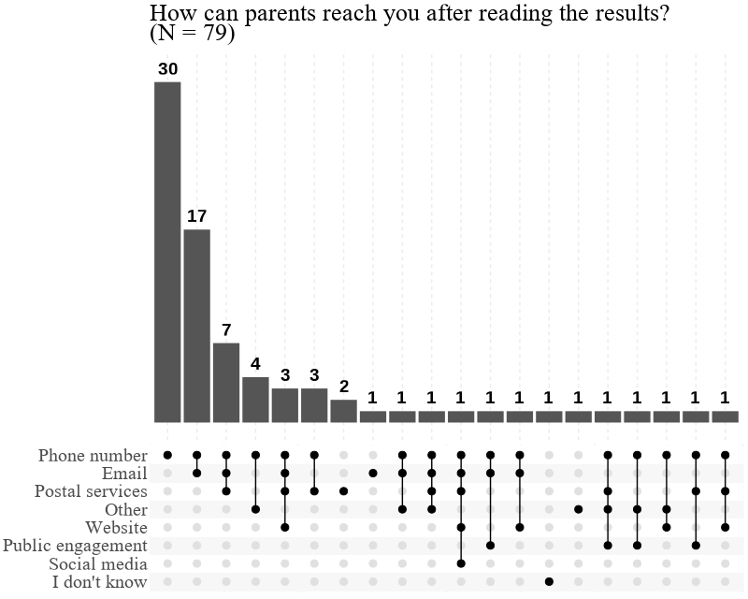
Figure 2: Methods of contact available to parents inside the result letters
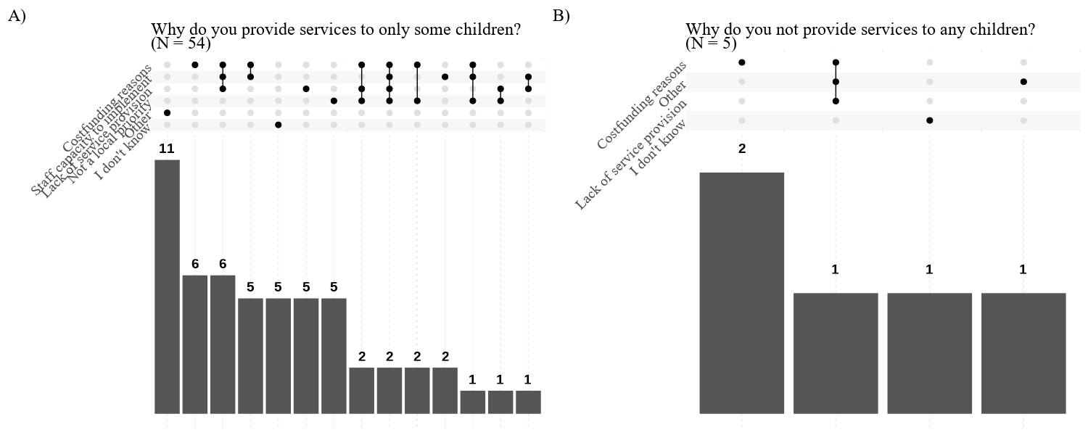
Figure 3: Reasons for limited service provision

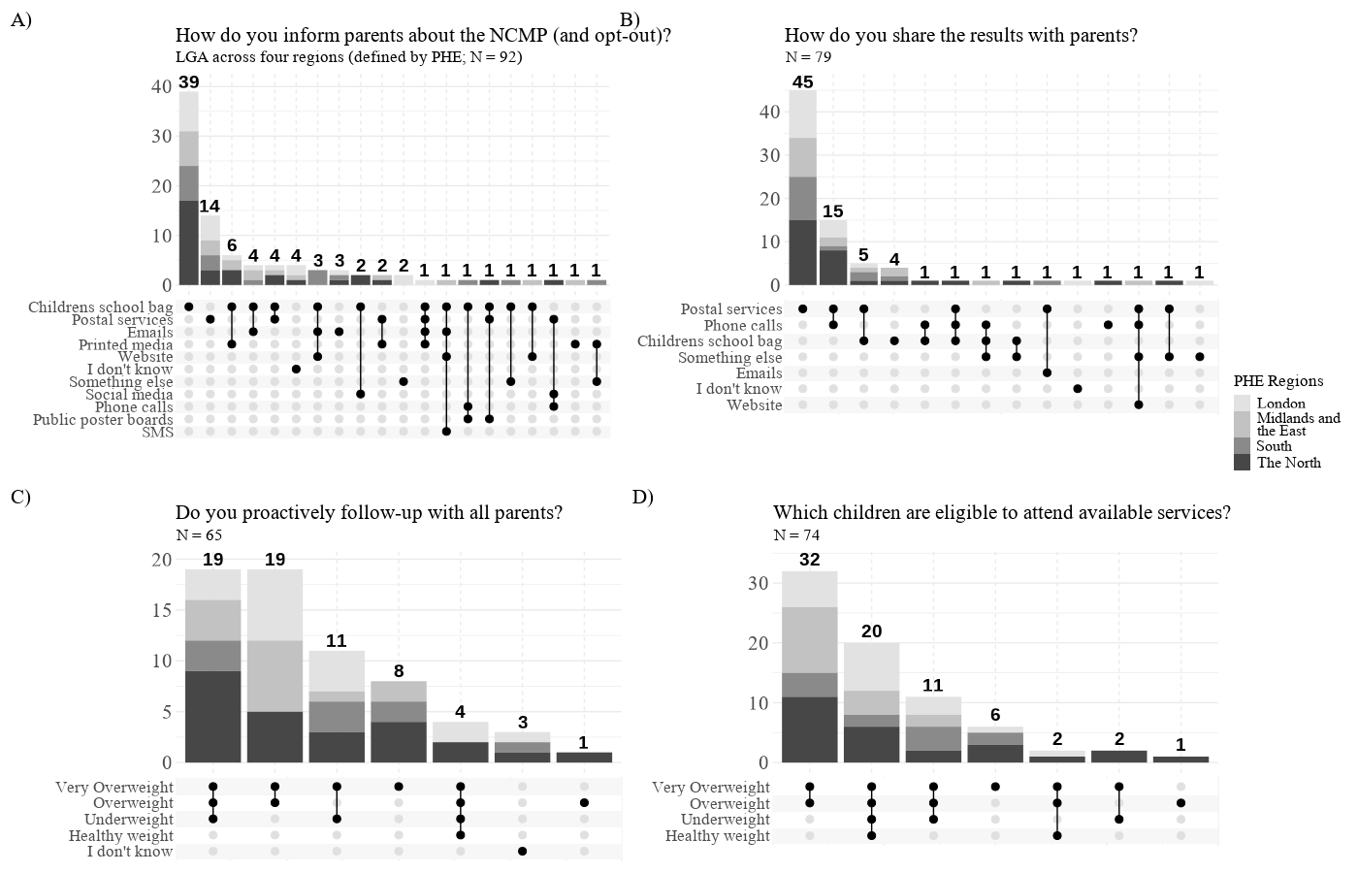
Figure 4: Comparison of responses across PHE regions
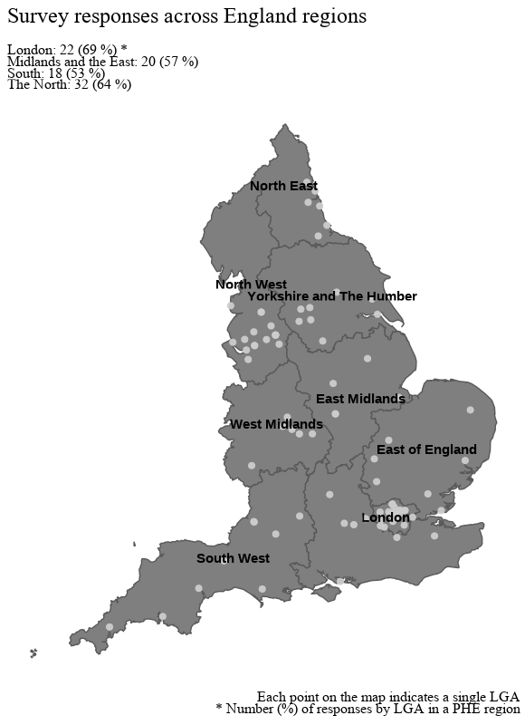
Figure 5: Map of survey responses across England – General
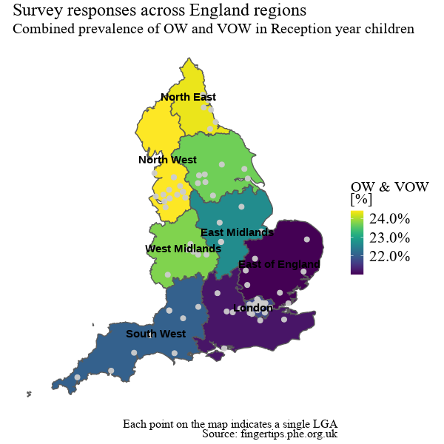
Figure 6: Map of survey responses across England – RY OW and VOW prevalence
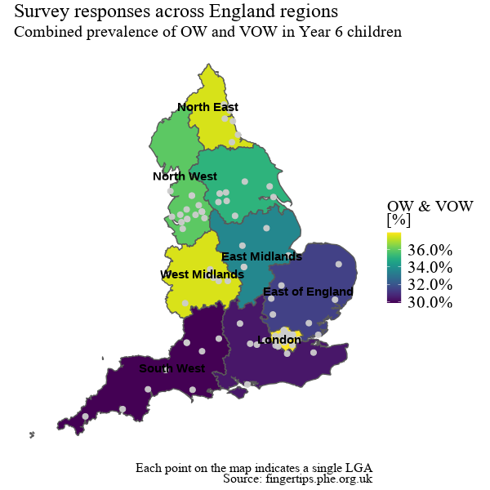
Figure 7: Map of survey responses across England – Y6 OW and VOW prevalence
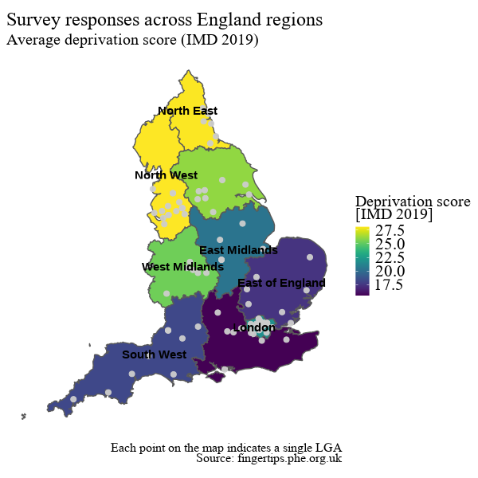
Figure 8: Map of survey responses across England – IMD

