Theoretical Framework of Acceptability Coding

Coding instructions:
1) Code each barrier and enabler for TFA category (if applicable) using brackets and abbreviations for TFA category (e.g. Affective Attitude = AA)
2) For factor, put overall categories coded, e.g. AA and B if both Affective attitude and Burden are coded for enablers/barriers within that factor.
3) Don’t code if TFA category not relevant

Consensus process:
1) Compare coding – highlight any discrepancy
2) Discuss categories and perceived meaning within this intervention
3) Discuss specific discrepancies revisit coding mutually within discussion
4) Consensus achieved for final codes

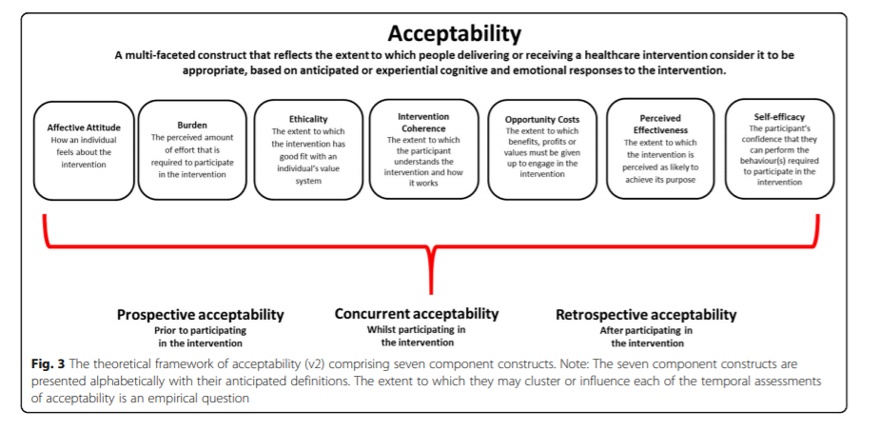
Sekhon et al 2017

Codebook:

Affective Attitude –HCPs perceptions of the importance of the intervention, how they feel about being the ones tasked to deliver the intervention, e.g. it being their role or not
Burden – HCPs perceptions about effort to participate in intervention due to staffing, funding limitations, their existing roles and priorities etc
Ethicality – HCPs’ personal views about the importance of this topic, and how this intervention is important and fits with their personal value system
Opportunity Cost – HCPs thoughts on how to balance time/resources required with potential for gain (i.e. minimising opportunity cost)
Perceived Effectiveness – Specific aspects of this intervention that HCPs perceived would probably impact on intervention effectiveness
Self-Efficacy – HCPs’ confidence about their own level of knowledge and skills eg communication needed to deliver the intervention

