Supplementary Material
Supplementary Table 1 Correlation matrix of plasma carotenoids and vitamins in Aboriginal people in Australia (n=324)
 | β-cryptoxanthin | β-carotene | Lycopene | Lutein-zeaxanthin | α-tocopherol
 | Pearson’s r | Pearson’s r | Pearson’s r | Pearson’s r | Pearson’s r
β-cryptoxanthin | -
β-carotene | 0.59** | -
Lycopene | 0.40** | 0.36** | -
Lutein-zeaxanthin | 0.52** | 0.25** | 0.43** | -
α-tocopherol | 0.27** | 0.22** | 0.25** | 0.57** | -
Retinol | 0.10 | 0.08 | 0.10 | 0.25** | 0.43**
** Correlation is significant at the level 0.01. * Correlation is significant at the level 0.05

Supplementary Table 2 Total Variance Explained (for Kaiser’s criterion as part of the PCA)
Component | Total | Initial Eigenvalues |  | Extraction Sums of Squared Loadings  Retinol |  |  | Rotation Sums of Squared Loadings*  Total
 |  | % of Variance | Cumulative % | Total | % of Variance | Cumulative %
1 | 2.67 | 44.45 | 44.45 | 2.67 | 44.45 | 44.45 | 2.36
2 | 1.23 | 20.49 | 64.94 | 1.23 | 20.49 | 64.94 | 1.88
3 | 0.74 | 12.41 | 77.35
4 | 0.63 | 10.44 | 87.79
5 | 0.46 | 7.68 | 95.47
6 | 0.27 | 4.53 | 100.00
Extraction Method: Principle Component Analysis
*When components are correlated, sums of squared loadings cannot be added to obtain a total variance

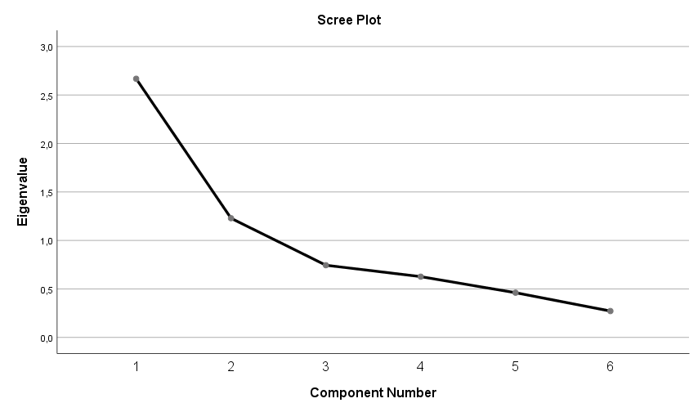

Supplementary Figure 1: Scree Plot for the PCA

Supplementary Table 3 Comparison of eigenvalues from PCA and criterion values from parallel analysis
Component number | Actual eigenvalue from PCA | Criterion value from parallel analysis | Decision
1 | 2.67 | 1,1840 | Accept
2 | 1.23 | 1,0972 | Accept
3 | 0.74 | 1,0200 | Reject
4 | 0.63 | 0,9645 | Reject
5 | 0.46 | 0,9029 | Reject
6 | 0.27 | 0,8314 | Reject

Supplementary Table 4 Component and Pattern Matrix for PCA
Antioxidant biomarkers | Component Matrix |  | Pattern Matrix
 | Component |  | Component
 | 1 | 2 | 1 | 2
β-cryptoxanthin | 0.76 | -0.39 | 0.85 | 0.01
β-carotene | 0.64 | -0.47 | 0.82 | -0.13
Lycopene | 0.65 | -0.25 | 0.67 | 0.08
Lutein-zeaxanthin | 0.79 | 0.16 | 0.49 | 0.53
α-tocopherol | 0.68 | 0.52 | 0.16 | 0.80
Retinol | 0.41 | 0.70 | -0.18 | 0.84

Supplementary Table 5 Principle component analysis, the antioxidant component in remote Australian Aboriginal people (n=324)
Antioxidant biomarkers | Antioxidant component
 | Component Matrix
β-cryptoxanthin | 0.761
β-carotene | 0.639
Lycopene | 0.650
Lutein-zeaxanthin | 0.793
α-tocopherol | 0.681
Retinol | 0.406
Kaiser-Meyer-Olkin Measure of Sampling Adeuancy: 0.666,
Bartlett’s Test of Sphericity: Approx. Chi-Square 527.480, p < 0.001

Supplementary Table 6 Comparison of age and sex among the study population and house to house census 2002
Age | Men (%) |  | Women (%)
 | Study population¹  n =147 (45.4%) | House to house census  n = 315 (44.6%) | Study population  n = 177 (54.6) | House to house census  n = 391 (55.4)
15 – 24 | 34.7 | 33.3 | 18.1 | 33.3
25 – 34 | 23.8 | 28.6 | 27.1 | 27.1
35 – 44 | 17.7 | 17.1 | 32.2 | 21.0
45 – 54 | 15.6 | 13.3 | 10.2 | 9.2
55 + | 8.2 | 7.6 | 12.4 | 9.5
¹Measurements of anthropometric, fasting blood samples and urine analyses

Supplementary Table 7 Multiple linear regression antioxidant component and cardio-metabolic risk markers for participants without self-reported diabetes, heart disease, kidney disease or gestational diabetes (n=253)
 | Model 1 |  |  | Model 2
 | Unstandardized Beta 95% CI | Coeff. SE | p-value | Unstandardized Beta 95% CI | Coeff. SE | p-value
Body Mass Index (kg/m²) | 0.04 [0.01;0.06] | 0.01 | 0.01 | 0.02 [<-0.01; 0.05] | 0.01 | 0.07
Waist circumference (cm) | 0.01 [<0.01; 0.02] | 0.01 | 0.06 | 0.01 [<-0.01;0.02] | 0.01 | 0.22
Waist-to-hip-ratio | 0.91 [-0.71; 2.53] | 0.82 | 0.27 | 0.39 [-1.40; 2.17] | 0.91 | 0.67
Waist-to-height ratio | 1.35 [-0.20; 2.91] | 0.79 | 0.09 | 0.77 [-0.85; 2.39] | 0.82 | 0.35
Fasting blood glucose (mmol/L)* | 0.56 [-0.79; 1.92] | 0.69 | 0.41 | 0.40 [-0.88;1.68] | 0.65 | 0.54
Glycated haemoglobin (%)* | 0.17 [-2.05; 2.40] | 1.13 | 0.88 | -0.12 [-2.32; 2.08] | 1.11 | 0.91
Systolic blood pressure (mmHg)** | <-0.01 [-0.01; 0.01] | <0.01 | 0.60 | <0.01 [-0.01; 0.01] | <0.01 | 0.95
Diastolic blood pressure (mmHg)** | <-0.01 [-0.02; 0.01] | <0.01 | 0.54 | <0.01 [-0.01; 0.01] | 0.01 | 0.98
Albumin/creatinine ratio* | -1.19 [-0.42; 0.05] | 0.12 | 0.12 | -0.26 [-0.49; -0.03] | 0.12 | 0.03
C-reactive protein (mg/dL)* | -0.14 [-0.39; 0.12] | 0.13 | 0.29 | -0.25 [-0.48; -0.01] | 0.12 | 0.04
Model 1: Unadjusted Model 2: Adjusted for sex, age, total cholesterol and current smoking. * Original variables were not normally distributed and were therefore transformed to lg10 values, in this model back transformed values. **Individuals reporting to take blood pressure medication was excluded for this analysis (n=3)

