Figure S1: Repeat cross-sectional study design, with of 5 age cohorts in 2001-04 (T1) and in 2014-18 (T2). The majority of youngest age groups at T2 were newly recruited, while remaining age groups were originally recruited at T1 and re-examined at T2.

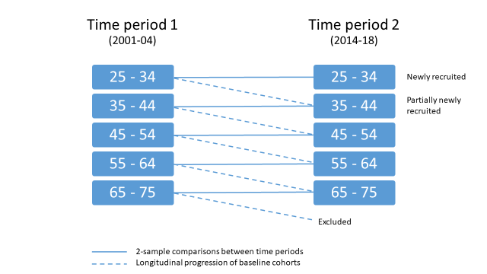

Figure S2: Relative climate impact changes by age group and further stratified by sex (left), weight status (middle), and university education (right), adjusted for age, sex, overweight, university education, and total food intake. Interactions between time period and sex, weight status and education were tested for each age group; none was statistically significant except for time period by weight status interaction in the 35-44 year age group (middle).

