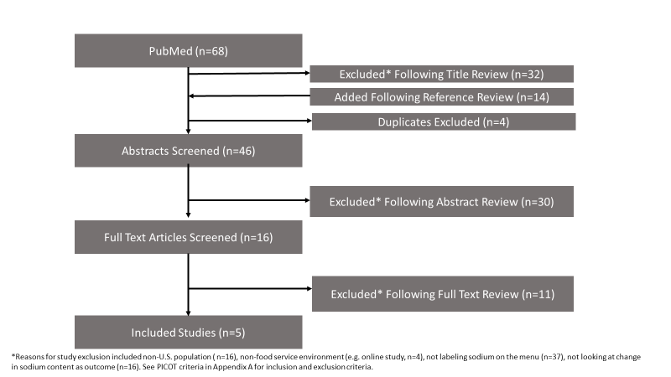
Appendix Figure 1: Flow diagram of the literature search and filtering results
Appendix A

Search Strategy Details
PubMed was searched on March 27, 2019 and updated on April 27, 2020 using the following search strategy: “(Restaurants[mesh] OR restaurant*[tiab] OR fast food[tiab] OR cafeteria[tiab]) AND (menu label* OR calorie label* OR sodium label*) AND sodium[tiab].” Including [tiab] requires the adjacent keyword to be included in the abstract and/or title, and [mesh] is a keyword identifier that will include studies that have been indexed with the adjacent term (in this case, restaurants).

PICOT Criteria

Population, Intervention, Comparison, Outcome, Time (PICOT) framework
Criteria | Details
Population | - Focus on the U.S. population  - Set in a food service environment (e.g. restaurant, cafeteria)
Intervention | - Interventions that labeled sodium content on the menu
Comparison | - Used any study design, including designs with and without comparison groups
Outcome | - Evaluated the impact of menu labeling on either the sodium content of menu items offered by restaurants or the sodium content of menu items purchased by consumers
Time | - Published any time before April 27, 2020 (when article was completed).

