Supplemental files legends
Supplementary table 1. Systematic literature review search terms and strategy
Supplementary table 2. Basic characteristics of population-based epidemiological studies investigating the association between sugar and artificially sweetened beverage consumption and the risk of metabolic syndrome
Supplementary figure 1. Dose–response subgroup association between total sweetened beverage consumption and the risk of metabolic syndrome that was assessed by using a restricted cubic splines model
Supplementary figure 2. Dose–response subgroup association between sugar sweetened beverage consumption and the risk of metabolic syndrome that was assessed by using a restricted cubic splines model
Supplementary table 1. Systematic literature review search terms and strategy
Search terms for PubMed (n=756)
#1 ("beverages"[Mesh] OR "drink"[Title/Abstract] OR "drinks"[Title/Abstract] OR "beverage"[Title/Abstract] OR "beverages"[Title/Abstract] OR "soda"[Title/Abstract] OR "pop"[Title/Abstract] OR "sweetened iced tea"[Title/Abstract] OR "fruit punch"[Title/Abstract] OR "cordials"[Title/Abstract] OR "squashes"[Title/Abstract] OR "lemonade"[Title/Abstract])
#2 ("Metabolic Syndrome X"[Mesh] OR “metabolic syndrome” [Title/Abstract] OR “syndrome X” [Title/Abstract] OR “insulin resistance syndrome” [Title/Abstract] OR MetS [Title/Abstract])
#1 AND #2
Search terms for Embase (n=1,130)
#1 beverage/ or beverage.mp. or beverages.mp. or drink.mp. or drinks.mp. or soda.mp. or pop.mp. or fruitades.mp. or sweetened iced tea.mp. or fruit punch.mp. or cordials.mp. or squashes.mp. or lemonade.mp.
#2 metabolic syndrome X/ OR Metabolic Syndrome X.mp. OR metabolic syndrome.mp. OR syndrome X.mp. OR insulin resistance syndrome.mp. OR MetS.mp.
#1 AND #2
Search terms for Web of Science (n=1,954)
#1 TS=("drink" OR "drinks" OR "beverage" OR "beverages" OR "soda" OR "pop" OR "sweetened iced tea" OR "fruit punch" OR "cordials" OR "squashes" OR "lemonade")
#2 TS= ("Metabolic Syndrome X" OR “metabolic syndrome” OR “syndrome X” OR “insulin resistance syndrome” OR MetS)
#1 AND #2

Supplementary table 2. Basic characteristics of population-based epidemiological studies investigating the associations between sugar and artificially sweetened beverage consumption and the risk of metabolic syndrome
No | Author, year | Country | Study design | Dietary assessment method | Definition of MetS | Sex | Age (mean age or range) | Sample size (% men) | MetS patients | Exposure | Unit | Exposure category | OR/RR/HR | Adjustment for potential confounding factors | NOS/  AHRQ
1 | Dhingra et al. 2007 | America | Cross-sectional study | 13-item FFQ | AHA/NHLBI, NCEP ATP III | All | 53 | 8997 (46) | 2777 | Soft drinks | servings/day | 0 | Reference | age, sex, physical activity index, smoking, dietary consumption of saturated fat, trans fat, fiber, magnesium, total calories, glycemic index | 9
 | Dhingra et al. 2007 |  | Cross-sectional study |  | AHA/NHLBI, NCEP ATP III |  |  |  |  | Soft drinks | servings/day | 1 | 1.38 (1.19-1.61) |  | 9
 | Dhingra et al. 2007 |  | Cross-sectional study |  | AHA/NHLBI, NCEP ATP III |  |  |  |  | Soft drinks | servings/day | ≥2 | 1.67 (1.38-2.01) |  | 9
 | Dhingra et al. 2007 |  | Longitudinal study | 13-item FFQ | AHA/NHLBI, NCEP ATP III | All | 53 | 6154 (43) | 1150 | Soft drinks | servings/day | 0  1  ≥2 | Reference  1.53 (1.24-1.89)  1.29 (0.98-1.70) |  | 8
2 | Lutsey et al. 2008 | America | Longitudinal study | 66-item FFQ | AHA | All | 54 | 9514 (44.1) | 3782 | Sweetened beverages | servings/day | Q1 | Reference | age, sex, race, education, center, total calories, smoking status, pack-years, physical activity, intakes of meat, dairy, fruits and vegetables, whole grains, refined grains | 8
 | Lutsey et al. 2008 | America | Longitudinal study |  |  |  |  |  |  |  |  | Q2 | 1.02 (0.94–1.11)
 | Lutsey et al. 2008 | America | Longitudinal study |  |  |  |  |  |  |  |  | Q3 | 1.09 (0.99–1.19)
 |  |  |  |  |  |  |  |  |  | Diet soda | servings/day | Q1 | Reference
 |  |  |  |  |  |  |  |  |  |  |  | Q2 | 1.05 (0.96-1.15)
 |  |  |  |  |  |  |  |  |  |  |  | Q3 | 1.34 (1.24-1.44)
3 | Nettleton et al. 2009 | America | Longitudinal study | 120-item FFQ | NCEP ATP III | All | 45-84 | 3878 (NA) | 871 | Diet soda | serving | 0 | Reference | study site, age, sex, race/ethnicity, energy intake, education, physical activity, smoking status, pack-years, and weekly or more supplement use, waist circumference, body mass index | 8
 | Nettleton et al. 2009 |  | Longitudinal study |  |  |  |  |  |  |  |  | 0-1 serving/week | 1.30 (1.04-1.62) |  | 8
 | Nettleton et al. 2009 |  |  |  |  |  |  |  |  |  |  | 1 serving/week-1 serving/day | 1.15 (0.95-1.38) |  | 8
 | Nettleton et al. 2009 |  |  |  |  |  |  |  |  |  |  | ≥1 serving/day | 1.17 (0.96-1.44) |  | 8
 |  |  |  |  |  |  |  |  |  | Sugar sweetened beverages | serving | highest versus lowest | 1.15 (0.92-1.42)
4 | Hostmark et al. 2010 | Oslo | Longitudinal study | Questionaire | IDF | All | 30-60 | 11554 (47) | 2356 | Soft drink  With sugar  Colas  Noncolas | glasses |  |  | age, sex, noncola (cola) intake, time since the last meal and use of soft drinks with or without sugar, frequency of intake of cheese, fatty fish, coffee, alcohol, smoking, leisure time physical activity, years at school, birth place | 8
 |  |  |  |  |  |  |  |  |  |  |  | per glasses  per glasses | 1.15 (1.06-1.25)  1.03 (0.93-1.14) |  | 8
5 | Denova-Gutie´rrez et al. 2010 | Morelos and Mexico | Cross-sectional study | 116-item FFQ | NCEP ATP III | All | 39 (20-70) | 5240 (28) | 1394 | Sweetened beverages | servings (355 ml)/day | 0 | Reference | age, sex, body mass index, weight change within past year, physical activity, total energy intake , alcohol intake, SFA intake, PUFA intake, trans fatty acid intake, cigarette smoking, place of residence | 7
 | Denova-Gutie´rrez et al. 2010 | Morelos and Mexico | Cross-sectional study |  |  |  |  |  |  |  | servings (355 ml)/day | 0-1 | 1.4 (1.2-1.7) |  | 7
 | Denova-Gutie´rrez et al. 2010 | Morelos and Mexico | Cross-sectional study |  |  |  |  |  |  |  | servings (355 ml)/day | 1-2 | 1.7 (1.3- 2.0) |  | 7
 | Denova-Gutie´rrez et al. 2010 | Morelos and Mexico | Cross-sectional study |  |  |  |  |  |  |  | servings (355 ml)/day | >2 | 2.0 (1.1-3.1) |  | 7
6 | Hostmark et al. 2012 | Oslo | Cross-sectional study | Questionaire | IDF | All | 30-60 | 18770 (29) | 2340 | Soft drink | glasses | per glasses | 1.07 (1.03-1.11) | sex, age, time since the last meal, and inclusion of an interaction factor=intake frequency of soft drinks multiplied by that of cheese, intake frequency of fruit/berries, fruit juice, fatty fish, coffee, alcohol, smoking, leisure time physical activity and years at school | 8
7 | Mattei et al. 2012 | Costa Rica | Case-control study | 135-item FFQ | ATP III | All | 57 | 1872 (NA) | 547 | Sugar sweetened beverages | serving (237 mL) /week | 0 | Reference | age, sex, area of residence, income, alcohol intake, smoking, physical activity, dietary fiber, PUFA:SFA ratio, sugar added to food or beverages, caffeine, low-fat milk, fruit consumption, and other beverages depending on the model | 7
 | Mattei et al. 2012 |  | Case-control study |  |  |  |  |  |  | Sugar sweetened beverages | serving (237 mL) /week | 0-1 | 1.07 (0.82-1.41) |  | 7
 | Mattei et al. 2012 |  | Case-control study |  |  |  |  |  |  |  | serving (237 mL) /week | 2-6 | 1.18 (0.94-1.47) |  | 7
 | Mattei et al. 2012 |  | Case-control study |  |  |  |  |  |  |  | serving (237 mL) /week | ≥7 | 1.39 (1.08-1.80) |  | 7
8 | López-Molin-a et al. 2013 | Mexico | Longitudinal study | 85-item FFQ | ATP-III | All | 63 | 1116 (39) | NA | Sweetened beverages | bottle/day | 1/week-1/day | 1.07 (0.72-1.57) | age, sex, years of study, current smoking, glomerular fltration rate | 7
 | López-Molin-a et al. 2013 |  | Longitudinal study |  |  |  |  |  |  |  |  | 1/day | 1.38 (0.88-2.15)
 |  |  | Longitudinal study |  |  |  |  |  |  |  |  | >1/day | 1.36 (0.83-2.23)
9 | Grosso et al. 2014 | Italy | Cross-sectional study | Questionnaire | IDF | ALL | 50 | 1889 (40) | 226 | Soft drinks | cup/day | per 1 cup/day | 1.15 (0.74-1.56) | age, sex, body mass index, educational level, socioeconomic status, energy intake, smoking status, alcohol drinking, physical activity level, MedDietScore, caffeine, source of caffeine. | 6
10 | Chan et al. 2014 | China | Cross-sectional study | 23-item FFQ | Cook et al. criteria | All | 12-16 | 2727 (NA) | 82 | Sugar sweetened beverages | mL/day |  |  | study area, age, physical activity, total calories, the intake of meat, fruit, fried food, food with jelly/honey, alcohol drinking, cigarette smoking | 7
 | Chan et al. 2014 |  | Cross-sectional study |  | Cook et al. criteria | Women |  |  | 27 | Sugar sweetened beverages | mL/day | 0 | Reference |  | 7
 | Chan et al. 2014 |  | Cross-sectional study |  | Cook et al. criteria |  |  |  |  | Sugar sweetened beverages | mL/day | 1-500 | 3.2 (0.6-17.8) |  | 7
 | Chan et al. 2014 |  | Cross-sectional study |  | Cook et al. criteria |  |  |  |  | Sugar sweetened beverages | mL/day | >500 | 5.9 (0.8-43.8) |  | 7
 | Chan et al. 2014 |  | Cross-sectional study |  | Cook et al. criteria | Men |  |  | 55 | Sugar sweetened beverages | mL/day | 0 | Reference |  | 7
 | Chan et al. 2014 |  | Cross-sectional study |  | Cook et al. criteria |  |  |  |  | Sugar sweetened beverages | mL/day | 1-500 | 4.9 (1.1-21.1) |  | 7
 | Chan et al. 2014 |  | Cross-sectional study |  | Cook et al. criteria |  |  |  |  | Sugar sweetened beverages | mL/day | >500 | 5.1 (1.01-25.5) |  | 7
11 | Mirmiran et al. 2015 | Tehran | Longitudinal study | 168-item FFQ | Cook et al. criteria | All | 14 (6-18) | 424 (32) | 47 | Sugar sweetened beverages | mL/day | <19.2 | Reference | age, sex, total energy intake, physical activity, family history of diabetes, dietary fiber, tea and coffee, red and processed meat, fruit, vegetable, body mass index | 8
 | Mirmiran et al. 2015 |  | Longitudinal study |  | Cook et al. criteria |  |  |  |  | Sugar sweetened beverages | mL/day | 19.2-43.8 | 1.11 (0.31-3.81) |  | 8
 | Mirmiran et al. 2015 |  |  |  | Cook et al. criteria |  |  |  |  | Sugar sweetened beverages | mL/day | 43.9-91.5 | 2.96 (0.99-8.80) |  | 8
 | Mirmiran et al. 2015 |  |  |  | Cook et al. criteria |  |  |  |  | Sugar sweetened beverages | mL/day | >91.6 | 3.50 (1.12-10.92) |  | 8
12 | Crichton et al. 2015 | America | Cross-sectional study | 146-item FFQ | NCEP ATP III | All | 23-98 | 803 (NA) | 353 | Total soft drink | servings (330 mL)/day | 0 | Reference | age, sex, education, smoking, physical activity, alcohol, total intakes of vegetables, fruit, grains and meat, total energy | 6
 | Crichton et al. 2015 |  | Cross-sectional study |  |  |  |  |  |  |  | servings (330 mL)/day | 1 | 2.4 (1.5-3.9) |  | 6
 | Crichton et al. 2015 |  | Cross-sectional study |  |  |  |  |  |  |  | servings (330 mL)/day | ≥2 | 2.1 (1.2-3.8) |  | 6
 | Crichton et al. 2015 |  | Cross-sectional study |  |  |  |  |  |  | Diet soft drink | servings (330 mL)/day | 0 | Reference | age, sex, education, smoking, physical activity, alcohol, total intakes of vegetables, fruit, grains, meat, total energy, regular soft drinks/day | 6
 | Crichton et al. 2015 |  | Cross-sectional study |  |  |  |  |  |  |  | servings (330 mL)/day | 1 | 2.2 (1.3-3.7) |  | 6
 | Crichton et al. 2015 |  | Cross-sectional study |  |  |  |  |  |  |  | servings (330 mL)/day | ≥2 | 1.8 (0.9-3.5) |  | 6
 |  | Luxembourg | Cross-sectional study | 134-item FFQ | NCEP ATP III | All | 18-69 | 1323 (NA) | 346 | Total soft drink | servings (330 mL)/day | 0 | Reference | age, sex, education, smoking, physical activity, alcohol, total intakes of vegetables, fruit, grains, meat, total energy | 7
 |  |  | Cross-sectional study |  |  |  |  |  |  |  | servings (330 mL)/day | 1 | 2.0 (1.4-2.8) |  | 7
 |  |  | Cross-sectional study |  |  |  |  |  |  |  | servings (330 mL)/day | ≥2 | 2.1 (1.1-4.0) |  | 7
 |  |  | Cross-sectional study |  |  |  |  |  |  | Diet soft drink | servings (330 mL)/day | 0 | Reference | age, sex, education, smoking, physical activity, alcohol, total intakes of vegetables, fruit, grains and meat, total energy, regular soft drinks/day | 7
 |  |  | Cross-sectional study |  |  |  |  |  |  |  | servings (330 mL)/day | 1 | 1.4 (0.9-2.0) |  | 7
 |  |  | Cross-sectional study |  |  |  |  |  |  |  | servings (330 mL)/day | ≥2 | 3.9 (1.5-10.3) |  | 7
13 | Velasquez-Melendez et al. 2016 | Brazil | Cross-sectional study | Questionnaire | NCEP ATP III | All | 51 (35-74) | 8825 (57) | 1314 | Soft drink | servings (250 ml)/day | <0.1 | Reference | age, sex, education level, income, physical activity, smoking, calorie intake, daily intake of fruits and vegetables | 7
 | Velasquez-Melendez et al. 2016 |  | Cross-sectional study |  |  |  |  |  |  |  | servings (250 ml)/day | 0.2-0.3 | 1.26 (1.07-1.47) |  | 7
 | Velasquez-Melendez et al. 2016 |  | Cross-sectional study |  |  |  |  |  |  |  | servings (250 ml)/day | 0.4-1.0 | 1.39 (1.17-1.65) |  | 7
 | Velasquez-Melendez et al. 2016 |  | Cross-sectional study |  |  |  |  |  |  |  | servings (250 ml)/day | ≥1 | 1.95 (1.60-2.38) |  | 7
14 | Ferreira-Peˆgo et al. 2016 | Spain | Longitudinal study | 137-item FFQ | IDF, AHA, NHLBI | All | 55-80 | 1868 (48) | 930 | Sugar sweetened beverages | servings (200 mL)/week | <1  1-5  >5 | Reference  0.91 (0.71-1.12)  1.43 (1.00-2.15) | intervention group, age, sex, leisure time physical activity, body mass index, smoking status, cumulative average consumption of dietary variables in continuous (vegetables, legumes, fruit, cereals, meat, fish, bakery, dairy products, olive oil, and nuts), cumulative total energy intake, alcohol, and alcohol squared in grams per day, metabolic syndrome components at baseline | 9
 | Ferreira-Peˆgo et al. 2016 |  |  |  | IDF, AHA, NHLBI |  |  |  |  | Artificially sweetened beverages | servings (200 mL)/week | <1 | Reference |  | 9
 | Ferreira-Peˆgo et al. 2016 |  |  |  | IDF, AHA, NHLBI |  |  |  |  | Artificially sweetened beverages | servings (200 mL)/week | 1-5 | 0.93 (0.75-1.17) |  | 9
 | Ferreira-Peˆgo et al. 2016 |  |  |  | IDF, AHA, NHLBI |  |  |  |  | Artificially sweetened beverages | servings (200 mL)/week | >5 | 1.74 (1.26-2.41) |  | 9
15 | Kang et al. 2017 | Korea | Longitudinal study | 103-item FFQ | NCEP ATP III | All | 51 (40-69) | 5797 (52) | 2129 | Soft drink | serving (200 ml)/week | 0  0-1  1-4  ≥4 | Reference  0.95 (0.87-1.05)  1.18 (1.04-1.34)  1.35 (1.06-1.71) | unadjusted model | 7
 | Kang et al. 2017 |  |  |  |  | Men |  | 3027 | 1046 |  | serving (200 ml)/week | 0 | Reference | age, income level, education level, alcohol consumption, smoking status, physical activity, body mass index, energy intake, percentage of fat, fibre intake, presence of diseases | 9
 | Kang et al. 2017 |  |  |  |  |  |  |  |  |  | serving (200 ml)/week | 0-1 | 0.86 (0.74-0.99) |  | 9
 | Kang et al. 2017 |  |  |  |  |  |  |  |  |  | serving (200 ml)/week | 1-4 | 0.98 (0.83-1.16) |  | 9
 | Kang et al. 2017 |  |  |  |  |  |  |  |  |  | serving (200 ml)/week | ≥4 | 1.09 (0.79-1.49) |  | 9
 | Kang et al. 2017 |  |  |  |  | Women |  | 2770 | 1083 |  | serving (200 ml)/week | 0 | Reference |  | 9
 | Kang et al. 2017 |  |  |  |  |  |  |  |  |  | serving (200 ml)/week | 0-1 | 1.01 (0.89-1.16) |  | 9
 | Kang et al. 2017 |  |  |  |  |  |  |  |  |  | serving (200 ml)/week | 1-4 | 1.39 (1.15-1.69) |  | 9
 | Kang et al. 2017 |  |  |  |  |  |  |  |  |  | serving (200 ml)/week | ≥4 | 1.82 (1.24-2.68) |  | 9
16 | Hooshmand et al. 2018 | Tehran | Longitudinal study | 168-item FFQ | Cook et al. criteria/ADA/  NHLBI/JIS | All | 14 (6-18) | 424 (43) | 47 | Sugar sweetened beverages | servings/day | per servings/day | 0.90 (0.80-1.02) | age, sex, total energy intake, physical activity, body mass index | 9
17 | Lin et al. 2019 | China | Cross-sectional study | NA-item FFQ | TPA, IDF, JIS | All | 15 (12-18) | 1920 (49) | 58 |  |  |  |  |  | 8
 | Lin et al. 2019 |  | Cross-sectional study |  |  | Men |  | 949 |  | Soda | drink/week | <1 | Reference | area, age, daily energy intake, total sugar-sweetened beverage intake, puberty, physical activity, smoking, alcohol drinking, coffee, sport drink, tea, soda | 8
 | Lin et al. 2019 |  | Cross-sectional study |  |  |  |  |  |  |  |  | 1–6 | 0.8 (0.4-1.9) |  | 8
 | Lin et al. 2019 |  | Cross-sectional study |  |  |  |  |  |  |  |  | ≥7 | 4.6 (1.1-18.5) |  | 8
 | Lin et al. 2019 |  | Cross-sectional study |  |  | Women |  | 971 |  | Sport drink |  | <1 | Reference |  | 8
 | Lin et al. 2019 |  | Cross-sectional study |  |  |  |  |  |  |  |  | 1–6 | 4.0 (1.4-12.0) |  | 8
 | Lin et al. 2019 |  | Cross-sectional study |  |  |  |  |  |  |  |  | ≥7 | 2.0 (0.2-22.8) |  | 8
 | Lin et al. 2019 |  | Cross-sectional study |  |  | Men |  | 949 |  | Sport drink |  | <1 | Reference | area, age, daily energy intake, total sugar-sweetened beverage intake, puberty, physical activity, smoking, alcohol drinking | 8
 | Lin et al. 2019 |  | Cross-sectional study |  |  |  |  |  |  |  |  | 1–6 | 0.5 (0.2-1.3) |  | 8
 | Lin et al. 2019 |  | Cross-sectional study |  |  |  |  |  |  |  |  | ≥7 | 3.4 (0.97-12.1) |  | 8
 | Lin et al. 2019 |  | Cross-sectional study |  |  |  |  |  |  | Soda |  | <1 | Reference |  | 8
 | Lin et al. 2019 |  | Cross-sectional study |  |  |  |  |  |  |  |  | 1–6 | 0.8 (0.4-1.9) |  | 8
 | Lin et al. 2019 |  | Cross-sectional study |  |  |  |  |  |  |  |  | ≥7 | 4.6 (1.1-19.0) |  | 8
 | Lin et al. 2019 |  | Cross-sectional study |  |  | Women |  | 971 |  | Sport drink |  | <1 | Reference |  | 8
 | Lin et al. 2019 |  | Cross-sectional study |  |  |  |  |  |  |  |  | 1–6 | 4.7 (1.3-17.0) |  | 8
 | Lin et al. 2019 |  | Cross-sectional study |  |  |  |  |  |  |  |  | ≥7 | 1.9 (0.2-18.1) |  | 8
ADA, American Diabetes Association; AHA, American Heart Association; AHRQ, Agency for Healthcare Research and Quality, HR, hazard ratio; IDF, International Diabetes Federation; NA, not applicable; NCEP ATP III, National Cholesterol Education Program Adult Treatment Panel III; NHLBI; National Heart, Lung, and Blood Institute; NOS, Newcastle-Ottawa scale, FFQ, food frequency questionnaire; JIS, Joint Interim Statement; OR, odds ratio; Q, quartile; RR, relative risk; TPA, Taiwan Pediatric Association

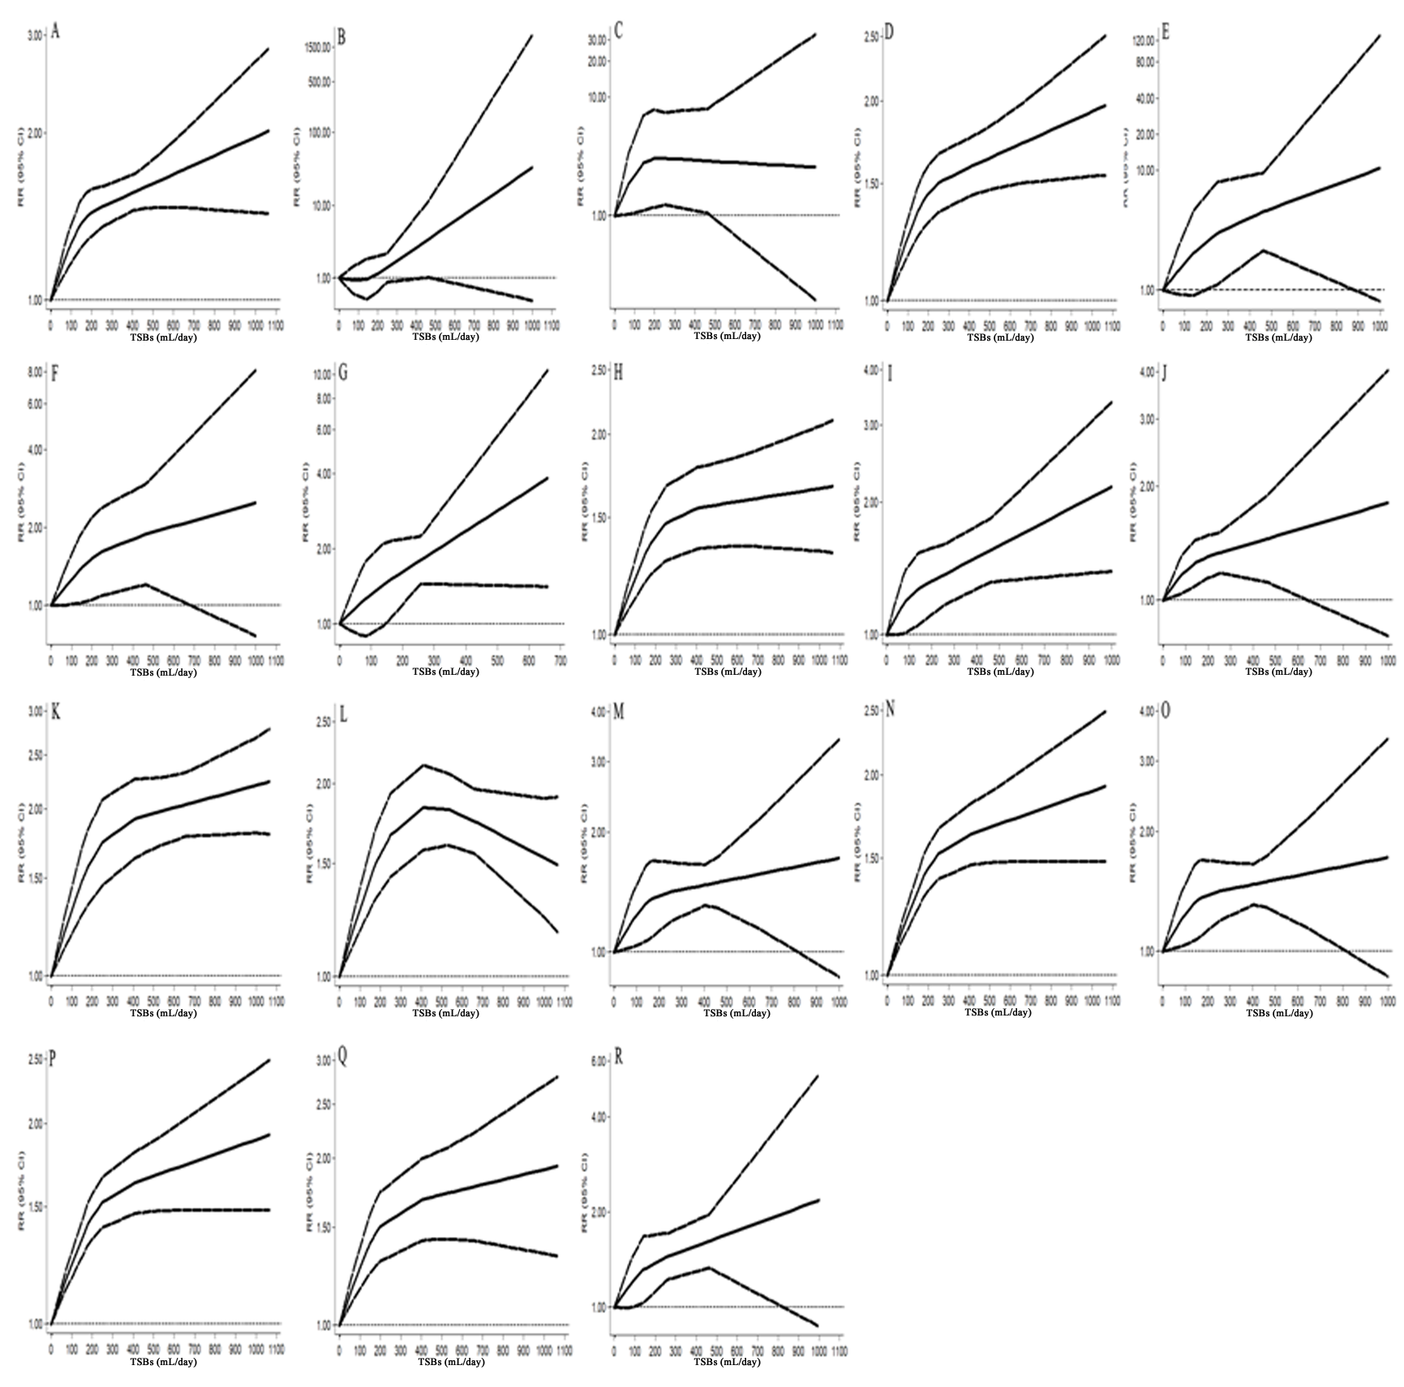Supplementary figure 1. Dose–response subgroup association between total sweetened beverage consumption and the risk of metabolic syndrome that was assessed using a restricted cubic splines model. A, Men/Women; B, Men; C, Women; D, Adult population (≥18 years old); E, Children and adolescents (<18 years old); F, Asia; G, Europe; H, America; I, Longitudinal study; J, Longitudinal study based on all population; K, Cross–sectional study; L, Cross–sectional study based on adult population; M, Sample size<10,000; N, Sample size≥10,000; O, Number of MetS patients<500; P, Number of cases of MetS≥500; Q, Definition of MetS based on NCEP ATP III; R, Definition of MetS not based on NCEP ATP III. CI, confidence interval; MetS, metabolic syndrome; NCEP ATP III, National Cholesterol Education Program Adult Treatment Panel III; RR, relative risk; TSBs, total sweetened beverages.
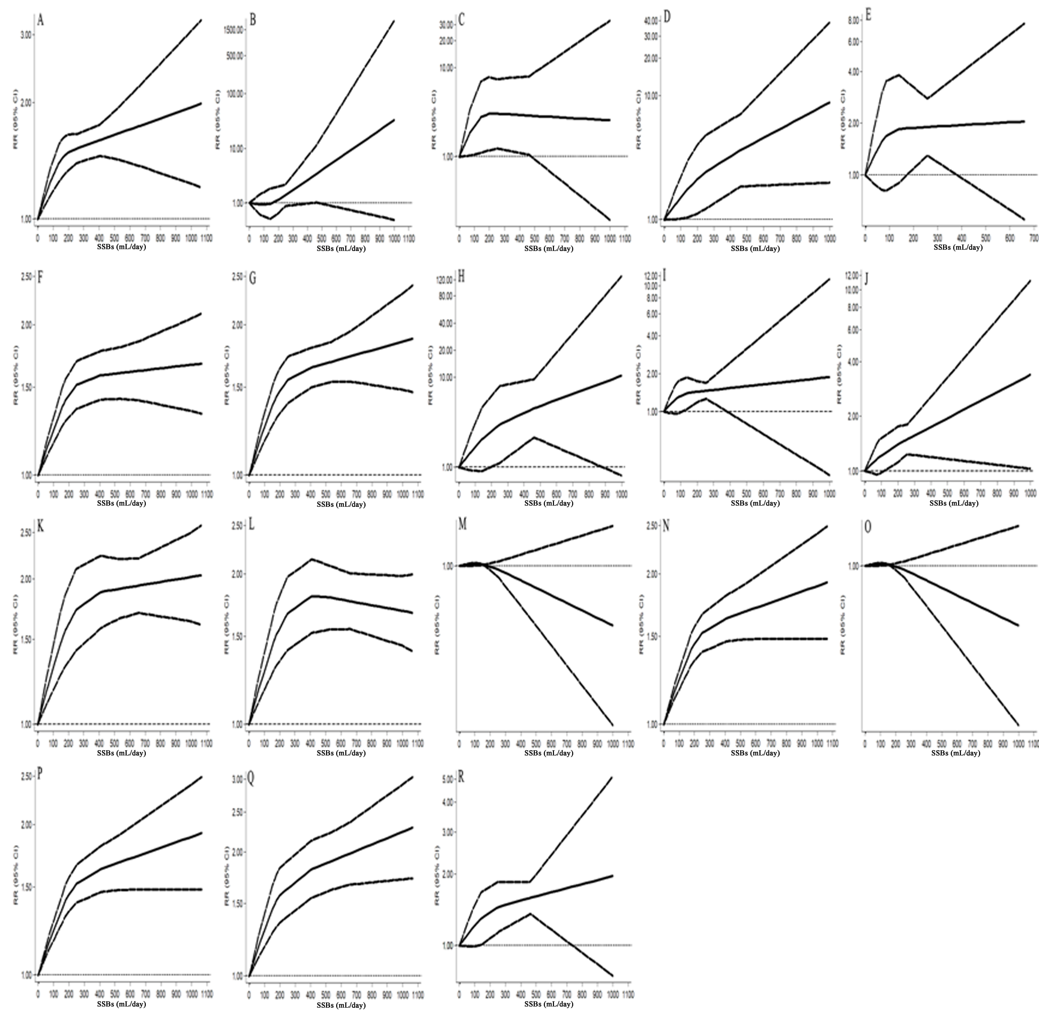Supplementary figure 2. Dose–response subgroup association between sugar sweetened beverage consumption and the risk of metabolic syndrome that was assessed using a restricted cubic splines model. A, Men/Women; B, Men; C, Women; D, Adult population (≥18 years old); E, Children and adolescents (<18 years old); F, Asia; G, Europe; H, America; I, Longitudinal study; J, Longitudinal study based on all population; K, Cross–sectional study; L, Cross–sectional study based on adult population; M, Sample size<10,000; N, Sample size≥10,000; O, Number of cases of MetS<500; P, Number of MetS patients≥500; Q, Definition of MetS based on NCEP ATP III; R, Definition of MetS not based on NCEP ATP III. CI, confidence interval; MetS, metabolic syndrome; NCEP ATP III, National Cholesterol Education Program Adult Treatment Panel III; RR, relative risk; SSBs, sugar sweetened beverages.

